- Call the Application #5000#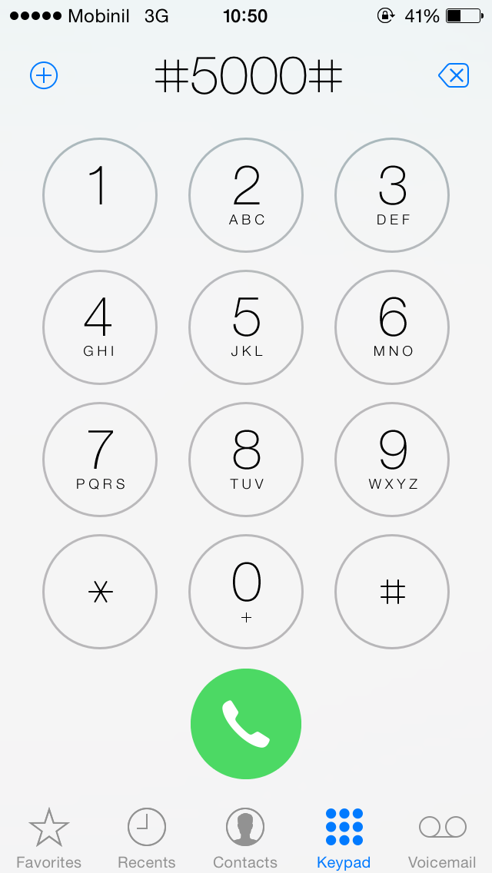
- Choose the desired language to continue with. 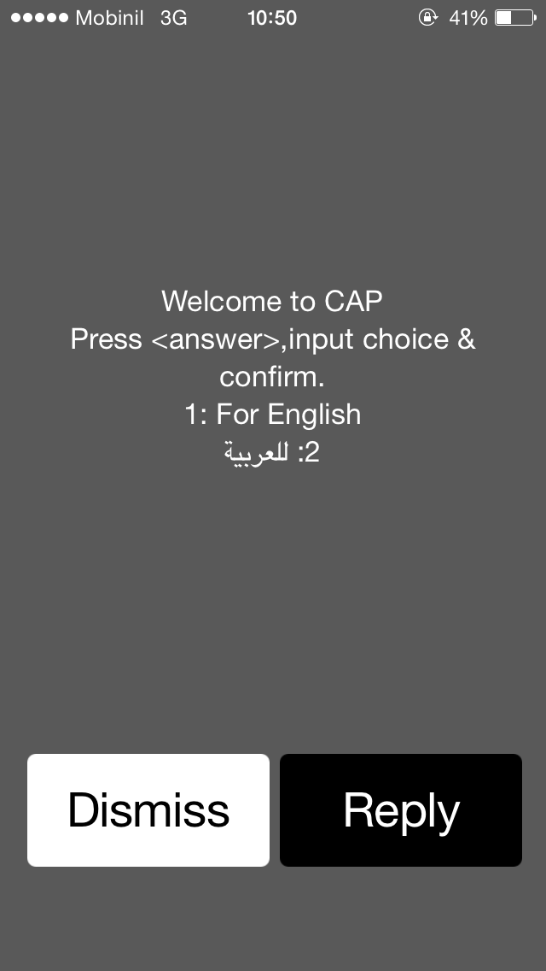

- Enter the PIN code recived by SMS when your Number is registerd on the System.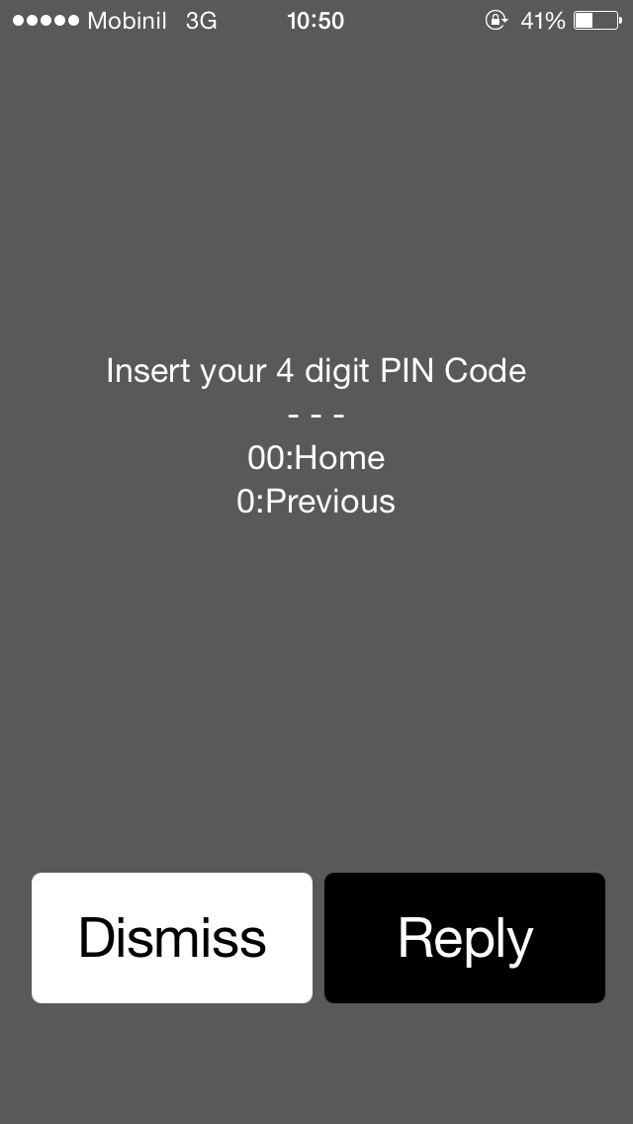

- Choose the Intervention needed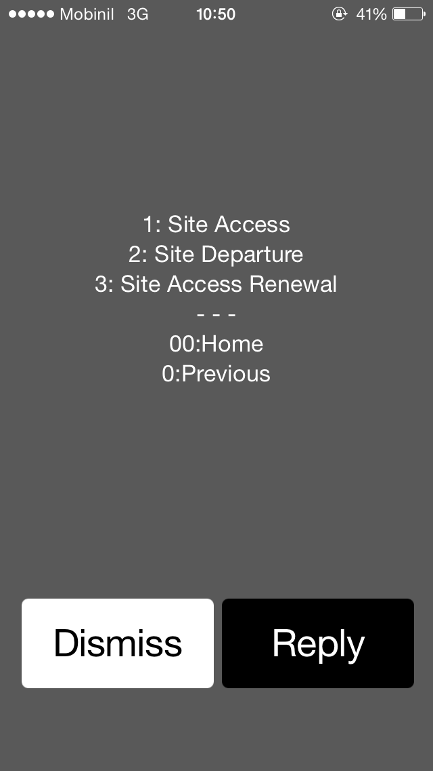.
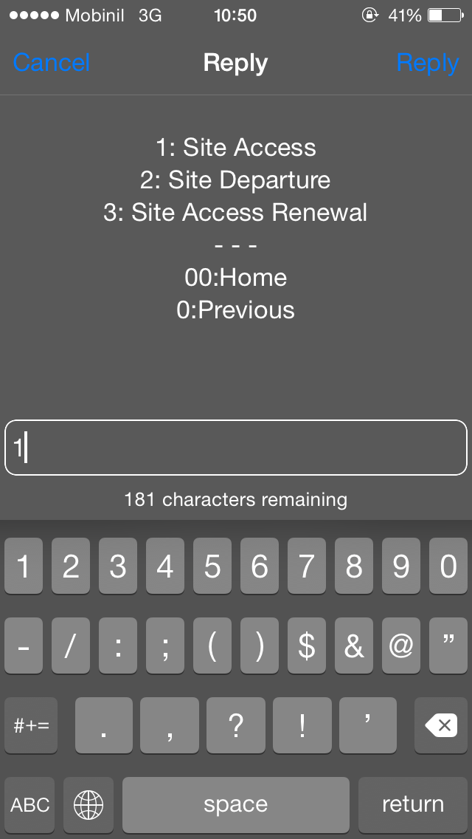
- If you choose access determine if you are continuing work choose continue task if you are starting new task choose new Task.
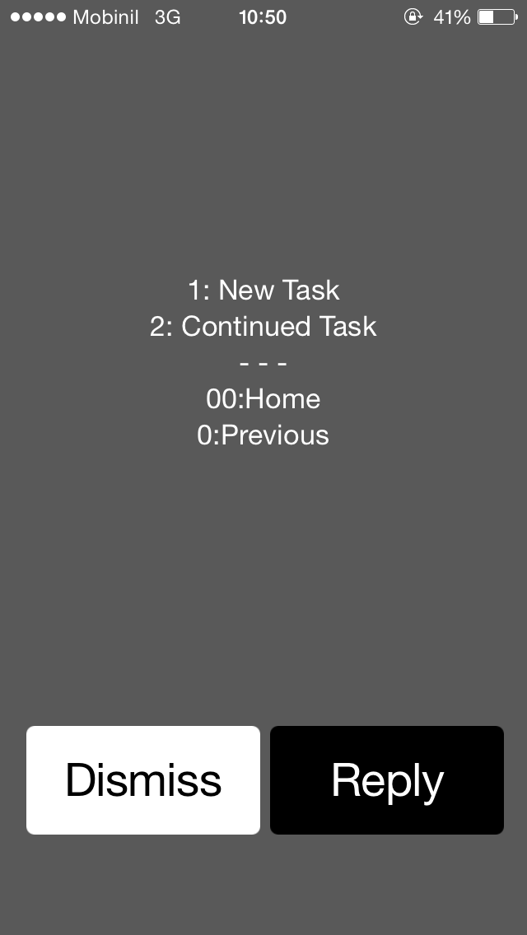

For New Task continue with the Site Area (according to the Site code suffix) and the Site code (ex: 1234CA or , 9876AL)
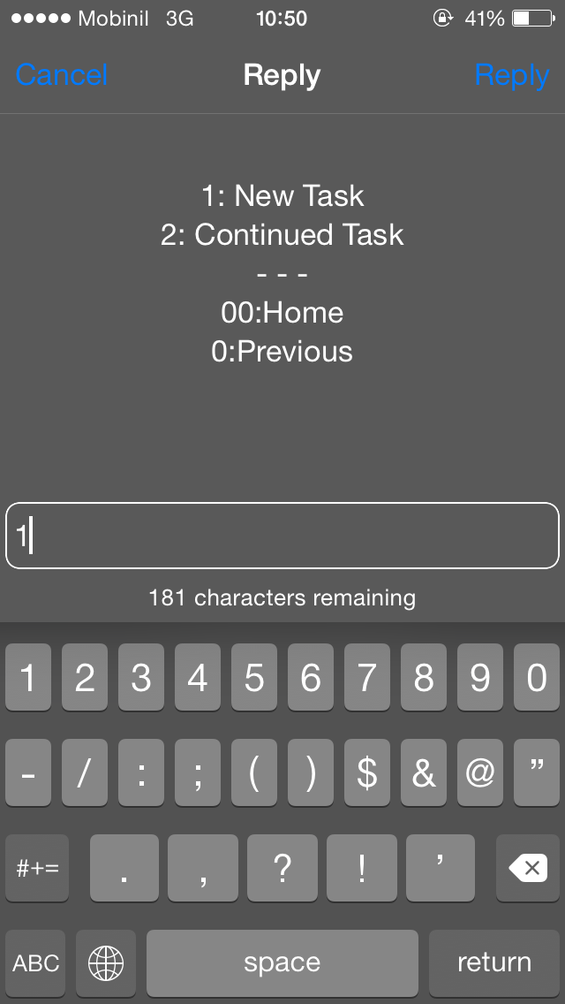
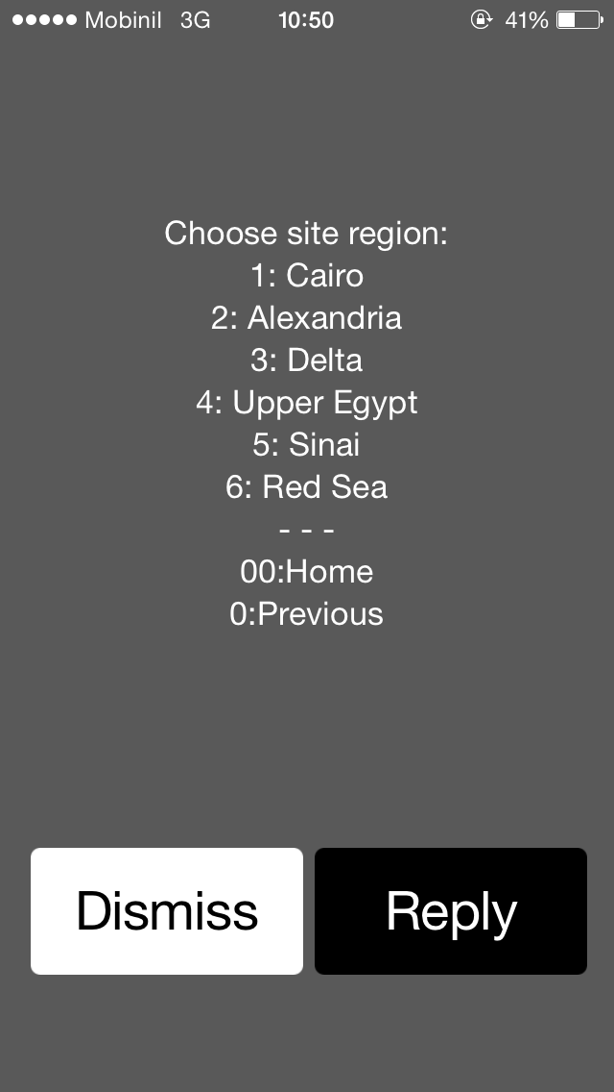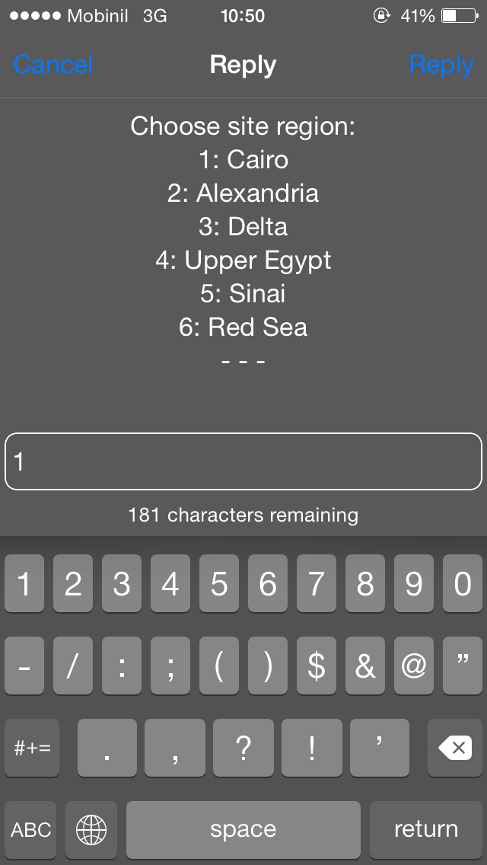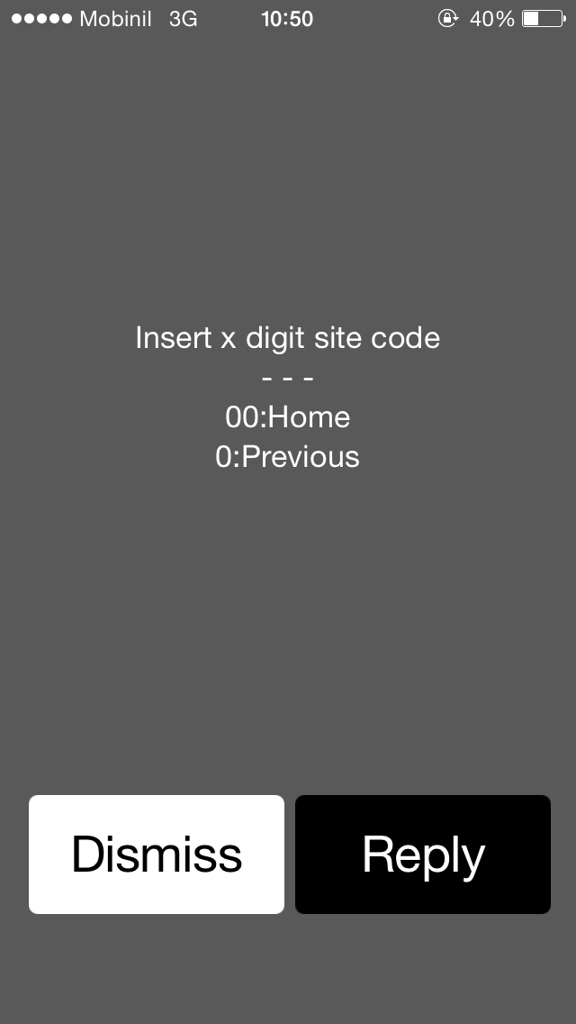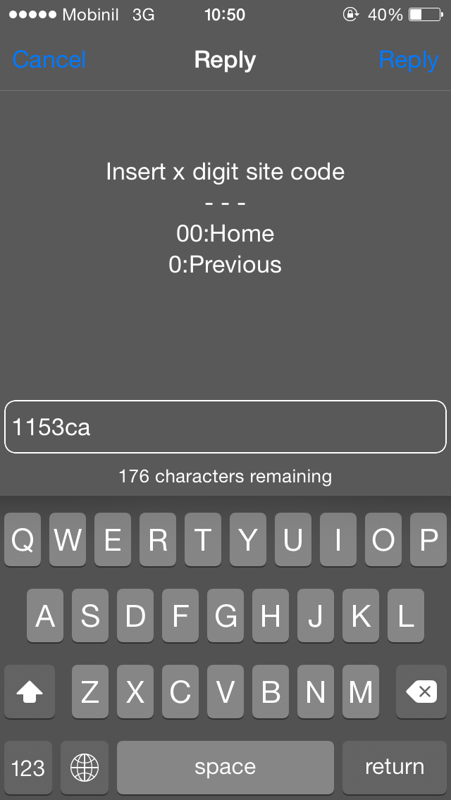
- Now Choose the Intervention type
- If Action plan user enter the Action plan numbe: (C*****)
- If Incident user enter the Incident number: (IM******)
- Fax Report user enter the number: (FX********)
- Other actions option is only for Mobinil Personal to have this privileges approval mail must sent from the Area Owner (maintenance Team leader and/or Manager)
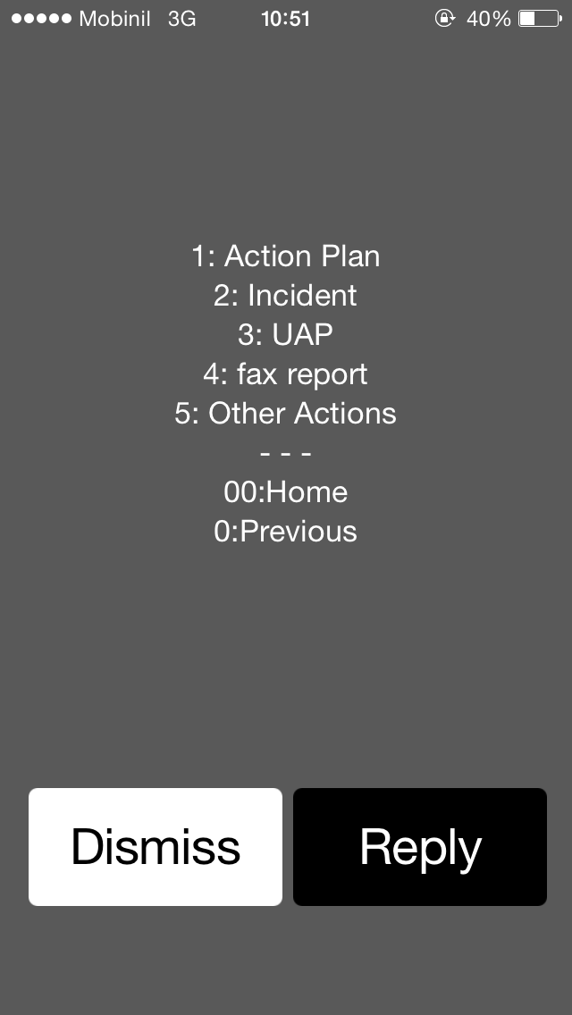
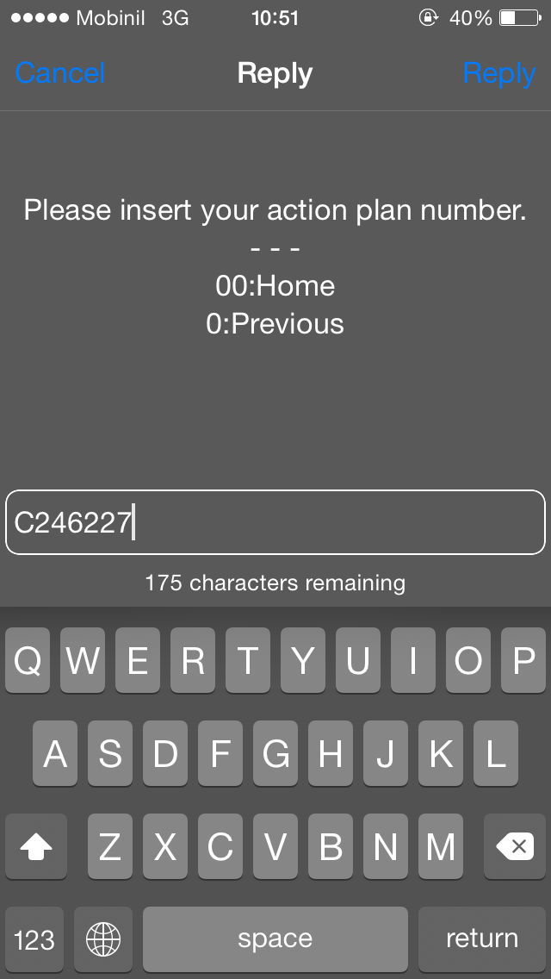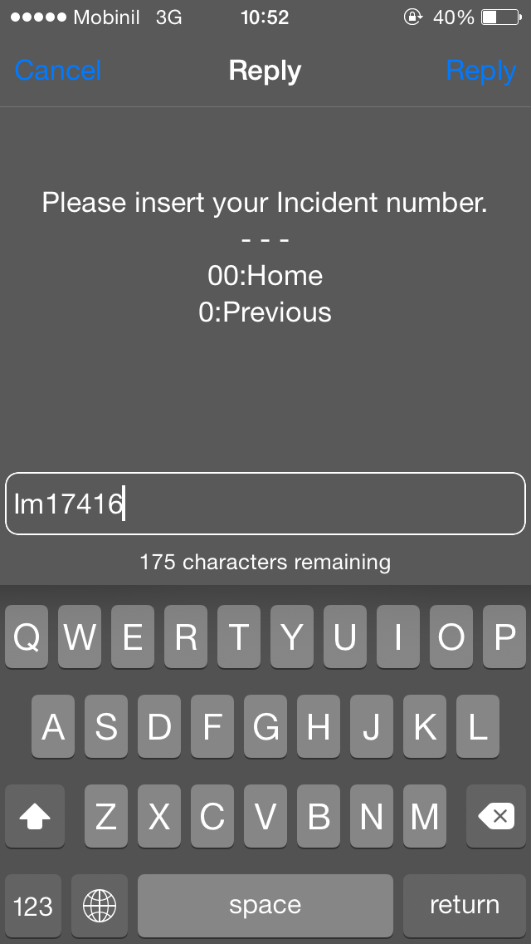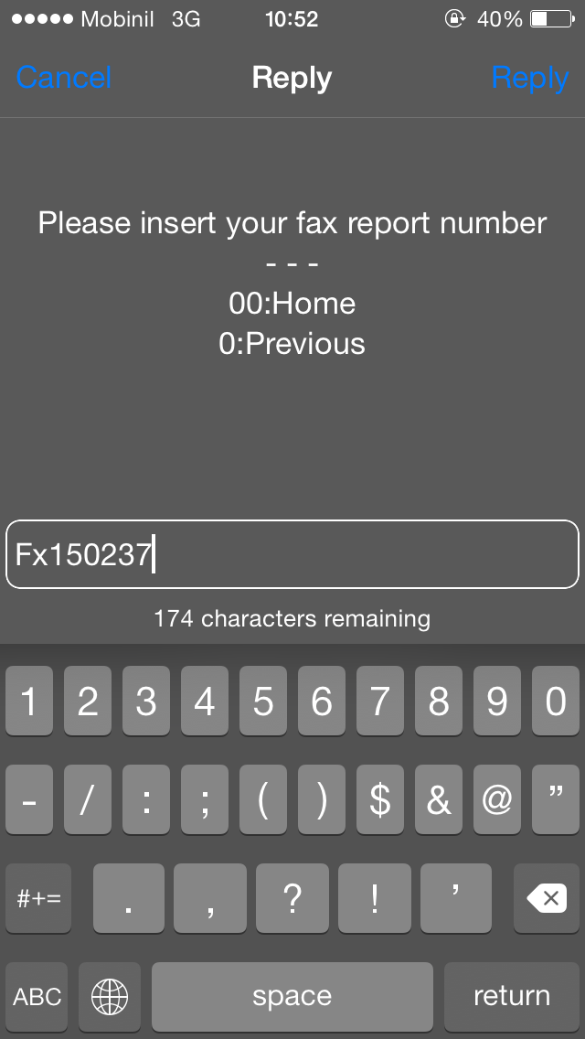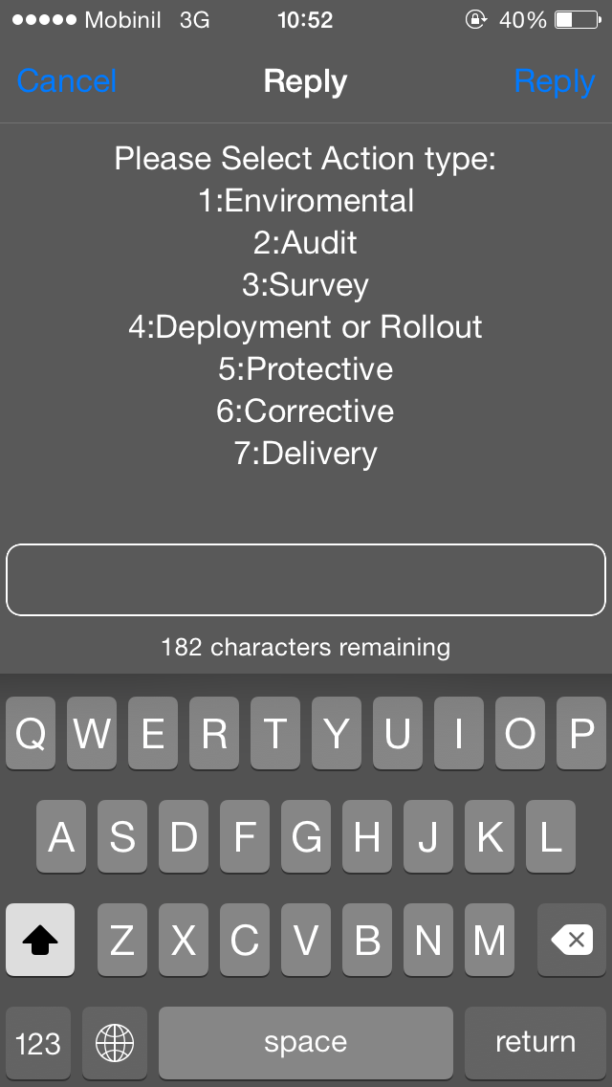
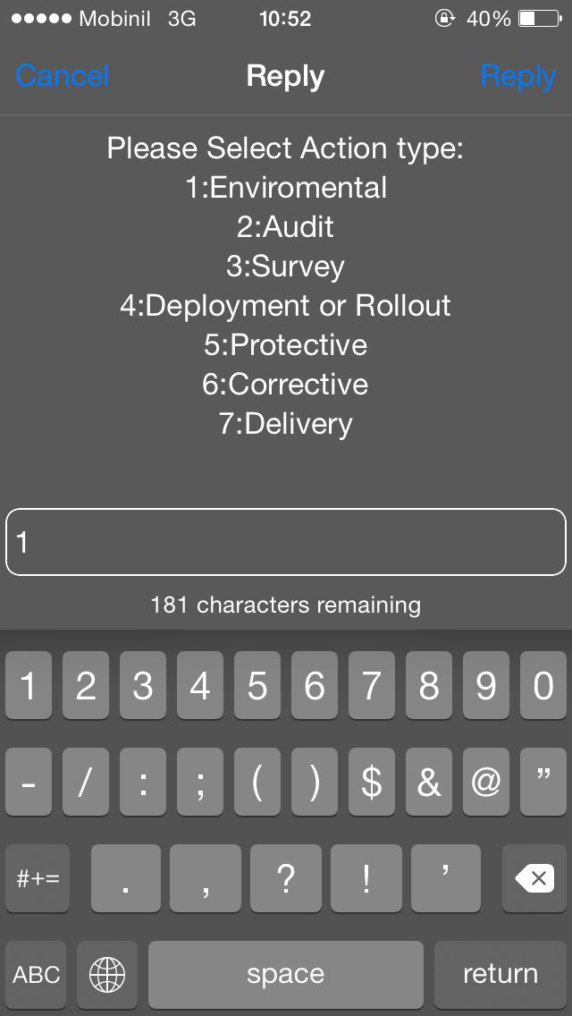
- If all data summited correct you will receive the below Massage from the USSD.
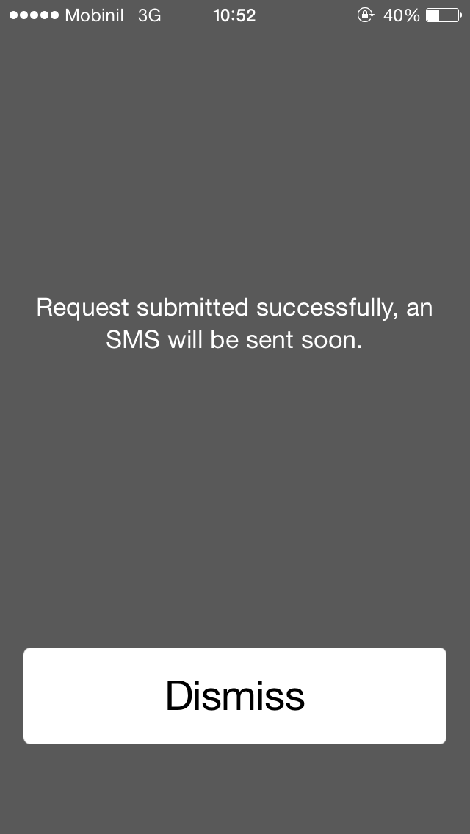

- User will receive a massage that you access is granted to mentioned Site code. You will receive also a code. This code will be used in other requests (renewal, departure, continue Task) and as intervention serial number to confirm with the field engineers.
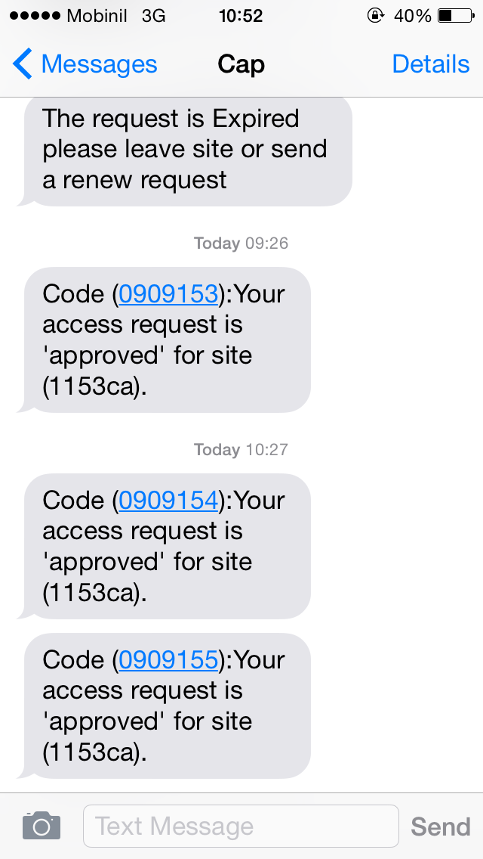

- After three hours the requestor (on site Engineer) will receive an SMS to depart the site or renew access.
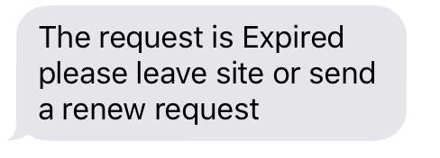
- User will call the CAP application and request Renew access and enter the last Confirmation serial received regarding this site.
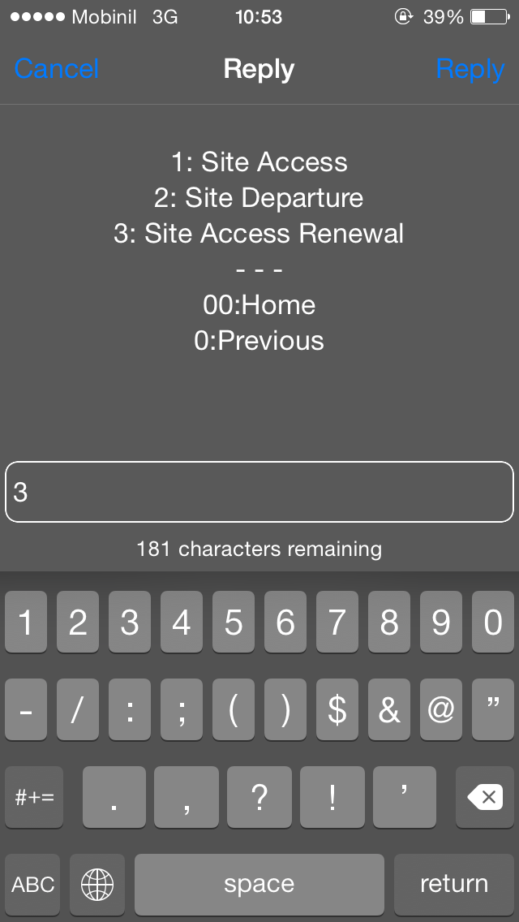

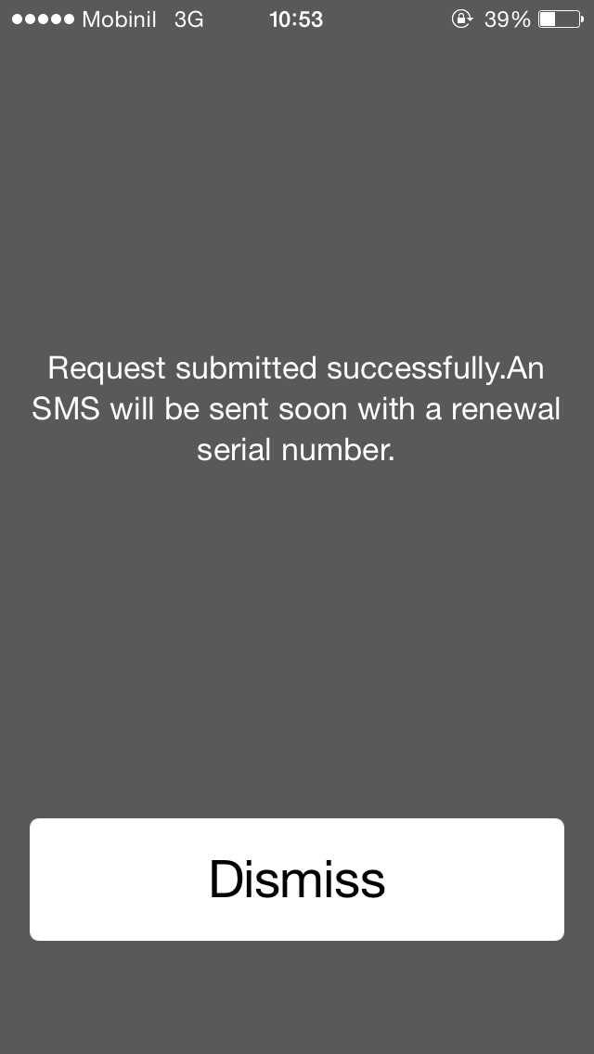
- User will receive a massage that you access renewal is approved to mentioned Site code. You will receive also a code. This code will be used in other requests (renewal, departure, continue Task) and as intervention serial number to confirm with the field engineers.
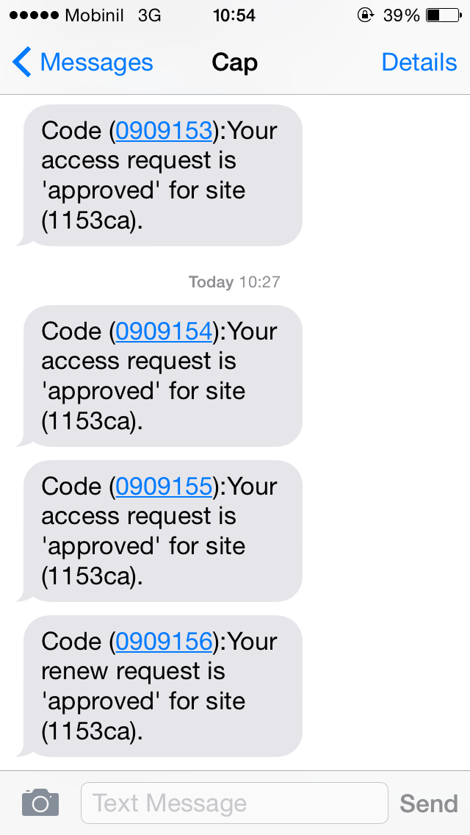

- At any time user can call the CAP application and request depart site and enter the last Confirmation serial received regarding this site.
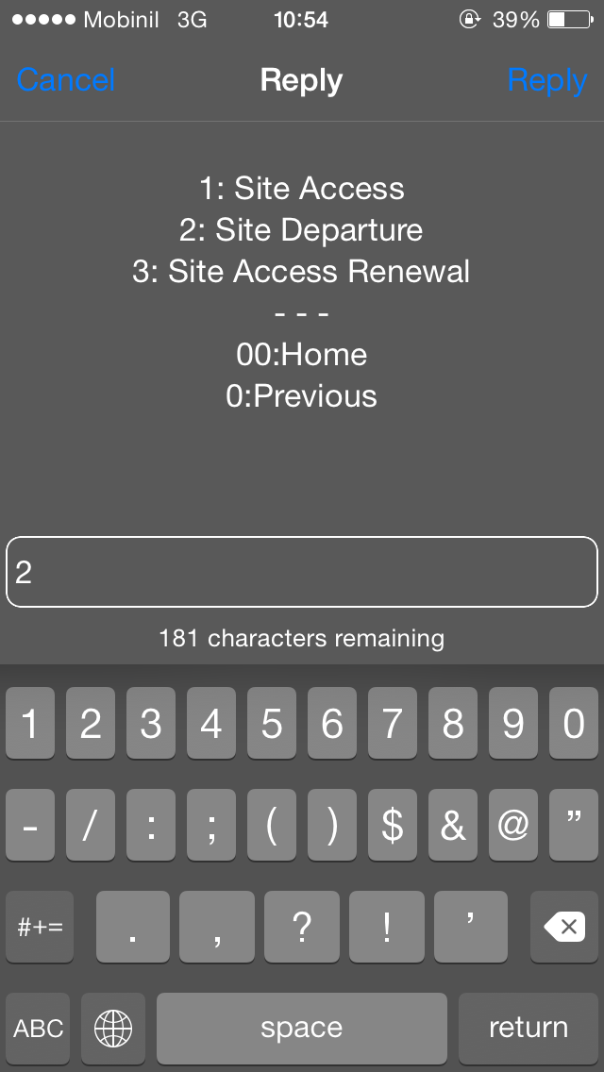
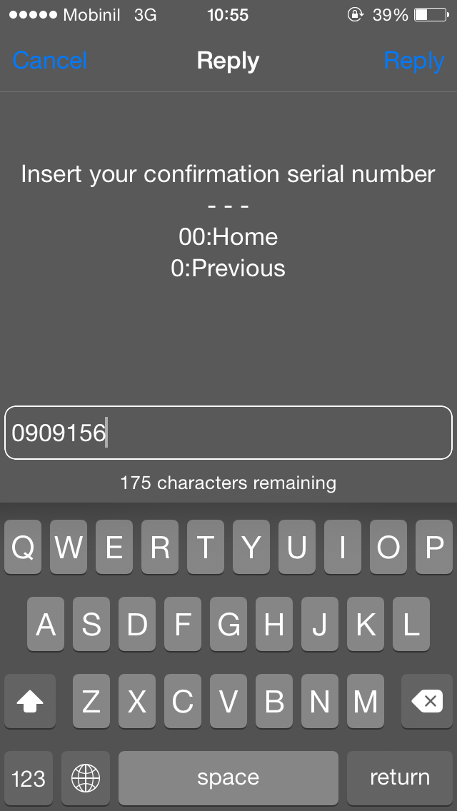
- User Choose the Status of work before they depart
- Finished
- Not finished
- Fished pending another site
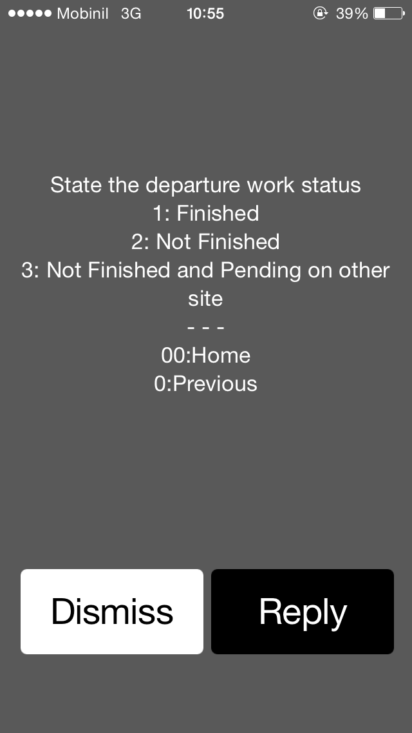
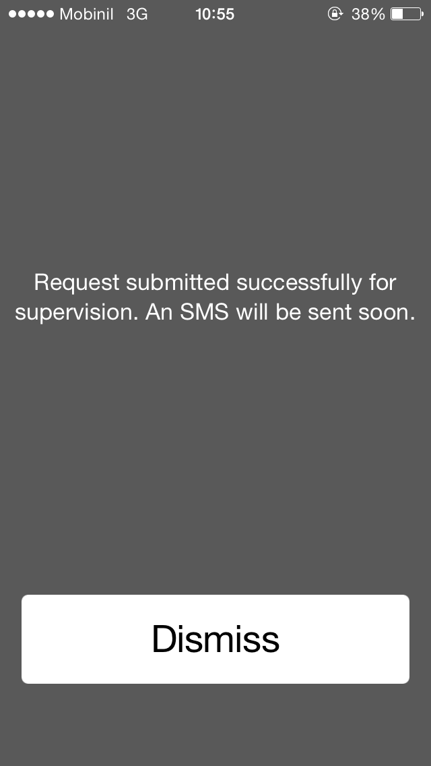
- If User choose option 3 Not finished pending another Site the system will request the second site information (Site Area (according to the Site code suffix) and the Site code (ex: 1234CA or , 9876AL))
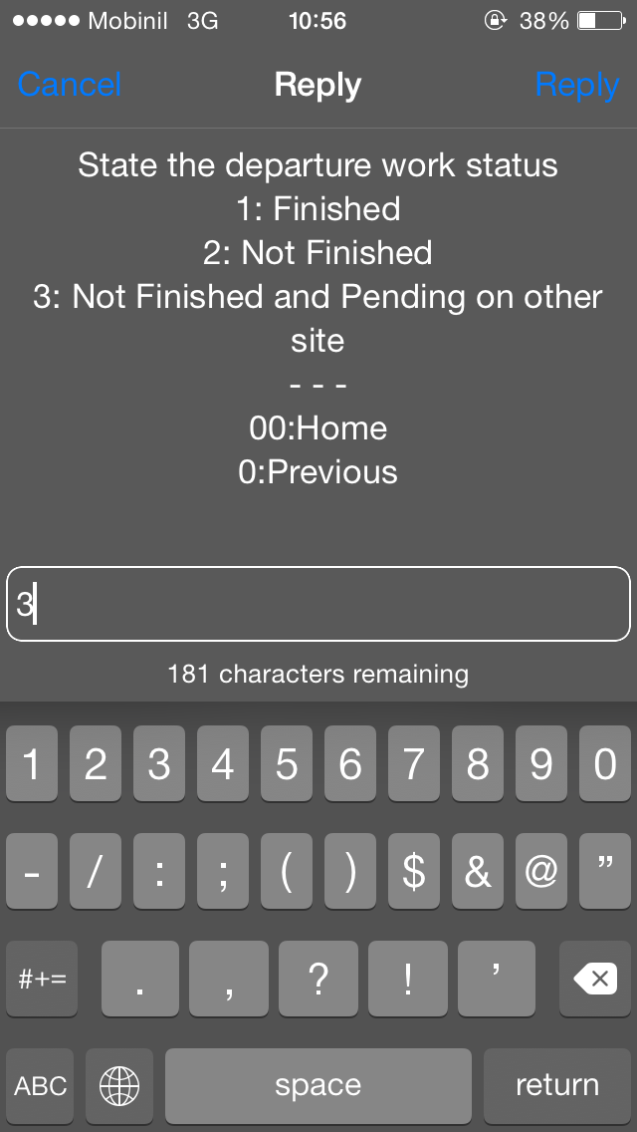
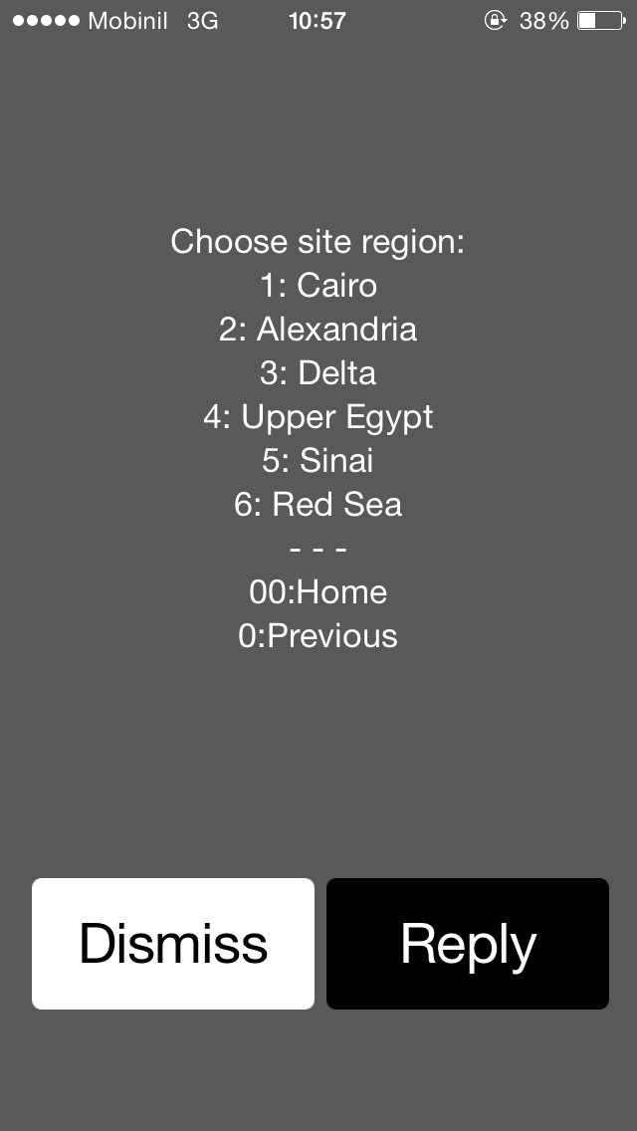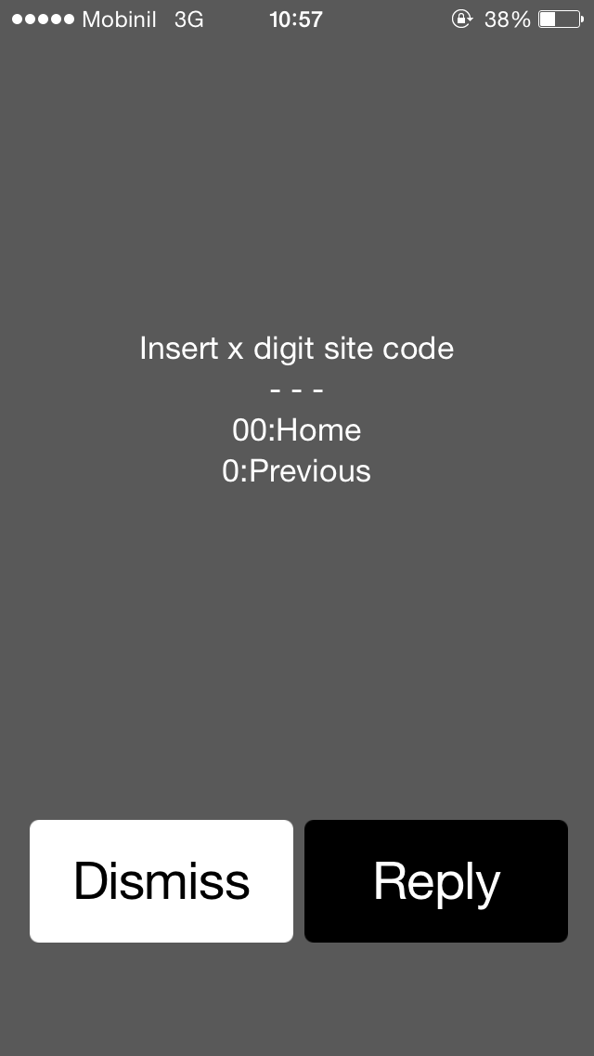

- Departure request will be sent to Supervision team to approve or reject the departure and User will receive a massage with supervision replay mentioned Site code. You will receive also a code. This code will be used in other requests (access, renewal, departure, continue Task) and as intervention serial number to confirm with the field engineers.
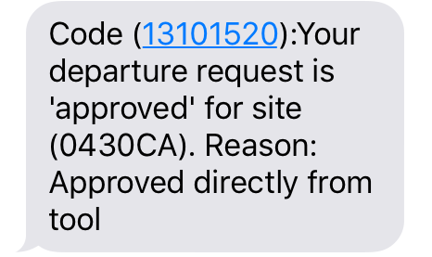

- Some General Notes regarding the system.
- If the user submitted a request and no door alarm generated from the site the user will receive an SMS stating that their request expired and user will have to submit a new request.
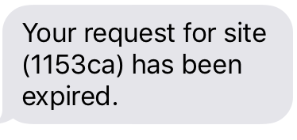
- If on-site Engineer is SOCED (considered and illegal intervention) user will an SMS stating that their access to this site is illegal.
