

CAP Reports
User Manual
Prepared by Business Analysis Team

Contents
Contents 2
Table of Figures 2
Revision History 3
1. Document Overview 4
2. SYSTEM OVERVIEW 5
2.1. Site Interventions process 5
3. Reports 7
3.1. SOCed Alert Report 9
3.2. Illegal Intervention Report 12
3.3. Legal Intervention Report 15
3.4. PM Intervention Report 19
3.5. Warning Alert Report 22

Table of Figures
Figure 1: Reports system menu 8
Figure 2: SOCed Alert Report 11
Figure 3: Illegal Intervention Report 14
Figure 4: Legal Intervention Report 18
Figure 5: PM Intervention Report 21
Figure 6: Warning Alert Report 24

Revision History
Date | Description | Author | Comments
31/07/2017 | User Manual V0.1 | Ahmed Ashraf | Initial Document

Document Overview
The user’s manual consists of three sections: System Overview and Reports
- System Overview section provides a general overview of the system. The summary outlines the basic flow of the site interventions.
- Reports section explains how to access CAP reports.

SYSTEM OVERVIEW
CAP is an application intended to manage Orange sites and guard(s) of each site and to control sites interventions.

Site Interventions process
- The requester is someone who is assigned to do specific task(s) in a specific site.

- The requester can initiate a site intervention using USSD from his mobile.

- Site hardware components (ex. Site main door) is configured to send E-mails to the system as per specific actions (ex. Door opening) which is parsed by the system and considered as alert.

- If a major task on a site are needed during a specific period, then an action plan will be created on the system to allow the requester to access the site during that period.

- Access request:
  - The system receives an access request from a requester on a specific site followed by a door alert from the same site, or the system receives a door alert from a specific site followed by an access request from a requester on the same site.
  - The system automatically approves the access request.

- Request timeout:
  - The system receives an access request from a requester on a specific site.
  - The system waits for a predefined period (ex. 30 minutes) to receive a door alert.
  - If no alert received, the system will set the status of the request as “Request timeout”.
  - The requester must create a new access request to enter the site.

- Renewal request:
  - The requester sends a renewal request if the access request time elapsed (ex: 3 hours), which is automatically approved by the system.

- Departure request:
  - The requester sends a departure request on leaving the site then the user approves the departure request.

- SOCed Without Request:
  - The system receives a door alert from a specific site without previous access request on the same site
  - The system waits for a predefined period (ex. 5 minutes) to receive an access request on this site.
  - If no access request received, then the system will set the status of this intervention as “SOCed Without Request”.

- SOCed No Renewal Request:
  - The requester access a specific site, and a predefined period (ex: 3 hours) elapses with no renewal or departure request, then the system will set the status of the intervention as “Waiting Renewal”.
  - If the requester didn’t send a renewal request within a predefined period (ex. 5 minutes), then the system will set the status of the intervention as “SOCed No Renewal Request”.

- SOCed Finished Action Plan:
  - The requester access a specific site using a non-expired action plan or any action type with end date and this action expires while the requester is still inside the site, then the system will set the status of the intervention as “SOCed Finished Action Plan”.

- Illegal interventions:
  - For any SOCed intervention, the user will click on the button “Illegal” on the screen “SOC alerts” to mark this intervention as illegal intervention after investigating the SOCed intervention which turned to be an illegal intervention.

Reports
- The system reports can be accessed from the menu (Reports -> Reports).

- The system contains the following reports:
  - SOCed Alert Report
  - Illegal Intervention Report
  - Legal Intervention Report
  - PM Intervention Report
  - Warning Alert Report

- Reports data can be filtered by filling one or more of its filtration criteria.

- The user can click the button "Filtration Options" to show/hide the checkboxes that controls the visibility of the filtration criteria.

- The user can reset the list filtration by clicking on the button “Reset”. This will do the following
  - Clear all the search fields.
  - Reload the report with all the data.

- Report data can be sorted by clicking on the header of the columns.

- If the report contains records more than the value selected in the list “Row count”, then it will be splitted into pages. The user can navigate between report pages by clicking on the “Next/Previous” and “First/Last” buttons below the list or by selecting a page from the list “Go to page”.

- Report can by exported as an excel sheet by clicking on the button “Export”.

- The user can click the button "Add To Dashboard" to add this report to the dashboard screen and to select also the columns that will be shown.
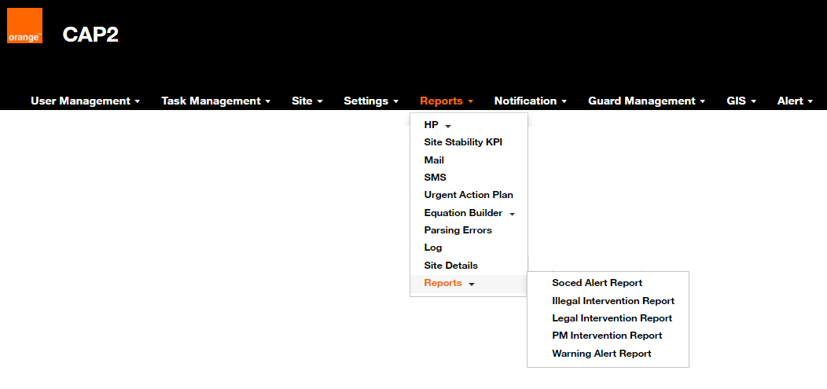
Figure 1: Reports system menu

SOCed Alert Report

Report Navigation:
- The user can access this report by clicking on the menu (Reports -> Reports -> SOCed Alert Report).

Report Description:
- This reports displays the following SOCed site interventions:
  - SOCed Without Request:
    - The system receives a door alert from a specific site without previous access request on the same site
    - The system waits for a predefined period (ex. 5 minutes) to receive an access request on this site.
    - If no access request received, then the system will set the status of this intervention as “SOCed Without Request”.

  - SOCed No Renewal Request:
    - The requester access a specific site, and a predefined period (ex: 3 hours) elapses with no renewal or departure request, then the system will set the status of the intervention as “Waiting Renewal”.
    - If the requester didn’t send a renewal request within a predefined period (ex. 5 minutes), then the system will set the status of the intervention as “SOCed No Renewal Request”.

  - SOCed Finished Action Plan:
    - The requester access a specific site using a non-expired action plan or any action type with end date and this action expires while the requester is still inside the site, then the system will set the status of the intervention as “SOCed Finished Action Plan”.

Report columns:
- The report will show the following fields for each SOCed intervention:
  - Site Code:
    - The code of the site where the SOCed intervention occurred.
  - Site Name:
    - The name of the site where the SOCed intervention occurred.
  - Alert Date:
    - The date when the SOCed intervention occurred.
  - Vendor Name:
    - The vendor of the site where the SOCed intervention occurred.
    - Can be one of the following values:
      - Alcatel
      - Nokia
      - ZTE
      - Huawei
      - Motorola

  - User Notes:
    - The note that the user specified by clicking the button “Add Notes” in screen “Main door alarm”.
  - Severity:
    - The severity of the alert.
    - It is specified on the E-mail that is sent as an alert.
    - Can be one of the following values:
      - Normal
      - Urgent
      - Major
      - Minor
      - Critical
  - Description:
    - The description of the alert.
    - It is specified on the E-mail that is sent as an alert.
  - Requester:
    - The name of the requester in case the intervention is one of the following types:
      - SOCed No Renewal Request
      - SOCed Finished Action Plan

Filtration Criteria:
The report data can be filtered using one or more of the following criteria, then clicking on the button “Search”:
  - Site Code:
    - Filter using any part of the code of the site where the SOCed intervention occurred.
  - Site Name:
    - Filter using any part of the name of the site where the SOCed intervention occurred.
  - Supplier:
    - Filter using the vendor of the site where the SOCed intervention occurred.
    - Can be one of the following values:
      - Alcatel
      - Nokia
      - ZTE
      - Huawei
      - Motorola
  - Severity:
    - Filter using the severity of the alert.
    - Can be one of the following values:
      - Normal
      - Urgent
      - Major
      - Minor
      - Critical

  - Start date/ End date:
    - Filter using date range when the SOCed intervention occurred (Alert Date).

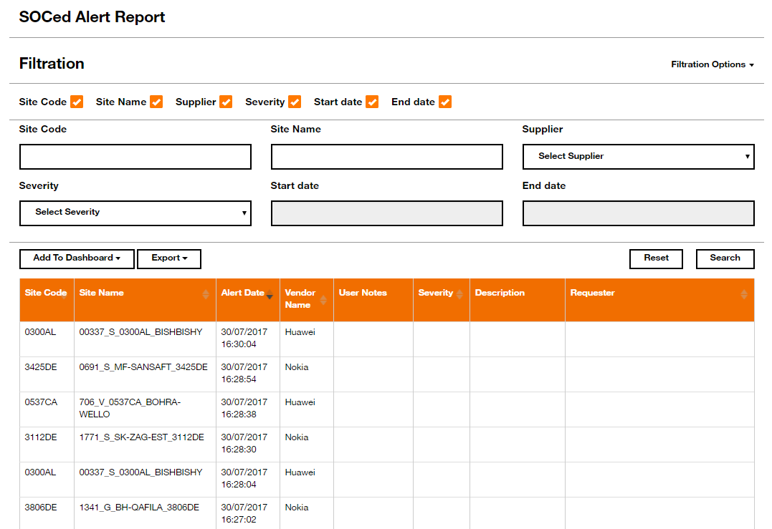
Figure 2: SOCed Alert Report

Illegal Intervention Report

Report Navigation:
- The user can access this report by clicking on the menu (Reports -> Reports -> Illegal Intervention Report).

Report Description:
- This reports displays the illegal site interventions.

- Illegal interventions:
  - For any SOCed intervention, the user will click on the button “Illegal” on the screen “SOC alerts” to mark this intervention as illegal intervention after investigating the SOCed intervention which turned to be an illegal intervention.

Report columns:
- The report will show the following fields for each illegal intervention:
  - Site Code:
    - The code of the site where the illegal intervention occurred.
  - Site Name:
    - The name of the site where the illegal intervention occurred.
  - BSC:
    - The BSC of the site where the illegal intervention occurred.
  - Alert Date:
    - The date when the illegal intervention occurred.
  - Vendor Name:
    - The vendor of the site where the illegal intervention occurred.
    - Can be one of the following values:
      - Alcatel
      - Nokia
      - ZTE
      - Huawei
      - Motorola
  - Comment:
    - The comment entered by the user in the "Illegal" popup in the screen “SOC alerts”.
  - Severity:
    - The severity of the alert.
    - It is specified on the E-mail that is sent as an alert.
    - Can be one of the following values:
      - Normal
      - Urgent
      - Major
      - Minor
      - Critical
  - Description:
    - The description (If exist) of the action specified on USSD.

  - Requester:
    - The name of the requester.

Filtration Criteria:
The report data can be filtered using one or more of the following criteria, then clicking on the button “Search”:
  - Site Name:
    - Filter using any part of the name of the site where the illegal intervention occurred.
  - BSC:
    - Filter using any part of the BSC of the site where the illegal intervention occurred.
  - Vendor:
    - Filter using the vendor of the site where the illegal intervention occurred.
    - Can be one of the following values:
      - Alcatel
      - Nokia
      - ZTE
      - Huawei
      - Motorola
  - Severity:
    - Filter using the severity of the alert.
    - Can be one of the following values:
      - Normal
      - Urgent
      - Major
      - Minor
      - Critical
  - Start date/ End date:
    - Filter using date range when the illegal intervention occurred (Alert Date).

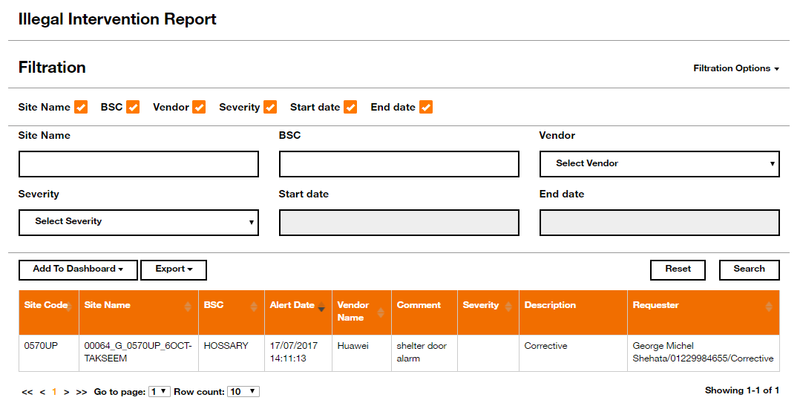
Figure 3: Illegal Intervention Report

Legal Intervention Report

Report Navigation:
- The user can access this report by clicking on the menu (Reports -> Reports -> Legal Intervention Report).

Report Description:
- This reports displays the legal site interventions.

- Legal interventions can be a result of one of the following action:
  - Access request:
    - The system receives an access request from a requester on a specific site followed by a door alert from the same site, or the system receives a door alert from a specific site followed by an access request from a requester on the same site.
    - The system automatically approves the access request.

Report columns:
- The report will show the following fields for each legal intervention:
  - Request Type:
    - The type of the request of the legal intervention.
    - Can be one of the following values:
      - Access
      - Renew
      - Departure
  - Request Status:
    - The current approval status of the request.
    - Can be one of the following values:
      - No Approval Required
      - Pending Approval
      - Approved
      - Rejected
      - Cancelled
  - BSC:
    - The BSC of the site where the legal intervention occurred.
  - Request Date:
    - The date of the request.
  - Supplier:
    - The vendor of the site where the legal intervention occurred.
    - Can be one of the following values:
      - Alcatel
      - Nokia
      - ZTE
      - Huawei
      - Motorola
  - Site Code:
    - The code of the site where the legal intervention occurred.
  - Site Name:
    - The name of the site where the legal intervention occurred.
  - User Notes:
    - The note that the user specified by clicking the button “Add Notes” in screen “Main door alarm”.
  - Action Date:
    - The date of the action specified in the request.
  - Action Type:
    - The action that the requester specified when creating the access request on USSD.
    - Can be one of the following values:
      - Action Plan
      - Audit
      - Corrective
      - Delivery
      - Deployment Or Rollout
      - Environmental
      - Fax Report
      - Incident
      - PM Generator
      - Protective
      - Survey
      - Urgent Action Plan
  - Contractor Name:
    - The name of the requester.
  - Contractor Number:
    - The mobile number of the requester.
  - Supervisor Approval Comment:
    - The comment that the user specified when approving/rejecting the departure request on screen “Main door alarm”.
  - Supervisor Notes:
    - The notes that the user specified on screen “Main door alarm”.
  - Requester:
    - The name of the requester.

Filtration Criteria:
The report data can be filtered using one or more of the following criteria, then clicking on the button “Search”:
  - Site Code:
    - Filter using any part of the code of the site where the legal intervention occurred.
  - Site Name:
    - Filter using any part of the name of the site where the legal intervention occurred.
  - BSC:
    - Filter using any part of the BSC of the site where the legal intervention occurred.
  - Requestor Name:
    - Filter using any part of the name of the requester.
  - Requestor Mobile Phone:
    - Filter using any part of the mobile number of the requester.
  - Vendor:
    - Filter using the vendor of the site where the legal intervention occurred.
    - Can be one of the following values:
      - Alcatel
      - Nokia
      - ZTE
      - Huawei
      - Motorola
  - Request Type:
    - Filter using the type of the request of the legal intervention.
    - Can be one of the following values:
      - Access
      - Renew
      - Departure
  - Action Type:
    - Filter using the action that the requester specified when creating the access request on USSD.
    - Can be one of the following values:
      - Action Plan
      - Audit
      - Corrective
      - Delivery
      - Deployment Or Rollout
      - Environmental
      - Fax Report
      - Incident
      - PM Generator
      - Protective
      - Survey
      - Urgent Action Plan
  - Request Status:
    - Filter using the current approval status of the request.
    - Can be one of the following values:
      - No Approval Required
      - Pending Approval
      - Approved
      - Rejected
      - Cancelled
  - Start date/ End date:
    - Filter using date range of (Request Date).

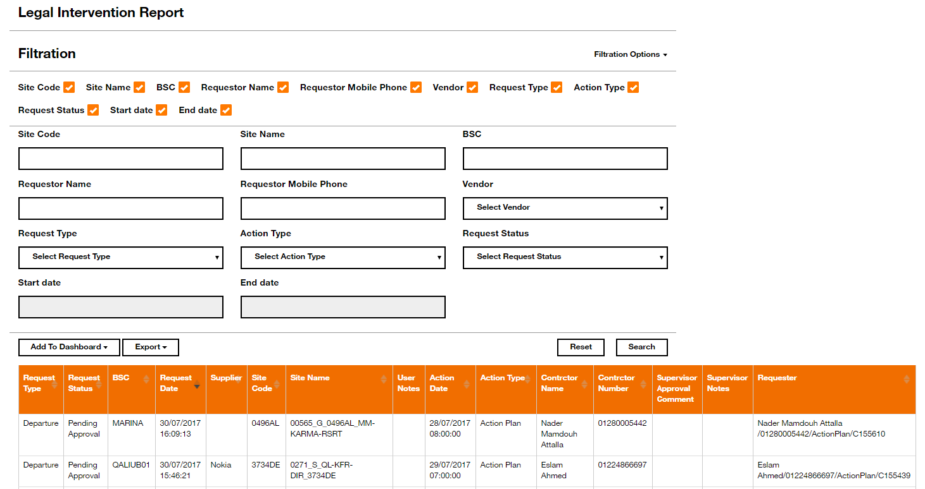
Figure 4: Legal Intervention Report

PM Intervention Report

Report Navigation:
- The user can access this report by clicking on the menu (Reports -> Reports -> PM Intervention Report).

Report Description:
- This reports displays the legal site interventions with one of the following actions:
  - PM Generator
  - Protective
  - Urgent Action Plan

- Legal interventions can be a result of one of the following action:
  - Access request:
    - The system receives an access request from a requester on a specific site followed by a door alert from the same site or the system receives a door alert from a specific site followed by an access request from a requester on the same site.
    - The system automatically approves the access request.
    - The request action should be (PM Generator, Protective or Urgent Action Plan).

Report columns:
- The report will show the following fields for each PM intervention:
  - Site Name:
    - The name of the site where the PM intervention occurred.
  - Vendor Name:
    - The vendor of the site where the PM intervention occurred.
    - Can be one of the following values:
      - Alcatel
      - Nokia
      - ZTE
      - Huawei
      - Motorola
  - Action Type:
    - The action that the requester specified when creating the access request on USSD.
    - Can be one of the following values:
      - PM Generator
      - Protective
      - Urgent Action Plan
  - Company Name:
    - The company where the requester is employed.
  - Request Date:
    - The date of the request.
  - Alarm Start Date:
    - The start date of the alert.
  - Alarm End Date:
    - The end date of the alert.

Filtration Criteria:
The report data can be filtered using one or more of the following criteria, then clicking on the button “Search”:
  - Site Name:
    - Filter using any part of the name of the site where the PM intervention occurred.
  - Vendor:
    - Filter using the vendor of the site where the PM intervention occurred.
    - Can be one of the following values:
      - Alcatel
      - Nokia
      - ZTE
      - Huawei
      - Motorola
  - Action Type:
    - Filter using the action that the requester specified when creating the access request on USSD.
    - Can be one of the following values:
      - PM Generator
      - Protective
      - Urgent Action Plan
  - Start date/ End date:
    - Filter using date range when the PM intervention occurred.
    - Filter against the fields “Alarm Start Date” and “Alarm End Date”.

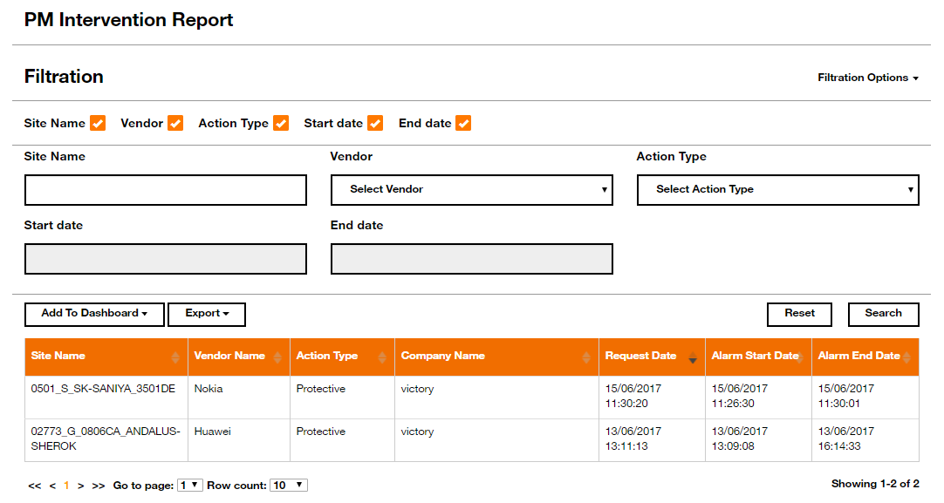
Figure 5: PM Intervention Report

Warning Alert Report

Report Navigation:
- The user can access this report by clicking on the menu (Reports -> Reports -> Warning Alert Report).

Report Description:
- This reports displays only the following SOCed site interventions:
  - SOCed No Renewal Request:
    - The requester access a specific site, and a predefined period (ex: 3 hours) elapses with no renewal or departure request, then the system will set the status of the intervention as “Waiting Renewal”.
    - If the requester didn’t send a renewal request within a predefined period (ex. 5 minutes), then the system will set the status of the intervention as “SOCed No Renewal Request”.

  - SOCed Finished Action Plan:
    - The requester access a specific site using a non-expired action plan or any action type with end date and this action expires while the requester still inside the site, then the system will set the status of the intervention as “SOCed Finished Action Plan”.

Report columns:
- The report will show the following fields for each warning intervention:
  - Site Name:
    - The name of the site where the warning intervention occurred.
  - Site Code:
    - The code of the site where the warning intervention occurred.
  - BSC:
    - The BSC of the site where the warning intervention occurred.
  - Action Code:
    - The code of the action that the requester specified when creating the access request on USSD.
  - Request Date:
    - The date of the request.
  - Supervisor Approval Date:
    - The date of the approval of the request.
  - Supervisor Approval Comment:
    - The comment specified when the departure request was approved.
  - Departure Next Site Code:
    - The code of the next site that the requester specified when creating a departure request.
  - Contractor Name:
    - The name of the requester.
  - Contractor Number:
    - The mobile number of the requester.

  - Contractor Secondary Number:
    - The secondary mobile number of the requester.
  - Contractor Email:
    - The E-mail of the requester.
  - Company Name:
    - The company where the requester is employed.
  - Intervention Status:
    - The current status of the intervention.
  - Request Type:
    - The type of the request of the warning intervention.
    - Can be one of the following values:
      - Access
      - Renew
      - Departure
  - Sms Last Reply Date:
    - The date when the last SMS was sent to the requester.
  - User Notes:
    - The note that the user specified by clicking the button “Add Notes” in screen “Main door alarm”.

Filtration Criteria:
The report data can be filtered using one or more of the following criteria, then clicking on the button “Search”:
  - Action Code:
    - Filter using any part of the code of the action that the requester specified when creating the access request on USSD.
  - Site Name:
    - Filter using any part of the name of the site where the warning intervention occurred.
  - BSC:
    - Filter using any part of the BSC of the site where the warning intervention occurred.
  - Contractor Number:
    - Filter using any part of the mobile number of the requester.
  - Contractor Name:
    - Filter using any part of the name of the requester.
  - Request Type:
    - Filter using the type of the request of the warning intervention.
    - Can be one of the following values:
      - Access
      - Renew
      - Departure
  - Start date/ End date:
    - Filter using date range of (Request Date).

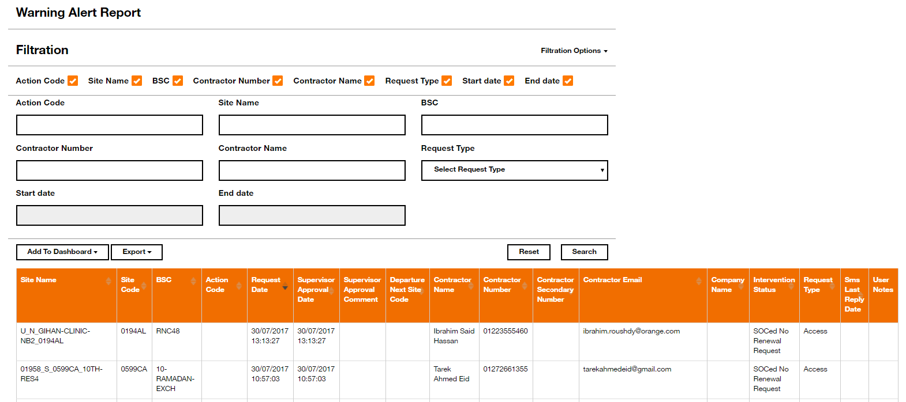
Figure 6: Warning Alert Report

