Victory Link
User’s Guide
CAP v2.1
Dev Team
09/12/2012

Table of Contents
Table of Figures 4
1 Revision History 6
2 Introduction 7
2.1 Purpose 7
2.2 Scope 7
2.3 Definitions 7
3 System Overview 8
3.1 Contractors 8
3.1.1 Default Intended Users 8
3.1.2 Menu Items 8
3.1.3 Description 8
3.2 Main door alarm 16
3.2.1 Default Intended Users 16
3.2.2 Menu Items 16
3.2.3 Description 16
3.3 SOC Alerts 26
3.3.1 Default Intended Users 26
3.3.2 Menu Items 26
3.3.3 Alerts 26
3.4 Sites 36
3.4.1 Default Intended Users 36
3.4.2 Menu Items 36
3.4.3 Description 36
3.4.4 Assign team 36
3.4.5 Add BSC Site 37
3.5 Search 39
3.5.1 Default Intended Users 39
3.5.2 Menu Items 39
3.6 Settings 46
3.6.1 Default Intended Users 46
3.6.2 Menu Items 46
3.7 Reports 56
3.7.1 Default Intended Users 56
3.7.2 Menu Items 56
3.8 User Profile 64
3.9 USSD Service 65
3.9.1 IsUserTrusted 65
3.9.2 IsPinCodeValid 65
3.9.3 IsUserMobinilStaff 65
3.9.4 Submit Request 65
4 References 70

Table of Figures
Figure 1 Contractors menu item 8
Figure 2 Mobinil staff 8
Figure 3 add Mobinil staff 9
Figure 4 add bulk of Mobinil staff 9
Figure 5 Edit Mobinil staff information 10
Figure 6 Delete Mobinil staff 10
Figure 7 trusted users 11
Figure 8 Add Trusted User 12
Figure 9 Add bulk trusted users 12
Figure 10 add trusted user 13
Figure 11 Delete trusted user 13
Figure 12 Unauthorized users 14
Figure 13 Allow unauthorized users 14
Figure 14 Add unauthorized user as Mobinil staff 15
Figure 15 Main door alarm menu item 16
Figure 16 main door alarms 16
Figure 17 edit main door alarm 19
Figure 18 legal main door alarms 20
Figure 19 legal main door alarms send mail 22
Figure 20 approve main door alarm 23
Figure 21 reject main door alarm 24
Figure 22 main door alarm history 25
Figure 23 Soc menu item 26
Figure 24 SOC Alerts 26
Figure 25 Active SOC Alerts 27
Figure 26 Mark alert as legal 28
Figure 27 Send mail legal alerts 30
Figure 28 Mark alert as illegal 31
Figure 29 edit soc active alarm 33
Figure 30 Soc warning alarm 33
Figure 31 false door alerts 34
Figure 32 Inactive SOC alerts 34
Figure 33 Sites menu Item 36
Figure 34 Sites List 37
Figure 35 Assign team to filtered sites 37
Figure 36 Sites, Add Bsc Button 37
Figure 37 BSC Bulk upload 38
Figure 38 Search menu Item 39
Figure 39 Search On Options 39
Figure 40 Search SOC alerts view 39
Figure 41 SOC alerts log view 40
Figure 42 alert log details 40
Figure 43 Search, Access request view 41
Figure 44 Request log view 42
Figure 45 Search, Renew request view 42
Figure 46 Search, Departure request view 43
Figure 47 Search, UAP view 44
Figure 48 Action Log view 45
Figure 49 Settings menu item 46
Figure 50 Interface users 46
Figure 51 editing interface user 47
Figure 52 assign vendor and BSCs to supervisor user 48
Figure 53 Editing maintenance user 48
Figure 54 editing user access roles 49
Figure 55 Subcontractors list 53
Figure 56 edit subcontractor 53
Figure 57 edit subcontractor 54
Figure 58 manage roles 55
Figure 59 Reports menu item 56
Figure 60 Legal report view 56
Figure 61 Illegal report view 58
Figure 62 Soc intervention report view 60
Figure 63 Warnings Report 61
Figure 64 PM report view 63
Figure 65 Add email in user profile 64

Revision History

Name | Date | Notes
Mohammed El-Khodary | 3/12/2012 | Document Guide
Mohamed El-Abacy | 4/12/2012 | Initiate Document
Hend Kamal | 12/12/2012 | Refining the document
Maha Khairy | 12/12/2012 | Add sections to document, and add missing snapshots
Hend Kamal | 27/12/2012 | Add new sections to document
Maha Khairy | 30/12/2012 | Review Document
Hend Kamal | 30/12/2012 | Modify some sections
Maha Khairy | 30/12/2012 | Review and refine document
Mohammed El-Khodary | 3/1/2013 | Review Document
Maha Khairy | 3/1/2013 | Refine document
Hend Kamal | 3/1/2013 | Sort document sections
Maha Khairy | 3/1/2013 | Review Document
Maha Khairy | 30/1/2013 | Update to version 1.11
Maha Khairy | 3/2/2013 | Include Khodary’s comments for UI
Hady Allam | 21/7/2013 | Update to version 2.0
Maha Khairy | 11/11/2013 | Update to version 2.1

Introduction

Purpose
This document is to describe in details how to interact with cap system

Scope
Document scope is to present how to interact with CAP system via
- web portal
- USSD service

Definitions
- Operational Database:
  - Contain active data that hasn't processed yet.
- Archived Database
  - Contain inactive data that its processing is finished, and used to view history of any item.
Note: Archiving occurs one time per day at about 12 PM.
- UAP
  - Urgent action plan

System Overview

Contractors

Default Intended Users
- Administrator.

Menu Items
- Mobinil staff
- Trusted users
- Unauthorized users
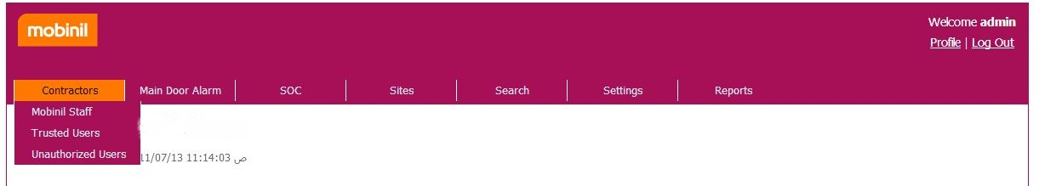
Figure 1 Contractors menu item

Description

Mobinil staff
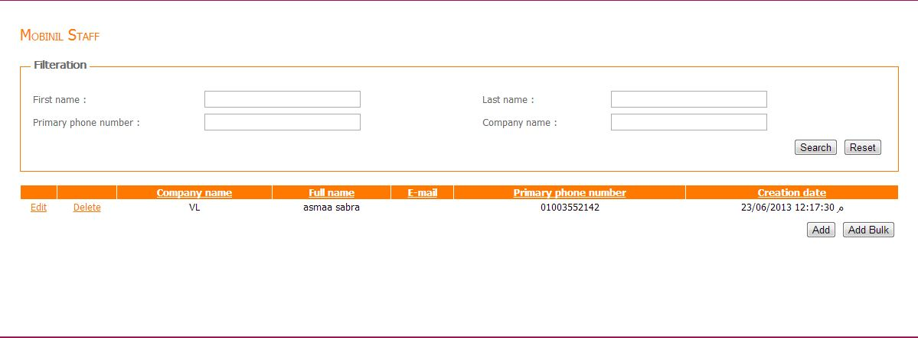
Figure 2 Mobinil staff
Display Mobinil staff based on the following filtering criteria:
- Optional fields
  - First name: where first name contains this value.
  - Last name: where last name contains this value.
  - Primary phone number: where primary phone number contains this value.
  - Company name: where company name contains this value.

Add
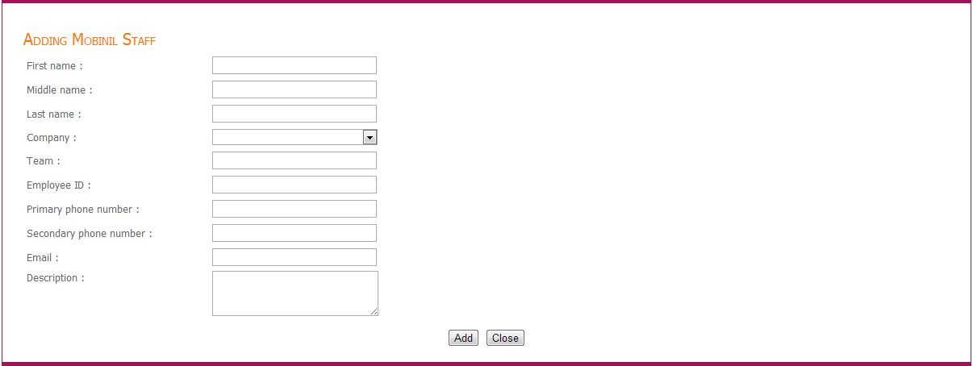
Figure 3 add Mobinil staff
From this page you can add new Mobinil staff by inserting his information then press "Add".

Add bulk
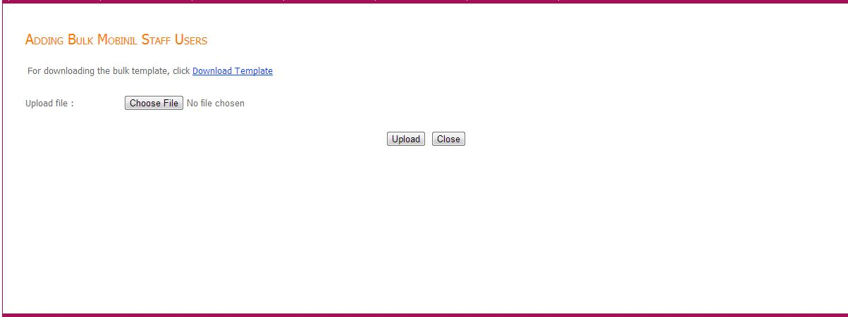
Figure 4 add bulk of Mobinil staff
From this page you can add bulk of Mobinil staff by uploading users file with bulk template.
And you can also download the bulk template by clicking on "Download Template" link.

Edit
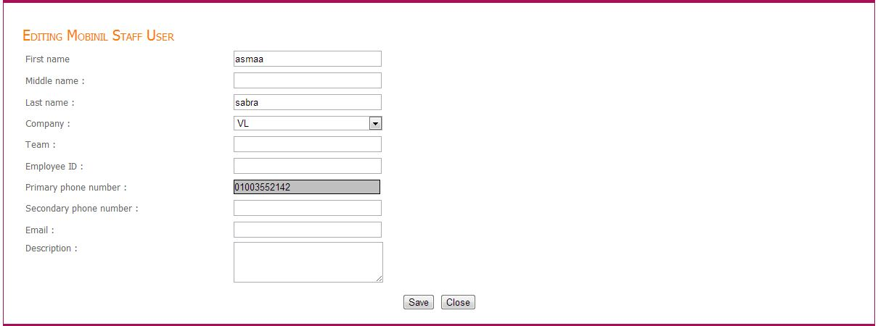
Figure 5 Edit Mobinil staff information
From this page you can edit the user information then click "save" button.

Delete
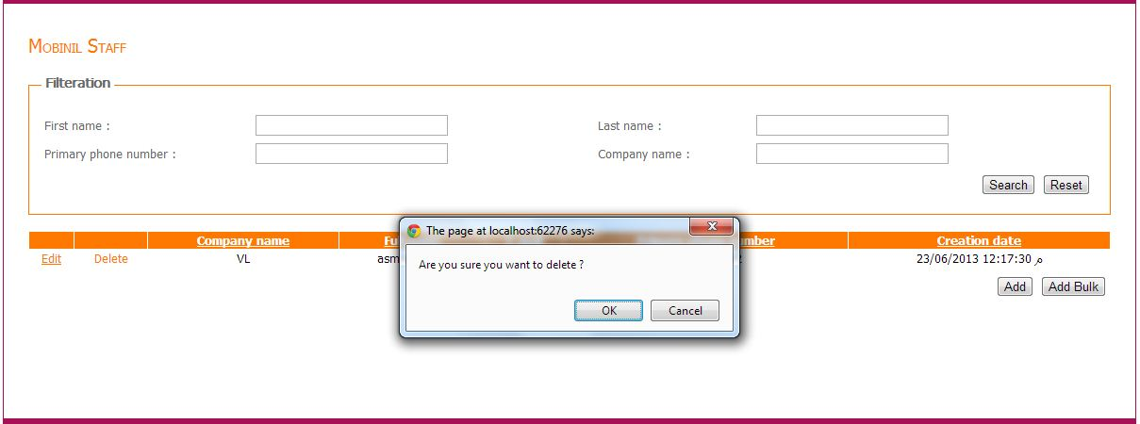
Figure 6 Delete Mobinil staff
You can delete some user by clicking "Delete" link beside its record then click "ok" at the confirmation message, deleting user flags it as ‘Unauthorized’, you can authorize it by visiting Unauthorized users

Trusted users
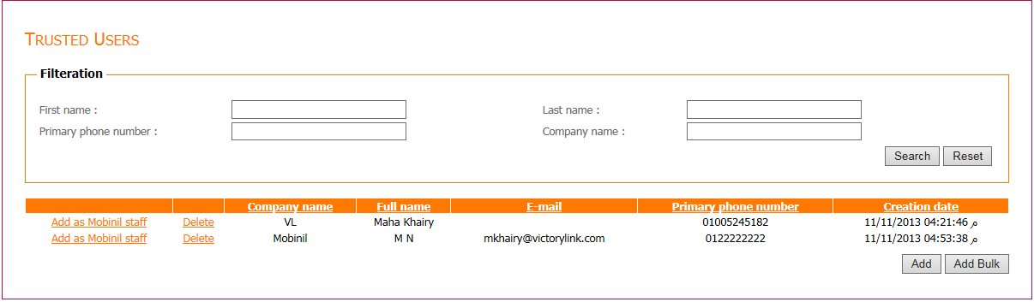
Figure 7
Figure 7 trusted users
Display trusted users based on the following filtering criteria:
- Optional fields
  - First name: where first name contains this value.
  - Last name: where last name contains this value.
  - Primary phone number: where primary phone number contains this value.
  - Company name: where company name contains this value.

Add

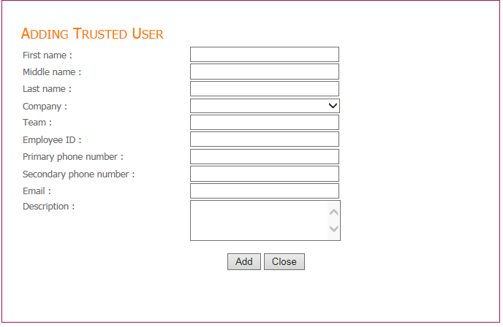
Figure 8 Add Trusted User
From this page you can add new Trusted user by inserting his information then press "Add".

Add bulk
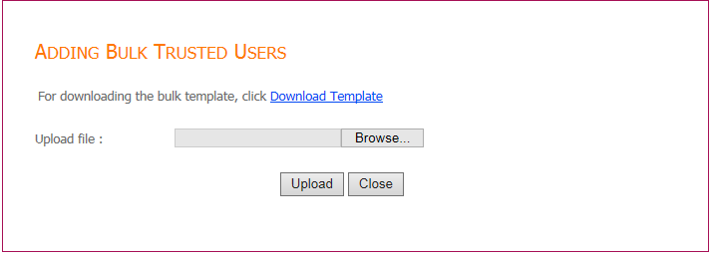
Figure 9 Add bulk trusted users
From this page you can add bulk of trusted users by uploading users file with bulk template.
And you can also download the bulk template by clicking on "Download Template" link.

Add as Mobinil staff
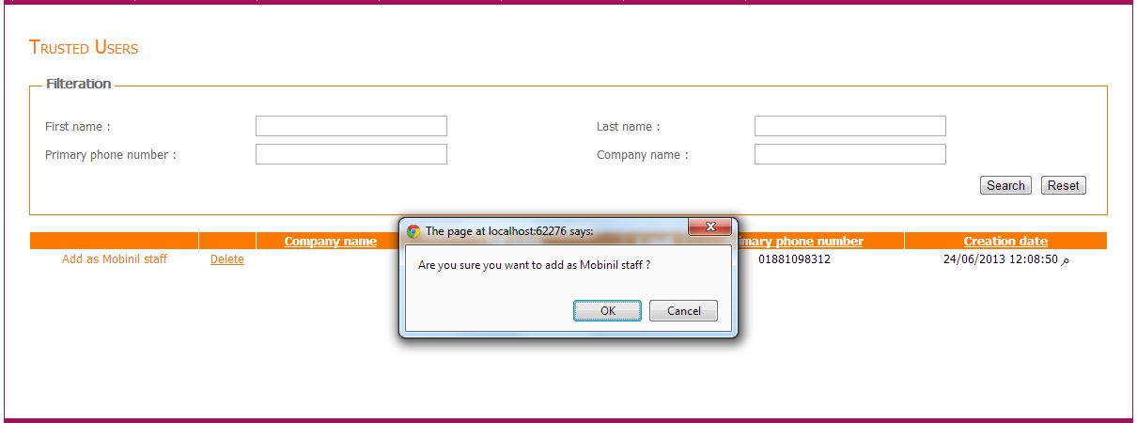
Figure 10 add trusted user
You can add a user as Mobinil staff by clicking “Add as Mobinil staff” link beside its record then clicks "ok" at the confirmation message.

Delete
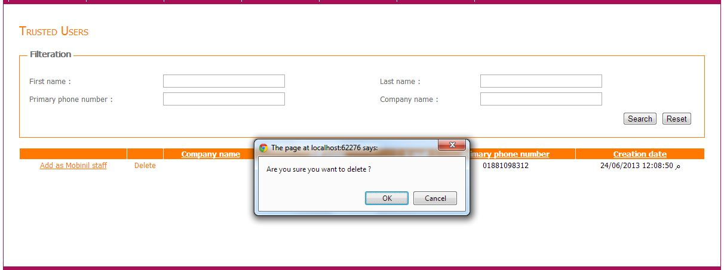
Figure 11 Delete trusted user
You can delete some user by clicking "Delete" link beside its record then click "ok" at the confirmation message, deleting user flags it as ‘Unauthorized’, you can authorize it by visiting Unauthorized users

Unauthorized users
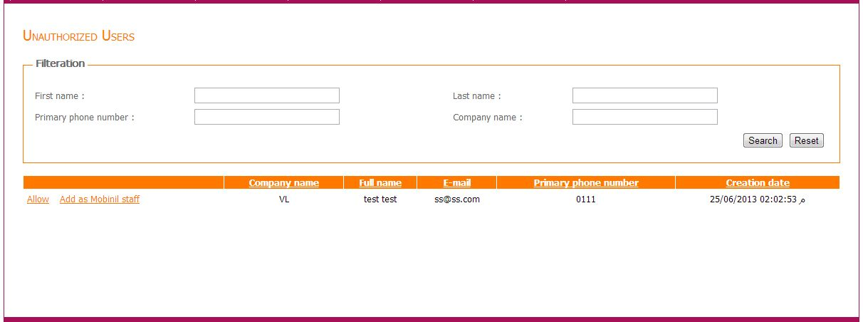
Figure 12 Unauthorized users
Display unauthorized users based on the following filtering criteria:
- Optional fields
  - First name: where first name contains this value.
  - Last name: where last name contains this value.
  - Primary phone number: where primary phone number contains this value.
  - Company name: where company name contains this value.

Allow
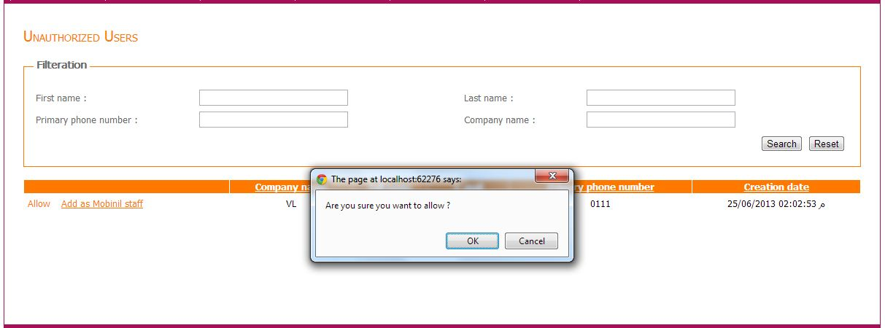
Figure 13 Allow unauthorized users
This link make the selected user be trusted.

Add as Mobinil staff
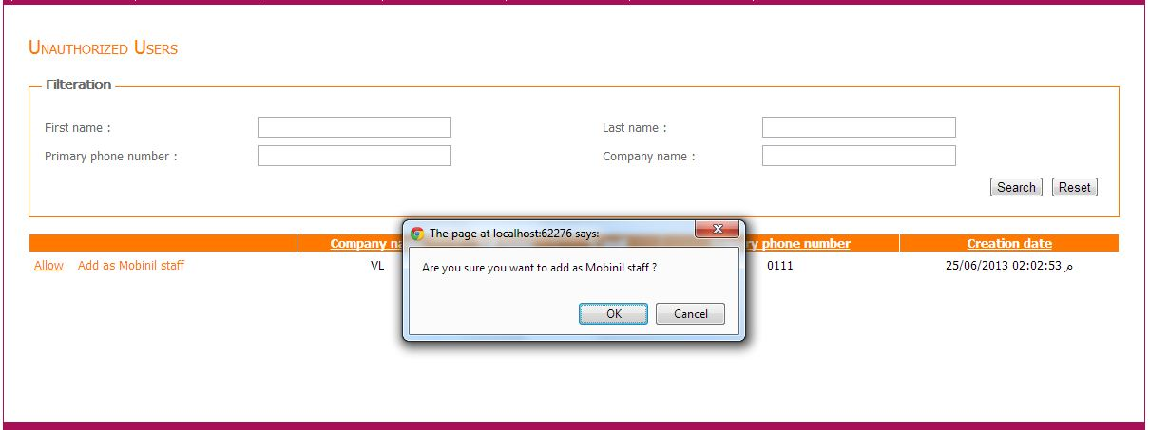
Figure 14 Add unauthorized user as Mobinil staff
This link make the selected user be trusted users Mobinil staff list.

Main door alarm

Default Intended Users
- Administrator.
- Supervisor.
- Supervisor Admin.

Menu Items
- Main door alarm.
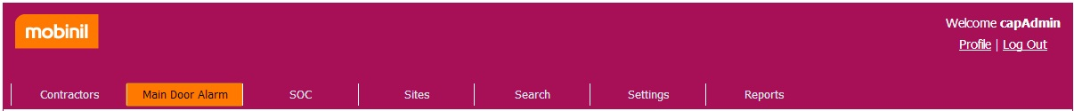
Figure 15 Main door alarm menu item

Description
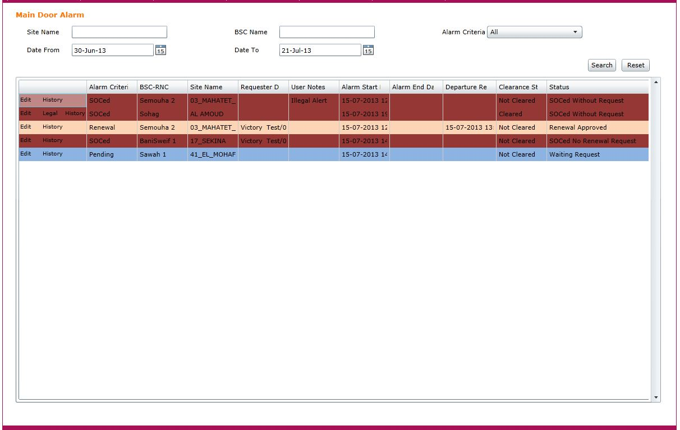
Figure 16 main door alarms
The main door alarms view is a new view that will display a list of alarms received from Native OMC via mail within the past 24 hours.
The view displays the following fields:
- Alarm criteria, this field contain a value from the following :
  - Pending, status for entries in this section is one of the following (“Waiting Request”, “Waiting Renewal”, “Finished Action plan”).
  - Access, this contains the alerts matched with an access request. Status for entries in this section is “request Approved”.
  - Departure, this contains the alerts matched with a Departure request. Status for entries in this section is one of the following (“Departure Approved”, “Departure Rejected”).
  - Renewal, this contains the alerts matched with a renew request. Status for entries in this section is “Renewal Approved”.
  - SOCed, this contains the alerts that was either:
    - SOCed with no request, Not matched with a request within 5 minutes of occurrence.
    - SOCed no renewal request, No received renew request and 3 hours passed from access occurrence time.
    - SOCed finished action plan, action plan end time has passed.
- BSC-RNC, this field contains the BSC received from alert.
- Site name, this field contains the Site name received from alert.
- Requester data, this field contains the following fields separated by ‘/’ :
  - Contractor name.
  - Contractor mobile.
  - Action type.
  - Action number.
- User note.
- Alarm start time, the occurrence time of the alarm Received from OMC via mail that is linked to Access request.
- Alarm end time, the end time of the alarm Received from OMC via mail that is linked to approve departure request.
- Departure request date, the date and time of the approval of departure request received from contractor.
- Clearance status, indicate the current alarm status as received via mail (cleared, not cleared).
- Status, reflects the current state of the door alarm, it could be one of the following:
  - Waiting Request, Alerts received within the past 5 minutes and not yet matched with Access request.
  - Waiting Renewal, Alerts with expired requests will be waiting renewal for 5 minutes before it is SOCed.
  - Finished Action Plan, Alerts with expired Action will be finished action plan for 5 minutes before it is SOCed.
  - Request Approved, Alerts received and matched with Access request.
  - Renewal Approved, Alerts matched with renew request.
  - Departure Request, Departure Requests Pending approval.
  - Departure Approved, Departure request approved.
  - Departure rejected, Departure request rejected.
  - SOCed without Request.
  - SOCed No Renewal Request.
  - SOCed Finished Action Plan.
- For each alarm there is a link “Edit” when clicked it displays a pop-up “Edit Alarm”.
- For alarms with status “Waiting Request” , “SOCed Without Request” , ”SOCed No Renewal Request” or ”SOCed Finished Action Plan” a link called “Legal” is displayed, and when clicked it opens a pop-up with “Legal Alert Details”.
- For alarms with status “Departure Request” a link called “Approve” is displayed, and when clicked it opens a pop-up “Approve Alarm”.
- For alarms with status “Departure Request” a link called “Reject” is displayed, and when clicked it opens a pop-up “Reject Alarm”.
- For each alarm there is a link “History” when clicked, it displays a pop-up “Alert History”.
- User can rearrange the order of fields and resize any desired field (Phase II as Bahaa Requested)
- The user displaying this view will only see a list of alarms that belong to vendors and BSCs assigned to him by supervisor admin, if none was assigned, this user won’t be able to view any alarms.
- Each Alarm criteria will be represented with a color determined from general settings
- User should be able to sort list by any field.

Note that, when alarm status is “Request Approved” or “Renewal Approved” any alerts on this site that is fired after approval shouldn’t be displayed in the “main door alarms” view until Alarm status becomes “Departure Approved” or the 3 hours duration from access or renewal time has passed.

Alarms filter
The user will be able to filter displayed alarms with the following fields:
- Site Name, user enter site name or part of it and the list will display Alarms with site name containing the entered text.
- BSC Name, user enter BSC name or part of it and the list will display Alarms with BSC name containing the entered text.
- Date from.
- Date to.
- Alarm Criteria , user chooses one from the following list:
  - All.
  - Pending.
  - Access.
  - Departure.
  - Renewal.
  - SOCed.

Edit
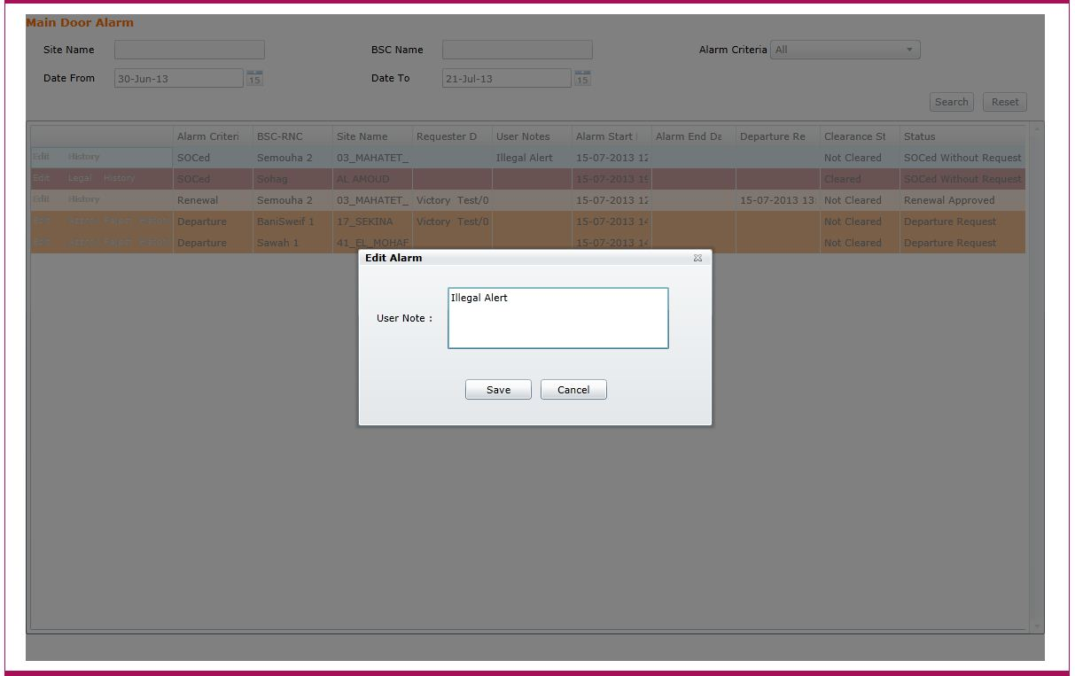
Figure 17 edit main door alarm
Edit alarm displays User notes field to be edited, and user can save by clicking “Save” button which saves user notes and closes the pop-up or cancel by clicking “Cancel” which closes pop-up without saving changes.

Legal
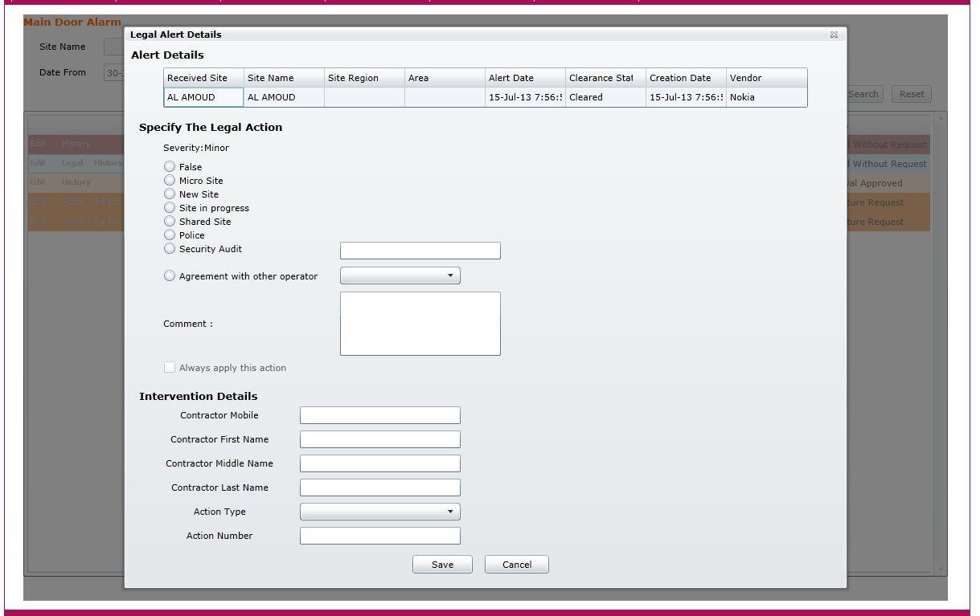
Figure 18 legal main door alarms
Will have three sections:
      - Alert details section, displays the details of alert, include the following fields:
    - Received site name.
    - Site name.
    - Site region.
    - Area.
    - Alert date.
    - Clearance status.
    - Creation date.
    - Vendor.
      - Specify The Legal Action section:
Displays a group of actions and the user selects one and insert the needed data
The actions are:
- False.
- Micro Site.
- New site.
- Site in progress.
- Shared Site.
- Police.
- Security audit, and field to enter auditor name.
- Agreement with other operator, and a list of operators to choose one from it (“Etisalat” and “Vodafone”).
- Comment.
On top of that section, a read only field called Severity will display the severity of this alert, and this value is set by administrator in General Settings called “DefaultLegalSeverity”.
In the bottom of this section a checkbox named “always apply this action” will be displayed, if it is checked, any further alerts from this site will be automatically marked with the legal action chosen by the user.
User in turn can clear this check by editing any alert marked as “always apply this action” and uncheck the checkbox; alerts from this site will not be marked automatically after the change is saved.

- Intervention Details section , used to enter the data of a legal intervention manually,
  - Contractor mobile.
  - Contractor First Name.
  - Contractor Middle Name.
  - Contractor Last Name.
  - Action Type, a list of types to choose one of the following:
    - Action plan.
    - Incident.
    - UAP.
    - Environmental.
    - Audit.
    - Survey.
    - Deployment Or Rollout.
    - Protective.
    - Corrective.
    - Delivery.
    - Fax Report.
    - PM Generator.
  - Action number.
If user marks a door alarm as false for a number of times determined via General Settings from field “FalseAlertsNumber” within number of days determined via General settings from field “FalseAlertsDuration”, alerts on this site should be automatically marked as false, and not displayed in “Active SOC alerts”, and displayed as only one record in the “False door alerts” list.
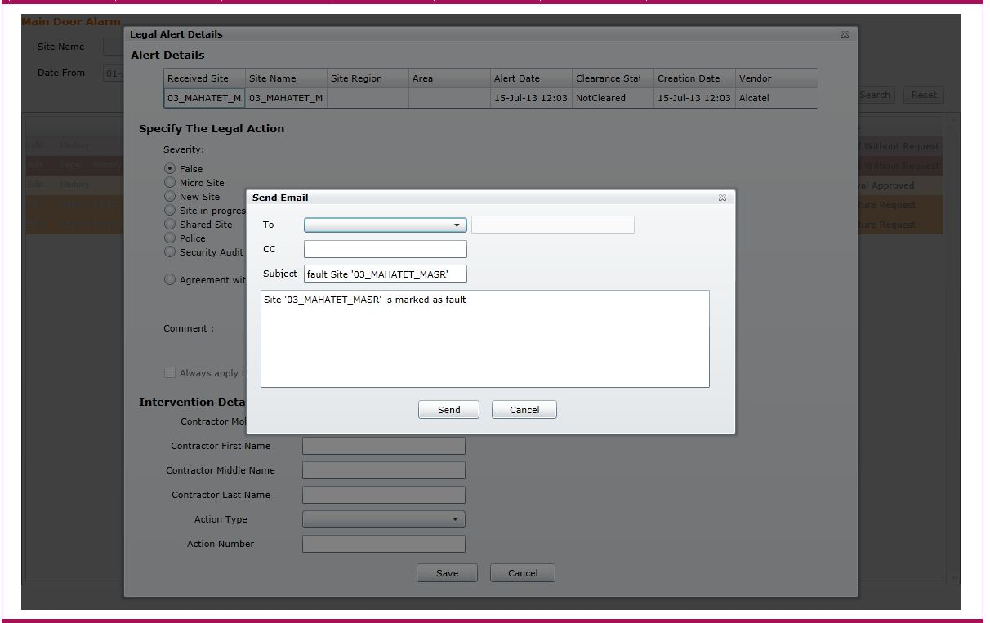
Figure 19 legal main door alarms send mail
And at the Xth time of marking alert as false in the specified duration a pop-up with the following fields will be displayed:
- To, a drop down list of previously configured emails (Soc User edit it via profile page) and the user select one of them, or he could select other and then a textbox will be enabled to enter an email.
- CC, an optional textbox to enter email to send a carbon copy of notification mail to.
- Subject, a textbox with default subject and the user can edit this subject.
- Body, a textbox with default body and user can edit it.
- Send button, sends the mail to specified emails in the “to” and “cc” fields.

Approve Alarm
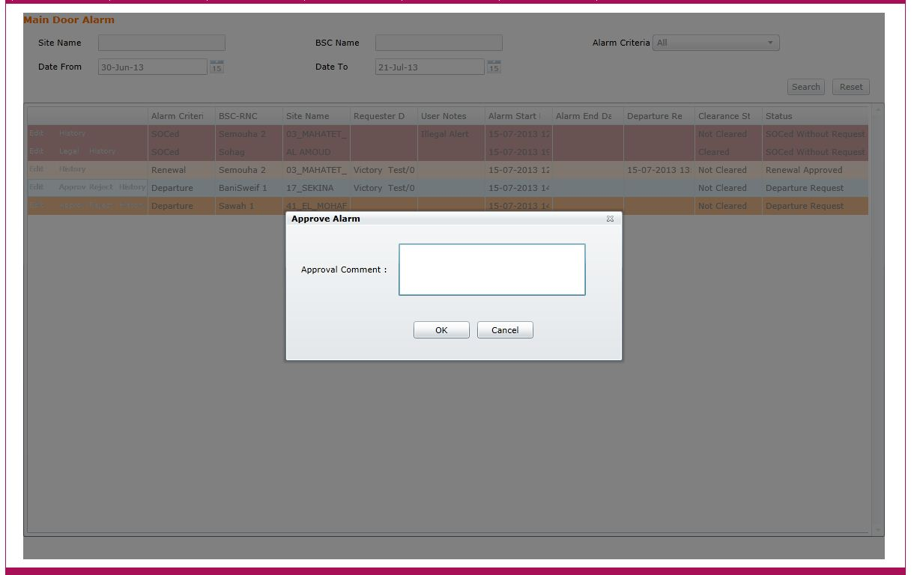
Figure 20 approve main door alarm
Approve alarm displays with an optional field to enter approval comment, user enters his comment or leaves it empty and press save the status of this alarm is changed into “Departure Approved”.

Reject Alarm
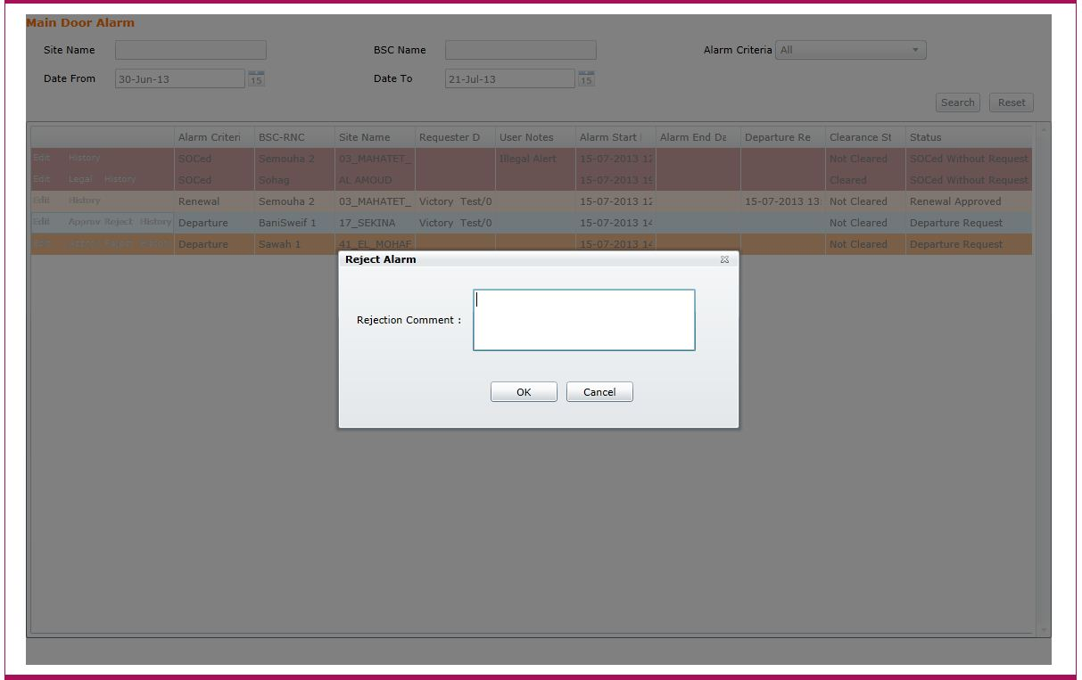
Figure 21 reject main door alarm
Reject alarm displays with a mandatory field to enter rejection comment, user enters his comment and press save and it changes the status of this alarm to “departure rejected”.

Alert History
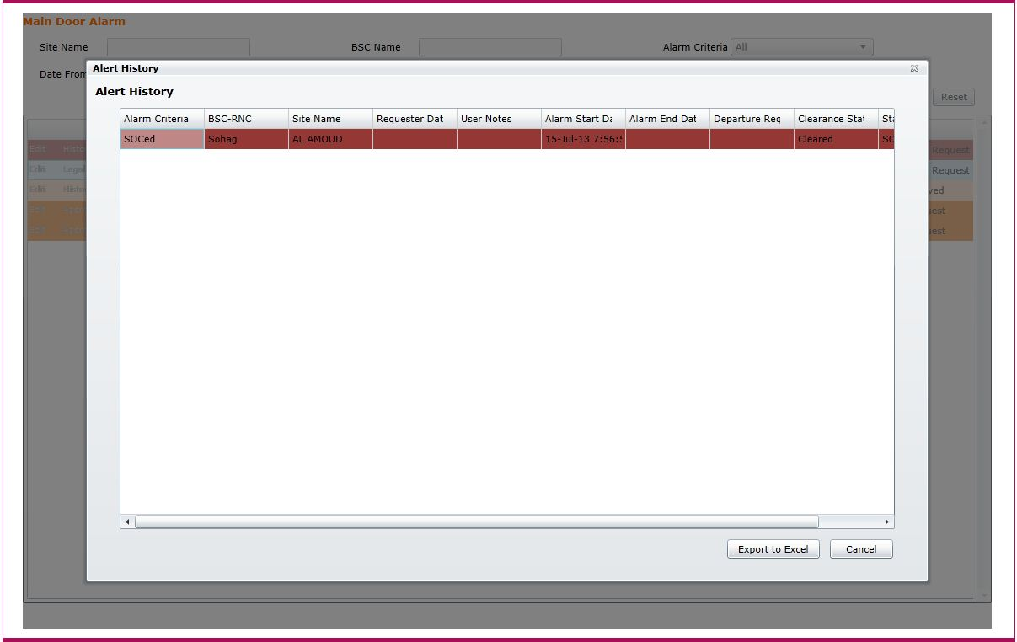
Figure 22 main door alarm history
Alert history is containing a list of Alarms (display the same fields as ‘Main door alarm view’) that occurred to Alarm site during previous 3 days, including the ones ignored in the main view, and a button called extract to excel will extract this history view to excel sheet.

SOC Alerts

Default Intended Users
- Administrator.
- SOC

Menu Items
- SOC
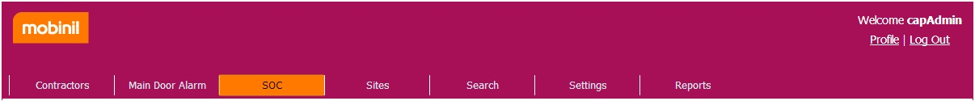
Figure 23 Soc menu item

Alerts

Description
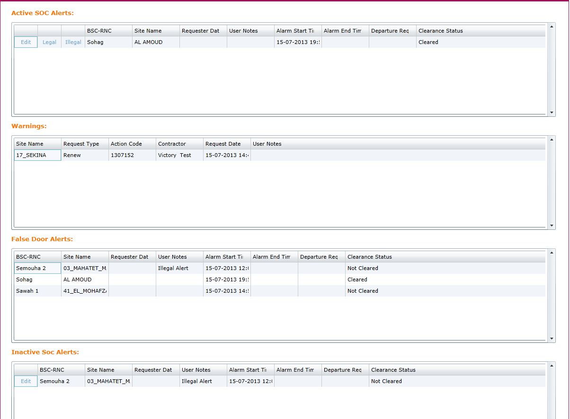
Figure 24 SOC Alerts
Will display 4 grids,

Active SOC Alerts
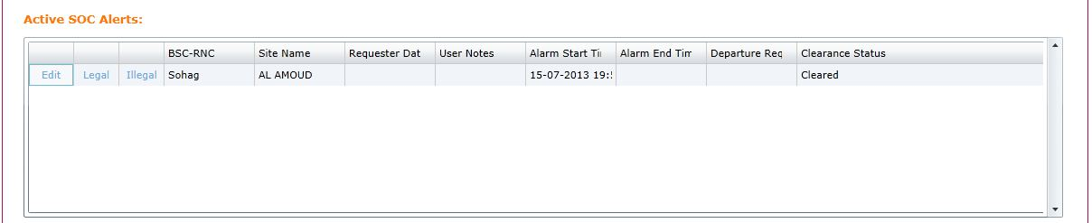
Figure 25 Active SOC Alerts
Displays a list of SOCed active alerts with status “SOCed without Request” that occurred within the past 24 hours with the following fields:
- Edit, a link opens a pop-up “Edit Alarm” to edit user notes.
- Legal, link opens a pop-up “Legal Alert Details” to enter legal details.
- Illegal, link opens a pop-up “Illegal Alert Details” to enter illegal details.
- BSC-RNC, this field contains the BSC received from alert.
- Site name, this field contains the Site name received from alert.
- Requester data, this field contains the following fields separated by ‘/’ :
    - Contractor name.
    - Contractor mobile.
    - Action type.
    - Action number.
- User note.
- Alarm start time, the occurrence time of the alarm matched with Access request.
- Alarm end time, the end time (if available) of the alarm matched with approved departure request.
- Departure request date, the date and time of the departure request received from contractor.
- Clearance status.

Legal
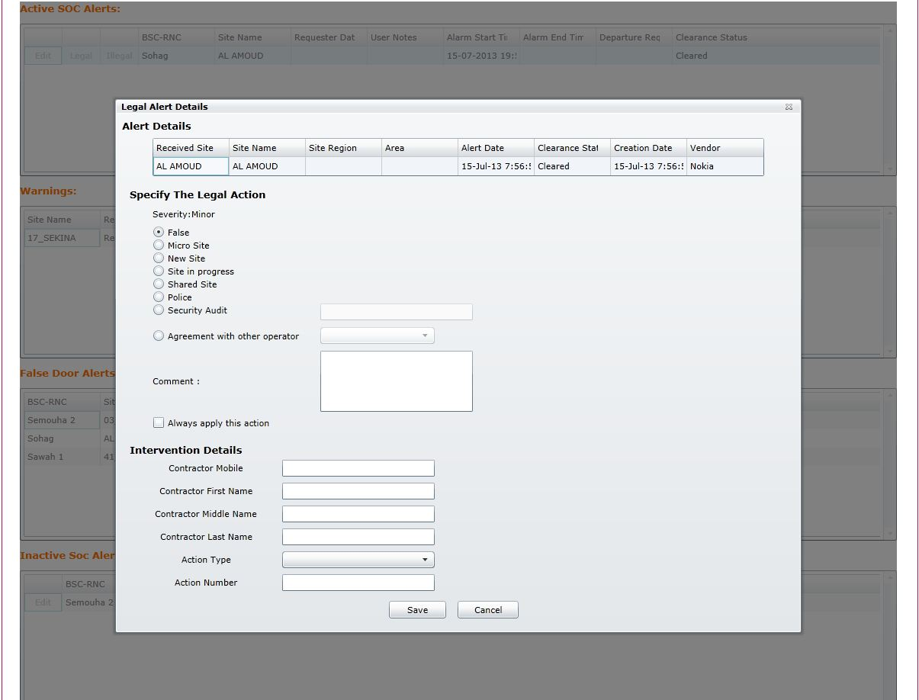
Figure 26 Mark alert as legal
Will have three sections:
      - Alert details section, displays the details of alert, include the following fields:
    - Received site name.
    - Site name.
    - Site region.
    - Area.
    - Alert date.
    - Clearance status.
    - Creation date.
    - Vendor.
      - Specify The Legal Action section,
Displays a group of actions and the user selects one and insert the needed data
The actions are:
- False.
- Micro Site.
- New site.
- Site in progress.
- Shared Site.
- Police.
- Security audit, and field to enter auditor name.
- Agreement with other operator, and a list of operators to choose one from it (“Etisalat” and “Vodafone”).
- Comment.
On top of that section, a read only field called Severity will display the severity of this alert, and this value is set by administrator in General Settings called “DefaultLegalSeverity”.
In the bottom of this section a checkbox named “always apply this action” will be displayed, if it is checked, any further alerts from this site will be automatically marked with the legal action chosen by the user.
User in turn can clear this check by editing any alert marked as “always apply this action” and uncheck the checkbox; alerts from this site will not be marked automatically after the change is saved.

- Intervention Details section , used to enter the data of a legal intervention manually
- Contractor mobile.
- Contractor First Name.
- Contractor Middle Name.
- Contractor Last Name.
- Action Type, a list of types to choose one of the following:
    - Action plan.
    - Incident.
    - UAP.
    - Environmental.
    - Audit.
    - Survey.
    - Deployment Or Rollout.
    - Protective.
    - Corrective.
    - Delivery.
    - Fax Report.
    - PM Generator.
- Action number.
If user marks a door alarm as false for a number of times determined via General Settings from field “FalseAlertsNumber” within number of days determined via General settings from field “FalseAlertsDuration”, alerts on this site should be automatically marked as false, and not displayed in “Active SOC alerts”, and displayed as only one record in the “False door alerts” list.
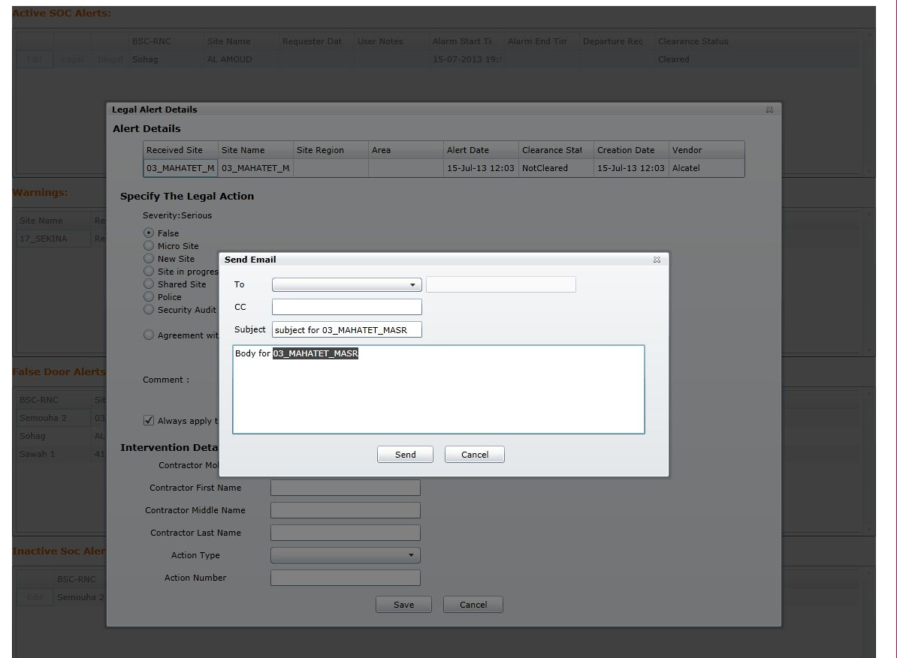
Figure 27 Send mail legal alerts
And at the Xth time of marking alert as false in the specified duration a pop-up with the following fields will be displayed:
- To, a drop down list of previously configured emails (Soc User edit it via profile page) and the user select one of them, or he could select other and then a textbox will be enabled to enter an email.
- CC, an optional textbox to enter email to send a carbon copy of notification mail to.
- Subject, a textbox with default subject and the user can edit this subject.
- Body, a textbox with default body and user can edit it.
Send button, sends the mail to specified emails in the “to” and “cc” fields.

Illegal
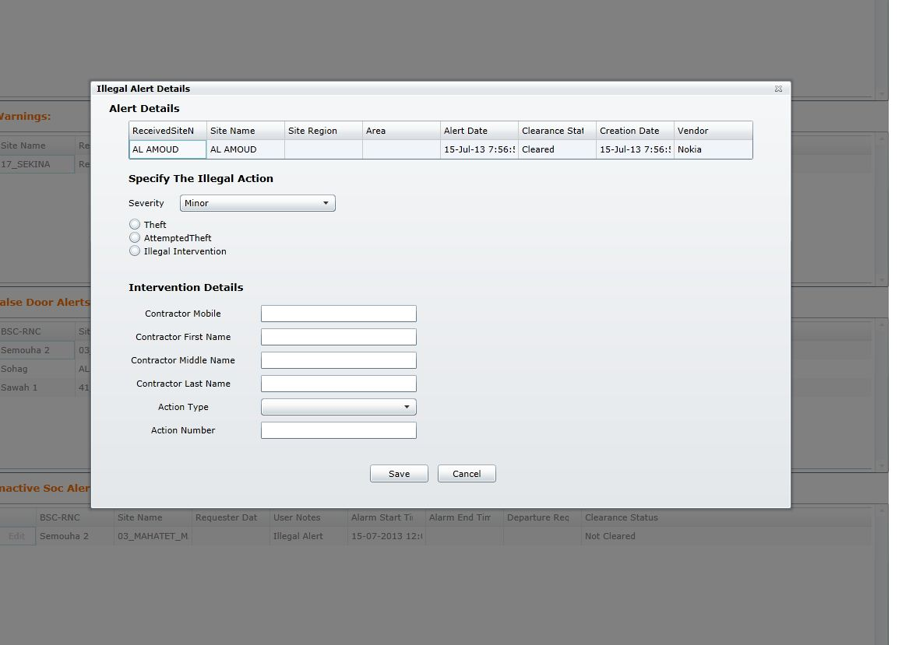
Figure 28 Mark alert as illegal
Will have two sections
- Alert details section, displays the details of alert, include the following fields:
- Received site name.
- Site name.
- Site region.
- Area.
- Alert date.
- Clearance status.
- Creation date.
- Vendor.
- Specify The Illegal Action section,
Displays a group of actions and the user selects one and insert the needed data
The actions are:
- Severity Dropdown list, contains the following options:
  - Minor.
  - Major.
  - Serious.
  - Critical.
  - Indeterminate.
  - Cancelled.
- Theft.
- Attempted theft.
- Illegal Intervention, if chosen some fields will be enabled for edit and these fields are:
  - Contractor mobile.
  - Contractor First Name.
  - Contractor Middle Name.
  - Contractor Last Name.
  - Action Type, a list of types to choose one
    - Action plan.
    - Incident.
    - UAP.
    - Environmental.
    - Audit.
    - Survey.
    - Deployment or Rollout.
    - Protective.
    - Corrective.
    - Delivery.
    - Fax Report.
    - PM Generator.
  - Action number.
  - Comment.

Edit
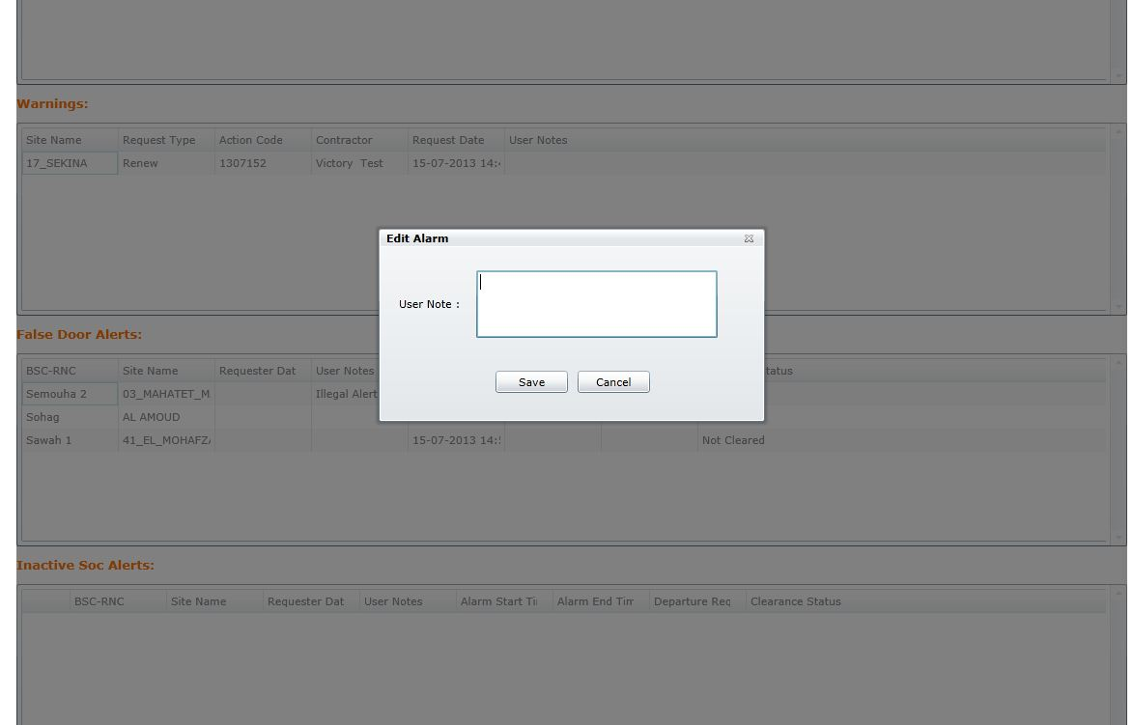
Figure 29 edit soc active alarm
Edit alarm displays User notes field to be edited, and user can save by clicking “Save” button which saves user notes and closes the pop-up or cancel by clicking “Cancel” which closes pop-up without saving changes.

Warnings
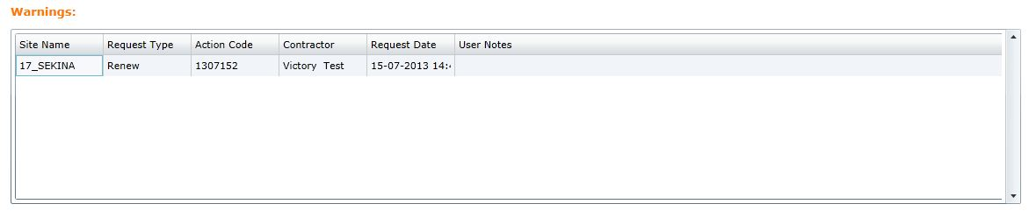
Figure 30 Soc warning alarm
Displays a list of SOCed alerts with status “SOCed No Renewal Request” or “SOCed Finished Action Plan” that occurred within the past 24 hours with the following fields:
  - Site name.
  - Request type.
  - Action code.
  - Contractor.
  - Contractor Phone.
  - Request date.
  - User notes.
They are considered illegal by default.

False door alerts
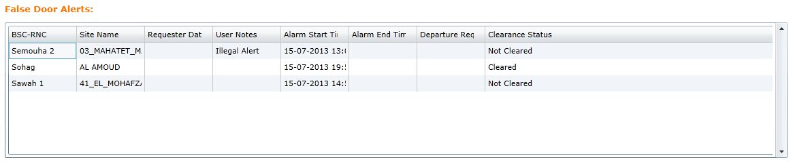
Figure 31 false door alerts
Display a list of Alerts that was marked false from “legal details view” within the past 24 hours, the list contains the following fields:
  - BSC-RNC, this field contains the BSC received from alert.
  - Site name, this field contains the Site name received from alert.
  - Requester data, this field contains the following fields separated by ‘/’ :
    - Contractor name.
    - Contractor mobile.
    - Action type.
    - Action number.
  - User note.
  - Alarm start time, the occurrence time of the alarm matched with Access request.
  - Alarm end time, the end time (if available) of the alarm matched with approved departure request.
  - Departure request date, the date and time of the departure request received from contractor.
  - Clearance status.

Inactive SOC Alerts
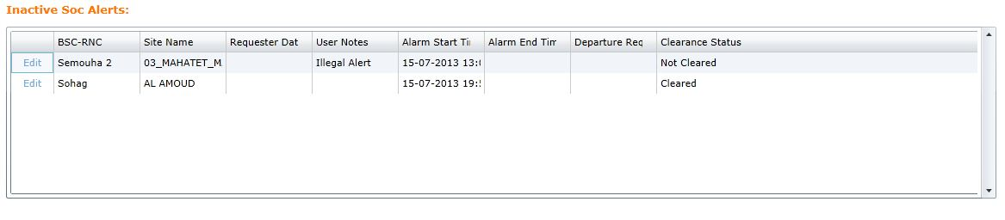
Figure 32 Inactive SOC alerts
Displays a list of SOCed alerts that was marked as legal or illegal within the past 24 hours with the following fields:
- Edit, link opens a pop-up with the details for this alert (legal or illegal according to how it was handled).
- BSC-RNC, this field contains the BSC received from alert.
- Site name, this field contains the Site name received from alert.
- Requester data, this field contains the following fields separated by ‘/’:
    - Contractor name.
    - Contractor mobile.
    - Action type.
    - Action number.
- User note.
- Alarm start time, the occurrence time of the alarm matched with Access request.
- Alarm end time, the end time (if available) of the alarm matched with approved departure request.
- Departure request date, the date and time of the departure request received from contractor.
- Clearance status.

Sites

Default Intended Users
- Administrator.

Menu Items
- Sites.
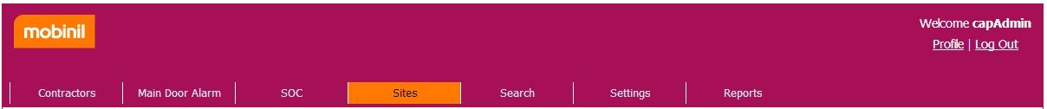
Figure 33 Sites menu Item

Description
Display all sites from operational database depend on the following filtering criteria:
- Mandatory fields
  - Site type: Site, NodeB, BSC, RNC.

- Optional fields
  - Site code: where site code contains this value.
  - Site name: where site name contains this value.
  - Site region: where site region contains this value.
- VIP: All, Yes, No.
- Team: All, HLG, NLG, ALG.

Assign team
There are two ways to assign team to sites:
- Selected Sites.
- Filtered Sites.

Selected sites
Manually assign team for each site and then click save.
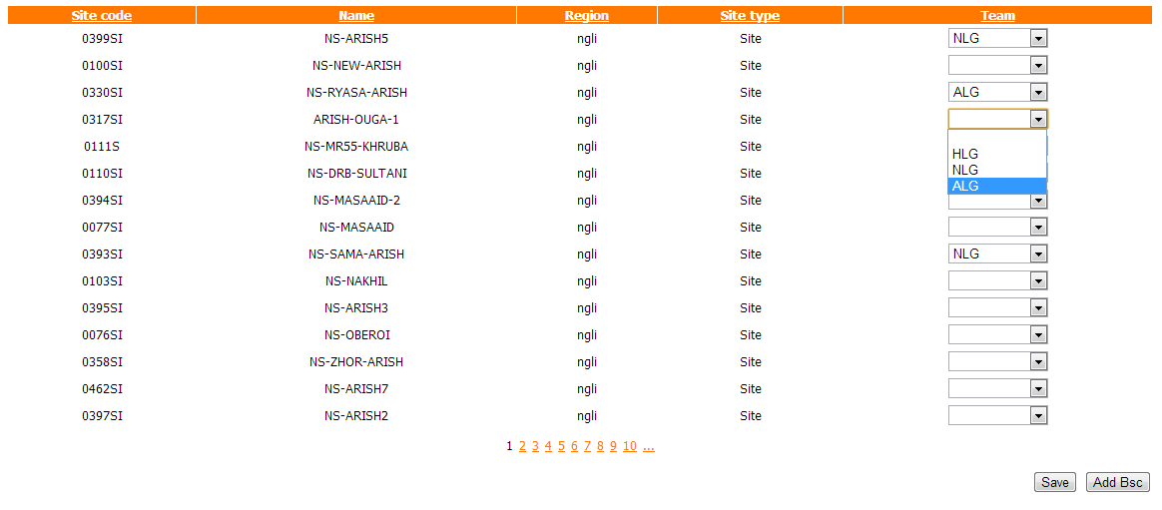
Figure 34 Sites List

Filtered sites
Using filtering criteria to filter sites and then assign team to the filtered sites.

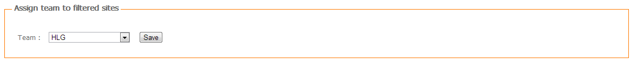
Figure 35 Assign team to filtered sites

Add BSC Site
Add bulk BSC site from UI.
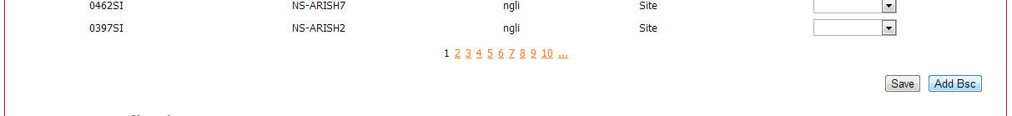
Figure 36 Sites, Add Bsc Button
When clicking Add Bsc button the upload page is displayed with an upload control top select .csv file from your computer. By clicking upload, system will convert the valid sites from uploaded bulk to actually sites on the system.
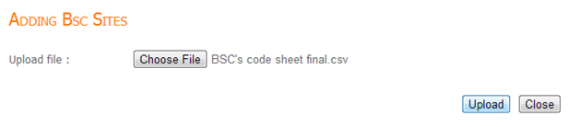
Figure 37 BSC Bulk upload

Search

Default Intended Users
- Administrator.

Menu Items
- Search.
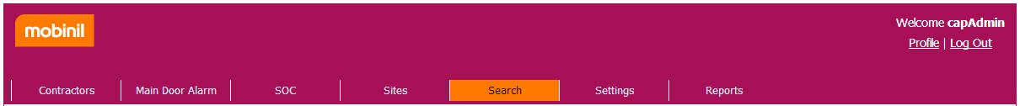
Figure 38 Search menu Item
User can search the following:
- SOC Alerts
- Access Requests
- Renew Requests
- Departure Requests
- UAP (Urgent action plans)
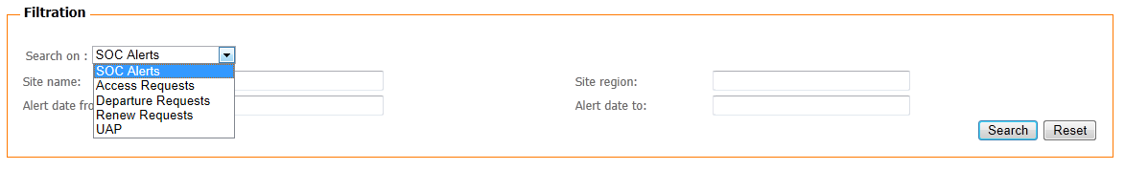
Figure 39 Search On Options

SOC Alerts
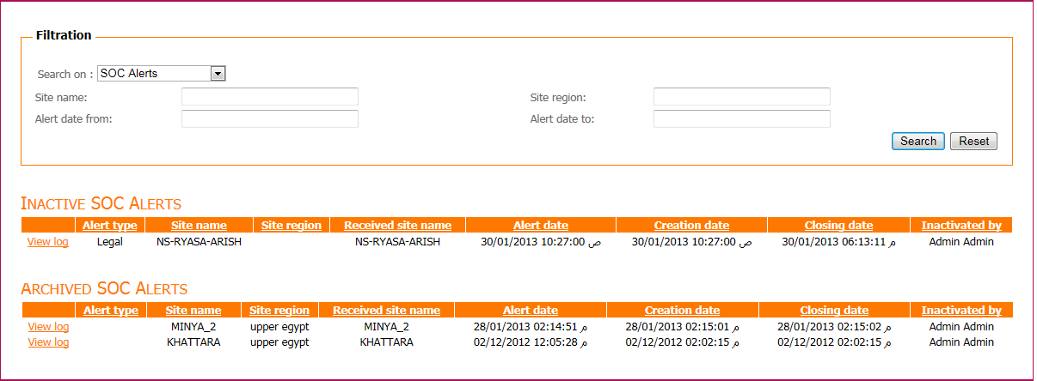
Figure 40 Search SOC alerts view
Display inactive SOC alerts from both operational and archived database based on the following filtering criteria:
- Optional fields:
  - Site name: where site name contains this value.
  - Site region: where site region contains this value.
- Alert date from: where alert date is greater than or equals this value.
- Alert date to: where alert date is less than or equals this value.

View log
Display history for this alert.
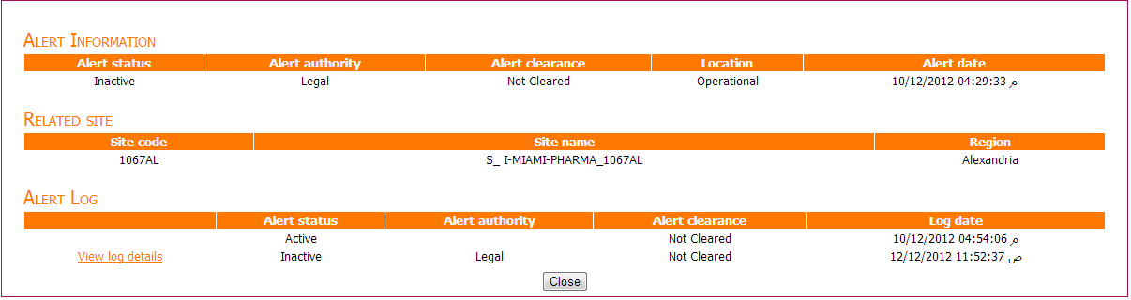
Figure 41 SOC alerts log view
The history for this alert is divided to 3 sections:
- The alert information, display the current information for this alert.
- The related site, display the info for the site associated with this alert.
- Alert log, display the history of changes made on that alert.
Alert log contains a link in front of each change made by a system user to display the details of that specific change called “View Log Details”.

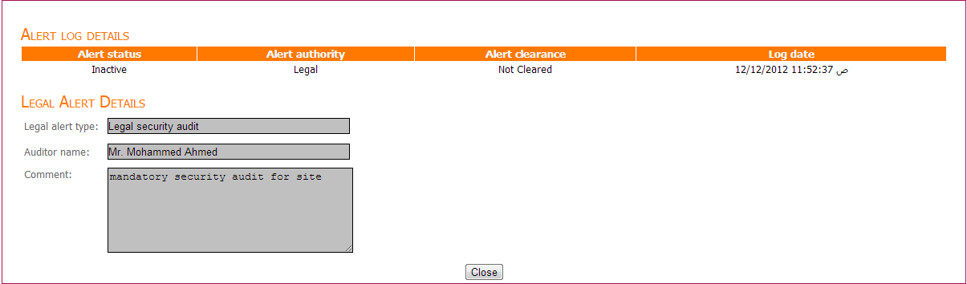
Figure 42 alert log details

Access Request
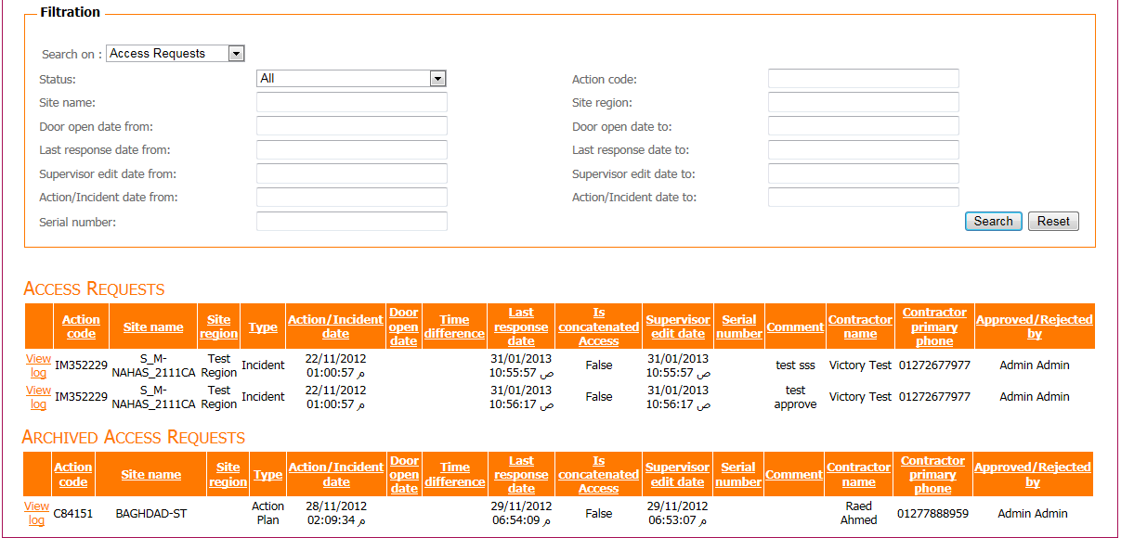
Figure 43 Search, Access request view
Display access requests from both operational and archived database based on the following filtering criteria:
- Mandatory fields:
  - Status: all, approved, rejected.

- Optional fields:
- Action code: where action code contains this value.
- Site name: where site name contains this value.
- Site region: where site region contains this value.
- Door open date from: where door open date is greater than or equals this value.
- Door open date to: where door open date is less than or equals this value.
- Last response date from: where last response date is greater than or equals this value.
- Last response date to: where last response date is less than or equals this value.
- Supervisor edit date from: where supervisor edit date is greater than or equals this value.
- Supervisor edit date to: where supervisor edit date is less than or equals this value.
- Action/Incident date from: where action/incident date is greater than or equals this value.
- Action/Incident date to: where action/incident date is less than or equals this value.
- Serial number.

View Log
Display history of this request.
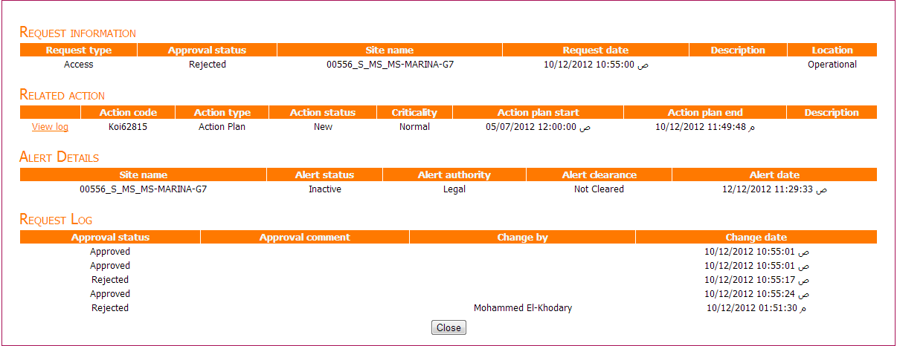
Figure 44 Request log view
The view is divided to 4 sections:
- Request information, displays the information for this request, and its current approval status.
- Related action, display the information of the action associated with this request, next to action there is a link to view log when clicked it displays the log for this action, see Action Log.
- Alert details, displays the information of the alert associated with this request if there is one.
- Request log, displays a list of changes made on this request .

Renew Request
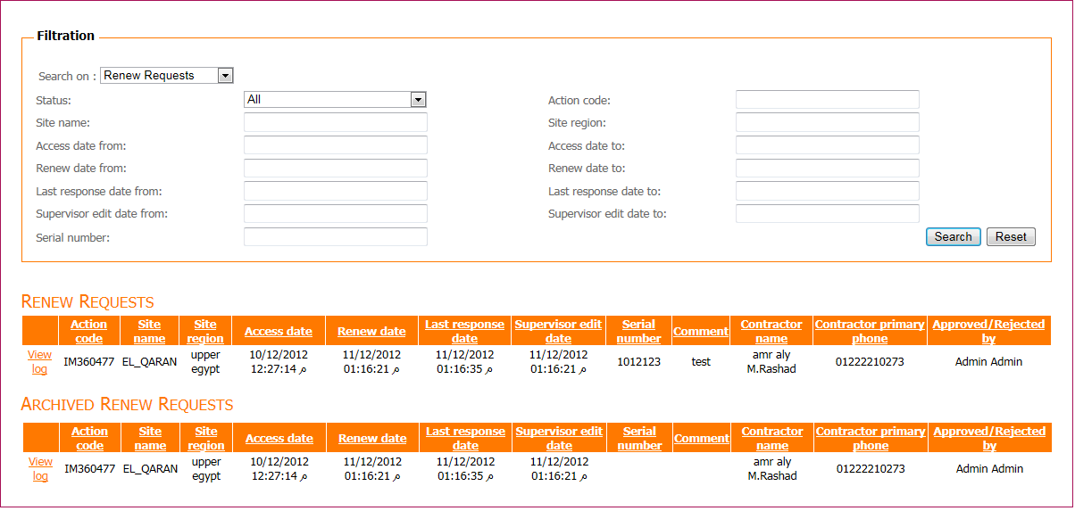
Figure 45 Search, Renew request view
Displays renew requests from both operational and archived database based on the following filtering criteria:
- Mandatory fields:
  - Status: all, approved, rejected.

- Optional fields:
  - Action code: where action code contains this value.
  - Site name: where site name contains this value.
- Site region: where site region contains this value.
- Access date from: where access date is greater than or equals this value.
- Access date to: where access date to is Less than or equals this value.
- Renew date from: where renew date is greater than or equals this value.
- Renew date to: where renew date to be Less than or equals this value.
- Last response date from: where last response date is greater than or equals this value.
- Last response date to: where Last response date is less than or equals this value.
- Supervisor edit date from: where supervisor edit date is greater than or equals this value.
- Supervisor edit date to: where supervisor edit date is less than or equals this value.
- Serial number.

View Log
Display history of this request. See View Log.

Departure Request
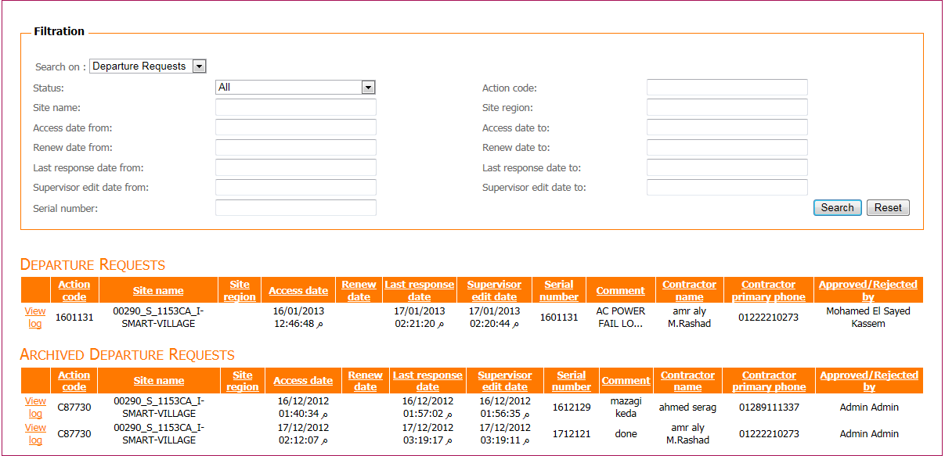
Figure 46 Search, Departure request view
Display departure requests from both operational and archived database based on the following filtering criteria:
- Mandatory fields:
  - Status: all, approved, rejected.

- Optional fields:
- Action code: where action code contains this value.
- Site name: where site name contains this value.
- Site region: where site region contains this value.
- Access date from: where access date is greater than or equals this value.
- Access date to: where access date is less than or equals this value.
- Renew date from: where renew date is greater than or equals this value.
- Renew date to: where renew date is less than or equals this value.
- Last response date from: where last response date is greater than or equals this value.
- Last response date to: where last response date is less than or equals this value.
- Supervisor edit date from: where supervisor edit date is greater than or equals this value.
- Supervisor edit date to: where supervisor edit date is less than or equals this value.
- Serial number.

View Log
Display history of this request.
See View Log.

UAP
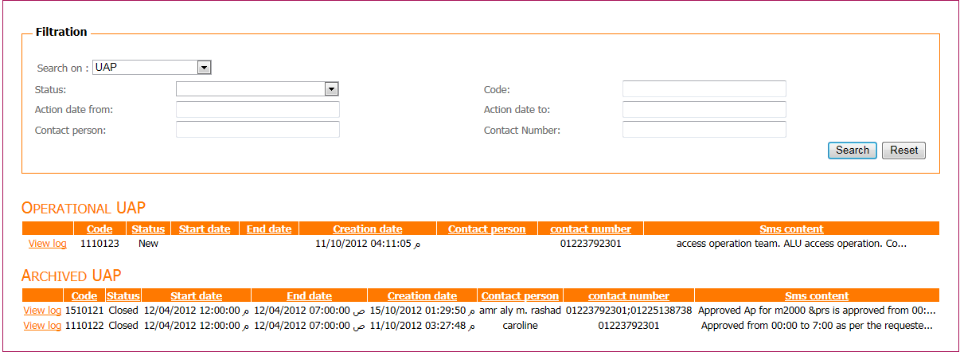
Figure 47 Search, UAP view
Display UAP from both operational database and archived database based on the following filtering criteria:
- Mandatory fields:
  - Status: all(empty), new, pending, closed, rejected
- Optional fields:
- Code: where action code contains this value.
- Action date from: where action date is greater than or equals this value.
- Action date to: where access date is less than or equals this value.
- Contact person: where contact person contains this value.
- Contact number: where contact number contains this number.

View Log
Display history of this action.
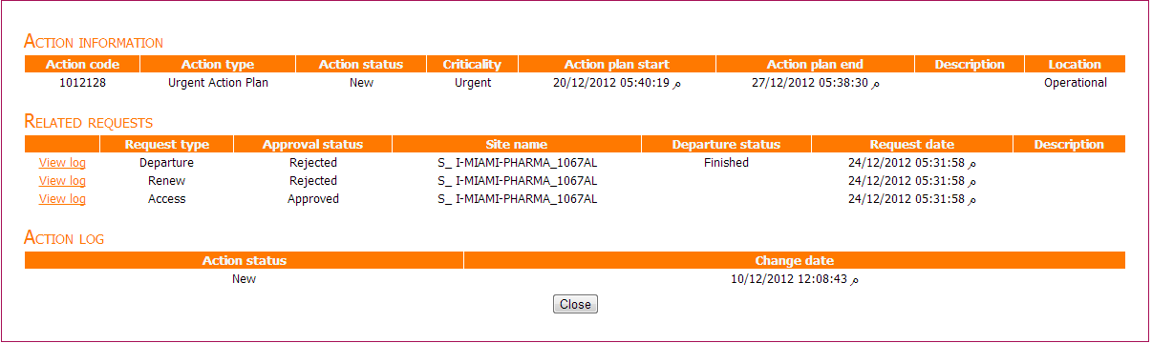
Figure 48 Action Log view
The view is divided into 3 sections:
- Action information, displays the information for this action.
- Related requests, displays a list of request made on this action, next to each request a view log link displays the log of this request, see Request Log.
- Action log, displays a list of changes made on this action.

Settings

Default Intended Users
- Administrator: can access all settings.
- Supervisor Admin: can access only interface users.
- SIC Admin: can access only interface users.

Menu Items
- Interface users
- General settings
- Subcontractors
- User Type
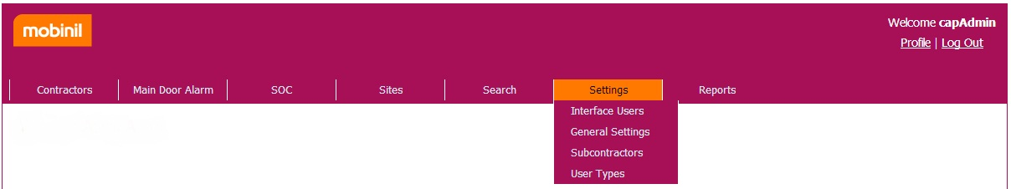
Figure 49 Settings menu item

Interface Users
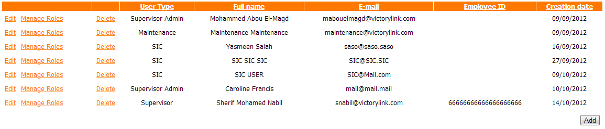
Figure 50 Interface users

Description
Display system users based on logged in user privileges to edit, manage roles or delete user as follows:
- Administrator: can manage all system users.
- Supervisor Admin: can manage all supervisor users.
- SIC Admin: can manage all SIC users.
Users list is filtered based on the following filtering criteria:
- Optional fields:
  - First name.
  - Last name.
  - Primary phone number.
  - Employee ID.
  - User type: Administrator, SIC Admin, SIC, SOC, Audit, Rollout, Power, Production, Deployment, Maintenance, Supervisor Admin, Supervisor.

Add
User can add user to his intended users according to their privileges
- Administrator: can add any system user except for Administrator (only one administrator is allowed on system)
- Supervisor Admin: can add supervisor users
- SIC Admin: can add SIC users

Edit
Admin user can edit his users’ information.

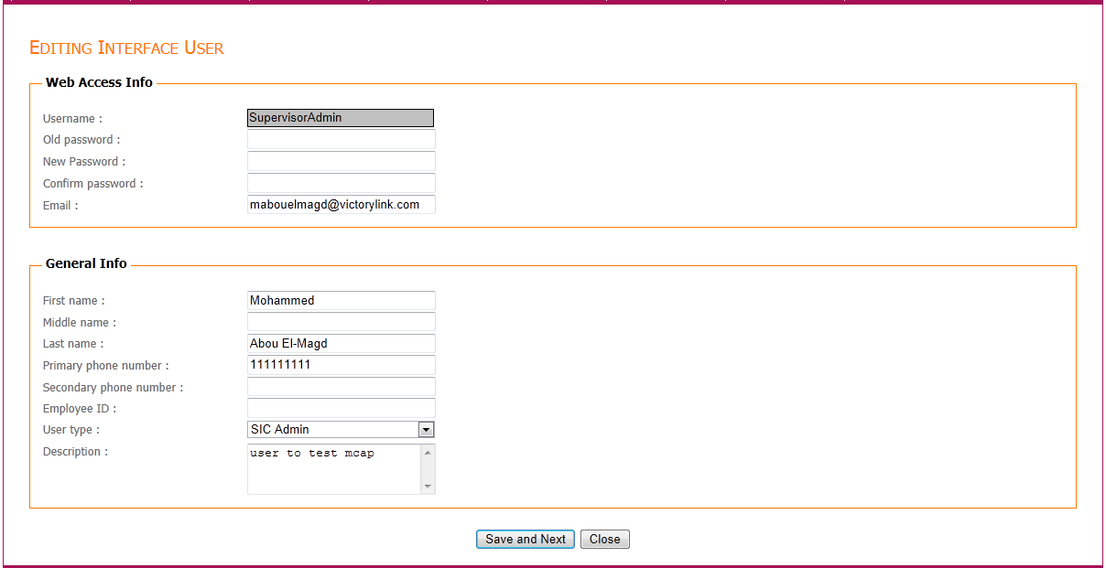
Figure 51 editing interface user
If selected user type is supervisor, there will be additional check list to assign vendor to this user and a BSCs is required
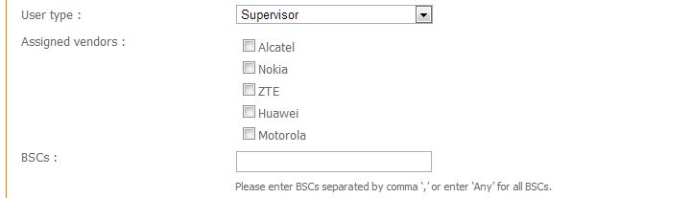
Figure 52 assign vendor and BSCs to supervisor user
If user type is Maintenance, there will be additional drop down list to choose maintenance team 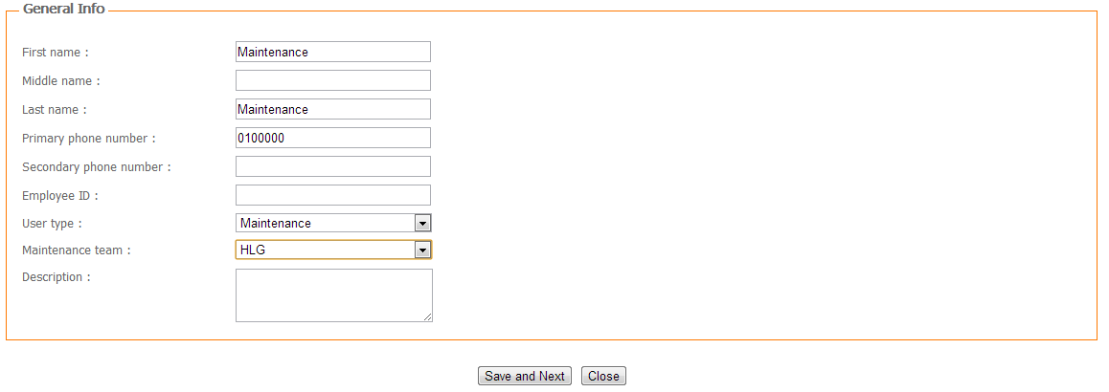
Figure 53 Editing maintenance user
By clicking “save and next” the changes will be saved and the page of user access roles will be displayed to change the roles of this users
By clicking close the changes will be discarded and you’ll be returned to interface user list

Manage roles
Where user can manage roles (view, add, edit and delete) of interface user and control what this user can do on the system.
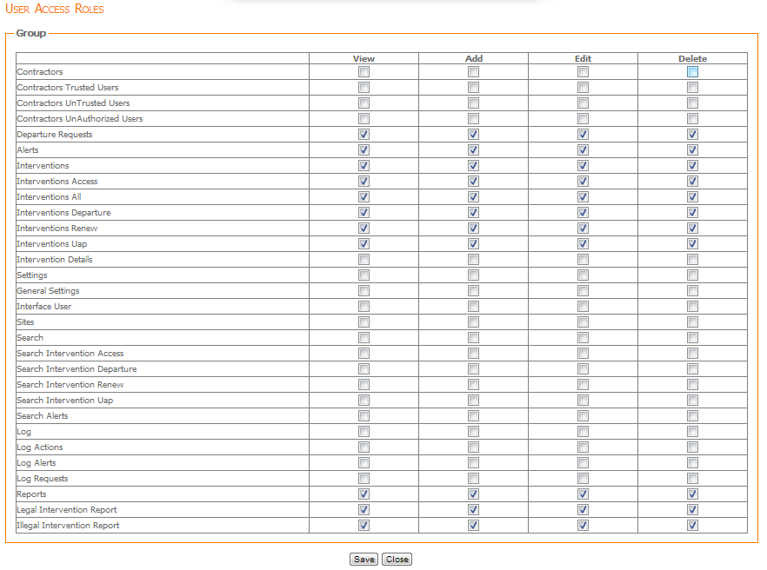
Figure 54 editing user access roles

Delete
Where user can delete an interface user
Note: when a user is deleted it is marked as deleted and hidden from list, no other user could be added with the same phone number

General Settings.
As mentioned previously, only administrator is intended to view general settings
These view include settings used all over the system

Description
Display all system configurations as following:
- Name: name of configuration.
- Default value: the default and recommended value for this item.
- Value: the current used value.
- Description: contain description of what this item affect.

Edit
- Enable administrator to change the value field that will be used by the system.

Settings description
- AlertsRefreshRate, This is used to set the interval in which alerts at "Active SOC Alerts" list will be refreshed in milliseconds. see SOC Alerts.
- InactiveAlertsHours, This is used to set the interval within which alerts marked as legal or illegal from "Active SOC Alerts" list remain displayed at "Inactive SOC Alerts" list in hours. see SOC Alerts.
- InactiveAlertsMaxRowNumbers, This is used to set the maximum number of rows (alerts) that be displayed at "Inactive SOC Alerts" list. see SOC Alerts.
- NewActiveAlertColor, This is used to set the color of new received active alert at "Active SOC Alert" list. see SOC Alerts.
- NewActiveAlertColorTimeSpan, This is used to set the interval in seconds, during which the new active alert at "Active SOC Alert" list remains displayed with the color set with "NewActiveAlertColor" value, see SOC Alerts.
- OldActiveAlertColor, This is used to set the color of alert at "Active SOC Alert" list after the time period that set at "NewActiveAlertColorTimeSpan" elapsed. see SOC Alerts.
- OldActiveAlertColorTimeSpan, This is used to set the interval in minutes, which the old active alert at "Active SOC Alert" list remains displayed with the color that set at "OldActiveAlertColor". see SOC Alerts.
- DepartureRequestsRefreshRate, This is used to set the interval in which departure requests at "Departure requests" list will be refreshed in milliseconds. See Departure requests.
- InterventionsRefreshRate, This setting is used to set the interval in which interventions at different Interventions lists will be refreshed in milliseconds. See Interventions.
- MaximumContractorTrials, This setting is used to set the maximum number of failed trials that a contractor can send via USSD request. If contractor exceeds this number he will be flagged as unauthorized contractor until he is allowed again by a system user. See Unauthorized users.
- InterventionHours, This is used to set number of hours before today to display interventions during this period (ex. InterventionHours=12, It means that the interventions lists will display only interventions with request date within past 12 hour). See Interventions.
- SmsWarningRefreshRate, This is used to set the time margin in milliseconds for sending a notification to contractor inside the site, prompting to leave site (ex. Your requested time is about to expire).
- SmsWarningHours, This is used to set the number of hours a contractor is allowed to stay in site after access or renew request, after that time a warning SMS is sent prompting to leave site.
- AlertRequestMargin, This is used to set the time margin between the request and alert, within this margin, if alert fired from the same site as request, this alert is associated to request and alert is flagged inactive.
- HpReciever_EnableLog, This is used to enable or disable logging for HPReciever service.
- HpReceiver_LogPath, This is used to set path where the log file of HPReceiver service will be stored.
- HpReceiver_ActionPlanDirPath, This is used to set the directory path of received action plans to be parsed by HPReceiver service.
- HpReceiver_IncidentDirPath, This is used to set the directory path of received incidents to be parsed by HPReceiver service.
- NgiReceiver_SftpIp, This is used to set the IP address of SFTP server to be used by NgiReceiver service.
- NgiReceiver_SftpUsername, This is used to set the username of SFTP server to be used by NgiReceiver service.
- NgiReceiver_SftpPassword, This is used to set the password of SFTP server to be used by NgiReceiver service.
- NgiReceiver_SftpDirectory, This is used to set the directory path of SFTP server from which NgiReceiver service can get BSC and RNC files and copy them to its output directories.
- NgiReceiver_SftpEnableLog, This is used to enable or disable log of SFTP client service.
- NgiReceiver_SftpLogPath, This is used to set path of the log file of SFTP client service.
- NgiReceiver_SftpBoolingTimer, This is used to set the timer interval in minutes to get BSC&RNC files from remote SFTP server to be stored at NgiReceiver output directories.
- NgiReceiver_SftpOutputDirectoryBSC, This is used to set path of the NgiReceiver service output directory at which BSC files read from "NgiReseiver_SftpDirectory" will be stored.
- NgiReceiver_SftpOutputDirectoryRNC, This is used to set path of the NgiReceiver service output directory at which RNC files read from "NgiReseiver_SftpDirectory" will be stored.
- NgiReceiver_EnableLog, This is used to enable or disable log of NgiReciever service.
- NgiReceiver_LogPath, This is used to set path of the log file of NgiReciever service.
- NgiReceiver_GetSharedNodeBFullPath, This is used to set the full file path (name & extension) of shared NodeB from which NgiReceiver service can read file and copy it to its output directory.
- NgiReceiver_GetSharedSitesFullPath, This is used to set the full file path (name & extension) of shared sites from which NgiReceiver service can read file and copy them to its output directories.
- NgiReceiver_GetSharedFoldersBoolingTimer, This is used to set the timer interval in minutes to get sites & nodeB files from shared folder to be stored at NgiReceiver output directories.
- NgiReceiver_GetSharedOutputDirectoryNodeB, This is used to set path of the NgiReceiver service output directory at which NodeB files read from "NgiReceiver_GetSharedNodeBFullPath" will be stored.
- NgiReceiver_GetSharedOutputDirectorySites, This is used to set path of the NgiReceiver service output directory at which sites files read from "NgiReceiver_GetSharedSitesFullPath " will be stored.
- NgiReceiver_GetSharedEnableLog, This is used to enable or disable log of shared directories monitoring service.
- NgiReceiver_GetSharedLogPath, This is used to set path of the log file of shared directories monitoring service.
- MailReceiver_EnableLog, This is used to enable or disable log of MailReciever service.
- MailReceiver_LogPath, This is used to set path of the log file of MailReciever service.
- SmsSender_EnableLog, This is used to enable or disable log of SmsSender service.
- SmsSender_LogPath, This is used to set path of the log file of SmsSender service.
- SmsSender_ServiceUrlTemplate, This is used to set kannel URL template that will be used by SmsSender service.
- HpReciever_BoolingTimer, This is used to set timer interval in minutes to get and parse action plans and incidents in HpReceiver service
- NgiReceiver_BoolingTimer, This is used to set timer interval in minutes to get and parse sites, nodeB, BSC and RNC in NgiReceiver service.
- SmsSender_EnableEncoding, This is used to enable or disable message encoding before sending it.
- PendingAlarmsColor, represent the record color for a pending Alarm in the “Main Alarm View”.
- DepartureAlarmsColor, represent the record color for a departure Alarm in the “Main Alarm View”.
- RenewalAlarmsColor, represent the record color for a renewal Alarm in the “Main Alarm View”.
- AccessAlarmsColor, represent the record color for an Access Alarm in the “Main Alarm View”.
- SOCedAlarmsColor, represent the record color for a SOCed Alarm in the “Main Alarm View”.
- DefaultLegalSeverity, represents the Severity displayed in the Legal Alert Details view.
- FalseAlertsNumber, the Number of alerts occurring during a period of time determined by the “FalseAlertsDuration” after which site is considered faulty and all alerts from this site will be marked false automatically.
- FalseAlertsDuration, the duration within which if a number of alerts determined by the “FalseAlertsNumber” occurred, site is considered faulty and all alerts from this site will be marked false automatically.
- MailSender_FromEmail, The email address that appears in the from field when a mail is sent from system.
- MailSender_EnableLog, Enable (1) or disable (0) Mail Sender Service on the application server.
- MailSender_LogPath, Log directory path of Mail Sender Service on the application server.
- MailSender_MaxNumberTrials, The max number of trials to send a mail via Mail Sender Service.
- MailSender_SmtpServer, Outgoing mails SMTP server sent via Mail Sender Service.
- MailSender_BoolingTimer, Timer to bool and send Mails in minutes.
- SocedInterventionMargin, the time in minutes before an intervention is SOCed.

Subcontractors
Figure 55 Subcontractors list
The list displays the following:
- Edit, a link when pressed it redirects to subcontractor edit page.
- The subcontractor name.

Edit
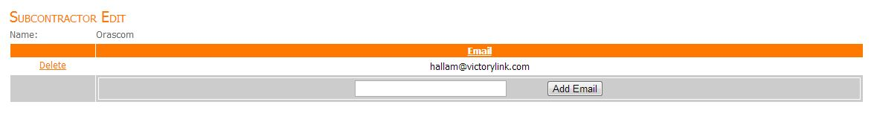
Figure 56 edit subcontractor
A view where user can add or deleted emails for this subcontractor displays the following:
      - the subcontractor name
      - a list of emails assigned to this subcontractor this list contains the following
        - Delete button where user can delete an email.
        - Email.
At the footer of the list a textbox for email and a button “Add email”, when add email button is pressed the email entered in the text box will be added to emails list.

User Types
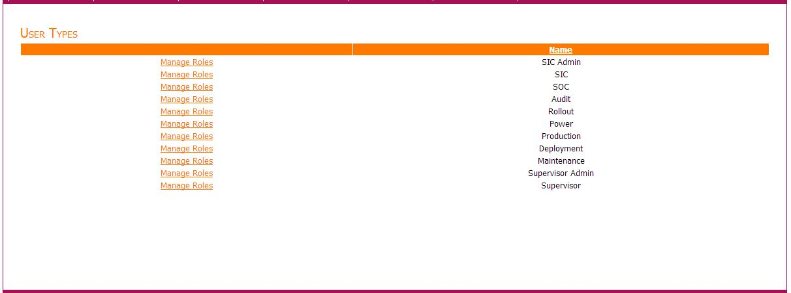
Figure 57 edit subcontractor
This displays list of user types in system; each type has a ‘Manage Roles’ link next to it, when clicked it redirects to a list of privileges assigned to this type, and the user can edit these roles and saves them to system or close page without saving. The new changes will override the roles of any existing user in system. See figure Manage Roles.
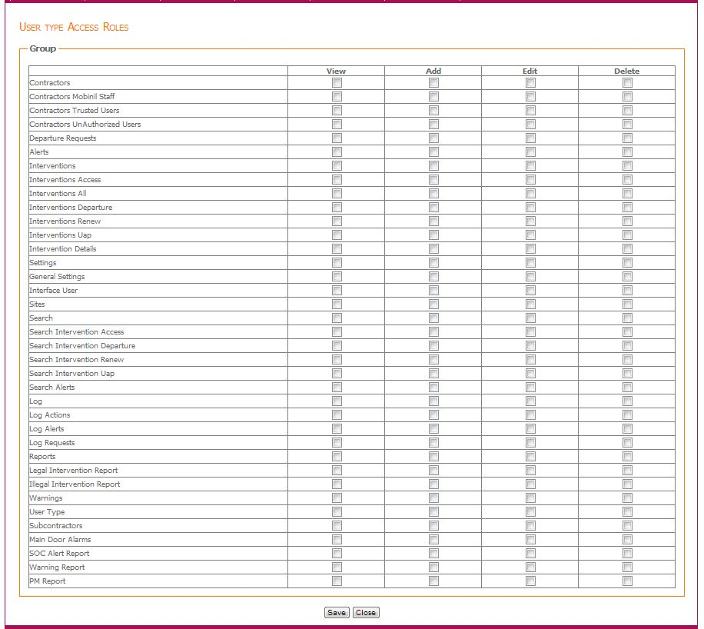
Figure 58 manage roles

Reports

Default Intended Users
- Administrator.
- Maintenance.
- Supervisor Admin.
- Supervisor.

Menu Items
- Legal Intervention
- Illegal Intervention
- Soc Intervention
- Warnings
- PM
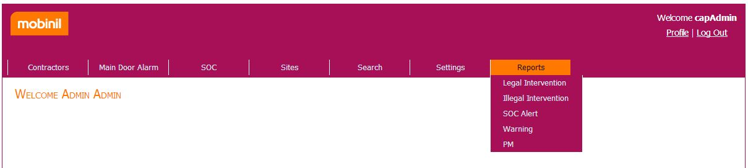
Figure 59 Reports menu item
      - Legal Intervention
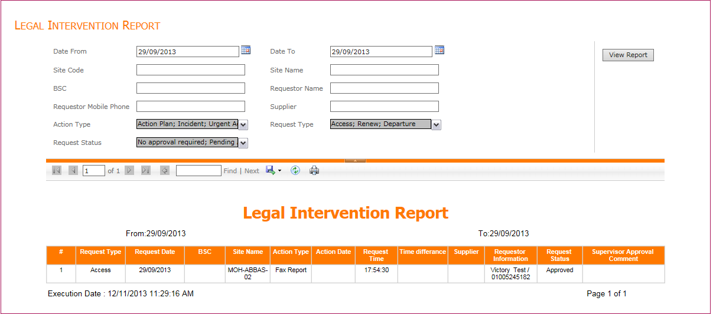
Figure 60 Legal report view
        - Description
Display legal interventions of both operational and archived databases based on the following filtering criteria:
- Mandatory fields
- Date From: where request date is greater than or equals this value.
- Date To: where request date is less than or equal this value.
- Action Type: select one or more or all of action types.
- Request Type: select one or more or all of Request Types.
- Request Status: select one or more or all of Request Status.

- Optional fields
- Site Code: where site code of intervention contains this value.
- Site Name: where site name of intervention contains this value.
- Requestor Name: where Requestor Name of intervention contains this value.
- Requestor Mobile Phone: where Requestor Mobile Phone of intervention start with this value.
- Supplier: where supplier of intervention included in this parameter
(Leaving it empty means all, or type a supplier or more separated by comas ‘,’).
- BSC.

Report columns:
- #: identity number.
- Request Type: access or renew or departure.
- Request Date.
- BSC.
- Site Name.
- Action Type.
- Action Date: start date of action.
- Request Time.
- Time difference: time in hour of difference between Request Date and Action Date.
- Supplier.
- Requestor Information: request owner /request mobile number.
- Request Status: Approved or Rejected.
- Supervisor Approval Comment.

      - Illegal Intervention
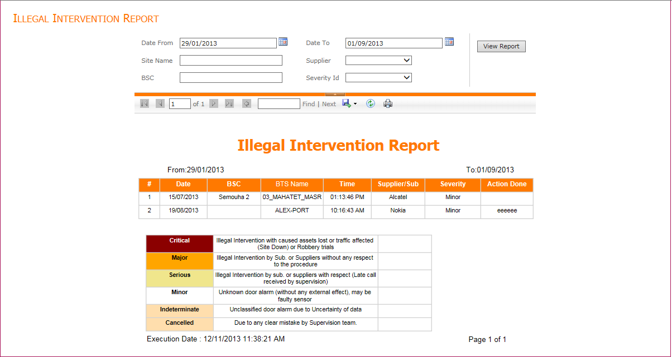
Figure 61 Illegal report view
        - Description
Display Interventions of both operational and archived databases for alerts that marked as illegal based on the following filtering criteria:
- Mandatory fields:
  - Date From: where alert date is greater than or equals this value.
  - Date To: where alert date is less than or equal this value.
- Optional fields:
  - BTS Name: user enter one or more BTS names separated by ‘;’ and the list will display illegal interventions with BTS name exactly matching one of the entered BTS names.
  - Supplier: select one or more or all of supplier.
  - BSC: user enter one or more BSC names separated by ‘;’ and the list will display illegal interventions with BSC name exactly matching one of the entered BSC names.
  - Severity.
Report columns:
- #: identity number.
- Date: alert date.
- BSC.
- Site Name: site name that make alert.
- Time: time of alert.
- Supplier/Sub.
- Severity.
- Action Done.
- Comments.

      - Soc Intervention
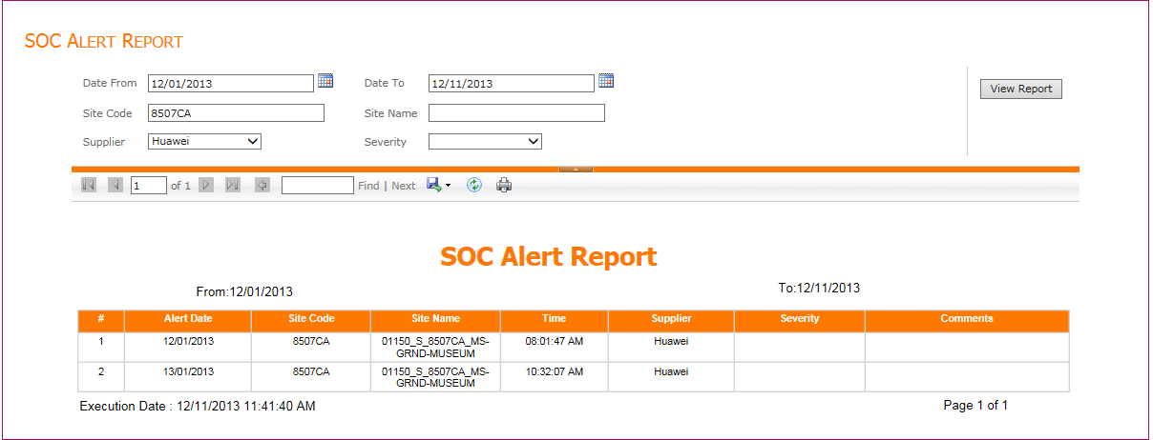
Figure 62 Soc intervention report view
        - Description
Display Soc Alerts based on the following filtering criteria:
- Mandatory fields:
  - Date From: where alert date is greater than or equals this value.
  - Date To: where alert date is less than or equal this value.
- Optional fields:
  - Site code: user enter one or more Site codes separated by ‘;’ and the list will display Alarms with Site code exactly matching one of the entered Site codes.
  - Site Name: user enter one or more BTS names separated by ‘;’ and the list will display illegal interventions with BTS name exactly matching one of the entered BTS names.
  - Supplier.
  - Severity.
Report columns:
- #: identity number.
- Alert Date: alert date.
- Site Code.
- Site Name: site name that make alert.
- Time: time of alert.
- Supplier.
- Severity.
- Comments.
      - Warnings
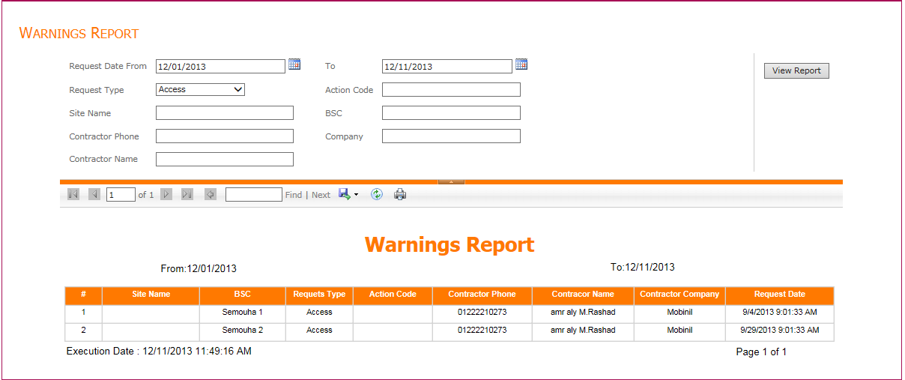
Figure 63 Warnings Report
        - Description
Display Warnings based on the following filtering criteria:
- Mandatory fields:
  - Request Date From: where request date is greater than or equals this value.
  - Request Date To: where request date is less than or equal this value.
- Optional fields:
  - Action code: user enter one or more action codes separated by ‘;’ and the list will display warnings with action code exactly matching one of the entered action codes.
  - Site Name: user enter one or more BTS names separated by ‘;’ and the list will display illegal interventions with BTS name exactly matching one of the entered BTS names.
  - Request type.
  - Contractor Phone.
  - BSC.
  - Company.
  - Contractor Name.
Report columns:
- #: identity number.
- Site Name: site name that make alert.
- BSC.
- Requests Type.
- Action Code.
- Contractor Phone.
- Contractor Name.
- Contractor Company.
- Request Date.

      - PM
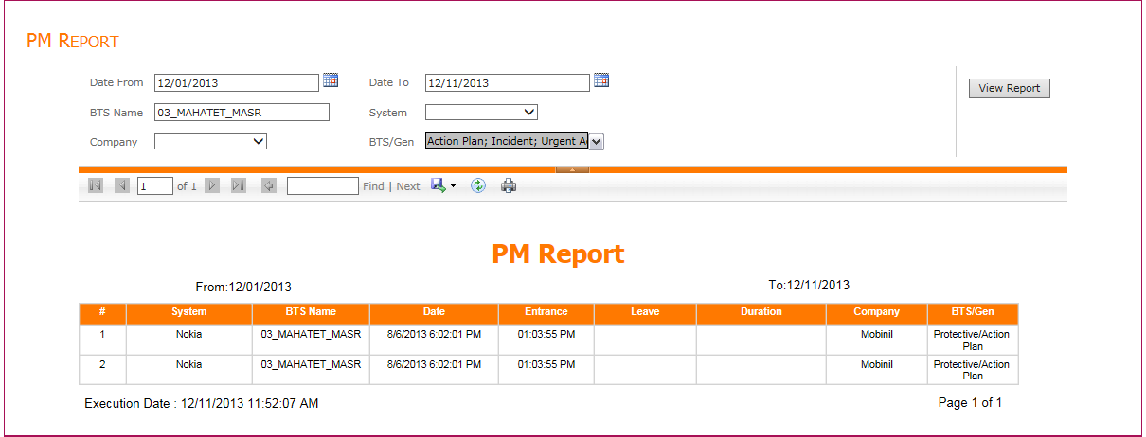
Figure 64 PM report view
        - Description
Display PM based on the following filtering criteria:
- Mandatory fields:
  - Date From: where alert date is greater than or equals this value.
  - Date To: where alert date is less than or equal this value.
  - BTS/Gen: select one or more Action type to be displayed in the report.
- Optional fields:
  - System.
  - BTS Name: user enter one or more BTS names separated by ‘;’ and the list will display interventions with BTS name exactly matching one of the entered BTS names.
  - Company.
Report columns:
- #: identity number.
- System.
- BTS Name.
- Date.
- Entrance.
- Leave.
- Duration.
- Company.
- BTS/Gen.

User Profile
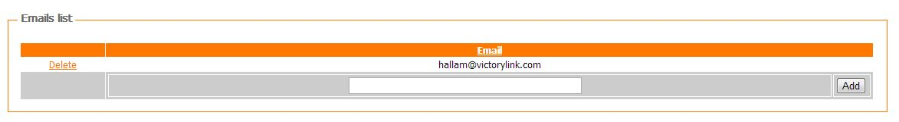
Figure 65 Add email in user profile
In case of SOC User profile, a section where user can enter an email address will be visible to enter emails to select from, when a site is faulty.
This section contains:
- A textbox to enter email address.
- A button “add” to add email address.
- A list of emails that was added before.

USSD Service

IsUserTrusted
Service takes a mobile number and returns either true if contractor with this mobile number is trusted, or false if not trusted.

IsPinCodeValid
Service takes a mobile number and pin code and returns either true if pin code is valid for contractor with this mobile number, or false if pin code is not valid.

IsUserMobinilStaff

Submit Request

Access

New access
When requesting a new access the following information should be available
- Request Type, it should be ‘Access’.
- User should be the following:
  - Is Mobinil staff or not.
  - Is trusted or not, and if user is trusted a valid pin code will be required.
  - Mobile number, belonging to a contractor that is not deleted or unauthorized.
  - Pin code.
- Action should be one of the following:
  - ActionType, could be one of the following:
    - ActionPlan.
    - Incident.
    - UAP.
    - FaxReport.
  - ActionPlan, in case of action plan action plan number will be required
This number should belong to an action plan that is not expired i.e. The end date of this action is not reached yet.
  - Incident, in case of incident, incident number will be required
This number should belong to an incident that is not expired i.e. The end date of this incident is not reached yet.
  - UAP, in case of urgent action plan, urgent action plan number will be required
This number should belong to an urgent action plan that is not expired i.e. The end date of this urgent action plan is not reached yet.
  - FaxReport, in case of fax report, fax report number will be required
This number should belong to a fax report that is not expired i.e. the end date of this fax report is not reached yet.
  - SubActionType could be one of the following:
    - Environment.
    - Audit.
    - Survey.
    - Deployment or Rollout.
    - Protective.
    - Corrective.
    - Delivery.
    - PmGenerator.
- Site code, the code should follow these conditions:
  - Site with code exist in system.
  - Site code cannot be empty, “#N/A”, “MS”, or “None”.
  - For action plan or incident, the site with this code should be associated to the action plan or incident with number specified above.
- Site region.

Concatenated access
When requesting a concatenated access the following information should be available:
- Request Type, it should be ‘Access’.
- User should be the following:
  - Is Mobinil staff or not.
  - Is trusted or not, and if user is trusted a valid pin code will be required.
  - Mobile number, belonging to a contractor that is not deleted or unauthorized.
  - Pin code.
- User should be the same user for previous request (which this request is concatenated to).
- Confirmation serial following these conditions:
  - Confirmation serial cannot be empty.
  - valid confirmation serial which you received from system.
  - Confirmation serial which is used before for another request is considered invalid.
  - Confirmation serial of a request which is not the latest request is considered invalid i.e. if other requests where concatenated to the request for which you received this confirmation serial, the confirmation serial will be considered invalid.
- Action (Action plan, incident or urgent action plan) of previous request (which this request is concatenated to) is still valid i.e. The end date of this action is not reached yet.

Renew
When submitting a renew request the following information should be available:
- Request Type, it should be ‘Renew’.
- User should be the following:
  - Is Mobinil staff or not.
  - Is trusted or not, and if user is trusted a valid pin code will be required.
  - Mobile number, belonging to a contractor that is not deleted or unauthorized.
  - Pin code.
- User should be the same user for previous request (which this request is concatenated to).
- Confirmation serial following these conditions:
  - Confirmation serial cannot be empty.
  - Valid confirmation serial which you received from system.
  - Confirmation serial which is used before for another request is considered invalid.
  - Confirmation serial of a request which is not the latest request is considered invalid i.e. if other requests where concatenated to the request for which you received this confirmation serial, the confirmation serial will be considered invalid.

Departure

Finished
When submitting a departure request the following information should be available:
- Request Type, it should be ‘Departure’.
- User should be the following:
  - Is Mobinil staff or not.
  - Is trusted or not, and if user is trusted a valid pin code will be required.
  - Mobile number, belonging to a contractor that is not deleted or unauthorized.
  - Pin code.
- User should be the same user for previous request (which this request is concatenated to).
- Departure Work Status should be ‘Finished’.
- Confirmation serial following these conditions.
  - Confirmation serial cannot be empty.
  - Valid confirmation serial which you received from system .
  - Confirmation serial which is used before for another request is considered invalid.
  - Confirmation serial of a request which is not the latest request is considered invalid i.e. if other requests where concatenated to the request for which you received this confirmation serial, the confirmation serial will be considered invalid.

Not finished
When submitting a departure request the following information should be available:
- Request Type, it should be ‘Departure’.
- User should be the following:
  - Is Mobinil staff or not.
  - Is trusted or not, and if user is trusted a valid pin code will be required.
  - Mobile number, belonging to a contractor that is not deleted or unauthorized.
  - Pin code.
- User should be the same user for previous request (which this request is concatenated to).
- Departure Work Status should be ‘NotFinished’.
- Confirmation serial following these conditions.
  - Confirmation serial cannot be empty.
  - Valid confirmation serial which you received from system.
  - Confirmation serial which is used before for another request is considered invalid.
  - Confirmation serial of a request which is not the latest request is considered invalid i.e. if other requests where concatenated to the request for which you received this confirmation serial, the confirmation serial will be considered invalid.

Pending another site
When submitting a departure request the following information should be available:
- Request Type, it should be ‘Departure’.
- User should be the following:
  - Is Mobinil staff or not.
  - Is trusted or not, and if user is trusted a valid pin code will be required.
  - Mobile number, belonging to a contractor that is not deleted or unauthorized.
  - Pin code.
- User should be the same user for previous request (which this request is concatenated to).
- Departure Work Status should be ‘Pending’.
- Confirmation serial following these conditions:
  - Confirmation serial cannot be empty.
  - valid confirmation serial which you received from system.
  - Confirmation serial which is used before for another request is considered invalid.
  - Confirmation serial of a request which is not the latest request is considered invalid i.e. if other requests where concatenated to the request for which you received this confirmation serial, the confirmation serial will be considered invalid.
- Site code.
- Site region.

- Referencesite region.

References

    - CAP Software design document.
    - CAP System version 2.1.
    - CAP User Stories document.

