

Solution Architecture

Prepared By Development Team

For

Table of Contents
1. Revision History 3
2. Purpose 4
3. SYSTEM OVERVIEW 4
4. System Architecture and Architecture Design 5
4.1 Application Layer 5
4.2 Common Service Specifications 6
4.3 Component Diagram 6
4.4 Sequence Diagrams 7
5. SYSTEM Component Description 12
5.1 Front-End Component 12
5.2 Back-End Component 13

Revision History
Date | Description | Author | Comments
12-12-2016 | Create Document V 1.0 | Mustafa Taye
21-12-2016 | Review | Waleed Abo Zaid

Purpose
The purpose of this document is to present a detailed description of the system’s Architectural design as well as the system’s flow.
A Design and system flow diagram is a graphical representation of the overall design of the system’s main Modules along with how these Modules are connected to each other through an information system, modelling its process aspects.
It shows the main architectural components of the system and how do they operate on the system’s modules to achieve the system’s purpose.

SYSTEM OVERVIEW

OCAP web application is an application which allows Orange team to manage their sites, received alarms, site problems. The tool provide the facility of reporting tool for the admin, managing teams , tool settings and GIS map for the sites.

System Architecture and Architecture Design
Cap Solution Depends on Service oriented architecture to allow mobile integration, below diagram describe how our solution component communicate with each other’s

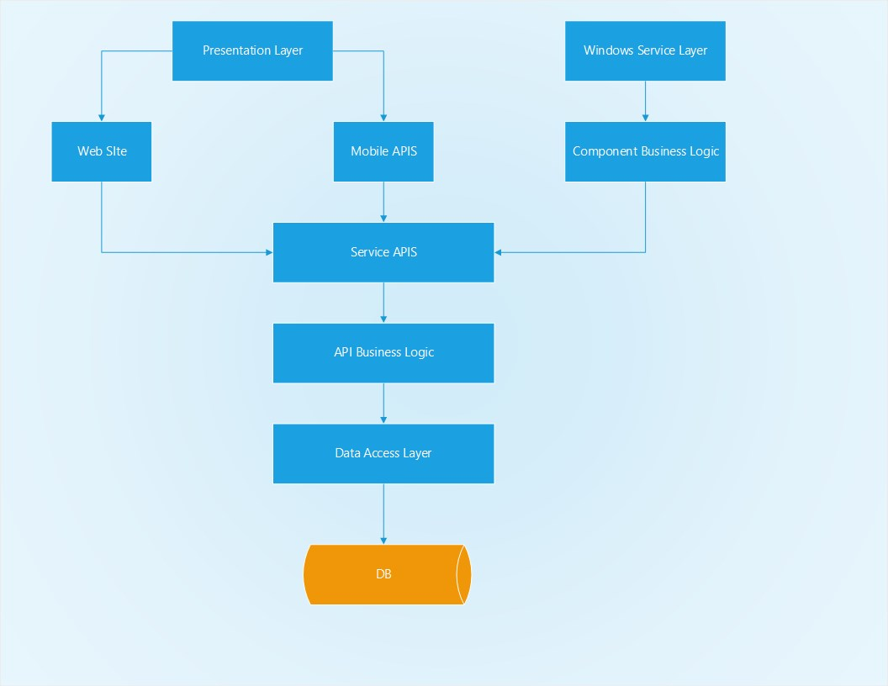
Figure 1.1 - Solution Architecture Overview Diagram
The system architecture is using service oriented concept as there will be a mobile applications integration which needs to deal with APIS , so the new architecture will contain 3 base layers (windows service , mobile APIS , Web Site), the windows service layer will communicate with the component business layer and the component business layer will communicate with the service APIS layer , but both web site layer and mobile APIS layer will communicate directly to our service APIS layer, so our migration will be dealing with implementing the business in our new service APIS layer.

4.1 Application Layer
- The layers of OCAP system.
- Window service, mobile, web tool.
- Services API.
- Core or business Logic.
- Repositories.
- Entities [Database].

4.2 Common Service Specifications
Common API: Used to load the setting of current running component
Log API: service used to log any (exception, information, error, or warning) occurred for any system component.

4.3 Component Diagram

4.4 Sequence Diagrams
OCAP System has a lot of diagrams used to show the interactions between actors and available features such as.
- USSD Access Request.
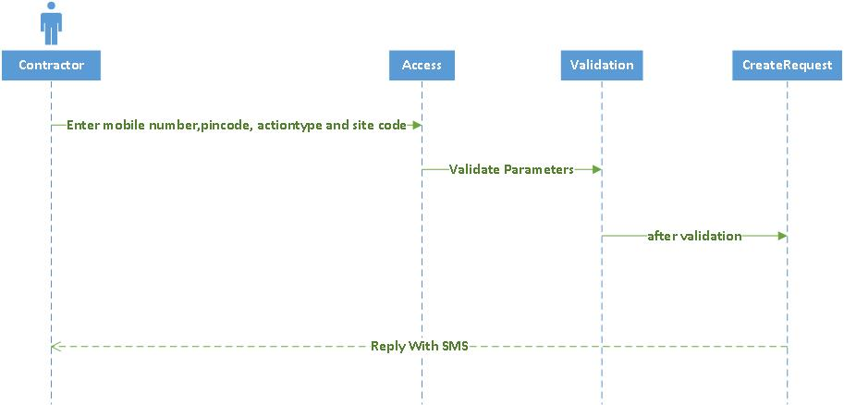
- USSD Renew request.
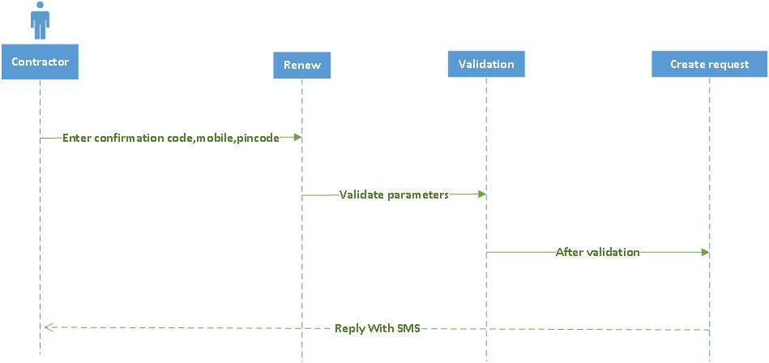
- USSD Departure finished.
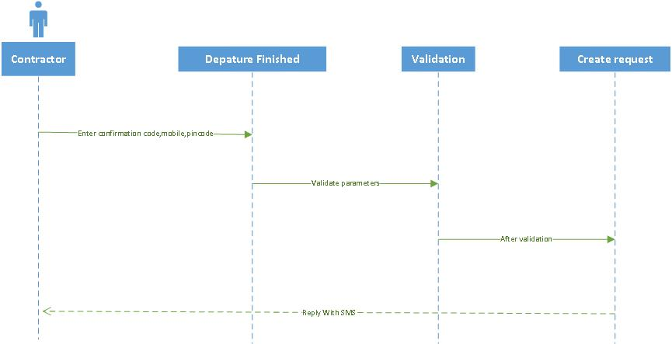
- USSD Departure not finished.
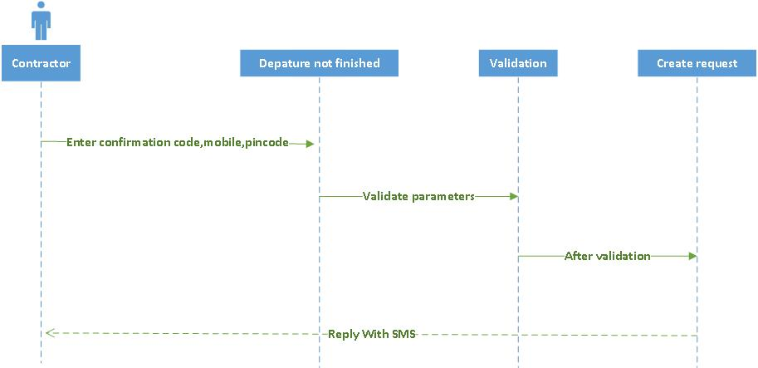
- USSD Departure pending another site.
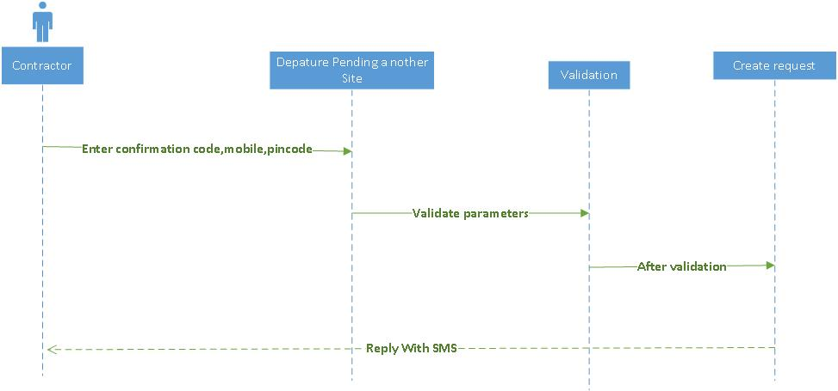
- USSD Access Pending another site.
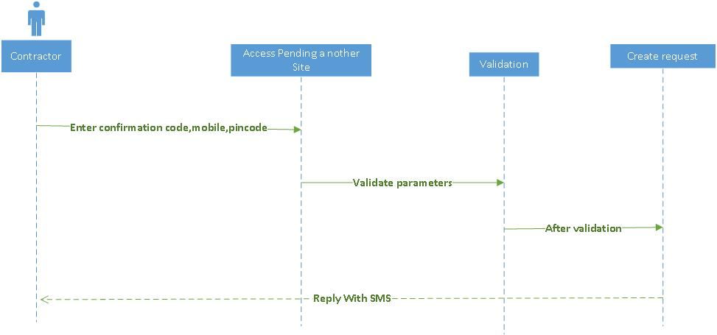
- Urgent action plan.
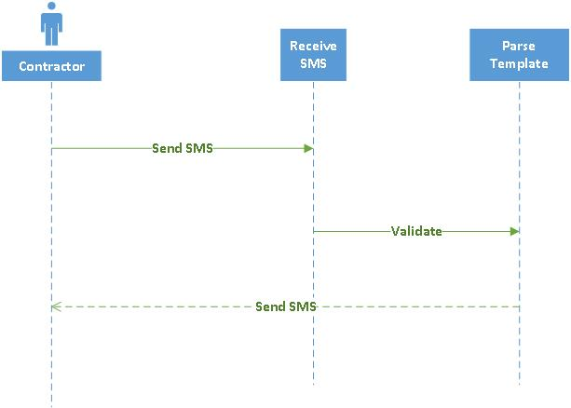
- Site parsing.
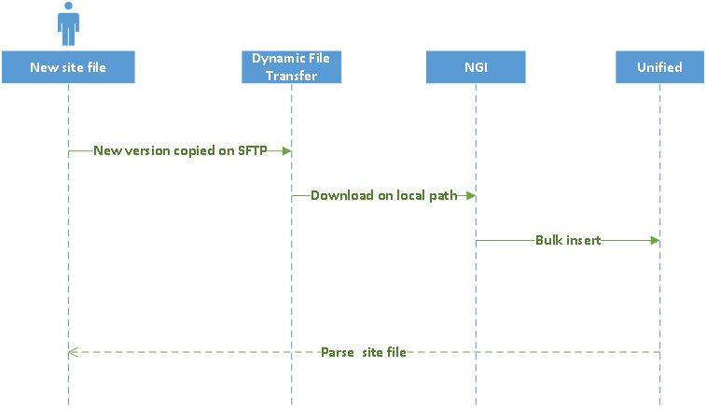
- Action plan and Incident.
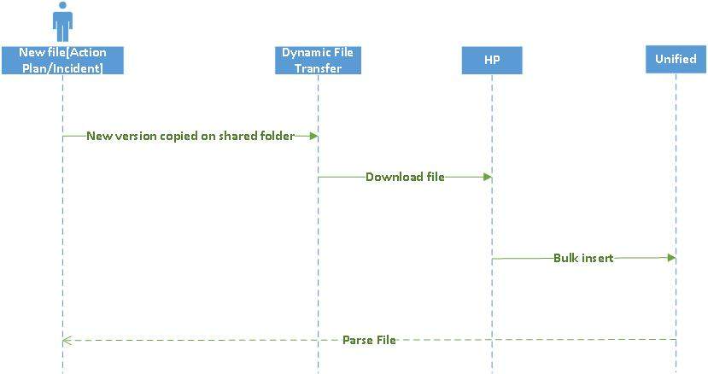

SYSTEM Component Description

5.1 Front-End Component
    - Web Tool
In the web tool the user can interact with the system and make a lot of functionality like managing users and sites. The user can view reports about parsing and site State. Managing alerts is very important to keep site online and secure. GIS map is very good tool to link site to its location and view real time state.

    - Mobile Application
Mobile application is very useful tool to keep all team member online. With mobile application you can view data about every site, send your location, visit site and leave comments, audit site and submit site problem.

    - Dynamic File Transfer Windows Service
Dynamic file transfer service is used to transfer parse file. It can work with various servers like (FTP Server, SFTP Server and Shared Folders).

    - HP Windows Service
HP windows service is used for read data from action plan sheets and incident sheets validate it and insert data into database.

    - Intervention Timeout Windows Service
Intervention timeout service is responsible for converting alert to be SOC alert after particular time to be handled by SOC team.

    - Mail Receiver and Parser Windows Services
Mail windows services are responsible for receiving mails about incident and fax, validate mail format, parse them and insert them into database to create incident or fax.

    - Mail Sender Windows Service
Mail sender service responsible for sending mails to inform user about a lot of things like new account created, password recovery and new fax created in database.

    - NGI Windows Service
NGI windows service is used for read data from every site sheet validate it and insert data into database.

    - Other Alarm Categorization Windows Service
Other alarm service allows admin to select some alarms based on search criteria and show them in separate page.

    - Parsing Guard Windows Service
Parsing Guard windows service is used for read data from guard sheet which is uploaded from web tool and insert data into database.

    - Parsing User Windows Service
Parsing User windows service is used for read data from guard sheet which is uploaded from web tool and insert data into database.

    - SMS Sender Windows Service
Send SMS to users.

    - Sending User Pin Code Windows Service
Generate pin code for CAP USSD users.

    - Monitor Windows Service
Monitor service monitor every component in the system and send notification in any failure.

    - USSD API
USSD API receives text and create request.

    - Urgent Action Plan API
This API responsible for receiving SMS and create urgent action plan.

Back-End Component
    - Common API
This API responsible for reading application setting from database.

    - Log API
This API responsible for writing logs about exceptions in the application.

    - Dynamic File Transfer API
This API responsible for transfer parse files.

    - Equation Builder API
This API responsible for handling report builder component
    - HP API
This API responsible for parsing Action plan and incident files.

    - Intervention API
This API responsible for handling alerts, requests and interventions which occurred on orange sites.

    - Mail Receiver API
This API responsible for receiving alert and fax mails.

    - Mail API
This API responsible for parse alert and fax mails.

    - Monitor API
This API responsible for monitor all component in the system and send notification at any failure.

    - NGI API
This API responsible for handling site sheets and parsing them.

    - Sending Channel API
This API responsible for sending SMS and mails.

    - User Management API
This API responsible for handling users, pools, guards and permissions.

