

Document Name
Prepared By Dev Team

For

Table of Contents
Revision History 3
Purpose 4
Audience 4
Introduction 4
Installing Redis Engine on Linux 5
.Net Client 6
Connect To Redis Engine from c# using StackExchange.Redis 6

Revision History
Date | Description | Author | Comments
11/10/2017 | Redis in-memory Database with C# | Hesham Yosry

Purpose
The purpose from this document is to show how to use Redis in-memory key-value store as a data store for c# application

Audience
The audience of this document is any one intend to use Redis with c#.

Introduction
Redis is an alternative to SQL database for fast access on objects, to use Redis effectively you must change your mind set from SQL tables to plain data structure.

Installing Redis Engine on Linux
Run the following commands
sudo yum install epel-release
sudo yum update
sudo yum install redis
sudo systemctl start redis
sudo systemctl enable redis

.Net Client
There is a 2 main .Net Clients for Redis:
- StackExchange.Redis (free)
- ServiceStack.Redis (paid)
We will use StackExchange.Redis with extra library “StackExchange.Redis.Extensions.Core”
- Projects Home Pages:
  - https://github.com/imperugo/StackExchange.Redis.Extensions
  - https://github.com/ServiceStack/ServiceStack.Redis

Connect To Redis Engine from c# using StackExchange.Redis

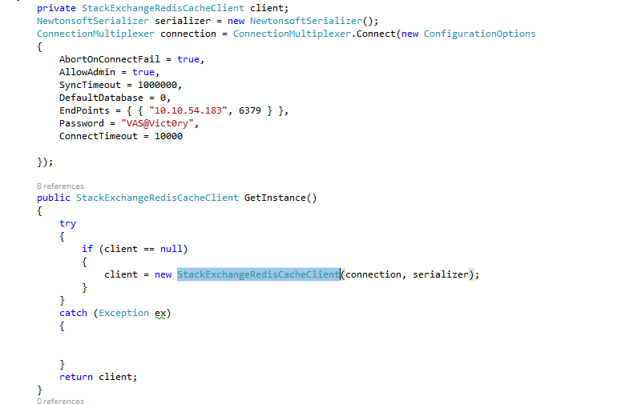
Source code attached

Notes on Attached code
Attached code was made for NOC Equation Builder, It’s so customized for this project but you can use some generic methods located in “EquationBuilderTest.RedisModel.Extensions” helper class.
How to migrate Data from SQL to Redis: please take a look on “EquationBuilderTest.RedisServices.DataBulkInsertService” class.

