

Technical Proposal
Azadea – Memory Game

Prepared by
VictoryLink Business Analysis Team
10 September 2017

Contents
Revision History 3
1. Document Overview 4
2. Project Purpose and Scope 4
3. Memory Games Ideas 5
3.1 Business Requirements 5
3.1.1 Secrets Closet Game 5
3.1.2 Hidden Objects Game 6
3.1.3 Memory Matching Game 7
3.2 Features List 9

Revision History
Date | Version | Author | Description
10/09/2017 | 1.0 | Bassem Labib | Initial Document

- Document Overview
The scope of this document is to describe the features of “Memory Game” for Azadea. This Document will illustrate the proposed scope of the Memory Game. The System Requirements will be declared in the Business Requirements and the List of Features. At the end of this document it gives to the stakeholders the Estimated Effort and Cost of the System.

- Project Purpose and Scope
VictoryLink is representing to Azadea Agency an idea of Memory Game Software revolving around the closet, as a marketing tool regarding its client “Reserved” for Fashion.
The purpose of this proposal is to illustrate 3 Ideas about Memory Game in order to be discussed and select the desired idea or all of it.
The Objectives of this games are to create awareness of the different lines of “Reserved” collections, Drive traffic to the store, Engage with the customers through a fun game and Increase sales.
The general scope of Memory Game Software as following:
- Interactive tool to get represent and play the games item.
- Register the participants’ contact information.
- Depend on the presence of a sales person with the participants to manually evaluate the player.
- Works based on offline mode.
- The game’s interface could be presented on a Touch Screen, Tablet (e.g. iPad) or Kinect Camera.
- The mobile application could have a (Launcher Screen) to launch all these games as a "Home Navigation Screen".
- The games should be opened for a periodical time.
- The participant has to guess the right solution items or submit the required solution, through answering the asked questions or other techniques.
- Winning participants will receive a gift voucher to be redeemed at the stores.

- Memory Games Ideas
System should be able to deliver the following the Idea of Memory Games and its specific requirements.
- Business Requirements
    - Secrets Closet Game
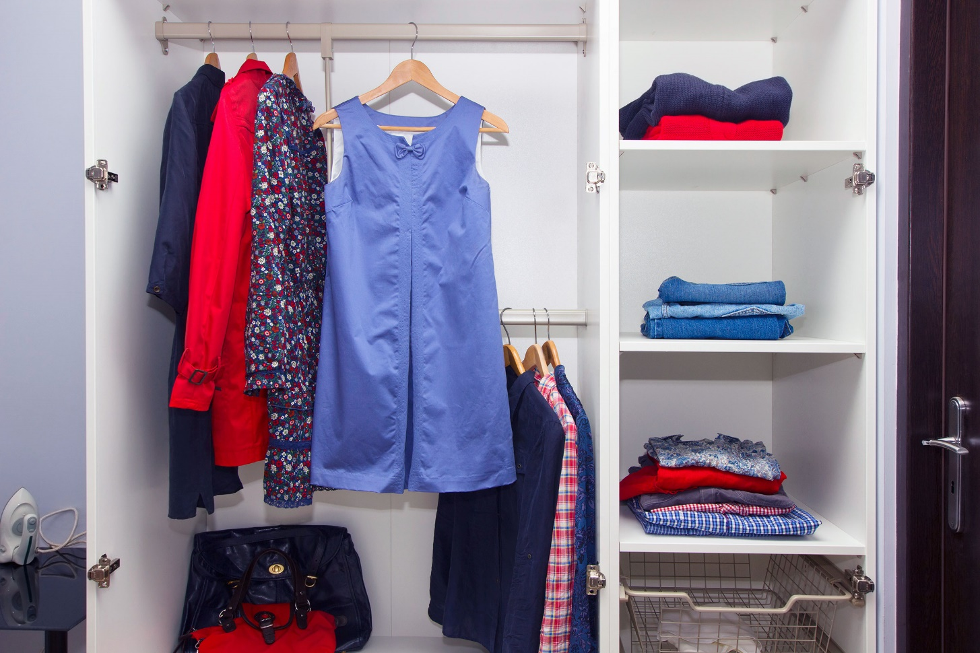
Secrets Closet Game contains three Locked Closets, the participant should choose one of them and the game will show a MCQ question related to the inside contents and within a certain time period. The participant should submit the write answer of the MCQ question to unlock the closet. Once the closet is unlocked it show a winner celebration message and the gift voucher.

This Game flow will contains the following:
- A screen that contains three closets to select one of them.
- A screen that contains the selected Closet with a related MCQ Question for a certain time period and a submit button
- Once the participant submit all MCQ questions successfully, the game should show a winner celebration message and the gift voucher, otherwise it should show a failed result message with an option to try the game again.
- System should save the result in order to be collected separately and update the campaign statistics.

    - Hidden Objects Game
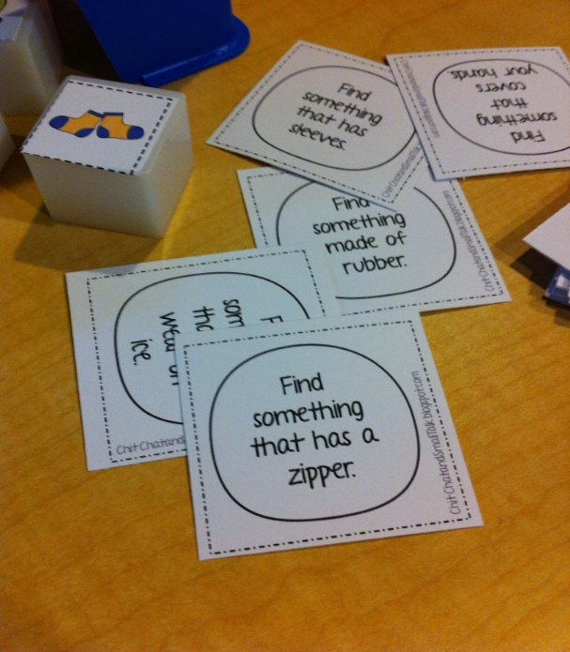
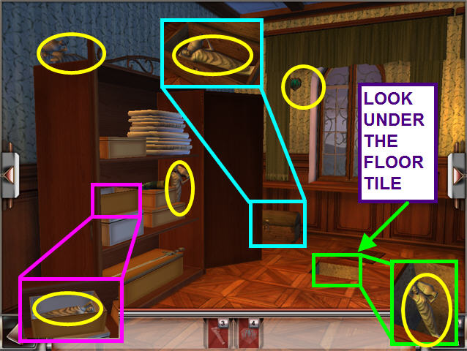
Hidden Objects Game idea is based on an Image of the store with lots of hidden objects on site, the participant shall try to find the required objects within a limited time period.

This Game flow will contains the following:
- A screen that contains Image of the store with lots of hidden objects on site.
- A screen that contains the description of required object(s) which the participant should try to find it within a certain time period.
- Once the participant find all required objects the game should show a winner celebration message and the gift voucher, otherwise it should show a failed result message with an option to try the game again.
- System should save the result in order to be collected separately and update the campaign statistics.

    - Memory Matching Game
Memory Matching Game idea is built on matching identical objects that the participant should discover it when flipping the tile in a matrix. The tiles matrix consists of 3 levels starts with 2*2 tiles then 3*3 tiles then 4*4 tiles.
When the participant solve or match all tiles successfully the game should show a winner celebration message and the gift voucher.
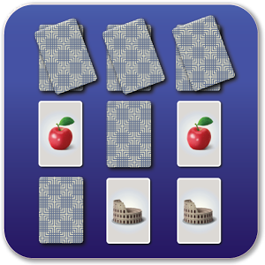
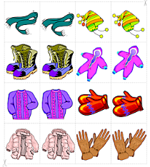

This Game flow will contains the following:
- The Participant should select the level of tiles matrix.
- A screen that contains the tiles matrix, all tiles are covered or flipped.
- The Participant should match the tiles each with its identical one within a certain time period.
- Once it is completed successfully the game should show a winner celebration message and the gift voucher, otherwise it should show a failed result message with an option to try the game again.
- System should save the result in order to be collected separately and update the campaign statistics.

- Features List
The Business requirements described above will be translated to an Application have the Modules, Functions and Use Cases.
# | Functions  (Tabs / Menu Item) | Use Cases  (Pages / Screens) | Comments
1 | Administrator Interface | Authentication Forms (Login/Logout/Change Password)
1 | Administrator Interface | Import Games Result
1 | Administrator Interface | Campaign Statistics Report
2 | Sales Person (Participant) Interface | Authentication Forms (Login/Logout/Change Password)
2 | Sales Person (Participant) Interface | Landing Page (Home Screen)
2 | Sales Person (Participant) Interface | Register Participant’s information Screen
2 | Sales Person (Participant) Interface | Select Game Screen
2 | Sales Person (Participant) Interface | Main Game Screen | To display the selected game
2 | Sales Person (Participant) Interface | Secondary Game Screen | If needed based on the selected game
2 | Sales Person (Participant) Interface | Game Results (with win/failed message) + Gift Voucher
2 | Sales Person (Participant) Interface | Export Game Result (PDF/XLS)

