

Iknow
User Manual
Prepared by Business Analysis Team

Contents
Contents 2
Table of Figures 5
Revision History 9
1. GENERAL INFORMATION 10
1.1. System Overview 10
1.2. Organization of the Manual 10
2. SYSTEM SUMMARY 11
2.1. System Configuration 11
2.2. User Access Levels 11
2.3. Constraints 11
3. GETTING STARTED 12
3.1. System login/log out 12
3.2. Change password screen 13
3.3. Landing Page 14
3.4. System Menu (Administrator) 15
3.4.1. Administrator section 16
3.4.1.1 Channel List Screen 16
3.4.1.2 Add Channel Screen 18
3.4.1.3 Edit Channel Screen 20
3.4.1.4 Function List Screen 21
3.4.1.5 Add Function Screen 22
3.4.1.6 Edit Function Screen 23
3.4.2. User Management section 24
3.4.2.1 Users List Screen 24
3.4.2.2 Add bulk of users Screen 26
3.4.2.3 Delete bulk of users Screen 27
3.4.2.4 Edit User Screen 28
3.4.3. Reports section 29
3.4.3.1 Login Report 29
3.4.3.2 Application Download Report 30
3.5. System Menu (Channel Administrator) 31
3.5.1. Privileges section 33
3.5.1.1 Channel List Screen 33
3.5.1.2 Edit Channel Screen 35
3.5.1.3 Function List Screen 36
3.5.1.4 Add Function Screen 37
3.5.1.5 Users List Screen 38
3.5.1.6 Upload User Sheet Screen 39
3.5.1.7 Add Channel Screen 40
3.5.2. Functions -> Tutorials List Screen 41
3.5.2.1 Add Tutorials Screen 43
3.5.2.2 Edit Tutorials Screen 44
3.5.3. Functions -> Think Tank Item List Screen 46
3.5.3.1 Think Tank Item Details Screen 48
3.5.4. Functions -> Business tips List Screen 49
3.5.4.1 Add Business tips Screen 51
3.5.4.2 Edit Business tips Screen 52
3.5.4.3 Business tips Topic List Screen 53
3.5.4.4 Add Business tips Item Screen 55
3.5.4.5 Edit Business tips Item Screen 56
3.5.5. Functions -> Network Coverage Category List Screen 57
3.5.5.1 Add Network Coverage Category Screen 59
3.5.5.2 Edit Network Coverage Category Screen 60
3.5.5.3 Network Coverage List Screen 61
3.5.5.4 Add Network Coverage Item Screen 63
3.5.5.5 Edit Network Coverage Item Screen 64
3.5.6. Functions -> “special” Program points Screen 66
3.5.6.1 Add “Special” Program points Screen 68
3.5.6.2 Edit “Special” Program points Screen 70
3.5.6.3 Supplier List Screen 72
3.5.6.4 Add Account’s points Supplier Screen 74
3.5.6.5 Edit Account’s points Supplier Screen 75
3.5.7. Functions -> Contests Category List Screen 76
3.5.7.1 Add Contests Category Screen 78
3.5.7.2 Edit Contests Category Screen 79
3.5.7.3 Contests File List Screen 80
3.5.7.4 Add Contests File Screen 82
3.5.7.5 Edit Contests File Screen 83
3.5.8. Functions -> My Business Category List Screen 84
3.5.8.1 Add My Business Category Screen 86
3.5.8.2 Edit My Business Category Screen 87
3.5.8.3 My Business File List Screen 88
3.5.8.4 Add My Business File Screen 90
3.5.8.5 Edit My Business File Screen 91
3.5.9. Functions -> Operational Forms Category List Screen 92
3.5.9.1 Add Operational Forms Category Screen 94
3.5.9.2 Edit Operational Forms Category Screen 95
3.5.9.3 Operational Forms Item List Screen 96
3.5.9.4 Add Operational Forms Item Screen 98
3.5.9.5 Edit Operational Forms Item Screen 99
3.5.10. Functions -> Orange Catalogue Screen 100
3.5.10.1 Add Orange Catalogue Item Screen 102
3.5.10.2 Add Orange Catalogue Category Screen 104
3.5.10.3 Edit Orange Catalogue Item Screen 105
3.5.10.4 Edit Orange Catalogue Category Screen 107
3.5.11. Functions -> Let’s Play List Screen 108
3.5.11.1 Add Let’s Play Screen 110
3.5.11.2 Edit Let’s Play Contest Screen 112
3.5.11.3 Let’s Play Questions List Screen 114
3.5.11.4 Add Let’s Play Question Screen 116
3.5.11.5 Edit Let’s Play Question Screen 118
3.5.12. Message List Screen 120
3.5.12.1 Add Message Screen 122
3.5.12.2 Edit Message Screen 123
3.5.13. Reports section 124
3.5.13.1 Login Report 124
3.5.13.2 Application Download Report 124
3.5.13.3 Gamification Users Report 124
3.5.13.4 Gamification Top Ten Report 126
3.6. The Iknow mobile application 128
3.6.1. System login screen 128
3.6.2. Change password screen 129
3.6.3. System Menu (Mobile user) 131
3.6.4. Notifications Screen 132
3.6.5. Orange Catalogue Screen 133
3.6.6. Tutorials Screen 135
3.6.7. Think Tank Screen 136
3.6.8. Business tips Screen 138
3.6.9. Network Coverage Screen 140
3.6.10. Special program points Screen 144
3.6.11. My Business Screen 146
3.6.12. Select Calculator Screen 147
3.6.13. Contests Screen 148
3.6.14. Operational Forms Screen 149
3.6.15. Let's Play Screen 150
3.5.15.1 Contest questions Screen 153
3.5.15.2 Contest result Screen 154
3.5.15.3 Contest top 10 ranks Screen 155
3.5.15.4 Contest answers Screen 156
3.6.16. Phone Advisor 157

Table of Figures
Figure 1: Login screen 12
Figure 2: Change password screen 13
Figure 3: Landing Page 14
Figure 4: System Menu (Administrator) 15
Figure 5: Channels list Screen 17
Figure 6: Add Channel Screen 19
Figure 7: Edit Channel Screen 20
Figure 8: Function List Screen 21
Figure 9: Add Function Screen 22
Figure 10: Edit Function Screen 23
Figure 11: Users List Screen 25
Figure 12: Add bulk of users Screen 26
Figure 13: Delete bulk of users Screen 27
Figure 14: Edit User Screen 28
Figure 15: Login Report 29
Figure 16: Application Download Report 30
Figure 17: System Menu (Channel Administrator) 32
Figure 18: Channel List Screen 34
Figure 19: Edit Channel Screen 35
Figure 20: Function List Screen 36
Figure 21: Add Function Screen 37
Figure 22: Users List Screen 38
Figure 23: Upload User Sheet Screen 39
Figure 24: Add Channel Screen 40
Figure 25: Tutorials List Screen 42
Figure 26: Add Tutorials Screen 43
Figure 27: Edit Tutorials Screen 45
Figure 28: Think Tank Item List Screen 47
Figure 29: Think Tank Item Details Screen 48
Figure 30: Business tips List Screen 50
Figure 31: Add Business tips Screen 51
Figure 32: Edit Business tips Screen 52
Figure 33: Business tips Topic List Screen 54
Figure 34: Add Business tips Item Screen 55
Figure 35: Edit Business tips Item Screen 56
Figure 36: Network Coverage Category List Screen 58
Figure 37: Add Network Coverage Category Screen 59
Figure 38: Edit Network Coverage Category Screen 60
Figure 39: Network Coverage List Screen 62
Figure 40: Add Network Coverage Item Screen 63
Figure 41: Edit Network Coverage Item Screen 65
Figure 42: “special” Program points Screen 67
Figure 43: Add “Special” Program points Screen 69
Figure 44: Edit “Special” Program points Screen 71
Figure 45: Supplier List Screen 73
Figure 46: Add Account’s points Supplier Screen 74
Figure 47: Edit Account’s points Supplier Screen 75
Figure 48: Contests Category List Screen 77
Figure 49: Add Contests Category Screen 78
Figure 50: Edit Contests Category Screen 79
Figure 51: Contests File List Screen 81
Figure 52: Add Contests File Screen 82
Figure 53: Edit Contests File Screen 83
Figure 54: My Business Category List Screen 85
Figure 55: Add My Business Category Screen 86
Figure 56: Edit My Business Category Screen 87
Figure 57: My Business File List Screen 89
Figure 58: Add My Business File Screen 90
Figure 59: Edit My Business File Screen 91
Figure 60: Operational Forms Category List Screen 93
Figure 61: Add Operational Forms Category Screen 94
Figure 62: Edit Operational Forms Category Screen 95
Figure 63: Operational Forms Item List Screen 97
Figure 64: Add Operational Forms Item Screen 98
Figure 65: Edit Operational Forms Item Screen 99
Figure 66: Orange catalogue section’s categories/items list 101
Figure 67: Add Orange Catalogue Item Screen 103
Figure 68: Add Orange Catalogue Category Screen 104
Figure 69: Edit Orange Catalogue Item Screen 106
Figure 70: Edit Orange Catalogue Category Screen 107
Figure 71: Let’s Play List Screen 109
Figure 72: Add Let’s Play Screen 111
Figure 73: Edit Let’s Play Contest Screen 113
Figure 74: Let’s Play Questions List Screen 115
Figure 75: Add Let’s Play Question Screen 117
Figure 76: Edit Let’s Play Question Screen 119
Figure 77: Message List Screen 121
Figure 78: Add Message Screen 122
Figure 79: Edit Message Screen 123
Figure 80: Gamification Users Report 125
Figure 81: Gamification Top Ten Report 127
Figure 82: System login screen 129
Figure 83: Change password screen 130
Figure 84: Mobile application menu 131
Figure 85: Function's channels list 131
Figure 86: Notifications Screen 132
Figure 87: Content view 134
Figure 88: Orange Catalogue Screen 134
Figure 89: Commercial Tutorials Screen 135
Figure 90: Tutorials Screen 135
Figure 91: Submit idea Screen 137
Figure 92: What’s Think Tank Screen 137
Figure 93: Think Tank Screen 137
Figure 94: Content view 139
Figure 95: Business tips Screen 139
Figure 96: Important Tips file view/send 142
Figure 97: Network Coverage Screen 142
Figure 98: Network Coverage Claim Form 143
Figure 99: Suppliers Screen 145
Figure 100: Program details screen 145
Figure 101: Special program points Screen 145
Figure 102: File view/send 146
Figure 103: My Business Screen 146
Figure 104: How many units do you want? 147
Figure 105: How much do you want to pay? 147
Figure 106: Select Calculator Screen 147
Figure 107: File view/send 148
Figure 108: Contests Screen 148
Figure 109: File view/send 149
Figure 110: Operational Forms Screen 149
Figure 111: Let's Play Screen 151
Figure 112: Open contest - Not played by the user 152
Figure 113: Open contest - Played by the user 152
Figure 114: Closed contest - Played by the user 152
Figure 115: Closed contest - Not played by the user 152
Figure 116: Contest questions Screen 153
Figure 117: Contest result Screen 154
Figure 118: Contest top 10 ranks Screen 155
Figure 119: Contest answers Screen 156

Revision History
Date | Description | Author | Comments
04/06/2017 | User Manual V1.0 | Ahmed Ashraf | Initial Document

GENERAL INFORMATION
General Information section explains in general terms the system and the purpose for which it is intended.

System Overview
- Iknow is an application intended to share contents added by the channel administrators with the Orange employees through the mobile application. These contents can be text or and file.
- Mobile users groups is called “Channels” in the system as a group of Orange employees. Channel can have one or more sub-channels.
- Each channel must have one channel administrator to manage its contents.
- Contents categories is called “Functions” in the system.
- Each channel can show one or more “Function(s)”.
- There are two types of functions
  - Public function
    - Can be assigned to only one channel.
    - Have a single content in the system.
    - Any user in any channel in the system can view the function contents.
  - Private function
    - Can be assigned to more than one channel at the same time.
    - Each channel will have its own contents for this function.
    - Only assigned channel’s users can view the function contents.
- The application consist of two parts
  - Administrators’ part: Web application which operates on any internet browser.
  - End users part: Mobile application on Android and iOS mobile phones.

Organization of the Manual
The user’s manual consists of three sections: General Information, System Summary and Getting Started
- General Information section explains in general terms the system and the purpose for which it is intended.
- System Summary section provides a general overview of the system. The summary outlines the uses of the system’s hardware and software requirements, system’s configuration, and user access levels.
- Getting Started section explains how to access Iknow admin tool web application. This section briefly presents the system menu.

SYSTEM SUMMARY
System Summary section provides a general overview of the system. The summary outlines the uses of the system’s hardware and software requirements, system’s configuration and user access levels.

System Configuration
Iknow admin tool application operates on any web browser such as Google Chrome, and Internet Explorer.

Iknow part for end user is a mobile application on Android and iOS mobile phones.

The application only requires a connection to Internet in order to retrieve or save data to database. After accessing any web browser, Iknow application can be used immediately without any configuration.

User Access Levels
- Only administrator and channel administrators are able to access Iknow admin tool.

- Only registered end users are able to access the mobile application.

- There are 3 User types:
  - Administrator: Manages and adds users to be able to use the mobile application and also manage the channels and define the channel administrator for each.
  - Channel Administrator: Manages the regular channel and provide content for the users, also receive users’ Ideas from think tank module.
  - Mobile User: Access the functions’ contents on the mobile application.

Constraints
NA.

GETTING STARTED
Getting Started section explains how to access Iknow application. The section presents briefly the application’s menu.

System login/log out
- The administrator/channel administrator will fill his user name and password in the login screen and then click “Log In” button.
- If the provided user name is invalid, then the system will show the following error message “Sorry, user is not found”.
- If the provided password is invalid, then the system will show the following error message “You should be administrator or channel administrator user to be able to access admin tool”.
- If the administrator has suspended this user, then the system will show the following error message “Sorry, user is suspended”.
- The administrator/channel administrator can log out from the system by clicking on “Log out” link on the upper right part of any screen.

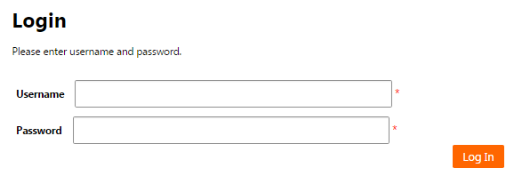

Figure 1: Login screen

Change password screen
- The administrator/channel administrator can change his/her password by clicking on his/her name on the upper right part of any screen.
- The administrator/channel administrator will be required to enter his/her old password, new password and to confirm the new password.
- The administrator/channel administrator will press “Change Password” button to change the password and return to the “Landing page”.
- The administrator/channel administrator will press “Close” button to return to the “Landing page”.

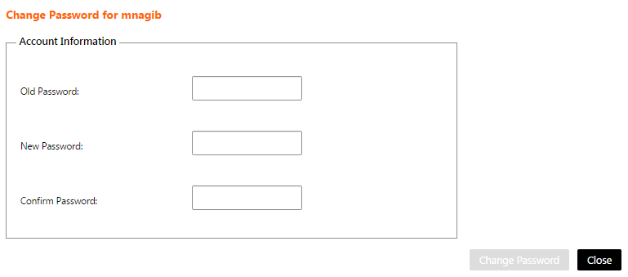
Figure 2: Change password screen

Landing Page
The system shall display the following Landing page when the administrator/channel administrator logins to the system or when the administrator/channel administrator clicks “Home” on the upper menu. The page will contain a list of the public functions in the system with the following data
- Function Name: The name of the public function in the system.
- Public Administrator User: The administrator of the channel who is responsible for modifying the contents of the function.
- Channel Name: The name of the channel that is assigned to this function.

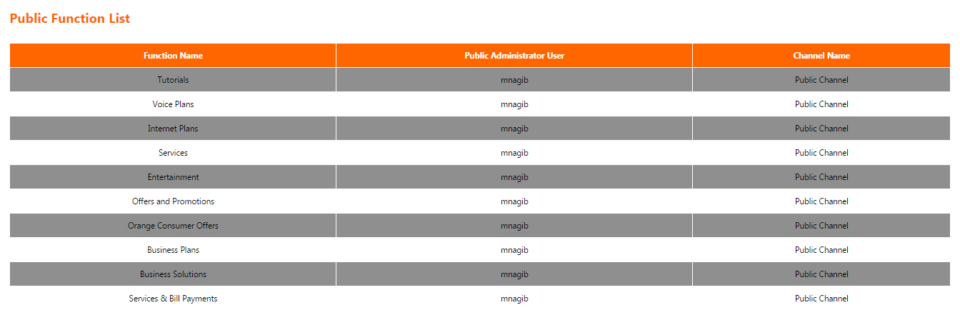
Figure 3: Landing Page

System Menu (Administrator)

Iknow application consists of 3 sections for administrator.
- Administrator
- User Management
- Reports

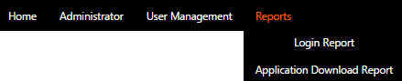

Figure 4: System Menu (Administrator)

Administrator section

Channel List Screen
The administrator will access this screen by clicking on the menu (Administrator).
This screen shows a list of the current channels on the system and enables the administrator to manage them.

- The current channels list have the following columns
  - Name: The name of the channel.
  - Functional Mail: The E-Mail address of the channel administrator.

- List can be sorted by clicking on the column header.

- If the list contains more than 15 records, then it will be splitted into pages and each page will show 15 records. The administrator can navigate between list pages by clicking on the page number below the list.

- The channel administrator can filter the channel list by filling the following field and click on the button “Search”:
  - Name: To search using the channel name.

- The administrator can reset the list filtration by clicking on the button “Reset”. This will do the following
  - Clear the field “Name”.
  - Reload the page with all the channels.

- The administrator can add a channel by clicking on the button “Add”. This will open “Add Channel screen”.

- The administrator can edit a channel by clicking on the link “Edit” on a specific channel on the list. This will open “Edit Channel screen”.

- Channel can only be deleted if it doesn’t have sub-channels. The administrator can delete a channel by clicking on the link “Delete Channel” on a specific channel on the list. Clicking this link will show the following confirmation message to the administrator “Are you sure to delete this channel? (OK/Cancel)”. The administrator can click “OK” button to continue and delete the channel or click “Cancel” button to cancel the operation.

- The administrator can manage the functions linked to a channel by clicking on the link “Manage Function” on a specific channel on the list. This will open “Function List screen”.

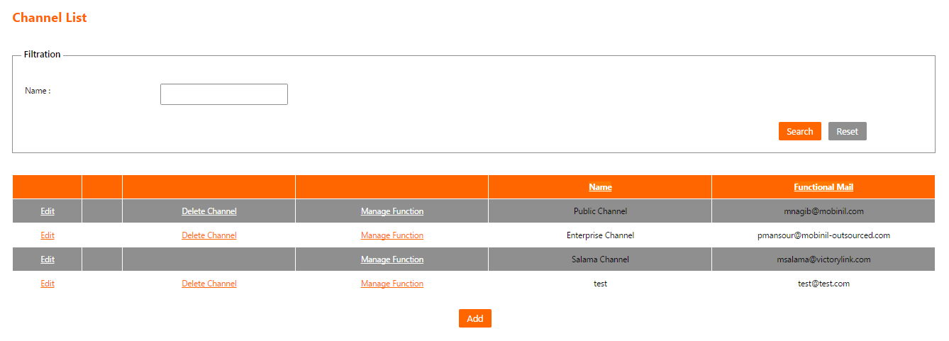
Figure 5: Channels list Screen

Add Channel Screen
The administrator will access this screen by clicking on the button “Add” on “Channel List Screen”.
This screen enables the administrator to add a new channel in the system.

The administrator is responsible only for the creation of the first level channels (That have no parent channels), then it will be the responsibility of those channels’ administrators to create subsequent sub-channels.

- The following fields are displayed for the new channel:
  - Name:
    - The name of the channel.
    - It is a mandatory field.
  - Functional mail:
    - The E-Mail address of the channel administrator.
    - It is a mandatory field.
    - The filled data must be in a valid E-Mail format.
  - Channel Administrator:
    - The user name of the channel administrator.
    - It is a mandatory field.
    - This field is auto complete. The administrator can fill the first few characters of the desired user name, then a list will be shown with the suggested user names that starts with the entered characters.

- The administrator can press “Save” button to save the channel and return to “Channel List Screen”.

- The administrator can press “Close” button to cancel the channel creation and return to “Channel List Screen”.
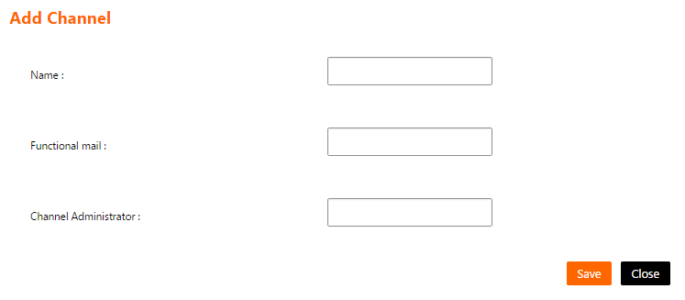
Figure 6: Add Channel Screen

Edit Channel Screen
The administrator will access this screen by clicking on the link “Edit” on a specific channel on the list on “Channel List Screen”.
This screen enables the administrator to edit the data of an existing channel in the system.

- The following fields are displayed and filled for the chosen channel:
  - Name:
    - The name of the channel.
    - It is a mandatory field.
  - Functional mail:
    - The E-Mail address of the channel administrator.
    - It is a mandatory field.
    - The filled data must be in a valid E-Mail format.
  - Channel Administrator:
    - The user name of the channel administrator.
    - It is a mandatory field.
    - This field is auto complete. The administrator can fill the first few characters of the desired user name, then a list will be shown with the suggested user names that starts with the entered characters.

- The administrator can press “Save” button to save the channel modifications and return to “Channel List Screen”.

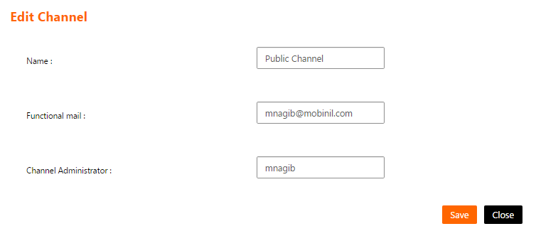
- The administrator can press “Close” button to cancel the channel modifications and return to “Channel List Screen”.
Figure 7: Edit Channel Screen

Function List Screen
The administrator will access this screen by clicking on the link “Manage Function” on a specific channel on the list on “Channel List Screen”.
This screen enables the administrator to manage the functions linked to a channel in the system.
- The function list have the following columns
  - Name: The name of the function.
  - Is Public: Indicates whether this function is currently public or private in the system.

- List can be sorted by clicking on the column header.

- If the list contains more than 15 records, then it will be splitted into pages and each page will show 15 records. The administrator can navigate between list pages by clicking on the page number below the list.

- The administrator can assign a function to this channel by clicking on the button “Add”. This will open “Add Function screen”.

- The button “Add” will be hidden if all the allowed functions in the system is already linked to the current channel.

- The administrator can edit a function link to this channel by clicking on the link “Edit” on a specific function on the list. This will open “Edit Function screen”.

- The administrator can delete a “function link” with the current channel by clicking on the link “Delete” on a specific function on the list. Clicking this link will show the following confirmation message to the administrator “Are you sure you want delete this record and all related data? (OK/Cancel)”. The administrator can click “OK” button to continue and delete the “function link” with the current channel or click “Cancel” button to cancel the operation.

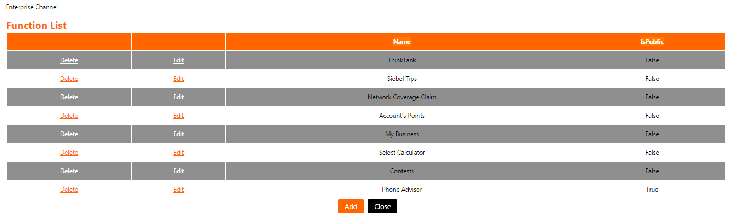
- The administrator can press “Close” button to return to “Channel List Screen”.
Figure 8: Function List Screen

Add Function Screen
The administrator will access this screen by clicking on the button “Add” on “Function List Screen”.
This screen enables the administrator to link a function to a channel in the system.

- The following fields are displayed for the function link:
  - Function:
    - A list that contains the following:
      - Functions not linked to any channels.
      - Functions linked to other channels as Private.
    - It is a mandatory field.
  - IsPublic:
    - Indicates whether this function is public or private in the system.
    - It is a mandatory field.

- The administrator can press “Add” button to save the function link and return to “Function List Screen”.

- The administrator can press “Close” button to cancel the function link creation and return to “Function List Screen”.

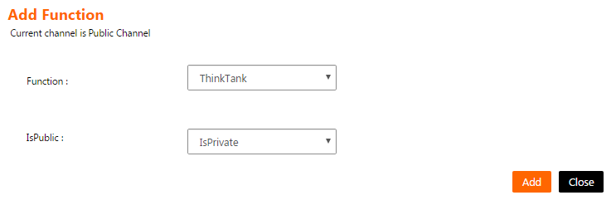
Figure 9: Add Function Screen

Edit Function Screen
The administrator will access this screen by clicking on the link “Edit” on specific function on the list on “Function List Screen”.
This screen enables the administrator to edit the data of a function link to a channel in the system.

- The following fields are displayed and filled for the chosen link:
  - Function:
    - The name of the function and can’t be changed.
  - IsPublic:
    - Indicates whether this function is public or private in the system.
    - It is a mandatory field.

- The administrator can press “Update” button to save the function link and return to “Function List Screen”.

- The administrator can press “Close” button to cancel the function link modifications and return to “Function List Screen”.

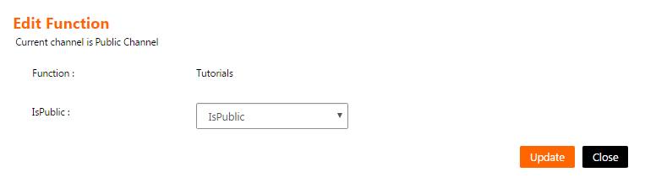
Figure 10: Edit Function Screen

User Management section

Users List Screen
The administrator will access this screen by clicking on the menu (User Management).
This screen shows a list of the current users on the system and enables the administrator to manage them.

- The users list have the following columns
  - Username: The name of the system user.
  - Email: The E-Mail address of the system user.
  - Phone Number: The phone of the system user.

- List can be sorted by clicking on the column header.

- If the list contains more than 15 records, then it will be splitted into pages and each page will show 15 records. The administrator can navigate between list pages by clicking on the page number below the list.

- The channel administrator can filter the users list by filling one or more of the following fields and click on the button “Search”:
  - User name: To search using the user name.
  - Email: To search using the E-Mail address of the user.
  - User type: To search using the type of the user (Channel Administrator - Mobile User).

- The administrator can reset the list filtration by clicking on the button “Reset”. This will do the following
  - Clear the fields "User name", "Email" and "User type".
  - Reload the page with all the system users.

- The administrator can add a number of users in one step by clicking on the button “Add Bulk”. This will open “Add bulk of users screen”.

- The administrator can delete a number of users in one step by clicking on the button “Delete Bulk”. This will open “Delete bulk of users screen”.

- The administrator can edit a user by clicking on the link “Edit” on a specific user on the list. This will open “Edit User screen”.

- The administrator can suspend a user by clicking on the link “Suspend” on a specific unsuspended user on the list. Clicking this link will show the following confirmation message to the administrator “Are you sure? (OK/Cancel)”. The administrator can click “OK” button to continue and suspend the user or click “Cancel” button to cancel the operation.

- The administrator can unsuspend a user by clicking on the link “UnSuspend” on a specific suspended user on the list. Clicking this link will show the following confirmation message to the administrator “Are you sure? (OK/Cancel)”. The administrator can click “OK” button to continue and unsuspend the user or click “Cancel” button to cancel the operation.

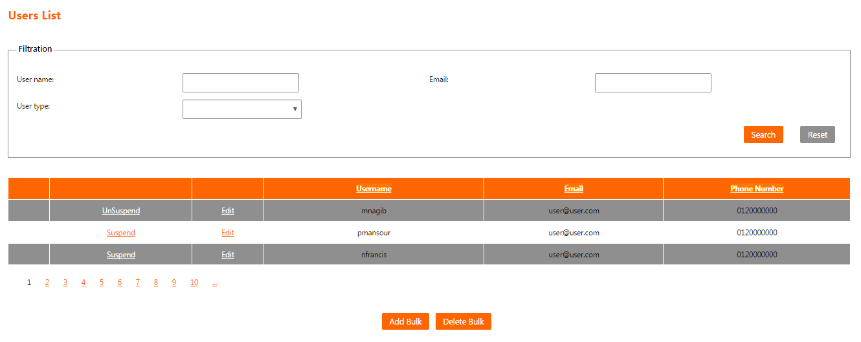
Figure 11: Users List Screen

Add bulk of users Screen
The administrator will access this screen by clicking on the button “Add Bulk” on “Users List Screen”.
This screen enables the administrator to add a number of users in the system in one step.

- The administrator will press “Download Template” link to download an excel sheet that contains the required data of the new users.

- The administrator will fill the sheet then click on the button “Choose File” and select the sheet file location.
  - Choosing any file which is not an excel sheet will give the following error message “Please choose a valid users excel sheet”.

- The administrator can press “Upload” button to upload the users to the system.
  - The system will validate the sheet records and upload them to the system then show a summary about
    - Sheet errors description.
    - Total number of successfully uploaded users.
    - Total number of failed users.

- The administrator can press “Close” button to return to “Users List Screen”.

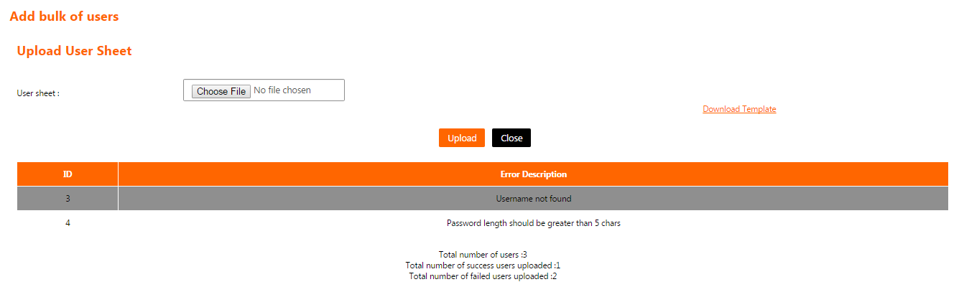
Figure 12: Add bulk of users Screen

Delete bulk of users Screen
The administrator will access this screen by clicking on the button “Delete Bulk” on “Users List Screen”.
This screen enables the administrator to delete a number of users in the system in one step.

- The administrator will press “Download Template” link to download an excel sheet that contains the required data to delete a number of users.

- The administrator will fill the sheet then click on the button “Choose File” and select the sheet file location.
  - Choosing any file which is not an excel sheet will give the following error message “Please choose a valid users excel sheet”.

- The administrator can press “Upload” button to delete the users from the system.
  - The system will validate the sheet records and delete the desired users from the system then show a summary about
    - Sheet errors description.
    - Total number of successfully deleted users.
    - Total number of failed users.

- The administrator can press “Close” button to return to “Users List Screen”.
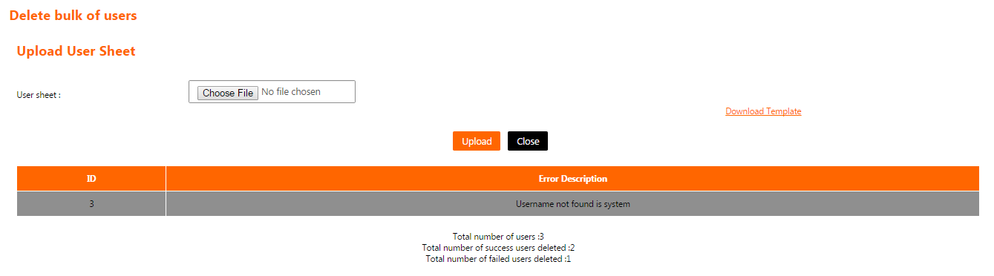
Figure 13: Delete bulk of users Screen

Edit User Screen
The administrator will access this screen by clicking on the link “Edit” on a specific user on the list on “Users List Screen”.
This screen enables the administrator to edit the data of an existing user in the system.

- The following fields are displayed and filled for the chosen user:
  - Email:
    - The E-Mail address of the system user.
    - It is a mandatory field.
    - The filled data must be in a valid E-Mail format.
  - Phone Number:
    - The phone number of the system user.
    - It is a mandatory field.
    - The filled data must be in a valid phone number.

- The administrator can press “Save” button to save the user data modifications and return to “Users List Screen”.

- The administrator can press “Close” button to cancel the user data modifications and return to “Users List Screen”.

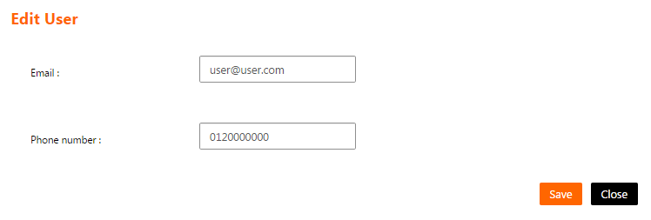
Figure 14: Edit User Screen

Reports section

Login Report
- The login report will show a list of all successful user logins.

- The administrator can filter the list using one or more of the following criteria
  - User: The name of the user who have made a successful logins.
  - Start/End Date: The start and end dates of the duration of successful logins.

- The administrator will click “Search” button
  - The system will show the message “No item found” if there is no result matching the filtration criteria.
  - The system will show the result list with the following fields
    - Name: The full name of the user.
    - Login Date: The date when the user made the login.
    - No of Logins: The number of times the user made the login in the specified Login Date.

- If the list contains more than 15 records, then it will be splitted into pages and each page will show 15 records. The administrator can navigate between list pages by clicking on the page number below the list.

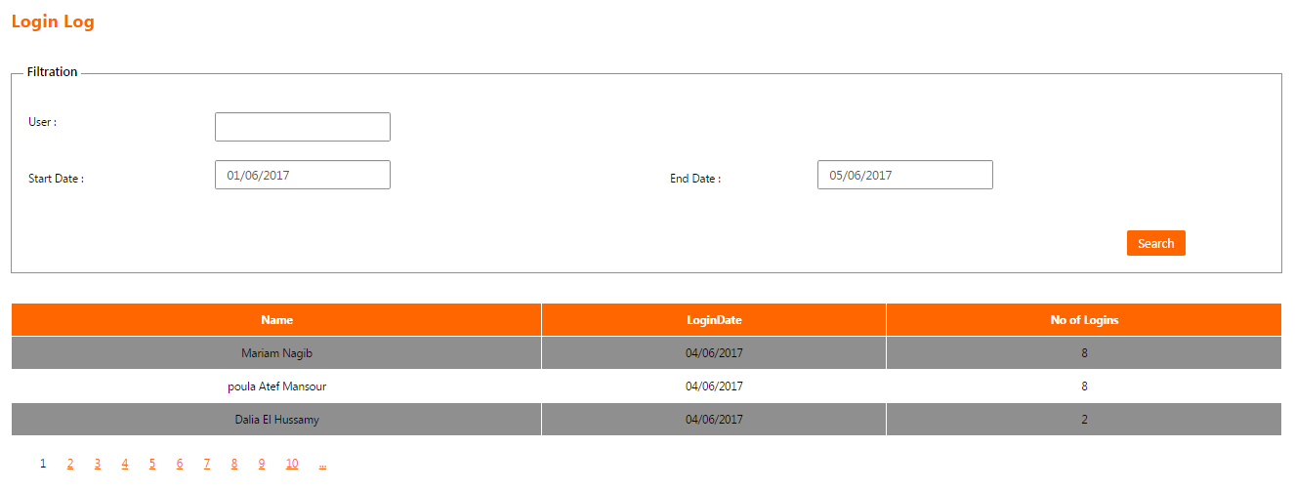
Figure 15: Login Report

Application Download Report
- This report will show a list of users who downloaded the mobile application on their mobile phones.

- The administrator can filter the list using the following criteria
  - Start/End Date: The start and end dates of the duration of application downloads.

- The administrator will click “Search” button
  - The system will show the message “No item found” if there is no result matching the filtration criteria.
  - The system will show the result list with the following fields
    - Description: The type of the mobile phone (IPhone - Android – Windows Phone - …).
    - Download Date: The date when the user downloaded the application.
    - Download Times: The number of times the users downloaded the application on the specified mobile phone type in the specified Download Date.

- If the list contains more than 15 records, then it will be splitted into pages and each page will show 15 records. The administrator can navigate between list pages by clicking on the page number below the list.

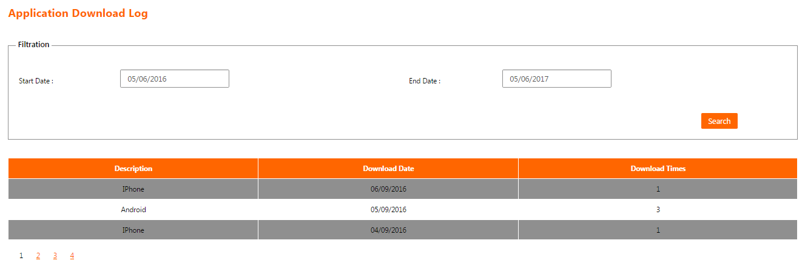
Figure 16: Application Download Report

System Menu (Channel Administrator)

Iknow application consists of 8 sections for the Channel Administrator.
- Privileges
- Function Content
- Orange Consumer (Orange Catalogue)
- Orange Business (Orange Catalogue)
- Orange (Orange Catalogue)
- Messages
- Reports
- Let's Play

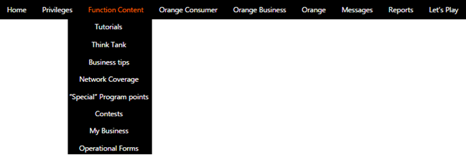

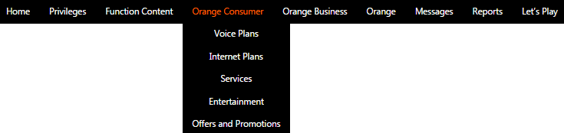

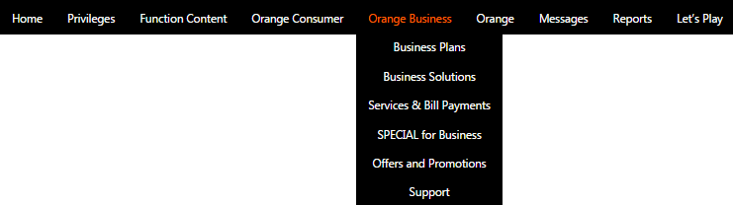
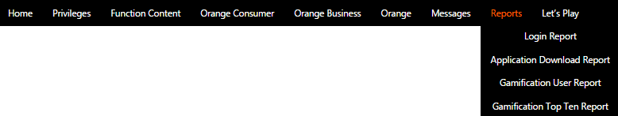

Figure 17: System Menu (Channel Administrator)

Privileges section

Channel List Screen
The channel administrator will access this screen by clicking on the menu (Privileges).
This screen shows a list of the channels that the current logged in user is an administrator on them and enables the channel administrator to manage them.

- The channels list have the following columns
  - Name: The name of the channel.
  - Functional Mail: The E-Mail address of the channel administrator.
  - Owner Channel: The name of the parent channel (If the channel is a sub-channel).

- List can be sorted by clicking on the column header.

- If the list contains more than 15 records, then it will be splitted into pages and each page will show 15 records. The channel administrator can navigate between list pages by clicking on the page number below the list.

- The channel administrator can filter the channel list by filling the following field and click on the button “Search”:
  - Name: To search using the name of the channel.

- The channel administrator can reset the list filtration by clicking on the button “Reset”. This will do the following
  - Clear the field “Name”.
  - Reload the page with list of the channels that the current logged in user is an administrator on them.

- The channel administrator can edit a channel by clicking on the link “Edit” on a specific channel on the list. This will open “Edit Channel screen”.

- Only sub-channels can be deleted by the channel administrator. The channel administrator can delete a sub-channel by clicking on the link “Delete” on a specific sub-channel on the list. Clicking this link will show the following confirmation message to the channel administrator “Are you sure to delete this sub-channel? (OK/Cancel)”. The channel administrator can click “OK” button to continue and delete the sub-channel or click “Cancel” button to cancel the operation.

- The channel administrator can manage the functions linked to a sub-channel by clicking on the link “Manage Function” on a specific channel on the list. This will open “Function List screen”.
  - The functions that are assigned to a sub-channel can be only one of the functions assigned to its parent channel.

- The channel administrator can manage the users inside a channel by clicking on the link “Manage Users” on a specific channel on the list. This will open “User List screen”.

- The channel administrator can add a sub-channel under a channel/sub-channel by clicking on the link “Add SubChannels” on a specific channel/sub-channel on the list. This will open “Add Channel screen”.
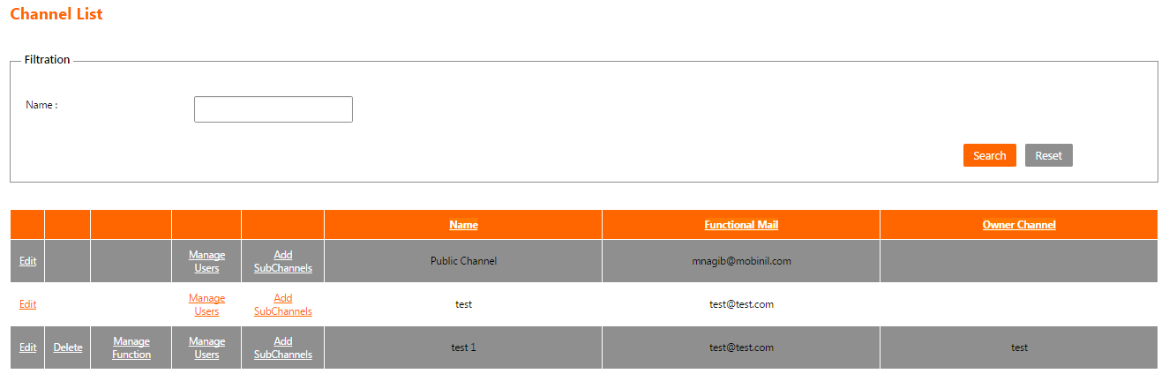
Figure 18: Channel List Screen

Edit Channel Screen
The channel administrator will access this screen by clicking on the link “Edit” on a specific channel on the list on “Channel List Screen”.
This screen enables the channel administrator to edit the data of an existing channel in the system.

- The following fields are displayed and filled for the chosen channel:
  - Name:
    - The name of the channel.
    - It is a mandatory field.
  - Functional mail:
    - The E-Mail address of the channel administrator.
    - It is a mandatory field.
    - The filled data must be in a valid E-Mail format.
  - Channel Administrator:
    - The user name of the channel administrator and cannot be changed.

- The channel administrator can press “Save” button to save the channel modifications and return to “Channel List Screen”.

- The channel administrator can press “Close” button to cancel the channel modifications and return to “Channel List Screen”.
Figure 19: Edit Channel Screen

Function List Screen
The channel administrator will access this screen by clicking on the link “Manage Function” on a specific sub-channel on the list on “Channel List Screen”.
This screen enables the channel administrator to manage the functions linked to a sub-channel in the system.

- The function list have the following columns
  - Name: The name of the function.
  - Is Public: Indicates whether this function is currently public or private in the system.

- List can be sorted by clicking on the column header.

- If the list contains more than 15 records, then it will be splitted into pages and each page will show 15 records. The channel administrator can navigate between list pages by clicking on the page number below the list.

- The channel administrator can assign a function to this channel by clicking on the button “Add”. This will open “Add Function screen”.

- The button “Add” will be hidden if all the allowed functions in the system is already linked to the current sub-channel.

- The channel administrator can delete a “function link” to this sub-channel by clicking on the link “Delete” on a specific function on the list. Clicking this link will show the following confirmation message to the channel administrator “Are you sure you want delete this record and all related data? (OK/Cancel)”. The channel administrator can click “OK” button to continue and delete the “function link” to this sub-channel or click “Cancel” button to cancel the operation.

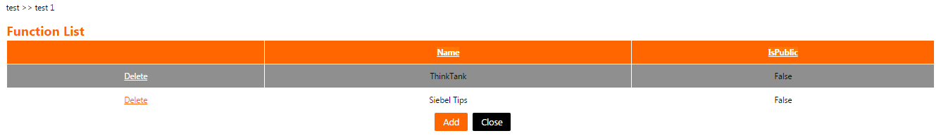
- The channel administrator can press “Close” button to cancel the function links modifications and return to “Channel List Screen”.

Figure 20: Function List Screen

Add Function Screen
The channel administrator will access this screen by clicking on the button “Add” on “Function List Screen”.
This screen enables the channel administrator to link a function to a sub-channel in the system.

- The following fields are displayed for the function link:
  - Function:
    - A list that contains the functions linked to the parent channel but not linked to the current sub-channel.
    - It is a mandatory field.

- The sub-channel will inherit the same link type (Public/Private) of the function with the parent channel and cannot be changed on the sub-channel level.

- The channel administrator can press “Add” button to save the function link and return to “Function List Screen”.

- The channel administrator can press “Close” button to cancel the link creation and return to “Function List Screen”.

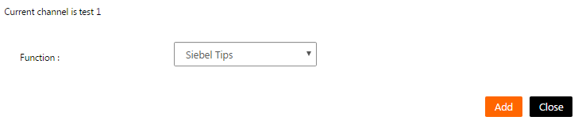
Figure 21: Add Function Screen

Users List Screen
The channel administrator will access this screen by clicking on the link “Manage Users” on a specific channel on the list on “Channel List Screen”. This screen will show all the users within the channel and enables the channel administrator to manage them.

- The users list have the following columns
  - Name: The full name of the system user.
  - Email: The E-Mail address of the system user.

- List can be sorted by clicking on the column header.

- If the list contains more than 15 records, then it will be splitted into pages and each page will show 15 records. The channel administrator can navigate between list pages by clicking on the page number below the list.

- The channel administrator can add a number of users in one step by clicking on the button “Add Bulk”. This will open “Upload User Sheet screen”.

- The channel administrator can remove a specific user from this channel by clicking on the link “Delete” on a specific user on the list. Clicking this link will show the following confirmation message to the channel administrator “Are you sure you want delete this record? (OK/Cancel)”. The channel administrator can click “OK” button to continue and remove the user from this channel or click “Cancel” button to cancel the operation.

- The channel administrator can press “Close” button to return to “Channel List Screen”.

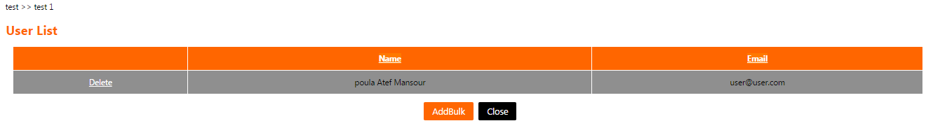

Figure 22: Users List Screen

Upload User Sheet Screen
The channel administrator will access this screen by clicking on the button “Add Bulk” on “Users List Screen”.
This screen enables the channel administrator to add a number of users in the system to a specific channel in one step.

- The channel administrator will press “Download Template” link to download an excel sheet that contains the required data of the users to add them to the current channel.

- The channel administrator will fill the sheet then click on the button “Choose File” and select the sheet file location.
  - Choosing any file which is not an excel sheet will give the following error message “Please choose a valid users excel sheet”.

- The channel administrator can press “Add” button
  - The system will validate the sheet records and adds the users on the sheet to the current channel on the system then shows a summary about
    - Sheet errors description.
    - Total number of successfully uploaded users.
    - Total number of failed users.

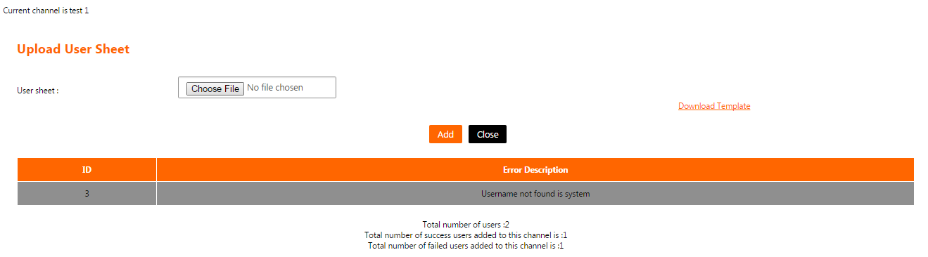
- The channel administrator can press “Close” button to return to “Users List Screen”.
Figure 23: Upload User Sheet Screen

Add Channel Screen
The channel administrator will access this screen by clicking on the link “Add Sub Channels” on a specific channel/sub-channel on the list on “Channel List Screen”.
This screen enables the channel administrator to add a sub-channel in the system.

- The following fields are displayed for the new sub-channel:
  - Name:
    - The name of the sub-channel.
    - It is a mandatory field.
  - Functional mail:
    - The E-Mail address of the sub-channel administrator.
    - It is a mandatory field.
    - The filled data must be in a valid E-Mail format.
  - Channel Administrator:
    - The user name of the sub-channel administrator.
    - It is a mandatory field.
    - This field is auto complete. The channel administrator can fill the first few characters of the desired user name, then a list will be shown with the suggested user names that starts with the entered characters.

- The channel administrator can press “Save” button to save the sub-channel and return to “Channel List Screen”.

- The channel administrator can press “Close” button to cancel the sub-channel creation and return to “Channel List Screen”.

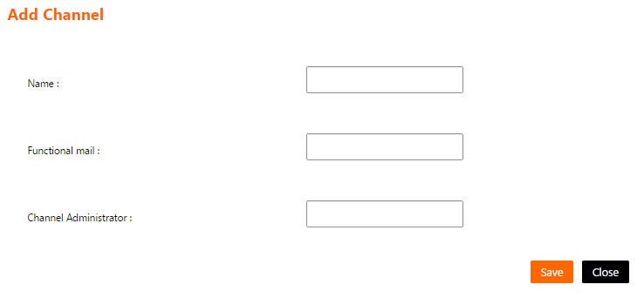

Figure 24: Add Channel Screen

Functions -> Tutorials List Screen
The channel administrator will access this screen by clicking on the menu (Function Content -> Tutorials).
This screen shows a list of Tutorials function contents and enables the channel administrator to manage them.

- The tutorials list have the following columns
  - Title: The title of the tutorial.
  - Description: The description of the tutorial.
  - Type: The type of the tutorial (Commercial - Sales).
  - Channel Name: The name of the channel linked to tutorials function and owns this tutorial.

- List can be sorted by clicking on the column header.

- If the list contains more than 15 records, then it will be splitted into pages and each page will show 15 records. The channel administrator can navigate between list pages by clicking on the page number below the list.

- The channel administrator can filter the tutorials list by filling one or more of the following fields and click on the button “Search”:
  - Search Text: To search using the tutorial’s title.
  - Channel Name: To search using the tutorial’s channel name.
  - Tutorial Type: To search using the tutorial’s type (Commercial - Sales).

- The channel administrator can reset the list filtration by clicking on the button “Reset”. This will do the following
  - Clear the fields "Search Text", "Channel Name" and "Tutorial Type".
  - Reload the page with all the tutorials.

- The channel administrator can add a tutorial by clicking on the button “Add”. This will open “Add Tutorials screen”.

- The channel administrator can edit a tutorial by clicking on the link “Edit” on a specific tutorial on the list. This will open “Edit Tutorials screen”.

- The channel administrator can delete a tutorial by clicking on the link “Delete” on a specific tutorial on the list. Clicking this link will show the following confirmation message to the channel administrator “Are you sure to delete this record? (OK/Cancel)”. The channel administrator can click “OK” button to continue and delete the tutorial or click “Cancel” button to cancel the operation.

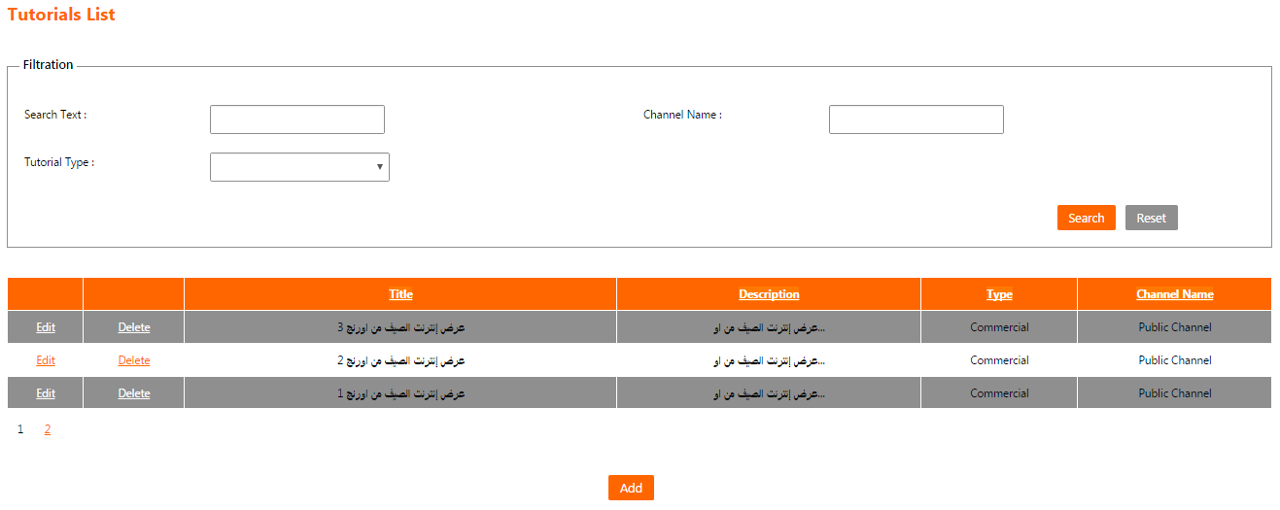
Figure 25: Tutorials List Screen

Add Tutorials Screen
The channel administrator will access this screen by clicking on the button “Add” on “Tutorials List Screen”.
This screen enables the channel administrator to add contents in tutorials function in the system.
- The following fields are displayed for the new tutorial:
  - Channel Name:
    - A list of channels linked to tutorials function and the current logged in user is administrator on them.
    - It is a mandatory field.
  - Name:
    - The title of the tutorial.
    - It is a mandatory field.
  - Description:
    - The description of the tutorial.
    - It is an optional field.
  - Tutorial Type:
    - The type of the tutorial.
    - It is a mandatory field.
    - It is a list that contains the choices (Commercial - Sales).
  - Push notification:
    - If checked, then a push notification will be sent to all users within the specified channel that a new tutorial had been added.

- The channel administrator can press “Add” button to save the tutorial and return to “Tutorials List Screen”.

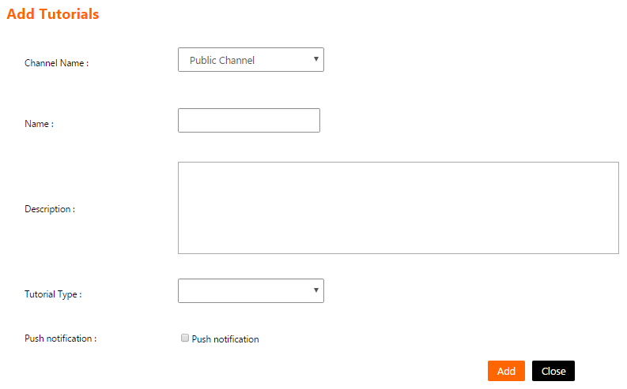
- The channel administrator can press “Close” button to cancel the tutorial creation and return to “Tutorials List Screen”.
Figure 26: Add Tutorials Screen

Edit Tutorials Screen
The channel administrator will access this screen by clicking on the link “Edit” on a specific tutorial on the list on “Tutorials List Screen”.
This screen enables the channel administrator to edit a specific content in tutorial function in the system.

- The following fields are displayed and filled for the chosen tutorial:
  - Channel Name:
    - A list of channels linked to tutorials function and the current logged in user is administrator on them.
    - It is a mandatory field.
  - Name:
    - The title of the tutorial.
    - It is a mandatory field.
  - Description:
    - The description of the tutorial.
    - It is an optional field.
  - Tutorial Type:
    - The type of the tutorial.
    - It is a mandatory field.
    - It is a list that contains the choices (Commercial - Sales).
  - YouTube URL:
    - The URL of the tutorial video on YouTube.
    - It is a mandatory field.
    - Must be a valid YouTube URL.
  - Push notification:
    - If checked, then a push notification will be sent to all users within the specified channel that this tutorial had been updated.

- The channel administrator can press “Update” button to save the tutorial modifications and return to “Tutorials List Screen”.

- The channel administrator can press “Close” button to cancel the tutorial modifications and return to “Tutorials List Screen”.

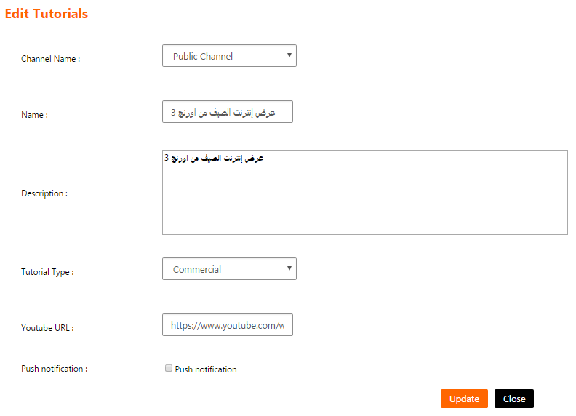
Figure 27: Edit Tutorials Screen

Functions -> Think Tank Item List Screen
The channel administrator will access this screen by clicking on the menu (Function Content -> Think Tank).
This screen shows a list of Think Tank function contents and enables the channel administrator to manage them.

- The think tank item list have the following columns
  - Idea Name: The name of the idea that the end user posted.
  - Main Concept: The main concept of the idea that the end user posted.
  - Area Development: The development area of the idea that the end user posted.
  - Post Date: The date that the end user posted the idea on the mobile application.

- List can be sorted by clicking on the column header.

- If the list contains more than 15 records, then it will be splitted into pages and each page will show 15 records. The channel administrator can navigate between list pages by clicking on the page number below the list.

- The channel administrator can filter the think tank item list by filling one or more of the following fields and click on the button “Search”:
  - Idea Name: To search using the name of the idea.
  - Channel Name: To search using the channel name of think tank function.

- The channel administrator can reset the list filtration by clicking on the button “Reset”. This will do the following
  - Clear the fields "Idea Name” and "Channel Name".
  - Reload the page with all the posted ideas.

- The channel administrator can delete an idea by clicking on the link “Delete” on a specific idea on the list. Clicking this link will show the following confirmation message to the channel administrator “Are you sure to delete this record? (OK/Cancel)”. The channel administrator can click “OK” button to continue and delete the idea or click “Cancel” button to cancel the operation.

- The channel administrator view full details about an idea by clicking on the link “View Details” on a specific idea on the list. This will open “Think Tank Item Details Screen”.

- The channel administrator can press “Close” button to return to the “Landing page”.

- The channel administrator can modify the text displayed to the end user on the mobile application under the tab “What's Think Tank” by editing the text in the field “Mobile Text” then click the button “Update”. The following message will be displayed “Mobile text updated successfully”.

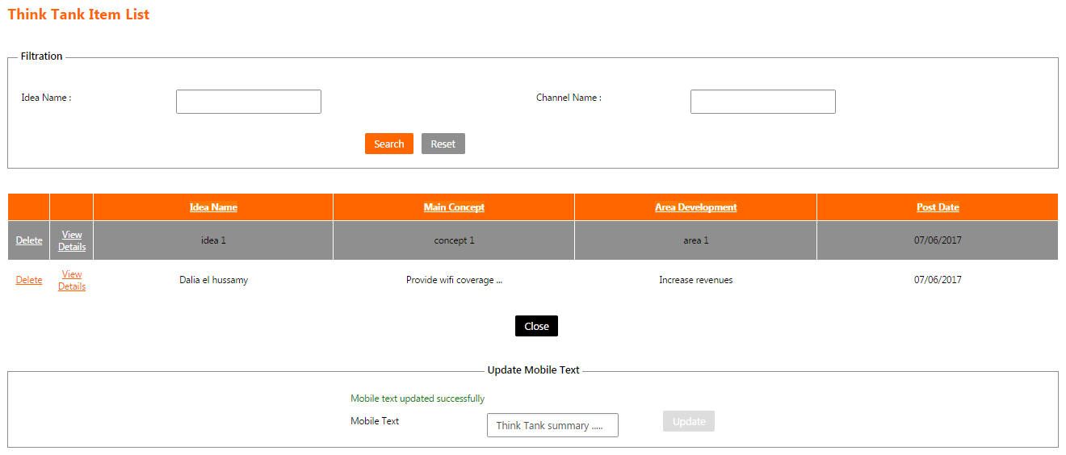
Figure 28: Think Tank Item List Screen

Think Tank Item Details Screen
The channel administrator will access this screen by clicking on the link “View Details” on a specific idea on the list on “Think Tank Item List Screen”.
This screen enables the channel administrator to view full details about an idea posted by an end user on the mobile application. The data is not editable.
- The following fields are displayed for the idea (All fields cannot be changed):
  - Idea Name: The name of the idea that the end user posted.
  - Main Concept: The main concept of the idea that the end user posted.
  - Expected For Orange: The expected value in return for Orange.
  - Expected For Customer: The expected value in return for Orange customers.
  - Area For Development: The development area of the idea that the end user posted.

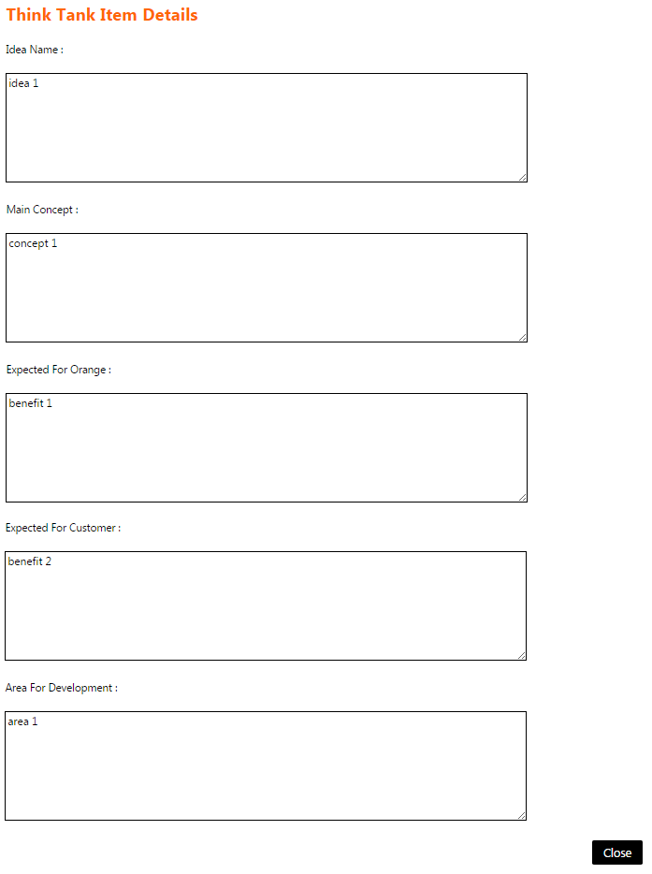
- The channel administrator can press “Close” button to return to “Think Tank Item List Screen”.
Figure 29: Think Tank Item Details Screen

Functions -> Business tips List Screen
The channel administrator will access this screen by clicking on the menu (Function Content -> Business tips).
This screen shows a list of Business tips function contents and enables the channel administrator to manage them.

- The business tips list have the following columns
  - Title: The title of the business tip.
  - Description: The description of the business tip.
  - Channel Name: The name of the channel linked to business tips function and owns this business tip.

- List can be sorted by clicking on the column header.

- If the list contains more than 15 records, then it will be splitted into pages and each page will show 15 records. The channel administrator can navigate between list pages by clicking on the page number below the list.

- The channel administrator can filter the business tips list by filling one or more of the following fields and click on the button “Search”:
  - Search Text: To search using the business tip’s title.
  - Channel Name: To search using the business tip’s channel.

- The channel administrator can reset the list filtration by clicking on the button “Reset”. This will do the following
  - Clear the fields "Search Text" and "Channel Name".
  - Reload the page with all the business tips.

- The channel administrator can add a business tip by clicking on the button “Add”. This will open “Add Business tips screen”.

- The channel administrator can edit a business tip by clicking on the link “Edit” on a specific business tip on the list. This will open “Edit Business tips screen”.

- The channel administrator can view sub-business tips by clicking on the link “View Subcategory” on a specific business tip on the list. This will open “Business tips List screen”.

- A business tip can be deleted only if it doesn’t have sub-business tips. The channel administrator can delete a business tip by clicking on the link “Delete” on a specific business tip on the list. Clicking this link will show the following confirmation message to the channel administrator “Are you sure to delete this record? (OK/Cancel)”. The channel administrator can click “OK” button to continue and delete the business tip or click “Cancel” button to cancel the operation.

- The channel administrator can add sub-business tips by clicking on the link “Add Subcategory” on a specific business tip on the list. This will open “Add Business tips screen”.

- The channel administrator can manage files attached to a sub-business tip by clicking on the link “View Items” on a specific sub-business tip on the list. This will open “Business tips Topic List screen”.

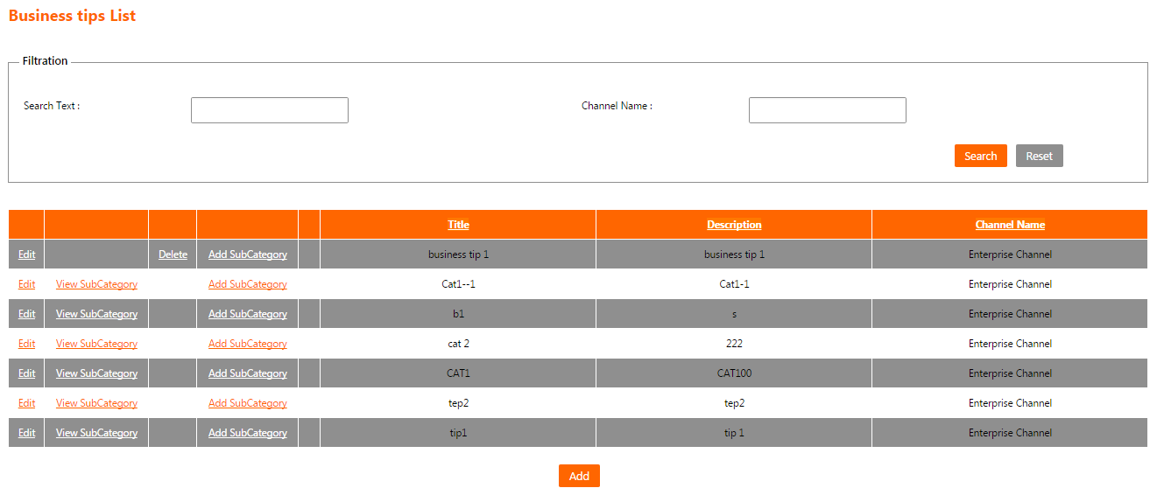
Figure 30: Business tips List Screen

Add Business tips Screen
The channel administrator will access this screen by clicking on the button “Add” on “Business tips List Screen”.
This screen enables the channel administrator to add contents in Business tips function in the system.

- The following fields are displayed for the new business tip:
  - Channel Name:
    - A list of channels linked to business tips function and the current logged in user is administrator on them.
    - It is a mandatory field.
  - Name:
    - The name of the business tip.
    - It is a mandatory field.
  - Description:
    - The description of the business tip.
    - It is an optional field.

- The channel administrator can press “Add” button to save the business tip and return to “Business tips List Screen”.

- The channel administrator can press “Close” button to cancel the business tip creation and return to “Business tips List Screen”.

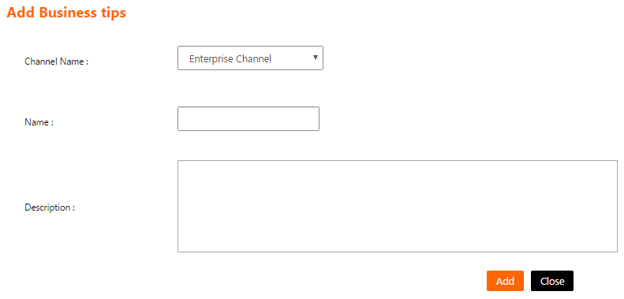
Figure 31: Add Business tips Screen

Edit Business tips Screen
The channel administrator will access this screen by clicking on the link “Edit” on a specific business tip on the list on “Business tips List Screen”.
This screen enables the channel administrator to edit a specific content in Business tips function in the system.

- The following fields are displayed and filled for the chosen business tip:
  - Channel Name:
    - A list of channels linked to business tips function and the current logged in user is administrator on them.
    - It is a mandatory field.
  - Name:
    - The title of the business tip.
    - It is a mandatory field.
  - Description:
    - The description of the business tip.
    - It is an optional field.

- The channel administrator can press “Update” button to save the business tip modifications and return to “Business tips List Screen”.

- The channel administrator can press “Close” button to cancel the business tip modifications and return to “Business tips List Screen”.
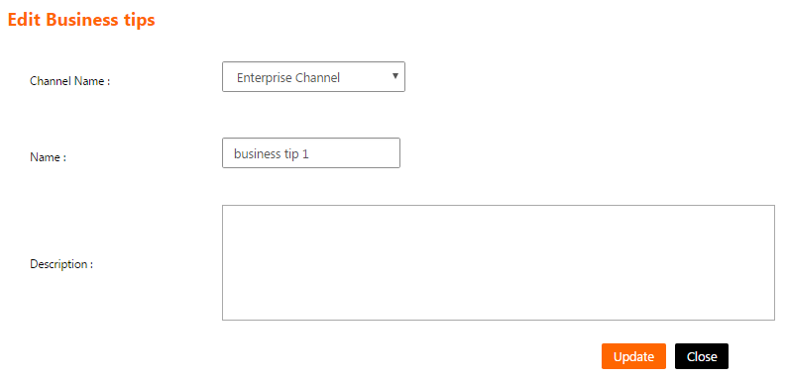
Figure 32: Edit Business tips Screen

Business tips Topic List Screen
The channel administrator will access this screen by clicking on the link “View Items” on a specific business tip on the list on “Business tips List Screen”.
This screen shows a list of files attached to a specific sub-business tip and enables the channel administrator to manage them.

- The business tip’s files list have the following columns
  - Title: The title of the business tip’s file.
  - Description: The description of the business tip’s file.

- List can be sorted by clicking on the column header.

- If the list contains more than 15 records, then it will be splitted into pages and each page will show 15 records. The channel administrator can navigate between list pages by clicking on the page number below the list.

- The channel administrator can filter the business tip files list by filling the following field and click on the button “Search”:
  - Search Text: To search using the business tip’s file title.

- The channel administrator can reset the list filtration by clicking on the button “Reset”. This will do the following
  - Clear the field "Search Text".
  - Reload the page with all the business tip’s files.

- The channel administrator can add a business tip’s file by clicking on the button “Add”. This will open “Add Business tips Item screen”.

- The channel administrator can edit a business tip’s file by clicking on the link “Edit” on a specific business tip’s file on the list. This will open “Edit Business tips Item screen”.

- The channel administrator can delete a business tip’s file by clicking on the link “Delete” on a specific business tip’s file on the list. Clicking this link will show the following confirmation message to the channel administrator “Are you sure to delete this record? (OK/Cancel)”. The channel administrator can click “OK” button to continue and delete the business tip’s file or click “Cancel” button to cancel the operation.

- The channel administrator can press “Close” button to return to “Business tips List Screen”.
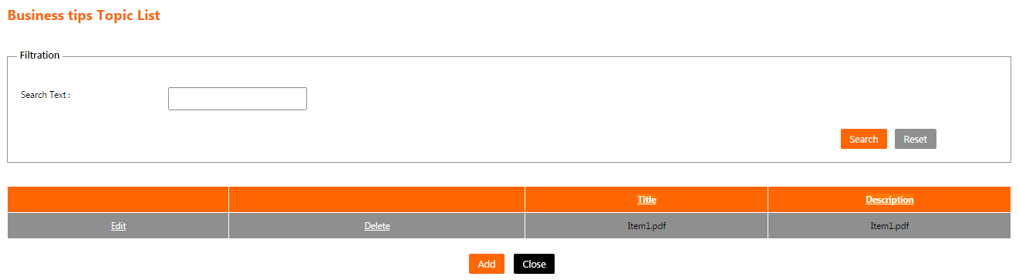
Figure 33: Business tips Topic List Screen

Add Business tips Item Screen
The channel administrator will access this screen by clicking on the button “Add” on “Business tips Topic List Screen”.
This screen enables the channel administrator to add a file for a business tip in the system.

- The following fields are displayed for the new business tip’s file:
  - Name:
    - The name of the business tip’s file.
    - It is a mandatory field.
  - Description:
    - The description of the business tip’s file.
    - It is a mandatory field.
  - File:
    - The file to be attached to this business tip.
    - It is an optional field.
  - Push notification:
    - If checked, then a push notification will be sent to all users within the specified channel that a new file had been added.

- The channel administrator can press “Add” button to save the business tip’s file and return to “Business tips Topic List screen”.

- The channel administrator can press “Close” button to cancel the business tip’s file adding and return to “Business tips Topic List screen”.

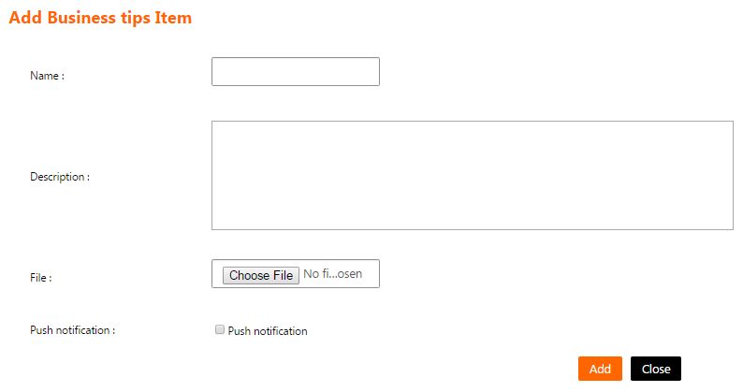
Figure 34: Add Business tips Item Screen

Edit Business tips Item Screen
The channel administrator will access this screen by clicking on the link “Edit” on a specific business tip’s file on the list on “Business tips Topic List Screen”.
This screen enables the channel administrator to change the data of a file for a business tip in the system.

- The following fields are displayed and filled for the chosen business tip’s file:
  - Name:
    - The name of the business tip’s file.
    - It is a mandatory field.
  - Description:
    - The description of the business tip’s file.
    - It is a mandatory field.
  - File:
    - The file to be attached to this business tip.
    - It is an optional field.
  - Push notification:
    - If checked, then a push notification will be sent to all users within the specified channel that the file had been updated.

- The channel administrator can press “Update” button to save the business tip’s file modifications and return to “Business tips Topic List screen”.

- The channel administrator can press “Close” button to cancel the business tip’s file modifications and return to “Business tips Topic List screen”.
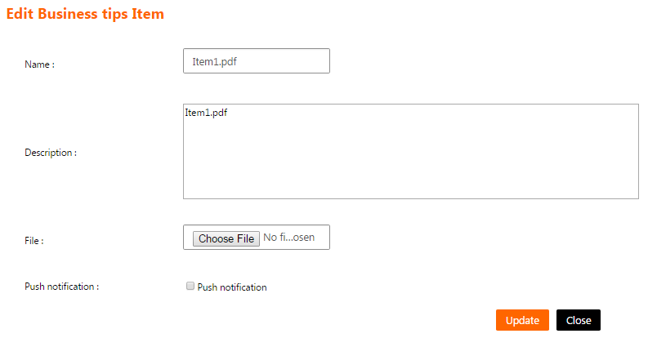
Figure 35: Edit Business tips Item Screen

Functions -> Network Coverage Category List Screen
The channel administrator will access this screen by clicking on the menu (Function Content -> Network Coverage).
This screen shows a list of Network Coverage function contents and enables the channel administrator to manage them.

- The network coverage category list have the following columns
  - Name: The name of the network coverage category.
  - Description: The description of the network coverage category.

- List can be sorted by clicking on the column header.

- If the list contains more than 15 records, then it will be splitted into pages and each page will show 15 records. The channel administrator can navigate between list pages by clicking on the page number below the list.

- The channel administrator can filter the network coverage category list by filling the following field and click on the button “Search”:
  - Name: To search using the network coverage category’s name.

- The channel administrator can reset the list filtration by clicking on the button “Reset”. This will do the following
  - Clear the field "Name".
  - Reload the page with all the network coverage categories.

- The channel administrator can add a network coverage category by clicking on the button “Add”. This will open “Add Network Coverage Category screen”.

- The channel administrator can edit a network coverage category by clicking on the link “Edit” on a specific network coverage category on the list. This will open “Edit Network Coverage Category screen”.

- The channel administrator can view network coverage sub-categories by clicking on the link “View Subcategory” on a specific network coverage category on the list. This will open “Network Coverage Category List screen”.

- A network coverage category can be deleted only if it doesn’t have sub-categories. The channel administrator can delete a network coverage category by clicking on the link “Delete” on a specific network coverage category on the list. Clicking this link will show the following confirmation message to the channel administrator “Are you sure to delete this record? (OK/Cancel)”. The channel administrator can click “OK” button to continue and delete the network coverage category or click “Cancel” button to cancel the operation.

- The channel administrator can add a network coverage sub-category by clicking on the link “Add Subcategory” on a specific network coverage category on the list. This will open “Add Network Coverage Category screen”.

- The channel administrator can manage files attached to a network coverage sub-category by clicking on the link “View Items” on a specific network coverage sub-category on the list. This will open “Network Coverage List screen”.

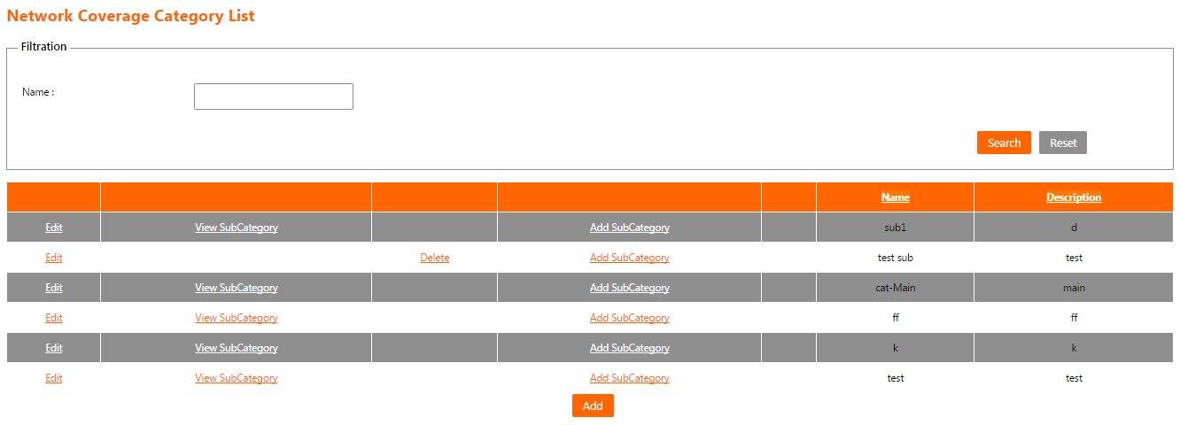
Figure 36: Network Coverage Category List Screen

Add Network Coverage Category Screen
The channel administrator will access this screen by clicking on the button “Add” on “Network Coverage Category List Screen”.
This screen enables the channel administrator to add a content in network coverage function in the system.

- The following fields are displayed for the new network coverage category:
  - Channel Name:
    - A list of channels linked to network coverage function and the current logged in user is administrator on them.
    - It is a mandatory field.
  - Name:
    - The name of the network coverage category.
    - It is a mandatory field.
  - Description:
    - The description of the network coverage category.
    - It is a mandatory field.

- The channel administrator can press “Save” button to save the network coverage category and return to “Network Coverage Category List Screen”.

- The channel administrator can press “Close” button to cancel the network coverage category creation and return to “Network Coverage Category List Screen”.

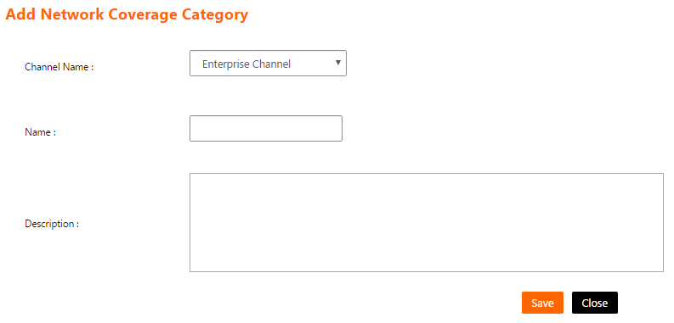
Figure 37: Add Network Coverage Category Screen

Edit Network Coverage Category Screen
The channel administrator will access this screen by clicking on the link “Edit” on a specific network coverage category on the list on “Network Coverage Category List Screen”.
This screen enables the channel administrator to edit a content in network coverage function in the system.

- The following fields are displayed and filled for the chosen network coverage category:
  - Channel Name:
    - A list of channels linked to network coverage function and the current logged in user is administrator on them.
    - It is a mandatory field.
  - Name:
    - The name of the network coverage category.
    - It is a mandatory field.
  - Description:
    - The description of the network coverage category.
    - It is a mandatory field.

- The channel administrator can press “Save” button to save the network coverage category modifications and return to “Network Coverage Category List Screen”.

- The channel administrator can press “Close” button to cancel the network coverage category modifications and return to “Network Coverage Category List Screen”.
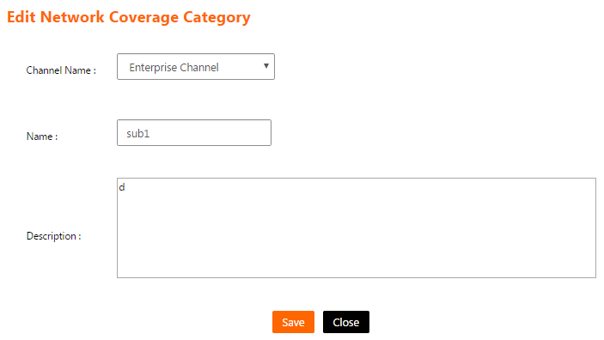
Figure 38: Edit Network Coverage Category Screen

Network Coverage List Screen
The channel administrator will access this screen by clicking on the link “View Items” on a specific network coverage sub-category on the list on “Network Coverage Category List screen”.
This screen shows a list of files attached to a specific network coverage category and enables the channel administrator to manage them.

- The network coverage category’s files list have the following columns
  - Title: The title of the network coverage category’s file.
  - Description: The description of the network coverage category’s file.

- List can be sorted by clicking on the column header.

- If the list contains more than 15 records, then it will be splitted into pages and each page will show 15 records. The channel administrator can navigate between list pages by clicking on the page number below the list.

- The channel administrator can filter the network coverage category’s files list by filling the following field and click on the button “Search”:
  - Title: To search using the network coverage category’s file title.

- The channel administrator can reset the list filtration by clicking on the button “Reset”. This will do the following
  - Clear the field "Title".
  - Reload the page with all the network coverage category’s files.

- The channel administrator can add a network coverage category’s file by clicking on the button “Add”. This will open “Add Network Coverage Item screen”.

- The channel administrator can edit a network coverage category’s file by clicking on the link “Edit” on a specific network coverage category’s file on the list. This will open “Edit Network Coverage Item screen”.

- The channel administrator can delete a network coverage category’s file by clicking on the link “Delete” on a specific network coverage category’s file on the list. Clicking this link will show the following confirmation message to the channel administrator “Are you sure to delete this record? (OK/Cancel)”. The channel administrator can click “OK” button to continue and delete the network coverage category’s file or click “Cancel” button to cancel the operation.

- The channel administrator can press “Close” button to return to “Network Coverage Category List Screen”.

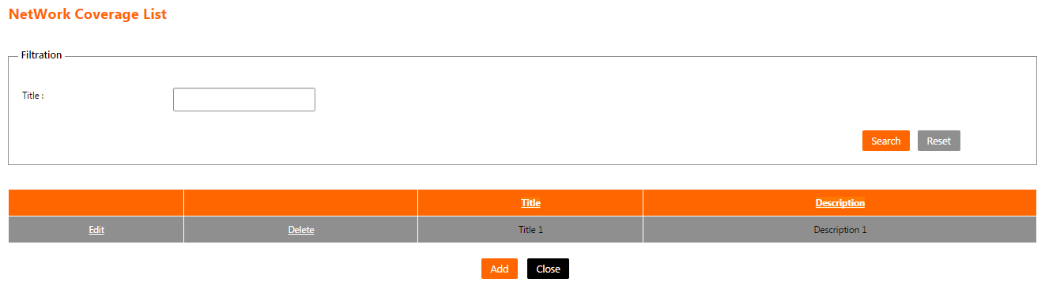

Figure 39: Network Coverage List Screen

Add Network Coverage Item Screen
The channel administrator will access this screen by clicking on the button “Add” on “Network Coverage List Screen”.
This screen enables the channel administrator to add file for a network coverage category in the system.

- The following fields are displayed for the new network coverage category’s file:
  - Title:
    - The title of the network coverage category’s file.
    - It is a mandatory field.
  - Description:
    - The description of the network coverage category’s file.
    - It is a mandatory field.
  - File:
    - The file to be attached to this network coverage category.
    - It is a mandatory field.
  - Push notification:
    - If checked, then a push notification will be sent to all users within the specified channel that a new file had been added.

- The channel administrator can press “Save” button to save the network coverage category’s file and return to “Network Coverage List screen”.

- The channel administrator can press “Close” button to cancel the network coverage category’s file adding and return to “Network Coverage List screen”.

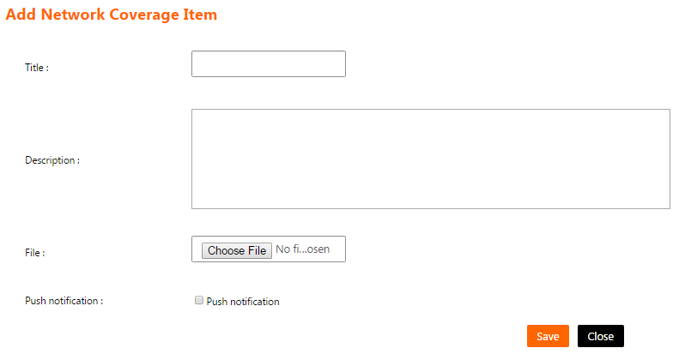
Figure 40: Add Network Coverage Item Screen

Edit Network Coverage Item Screen
The channel administrator will access this screen by clicking on the link “Edit” on a specific network coverage category’s file on the list on “Network Coverage List Screen”.
This screen enables the channel administrator to change the data of a file for a network coverage category in the system.

- The following fields are displayed and filled for the chosen network coverage category’s file:
  - Title:
    - The title of the network coverage category’s file.
    - It is a mandatory field.
  - Description:
    - The description of the network coverage category’s file.
    - It is a mandatory field.
  - File:
    - The file to be attached to this network coverage category.
    - It is an optional field.
  - Push notification:
    - If checked, then a push notification will be sent to all users within the specified channel that the file had been updated.

- The channel administrator can press “Save” button to save the network coverage category’s file modifications and return to “Network Coverage List screen”.

- The channel administrator can press “Close” button to cancel the network coverage category’s file modifications and return to “Network Coverage List screen”.

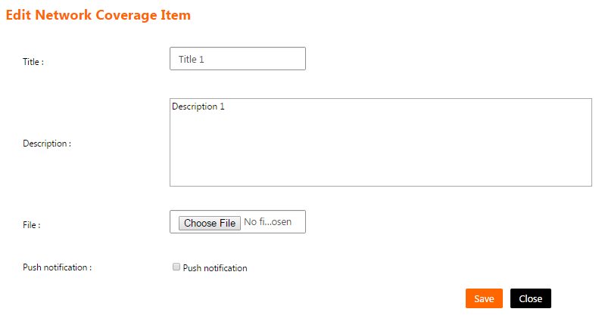
Figure 41: Edit Network Coverage Item Screen

Functions -> “special” Program points Screen
The channel administrator will access this screen by clicking on the menu (Function Content -> “Special” Program points).
This screen shows a list of “Special” Program points function contents and enables the channel administrator to manage them.

- The “Special“ Program points list have the following columns
  - Title: The title of the “Special” program points.
  - Description: The description of the “special” program points.
  - Channel Name: The name of the channel linked to “special” program points function and owns this “special” program points.

- List can be sorted by clicking on the column header.

- If the list contains more than 15 records, then it will be splitted into pages and each page will show 15 records. The channel administrator can navigate between list pages by clicking on the page number below the list.

- The channel administrator can filter the “Special” program points list by filling one or more of the following fields and click on the button “Search”:
  - Search Text: To search using the “Special” program points’ title.
  - Channel Name: To search using the “Special” program points’ channel.

- The channel administrator can reset the list filtration by clicking on the button “Reset”. This will do the following
  - Clear the fields "Search Text" and "Channel Name".
  - Reload the page with all the “Special” program points.

- The channel administrator can add a “Special” program points by clicking on the button “Add”. This will open “Add “Special” Program points screen”.

- The channel administrator can edit a “Special” program points by clicking on the link “Edit” on a specific “Special” program points on the list. This will open “Edit “Special” Program points screen”.

- The channel administrator can delete a “Special” program points by clicking on the link “Delete” on a specific “Special” program points on the list. Clicking this link will show the following confirmation message to the channel administrator “Are you sure to delete this record? (OK/Cancel)”. The channel administrator can click “OK” button to continue and delete the “Special” program points or click “Cancel” button to cancel the operation.

- The channel administrator can manage suppliers by clicking on the button “View Suppliers”. This will open “Supplier List screen”.
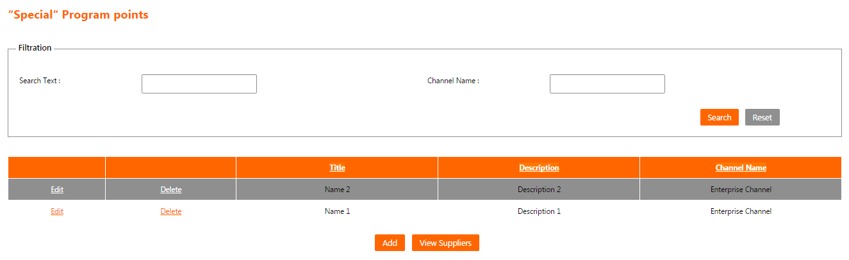
Figure 42: “special” Program points Screen

Add “Special” Program points Screen
The channel administrator will access this screen by clicking on the button “Add” on “Special” Program points Screen.
This screen enables the channel administrator to add a content in “Special” program points function in the system.

- The following fields are displayed for the new “Special” program points:
  - Channel Name:
    - A list of channels linked to “Special” program points function and the current logged in user is administrator on them.
    - It is a mandatory field.
  - Name:
    - The name of the “Special” program points.
    - It is a mandatory field.
  - Description:
    - The description of the “Special” program points.
    - It is a mandatory field.
  - Category Name:
    - The category of the “Special” program points.
    - It is a mandatory field.
    - It is a list that contains the choices (Individual - Corporate).
  - Type Name:
    - The type of the “Special” program points.
    - It is a mandatory field.
    - It is a list that contains the choices (Dial - Account).
  - Points:
    - The points of the “Special” program points.
    - It is a mandatory field.
    - It must be a numeric value with no fractions.

- The channel administrator can press “Add” button to save the “Special” program points and return to “Special” program points Screen.

- The channel administrator can press “Close” button to cancel the “Special” program points creation and return to “Special” program points Screen.

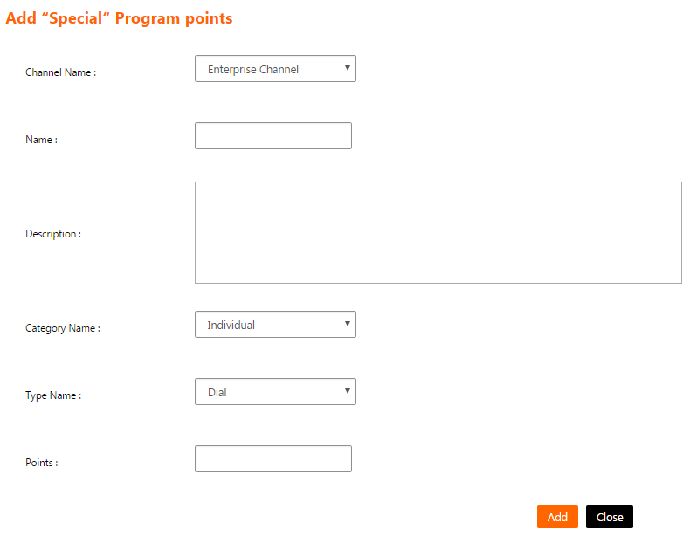
Figure 43: Add “Special” Program points Screen

Edit “Special” Program points Screen
The channel administrator will access this screen by clicking on the link “Edit” on a specific “Special” program points on the list on “Special” Program points Screen.
This screen enables the channel administrator to edit a content in “Special” program points function in the system.

- The following fields are displayed and filled for the chosen “Special” program points:
  - Channel Name:
    - A list of channels linked to “Special” program points function and the current logged in user is administrator on them.
    - It is a mandatory field.
  - Name:
    - The name of the “Special” program points.
    - It is a mandatory field.
  - Description:
    - The description of the “Special” program points.
    - It is a mandatory field.
  - Category Name:
    - The category of the “Special” program points.
    - It is a mandatory field.
    - It is a list that contains the choices (Individual - Corporate).
  - Type Name:
    - The type of the “Special” program points.
    - It is a mandatory field.
    - It is a list that contains the choices (Dial - Account).
  - Points:
    - The points of the “Special” program points.
    - It is a mandatory field.
    - It must be a numeric value with no fractions.

- The channel administrator can press “Update” button to save the “Special” program points modifications and return to “Special” program points Screen.

- The channel administrator can press “Close” button to cancel the “Special” program points modifications and return to “Special” program points Screen.
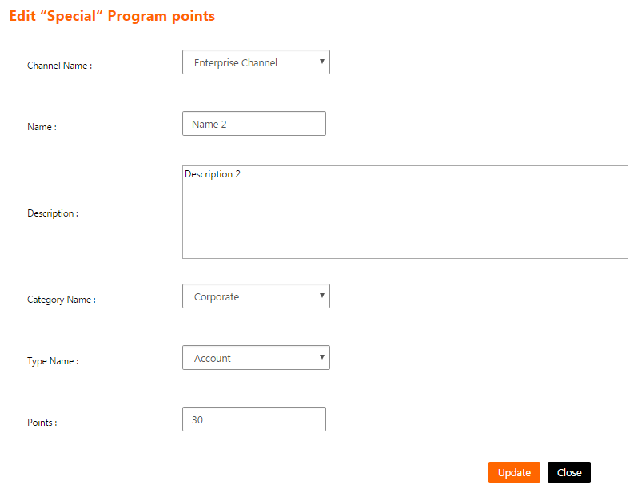
Figure 44: Edit “Special” Program points Screen

Supplier List Screen
The channel administrator will access this screen by clicking on the button “View Suppliers” on “Special” Program points Screen.
This screen shows a list of currently defined suppliers in the system that will be shown to the end users on the mobile application and enables the channel administrator to manage them.

- The suppliers list have the following columns
  - Name: The name of the supplier.
  - Address: The supplier’s web site address.
  - Phone: The phone number of the supplier.
  - Created by: The full name of the user who added this supplier on the system.

- List can be sorted by clicking on the column header.

- If the list contains more than 15 records, then it will be splitted into pages and each page will show 15 records. The channel administrator can navigate between list pages by clicking on the page number below the list.

- The channel administrator can filter the suppliers list by filling the following field and click on the button “Search”:
  - Name: To search using the name of the supplier.

- The channel administrator can reset the list filtration by clicking on the button “Reset”. This will do the following
  - Clear the field "Name".
  - Reload the page with all the defined suppliers.

- The channel administrator can add a supplier by clicking on the button “Add”. This will open “Add Account’s points Supplier screen”.

- The channel administrator can edit a supplier by clicking on the link “Edit” on a specific supplier on the list. This will open “Edit Account’s points Supplier screen”.

- The channel administrator can delete a supplier by clicking on the link “Delete” on a specific supplier on the list. Clicking this link will show the following confirmation message to the channel administrator “Are you sure to delete this record? (OK/Cancel)”. The channel administrator can click “OK” button to continue and delete the supplier or click “Cancel” button to cancel the operation.

- The channel administrator can press “Close” button to return to “Special” program points Screen.

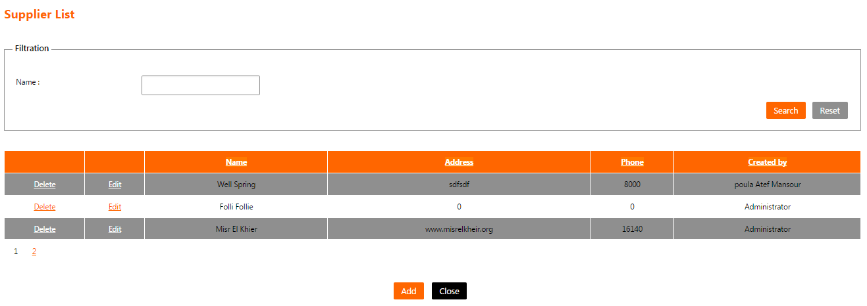
Figure 45: Supplier List Screen

Add Account’s points Supplier Screen
The channel administrator will access this screen by clicking on the button “Add” on “Supplier List Screen”.
This screen enables the channel administrator to add a supplier in the system.

- The following fields are displayed for the new supplier:
  - Supplier Name:
    - The name of the supplier.
    - It is a mandatory field.
  - Phone Number:
    - The phone number of the supplier.
    - It is a mandatory field.
    - It must be a numeric value with no fractions.
  - Address:
    - The supplier’s web site address.
    - It is a mandatory field.

- The channel administrator can press “Save” button to save the supplier and return to “Supplier List Screen”.

- The channel administrator can press “Close” button to cancel the supplier creation and return to “Supplier List Screen”.
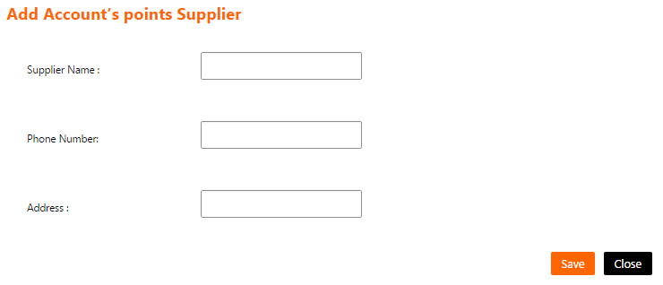
Figure 46: Add Account’s points Supplier Screen

Edit Account’s points Supplier Screen
The channel administrator will access this screen by clicking on the link “Edit” on a specific supplier on the list on “Supplier List Screen”.
This screen enables the channel administrator to modify a supplier in in the system.

- The following fields are displayed and filled for the chosen supplier:
  - Supplier Name:
    - The name of the supplier.
    - It is a mandatory field.
  - Phone Number:
    - The phone number of the supplier.
    - It is a mandatory field.
    - It must be a numeric value with no fractions.
  - Address:
    - The supplier’s web site address.
    - It is a mandatory field.

- The channel administrator can press “Update” button to save the supplier and return to “Supplier List Screen”.

- The channel administrator can press “Close” button to cancel the supplier modifications and return to “Supplier List Screen”.
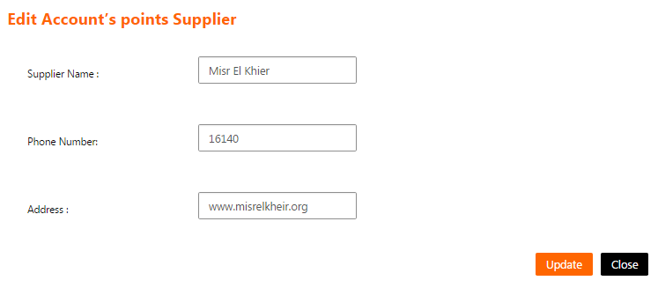
Figure 47: Edit Account’s points Supplier Screen

Functions -> Contests Category List Screen
The channel administrator will access this screen by clicking on the menu (Function Content -> Contests).
This screen shows a list of Contests function contents and enables the channel administrator to manage them.

- The contests category list have the following columns
  - Name: The name of the contests category.
  - Description: The description of the contests category.

- List can be sorted by clicking on the column header.

- If the list contains more than 15 records, then it will be splitted into pages and each page will show 15 records. The channel administrator can navigate between list pages by clicking on the page number below the list.

- The channel administrator can filter the contests category list by filling the following field and click on the button “Search”:
  - Name: To search using the contests category’s name.

- The channel administrator can reset the list filtration by clicking on the button “Reset”. This will do the following
  - Clear the field "Name".
  - Reload the page with all the contests categories.

- The channel administrator can add a contests category by clicking on the button “Add”. This will open “Add Contests Category screen”.

- The channel administrator can edit a contests category by clicking on the link “Edit” on a contests category on the list. This will open “Edit Contests Category screen”.

- The channel administrator can view contests sub-categories by clicking on the link “View Subcategory” on a specific contests category on the list. This will open “Contests Category List screen”.

- A contests category can be deleted only if it doesn’t have sub-categories. The channel administrator can delete a contests category by clicking on the link “Delete” on a specific contests category on the list. Clicking this link will show the following confirmation message to the channel administrator “Are you sure to delete this record? (OK/Cancel)”. The channel administrator can click “OK” button to continue and delete the contests category or click “Cancel” button to cancel the operation.

- The channel administrator can add a contests sub-category by clicking on the link “Add Subcategory” on a specific contests category on the list. This will open “Add Contests Category screen”.

- The channel administrator can manage files attached to a contests sub-category by clicking on the link “View Files” on a specific contests sub-category on the list. This will open “Contests File List screen”.

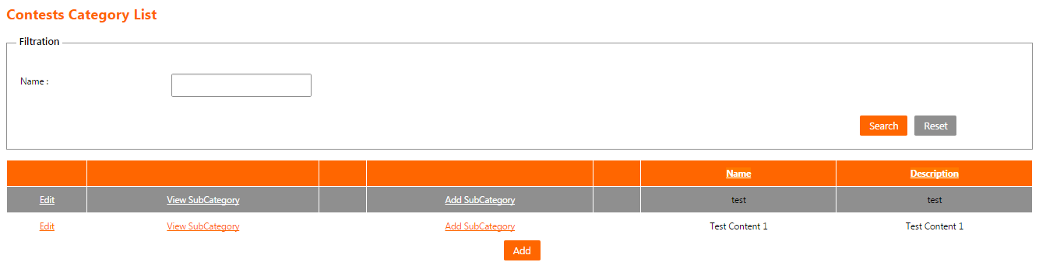

Figure 48: Contests Category List Screen

Add Contests Category Screen
The channel administrator will access this screen by clicking on the button “Add” on “Contests Category List Screen”.
This screen enables the channel administrator to add a content in contest function in the system.

- The following fields are displayed for the new contests category:
  - Channel Name:
    - A list of channels linked to contest function and the current logged in user is administrator on them.
    - It is a mandatory field.
  - Name:
    - The name of the contests category.
    - It is a mandatory field.
  - Description:
    - The description of the contests category.
    - It is a mandatory field.

- The channel administrator can press “Save” button to save the contests category and return to “Contests Category List Screen”.

- The channel administrator can press “Close” button to cancel the contests category creation and return to “Contests Category List Screen”.

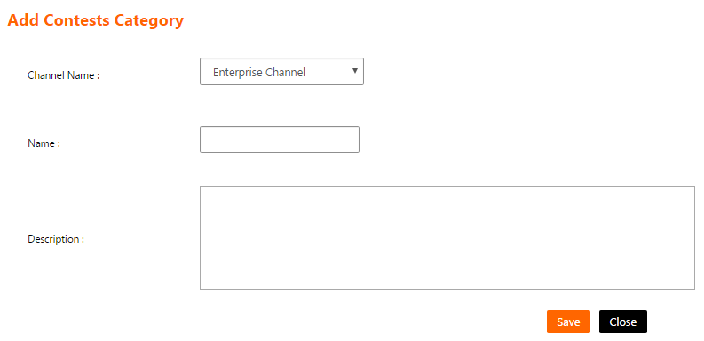
Figure 49: Add Contests Category Screen

Edit Contests Category Screen
The channel administrator will access this screen by clicking on the link “Edit” on a specific contests category on the list on “Contests Category List Screen”.
This screen enables the channel administrator to edit a content in contest function in the system.

- The following fields are displayed and filled for the chosen contests category:
  - Channel Name:
    - A list of channels linked to contest function and the current logged in user is administrator on them.
    - It is a mandatory field.
  - Name:
    - The name of the contests category.
    - It is a mandatory field.
  - Description:
    - The description of the contests category.
    - It is a mandatory field.

- The channel administrator can press “Save” button to save the contests category modifications and return to “Contests Category List Screen”.

- The channel administrator can press “Close” button to cancel the contests category modifications and return to “Contests Category List Screen”.
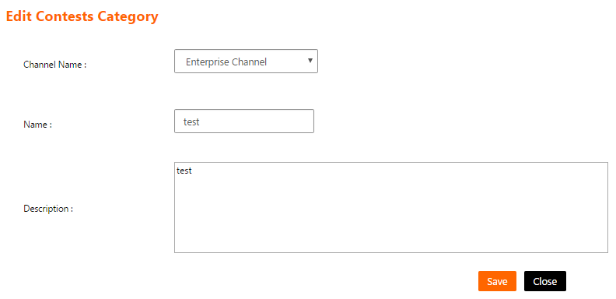
Figure 50: Edit Contests Category Screen

Contests File List Screen
The channel administrator will access this screen by clicking on the link “View Files” on a specific contests category on the list on “Contests Category List screen”.
This screen shows a list of files attached to a specific contests category and enables the channel administrator to manage them.

- The contests category’s files list have the following columns
  - Title: The title of the contests category’s file.
  - Description: The description of the contests category’s file.

- List can be sorted by clicking on the column header.

- If the list contains more than 15 records, then it will be splitted into pages and each page will show 15 records. The channel administrator can navigate between list pages by clicking on the page number below the list.

- The channel administrator can filter the contests category’s files list by filling the following field and click on the button “Search”:
  - Title: To search using the contests category’s file title.

- The channel administrator can reset the list filtration by clicking on the button “Reset”. This will do the following
  - Clear the field "Title".
  - Reload the page with all the contests category’s files.

- The channel administrator can add a contests category’s file by clicking on the button “Add”. This will open “Add Contests File screen”.

- The channel administrator can edit a contests category’s file by clicking on the link “Edit” on a specific contests category’s file on the list. This will open “Edit Contests File screen”.

- The channel administrator can delete a contests category’s file by clicking on the link “Delete” on a specific contests category’s file on the list. Clicking this link will show the following confirmation message to the channel administrator “Are you sure to delete this record? (OK/Cancel)”. The channel administrator can click “OK” button to continue and delete the contests category’s file or click “Cancel” button to cancel the operation.

- The channel administrator can press “Close” button to return to “Contests Category List Screen”.
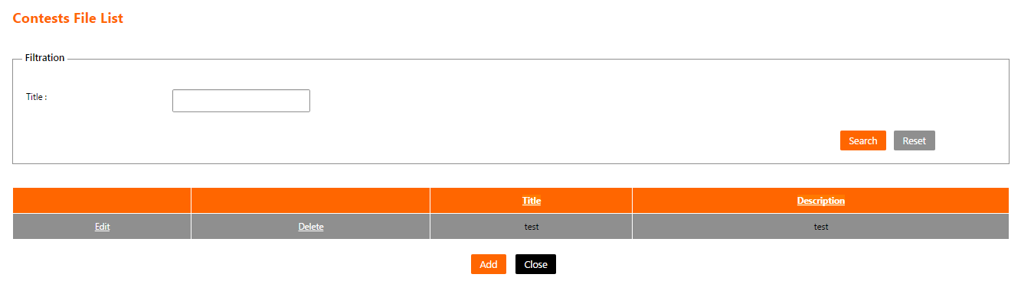
Figure 51: Contests File List Screen

Add Contests File Screen
The channel administrator will access this screen by clicking on the button “Add” on “Contests File List Screen”.
This screen enables the channel administrator to add a file for a contests category in the system.

- The following fields are displayed for the new contests category’s file:
  - Title:
    - The title of the contests category’s file.
    - It is a mandatory field.
  - Description:
    - The description of the contests category’s file.
    - It is a mandatory field.
  - File:
    - The file to be attached to this contests category.
    - It is a mandatory field.
  - Push notification:
    - If checked, then a push notification will be sent to all users within the specified channel that a new file had been added.

- The channel administrator can press “Save” button to save the contests category’s file and return to “Contests File List Screen”.

- The channel administrator can press “Close” button to cancel the contests category’s file adding and return to “Contests File List Screen”.

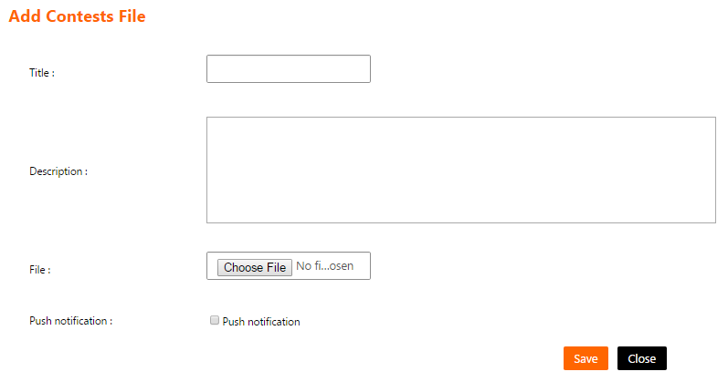
Figure 52: Add Contests File Screen

Edit Contests File Screen
The channel administrator will access this screen by clicking on the link “Edit” on a specific contests category’s file on the list on “Contests File List Screen”.
This screen enables the channel administrator to change the data of a file for a contests category in the system.

- The following fields are displayed and filled for the chosen contests category’s file:
  - Title:
    - The title of the contests category’s file.
    - It is a mandatory field.
  - Description:
    - The description of the contests category’s file.
    - It is a mandatory field.
  - File:
    - The file to be attached to this contests category.
    - It is an optional field.
  - Push notification:
    - If checked, then a push notification will be sent to all users within the specified channel that a new file had been updated.

- The channel administrator can press “Save” button to save the contests category’s file modifications and return to “Contests File List Screen”.

- The channel administrator can press “Close” button to cancel the contests category’s file modifications and return to “Contests File List Screen”.

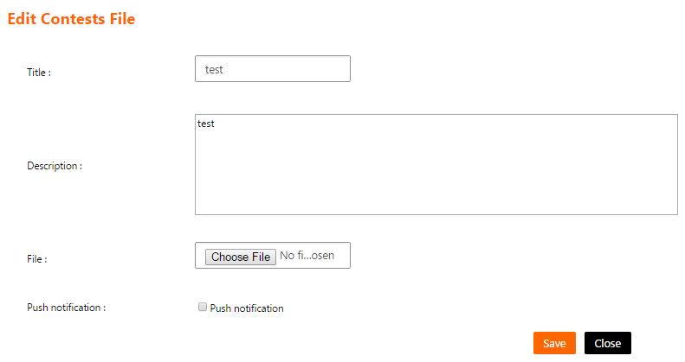
Figure 53: Edit Contests File Screen

Functions -> My Business Category List Screen
The channel administrator will access this screen by clicking on the menu (Function Content -> My Business).
This screen shows a list of My Business function contents and enables the channel administrator to manage them.

- The my business category list have the following columns
  - Name: The name of my business category.
  - Description: The description of my business category.

- List can be sorted by clicking on the column header.

- If the list contains more than 15 records, then it will be splitted into pages and each page will show 15 records. The channel administrator can navigate between list pages by clicking on the page number below the list.

- The channel administrator can filter my business category list by filling the following field and click on the button “Search”:
  - Name: To search using my business category’s name.

- The channel administrator can reset the list filtration by clicking on the button “Reset”. This will do the following
  - Clear the field "Name".
  - Reload the page with all my business categories.

- The channel administrator can add my business category by clicking on the button “Add”. This will open “Add My Business Category screen”.

- The channel administrator can edit my business category by clicking on the link “Edit” on a specific my business category on the list. This will open “Edit My Business Category screen”.

- The channel administrator can view my business sub-categories by clicking on the link “View Subcategory” on a specific my business category on the list. This will open “My Business Category List screen”.

- My business category can be deleted only if it doesn’t have sub-categories. The channel administrator can delete my business category by clicking on the link “Delete” on a specific my business category on the list. Clicking this link will show the following confirmation message to the channel administrator “Are you sure to delete this record? (OK/Cancel)”. The channel administrator can click “OK” button to continue and delete my business category or click “Cancel” button to cancel the operation.

- The channel administrator can add my business sub-category by clicking on the link “Add Subcategory” on a specific my business category on the list. This will open “Add My Business Category screen”.

- The channel administrator can manage files attached to my business sub-category by clicking on the link “View Files” on a specific my business sub-category on the list. This will open “My Business File List screen”.
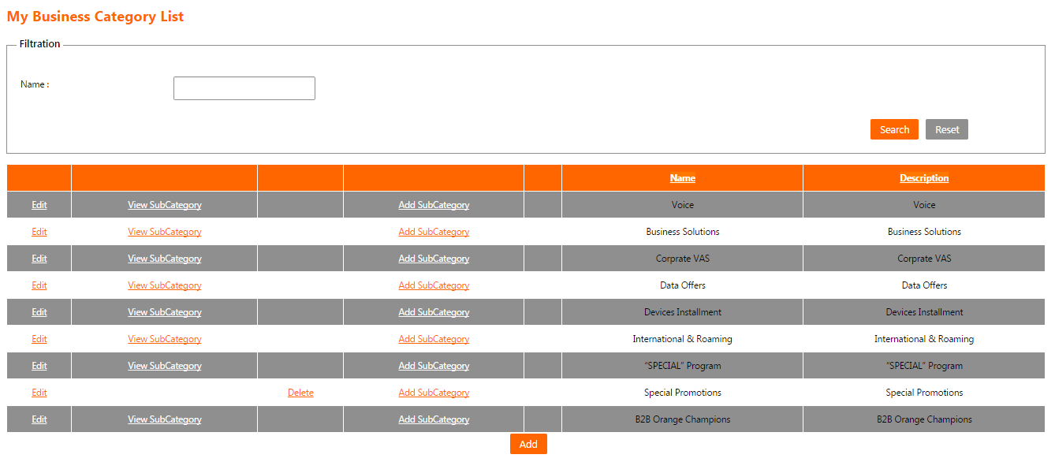
Figure 54: My Business Category List Screen

Add My Business Category Screen
The channel administrator will access this screen by clicking on the button “Add” on “My Business Category List Screen”.
This screen enables the channel administrator to add a content in my business function in the system.

- The following fields are displayed for the new my business category:
  - Channel Name:
    - A list of channels linked to my business function and the current logged in user is administrator on them.
    - It is a mandatory field.
  - Name:
    - The name of my business category.
    - It is a mandatory field.
  - Description:
    - The description of my business category.
    - It is a mandatory field.

- The channel administrator can press “Save” button to save my business category and return to “My Business Category List Screen”.

- The channel administrator can press “Close” button to cancel my business category creation and return to “My Business Category List Screen”.

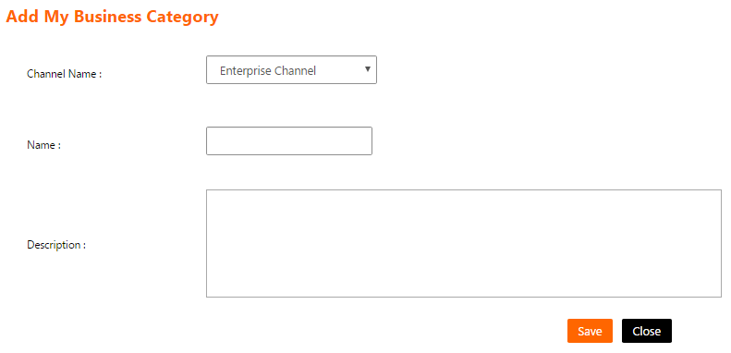
Figure 55: Add My Business Category Screen

Edit My Business Category Screen
The channel administrator will access this screen by clicking on the link “Edit” on a specific my business category on the list on “My Business Category List Screen”.
This screen enables the channel administrator to edit a content in my business function in the system.

- The following fields are displayed and filled for the chosen my business category:
  - Channel Name:
    - A list of channels linked to my business function and the current logged in user is administrator on them.
    - It is a mandatory field.
  - Name:
    - The name of my business category.
    - It is a mandatory field.
  - Description:
    - The description of my business category.
    - It is a mandatory field.

- The channel administrator can press “Save” button to save my business category and return to “My Business Category List Screen”.

- The channel administrator can press “Close” button to cancel my business category creation and return to “My Business Category List Screen”.

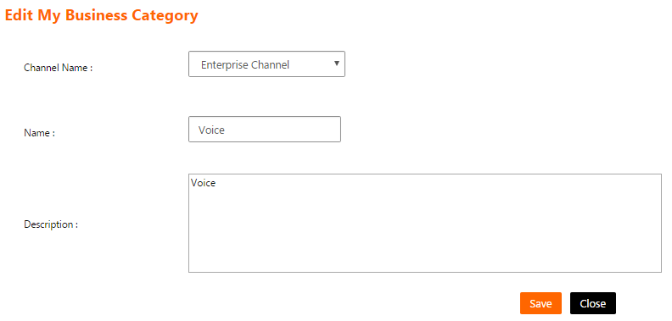
Figure 56: Edit My Business Category Screen

My Business File List Screen
The channel administrator will access this screen by clicking on the link “View Files” on a specific my business category on the list on “My Business Category List screen”.
This screen shows a list of files attached to a specific my business category and enables the channel administrator to manage them.

- The my business category’s files list have the following columns
  - Title: The title of my business category’s file.
  - Description: The description of my business category’s file.
  - Is Signed: Indicates whether the file is signed or not.

- List can be sorted by clicking on the column header.

- If the list contains more than 15 records, then it will be splitted into pages and each page will show 15 records. The channel administrator can navigate between list pages by clicking on the page number below the list.

- The channel administrator can filter my business category’s files list by filling one or more of the following fields and click on the button “Search”:
  - Title: To search using my business category’s file title.
  - Is Signed: To search on signed/unsigned my business category’s files.

- The channel administrator can reset the list filtration by clicking on the button “Reset”. This will do the following
  - Clear the fields "Title" and “Is Signed”.
  - Reload the page with all my business category’s files.

- The channel administrator can add my business category’s file by clicking on the button “Add”. This will open “Add My Business File screen”.

- The channel administrator can edit my business category’s file by clicking on the link “Edit” on a specific my business category’s file on the list. This will open “Edit My Business File screen”.

- The channel administrator can delete my business category’s file by clicking on the link “Delete” on a specific my business category’s file on the list. Clicking this link will show the following confirmation message to the channel administrator “Are you sure to delete this record? (OK/Cancel)”. The channel administrator can click “OK” button to continue and delete my business category’s file or click “Cancel” button to cancel the operation.

- The channel administrator can press “Close” button to return to “My Business Category List Screen”.
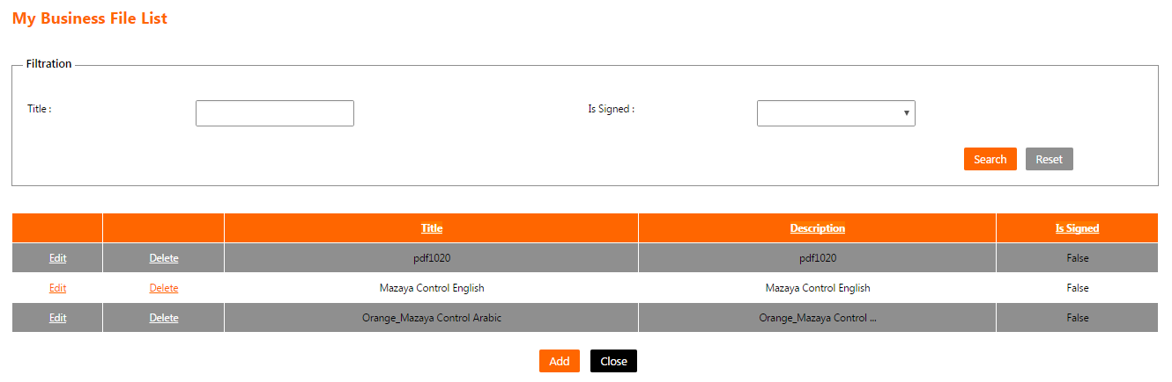
Figure 57: My Business File List Screen

Add My Business File Screen
The channel administrator will access this screen by clicking on the button “Add” on “My Business File List Screen”.
This screen enables the channel administrator to add a file for my business category in the system.

- The following fields are displayed for the new my business category’s file:
  - Title:
    - The title of my business category’s file.
    - It is a mandatory field.
  - Description:
    - The description of my business category’s file.
    - It is a mandatory field.
  - File:
    - The file to be attached to this my business category.
    - It is a mandatory field.
  - Is Signed:
    - Indicates whether the file is signed or not.
  - Push notification:
    - If checked, then a push notification will be sent to all users within the specified channel that a new file had been added.

- The channel administrator can press “Save” button to save my business category’s file and return to “My Business File List Screen”.

- The channel administrator can press “Close” button to cancel my business category’s file adding and return to “My Business File List Screen”.

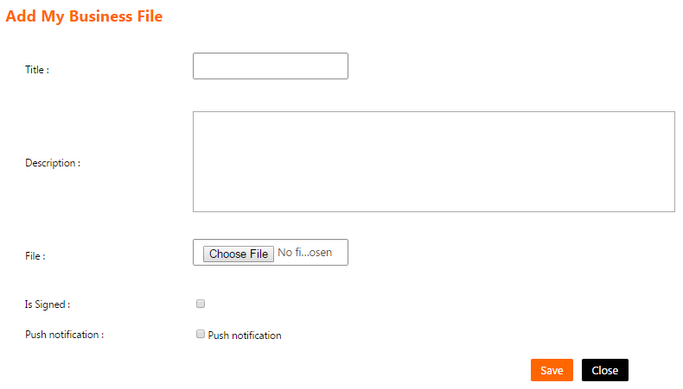
Figure 58: Add My Business File Screen

Edit My Business File Screen
The channel administrator will access this screen by clicking on the link “Edit” on a specific my business category’s file on the list on “My Business File List Screen”.
This screen enables the channel administrator to change the data of a file for my business category in the system.

- The following fields are displayed and filled for the chosen my business category’s file:
  - Title:
    - The title of my business category’s file.
    - It is a mandatory field.
  - Description:
    - The description of my business category’s file.
    - It is a mandatory field.
  - File:
    - The file to be attached to this my business category.
    - It is an optional field.
  - Is Signed:
    - Indicates whether the file is signed or not.
  - Push notification:
    - If checked, then a push notification will be sent to all users within the specified channel that a new file had been updated.

- The channel administrator can press “Save” button to save my business category’s file and return to “My Business File List Screen”.

- The channel administrator can press “Close” button to cancel my business category’s file modifications and return to “My Business File List Screen”.
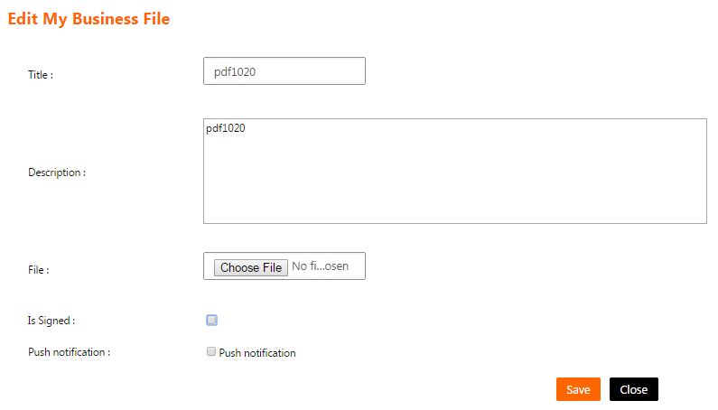
Figure 59: Edit My Business File Screen

Functions -> Operational Forms Category List Screen
The channel administrator will access this screen by clicking on the menu (Function Content -> Operational Forms).
This screen shows a list of Operational Forms function contents and enables the channel administrator to manage them.

- The operational forms category list have the following columns
  - Name: The name of the operational forms category.
  - Description: The description of the operational forms category.

- List can be sorted by clicking on the column header.

- If the list contains more than 15 records, then it will be splitted into pages and each page will show 15 records. The channel administrator can navigate between list pages by clicking on the page number below the list.

- The channel administrator can filter the operational forms category list by filling the following field and click on the button “Search”:
  - Name: To search using the operational forms category’s name.

- The channel administrator can reset the list filtration by clicking on the button “Reset”. This will do the following
  - Clear the field "Name".
  - Reload the page with all the operational forms categories.

- The channel administrator can add operational forms category by clicking on the button “Add”. This will open “Add Operational Forms Category screen”.

- The channel administrator can edit an operational forms category by clicking on the link “Edit” on a specific operational forms category on the list. This will open “Edit Operational Forms Category screen”.

- The channel administrator can view operational forms sub-categories by clicking on the link “View Subcategory” on a specific operational forms category on the list. This will open “Operational Forms Category List screen”.

- Operational forms category can be deleted only if it doesn’t have sub-categories. The channel administrator can delete operational forms category by clicking on the link “Delete” on a specific operational forms category on the list. Clicking this link will show the following confirmation message to the channel administrator “Are you sure to delete this record? (OK/Cancel)”. The channel administrator can click “OK” button to continue and delete operational forms category or click “Cancel” button to cancel the operation.

- The channel administrator can add operational forms sub-category by clicking on the link “Add Subcategory” on a specific operational forms category on the list. This will open “Add Operational Forms Category screen”.
- The channel administrator can manage files attached to operational forms sub-category by clicking on the link “View Files” on a specific operational forms sub-category on the list. This will open “Operational Forms Item List screen”.
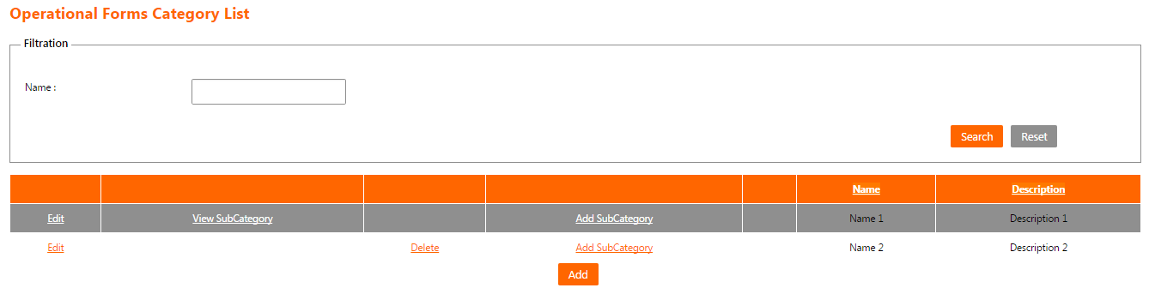

Figure 60: Operational Forms Category List Screen

Add Operational Forms Category Screen
The channel administrator will access this screen by clicking on the button “Add” on “Operational Forms Category List Screen”.
This screen enables the channel administrator to add a content in operational forms function in the system.

- The following fields are displayed for the new operational forms category:
  - Channel Name:
    - A list of channels linked to operational forms function and the current logged in user is administrator on them.
    - It is a mandatory field.
  - Name:
    - The name of operational forms category.
    - It is a mandatory field.
  - Description:
    - The description of operational forms category.
    - It is a mandatory field.

- The channel administrator can press “Save” button to save operational forms category and return to “Operational Forms Category List Screen”.

- The channel administrator can press “Close” button to cancel operational forms category creation and return to “Operational Forms Category List Screen”.

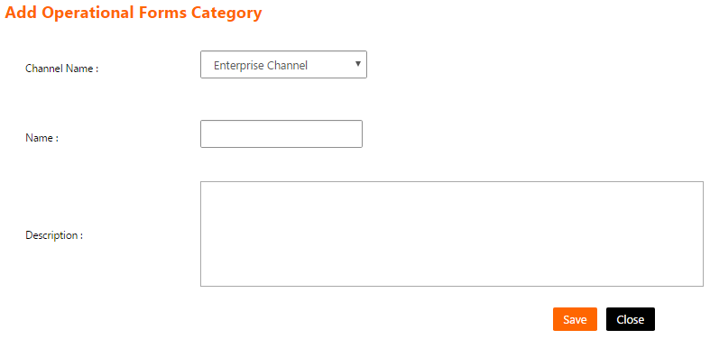
Figure 61: Add Operational Forms Category Screen

Edit Operational Forms Category Screen
The channel administrator will access this screen by clicking on the link “Edit” on a specific operational forms category on the list on “Operational Forms Category List Screen”.
This screen enables the channel administrator to edit a content in operational forms function in the system.

- The following fields are displayed and filled for the chosen operational forms category:
  - Channel Name:
    - A list of channels linked to operational forms function and the current logged in user is administrator on them.
    - It is a mandatory field.
  - Name:
    - The name of operational forms category.
    - It is a mandatory field.
  - Description:
    - The description of operational forms category.
    - It is a mandatory field.

- The channel administrator can press “Save” button to save operational forms category and return to “Operational Forms Category List Screen”.

- The channel administrator can press “Close” button to cancel operational forms category modifications and return to “Operational Forms Category List Screen”.

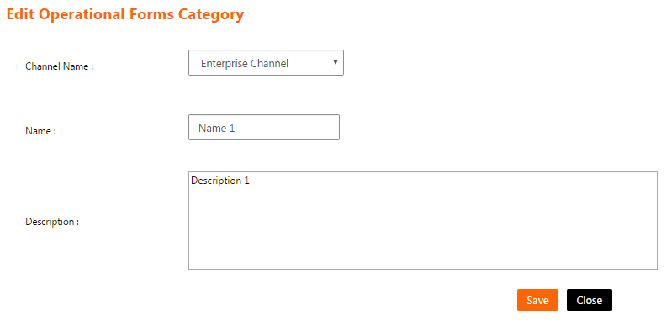
Figure 62: Edit Operational Forms Category Screen

Operational Forms Item List Screen
The channel administrator will access this screen by clicking on the link “View Files” on a specific operational forms category on the list on “Operational Forms Category List screen”.
This screen shows a list of files attached to a specific operational forms category and enables the channel administrator to manage them.

- The operational forms category’s files list have the following columns
  - Title: The title of operational forms category’s file.
  - Description: The description of operational forms category’s file.

- List can be sorted by clicking on the column header.

- If the list contains more than 15 records, then it will be splitted into pages and each page will show 15 records. The channel administrator can navigate between list pages by clicking on the page number below the list.

- The channel administrator can filter operational forms category’s files list by filling the following field and click on the button “Search”:
  - Title: To search using operational forms category’s file title.

- The channel administrator can reset the list filtration by clicking on the button “Reset”. This will do the following
  - Clear the field "Title".
  - Reload the page with all operational forms category’s files.

- The channel administrator can add operational forms category’s file by clicking on the button “Add”. This will open “Add Operational Forms Item screen”.

- The channel administrator can edit operational forms category’s file by clicking on the link “Edit” on a specific operational forms category’s file on the list. This will open “Edit Operational Forms Item screen”.

- The channel administrator can delete operational forms category’s file by clicking on the link “Delete” on a specific operational forms category’s file on the list. Clicking this link will show the following confirmation message to the channel administrator “Are you sure to delete this record? (OK/Cancel)”. The channel administrator can click “OK” button to continue and delete operational forms category’s file or click “Cancel” button to cancel the operation.

- The channel administrator can press “Close” button to return to “Operational Forms Category List Screen”.

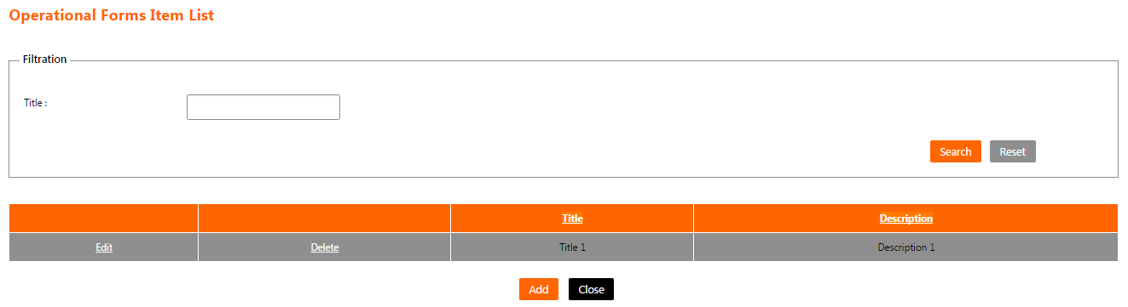
Figure 63: Operational Forms Item List Screen

Add Operational Forms Item Screen
The channel administrator will access this screen by clicking on the button “Add” on “Operational Forms Item List Screen”.
This screen enables the channel administrator to add a file for an operational forms category in the system.

- The following fields are displayed for the new operational forms category’s file:
  - Title:
    - The title of operational forms category’s file.
    - It is a mandatory field.
  - Description:
    - The description of operational forms category’s file.
    - It is a mandatory field.
  - File:
    - The file to be attached to this operational forms category.
    - It is a mandatory field.
  - Push notification:
    - If checked, then a push notification will be sent to all users within the specified channel that a new file had been added.

- The channel administrator can press “Save” button to save operational forms category’s file and return to “Operational Forms Item List Screen”.

- The channel administrator can press “Close” button to cancel operational forms category’s file adding and return to “Operational Forms Item List Screen”.

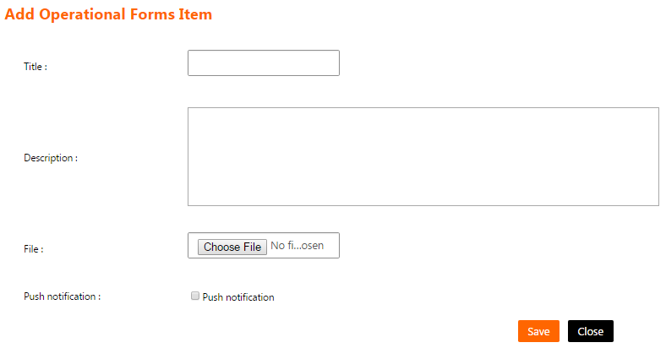
Figure 64: Add Operational Forms Item Screen

Edit Operational Forms Item Screen
The channel administrator will access this screen by clicking on the link “Edit” on a specific operational forms category’s file on the list on “Operational Forms Item List Screen”.
This screen enables the channel administrator to change the data of a file for an operational forms category in the system.

- The following fields are displayed and filled for the chosen operational forms category’s file:
  - Title:
    - The title of operational forms category’s file.
    - It is a mandatory field.
  - Description:
    - The description of operational forms category’s file.
    - It is a mandatory field.
  - File:
    - The file to be attached to this operational forms category.
    - It is an optional field.
  - Push notification:
    - If checked, then a push notification will be sent to all users within the specified channel that the file had been updated.

- The channel administrator can press “Save” button to save operational forms category’s file and return to “Operational Forms Item List Screen”.

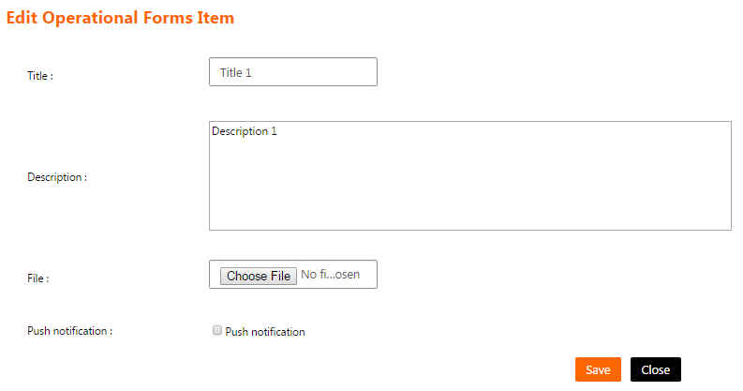
- The channel administrator can press “Close” button to cancel operational forms category’s file modifications and return to “Operational Forms Item List Screen”.
Figure 65: Edit Operational Forms Item Screen

Functions -> Orange Catalogue Screen
- The channel administrator will access this screen by clicking on the menu on one of the following orange catalogue sections
  - Orange Consumer ->
        - Voice Plan
        - Internet Plans
        - Services
        - Entertainment
        - Offers and Promotions
  - Orange Business ->
        - Business Plans
        - Business Solutions
        - Services & Bill Payments
        - SPECIAL for Business
        - Offers and Promotions
        - Support
  - Orange

- This screen shows a list of orange catalogue function section contents which can be either a category or an item and enables the channel administrator to manage them.

- The section’s categories/items list have the following columns
  - Title: The title of the section’s category/item.
  - Description: The description of the section’s category/item.
  - Channel Name: The name of the channel.
  - Type: The type of the section’s content (Category - Item).
  - Is Displayed: Indicates whether this section’s item is displayed on the mobile application for the end users or not.

- List can be sorted by clicking on the column header.

- If the list contains more than 15 records, then it will be splitted into pages and each page will show 15 records. The channel administrator can navigate between list pages by clicking on the page number below the list.

- The channel administrator can filter the section’s categories/items list by filling one or more of the following fields and click on the button “Search”:
  - Title: To search using the section’s category/item title.
  - Is Displayed: To search on hidden/shown items of the section.

- The channel administrator can reset the list filtration by clicking on the button “Reset”. This will do the following
  - Clear the fields "Title" and “Is Displayed”.
  - Reload the page with all the categories/items of the section.

- The channel administrator can add section’s item by clicking on the button “Add Item”. This will open “Add Orange Catalogue Item screen”.

- The channel administrator can add section’s category by clicking on the button “Add Category”. This will open “Add Orange Catalogue Category screen”.

- The channel administrator can edit a section’s item by clicking on the link “Edit” on a specific section’s item on the list. This will open “Edit Orange Catalogue Item screen”.

- The channel administrator can edit a section’s category by clicking on the link “Edit” on a specific section’s category on the list. This will open “Edit Orange Catalogue Category screen”.

- The channel administrator can delete a section’s category/item by clicking on the link “Delete” on a specific section’s category/item on the list. Clicking this link will show the following confirmation message to the channel administrator “Are you sure to delete this record? (OK/Cancel)”. The channel administrator can click “OK” button to continue and delete the section’s category/item or click “Cancel” button to cancel the operation.

- The channel administrator can view a section’s category’s sub-categories by clicking on the link “View Sub-Category” on a specific section’s category on the list.

- The channel administrator can hide a shown section’s item on the mobile application for the end users by clicking on the link “Hide” on a specific shown section’s item on the list.

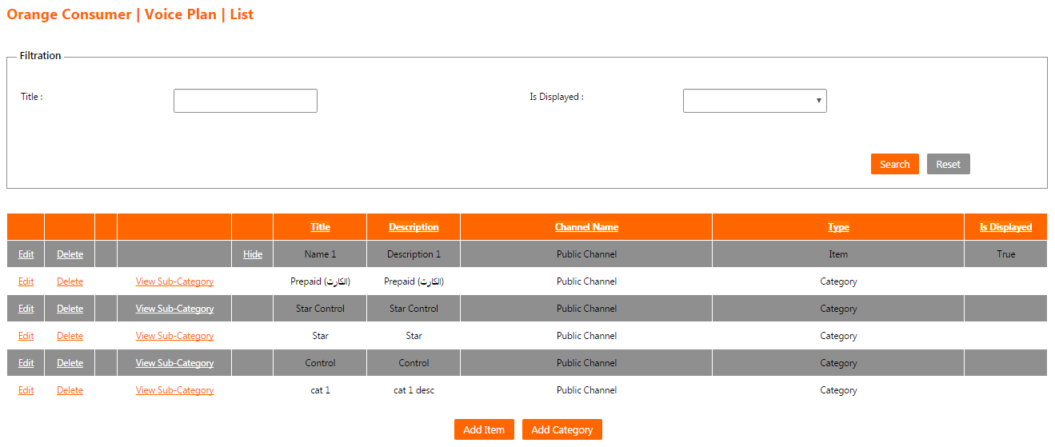
- The channel administrator can show a hidden section’s item on the mobile application for the end users by clicking on the link “Display” on a specific hidden section’s item on the list.
Figure 66: Orange catalogue section’s categories/items list

Add Orange Catalogue Item Screen
The channel administrator will access this screen by clicking on the button “Add Item” on “Orange catalogue Screen”.
This screen enables the channel administrator to add item in orange catalogue function in the system.

- The following fields are displayed for the new section’s item:
  - Channel Name:
    - A list of channels linked to orange catalogue function and the current logged in user is administrator on them.
    - It is a mandatory field.
  - Name:
    - The name of section’s item.
    - It is a mandatory field.
  - Description:
    - The description of section’s item.
    - It is an optional field.
  - Image
    - The image file to be attached to this item.
    - It is optional to add image.
  - Push notification:
    - If checked, then a push notification will be sent to all users within the specified channel that a new file had been added.

- The channel administrator can press “Add” button to save the section’s item and return to “Orange catalogue Screen”.

- The channel administrator can press “Close” button to cancel the section’s item creation and return to “Orange catalogue Screen”.

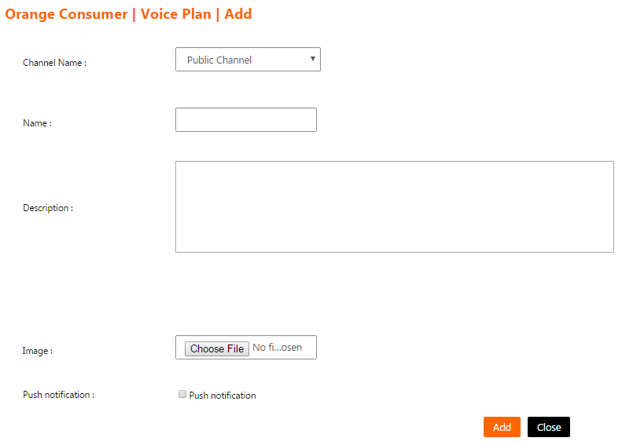
Figure 67: Add Orange Catalogue Item Screen

Add Orange Catalogue Category Screen
The channel administrator will access this screen by clicking on the button “Add Category” on “Orange catalogue Screen”.
This screen enables the channel administrator to add a category/sub category in orange catalogue function in the system.

- The following fields are displayed for the new section’s category:
  - Channel Name:
    - A list of channels linked to orange catalogue function and the current logged in user is administrator on them.
    - It is a mandatory field.
  - Name:
    - The name of the section’s category.
    - It is a mandatory field.
  - Description:
    - The description of the section’s category.
    - It is a mandatory field.

- The channel administrator can press “Save” button to save the section’s category and return to “Orange catalogue Screen”.

- The channel administrator can press “Close” button to cancel the section’s category creation and return to “Orange catalogue Screen”.

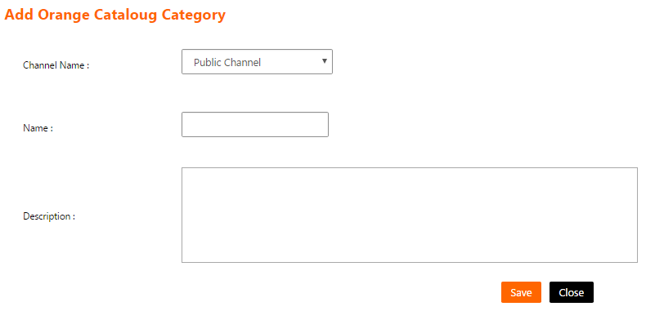
Figure 68: Add Orange Catalogue Category Screen

Edit Orange Catalogue Item Screen
The channel administrator will access this screen by clicking on the link “Edit” on a specific section’s item on “Orange catalogue Screen”.
This screen enables the channel administrator to edit an item in orange catalogue function in the system.

- The following fields are displayed and filled for the chosen section’s item:
  - Channel Name:
    - A list of channels linked to orange catalogue function and the current logged in user is administrator on them.
    - It is a mandatory field.
  - Name:
    - The name of the section’s item.
    - It is a mandatory field.
  - Description:
    - The description of the section’s item.
    - It is an optional field.
  - Image
    - The image file to be attached to this item.
    - It is optional to add image.
  - Push notification:
    - If checked, then a push notification will be sent to all users within the specified channel that a new file had been updated.

- The channel administrator can press “Update” button to save the section’s item modifications and return to “Orange catalogue Screen”.

- The channel administrator can press “Close” button to cancel the section’s item modifications and return to “Orange catalogue Screen”.

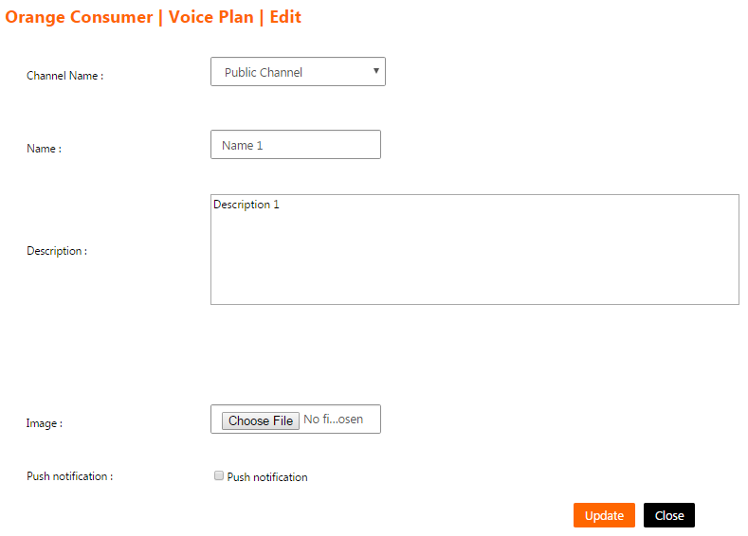
Figure 69: Edit Orange Catalogue Item Screen

Edit Orange Catalogue Category Screen
The channel administrator will access this screen by clicking on the link “Edit” on a specific section’s category on “Orange catalogue Screen”.
This screen enables the channel administrator to edit a category/sub category in orange catalogue function in the system.

- The following fields are displayed and filled for the chosen section’s category:
  - Channel Name:
    - A list of channels linked to orange catalogue function and the current logged in user is administrator on them.
    - It is a mandatory field.
  - Name:
    - The name of the section’s category.
    - It is a mandatory field.
  - Description:
    - The description of the section’s category.
    - It is a mandatory field.

- The channel administrator can press “Save” button to save the section’s category modifications and return to “Orange catalogue Screen”.

- The channel administrator can press “Close” button to cancel the section’s category modifications and return to “Orange catalogue Screen”.

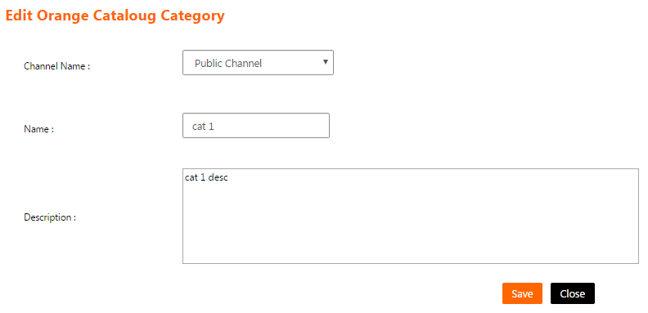
Figure 70: Edit Orange Catalogue Category Screen

Functions -> Let’s Play List Screen
The channel administrator will access this screen by clicking on the menu (Let’s Play -> Manage Contests).
This screen shows a list of Let’s Play function contents and enables the channel administrator to manage them.

- The let’s play list have the following columns
  - Title: The title of the contest.
  - Description: The description of the contest.
  - Channel Name: The name of the channel.
  - Start Date/Time: The start date and time of the contest.
  - End Date/Time: The end date and time of the contest.
  - Is Displayed: Indicates whether this contest is displayed on the mobile application for the end users or not.

- List can be sorted by clicking on the column header.

- If the list contains more than 15 records, then it will be splitted into pages and each page will show 15 records. The channel administrator can navigate between list pages by clicking on the page number below the list.

- The channel administrator can filter the contests list by filling one or more of the following fields then click on the button “Search”:
  - Title: To search using the contest’s title.
  - Is Displayed: To search on hidden/shown contests.
  - Start Date/Time: To search using the start date of the contest.
  - End Date/Time: To search using the end date of the contest.

- The channel administrator can reset the list filtration by clicking on the button “Reset”. This will do the following
  - Clear the fields "Title", “Is Displayed”, “Start Date” and “End Date”.
  - Reload the page with all the contests.

- The channel administrator can add a contest by clicking on the button “Add Let's Play”. This will open “Add Let’s Play screen”.

- The channel administrator can do the following for pending contests (Current date/time is less than contest’s Start Date/Time)
  - Clicking “Manage Questions” link on the list to manage the questions and answers of a specific contest. This will open “Let’s Play Questions List screen”.
  - Clicking “Edit” link on the list to edit the data of a specific contest. This will open “Edit Let's Play Contest screen”.
  - Clicking “Delete” link on the list to delete a specific contest. Clicking this link will show the following confirmation message to the channel administrator “Are you sure to delete this record? (OK/Cancel)”. The channel administrator can click “OK” button to continue and delete the contest or click “Cancel” button to cancel the operation.

- The channel administrator can do the following for currently open contests (Current date/time is greater than contest’s Start Date/Time and less than contest’s End Date/Time)
  - Clicking “View Top Ten” link on the list to view the top ten users with the highest score for a specific contest. This will open “Gamification Top Ten Report”.

- The channel administrator can do the following for closed contests (Current date/time is greater than contest’s End Date/Time)
  - Clicking “Hide” to hide a shown contest on the mobile application for the end users.
  - Clicking “Show” to show a hidden contest on the mobile application for the end users.
  - Clicking “View Top Ten” link on the list to view the top ten users with the highest score for a specific contest. This will open “Gamification Top Ten Report”.
Figure 71: Let’s Play List Screen
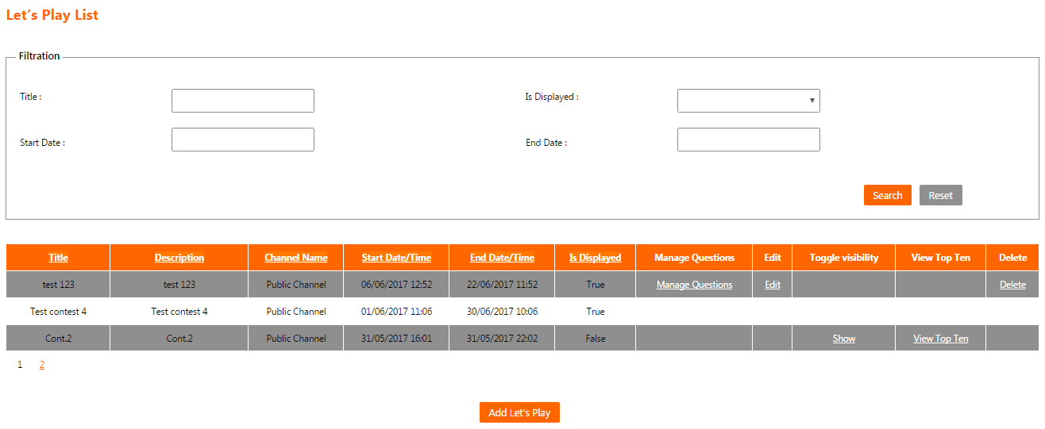

Add Let’s Play Screen
The channel administrator will access this screen by clicking on the button “Add Let’s Play” on “Let’s Play List Screen”.
This screen enables the channel administrator to add a contest in let’s play function in the system.

- The following fields are displayed for the new contest:
  - Channel Name:
    - The name of the channel.
    - It is a mandatory field.
  - Name:
    - The name of the contest.
    - It is a mandatory field.
  - Description:
    - The description of the contest.
    - It is a mandatory field.
  - Start Date/Time:
    - The start date and time of the contest.
    - Must be greater than current date/time plus one hour.
    - It is a mandatory field.
  - End Date/Time:
    - The end date and time of the contest.
    - Must be greater than the value of the field start date/time.
    - It is a mandatory field.
  - Art Work Image:
    - If checked, then the channel administrator can add an image to be used as a cover image when displaying the contest on the mobile application for the end users.
    - If checked, then it will be mandatory to select a valid image file.
  - Number of Rounds:
    - The allowed number of rounds for the end user to retake the contest.
    - It must be a numeric value with no fractions.
    - It is a mandatory field.

- The channel administrator can press “Add” button to save the contest and return to “Let’s Play List Screen”.

- The channel administrator can press “Close” button to cancel contest creation and return to “Let’s Play List Screen”.

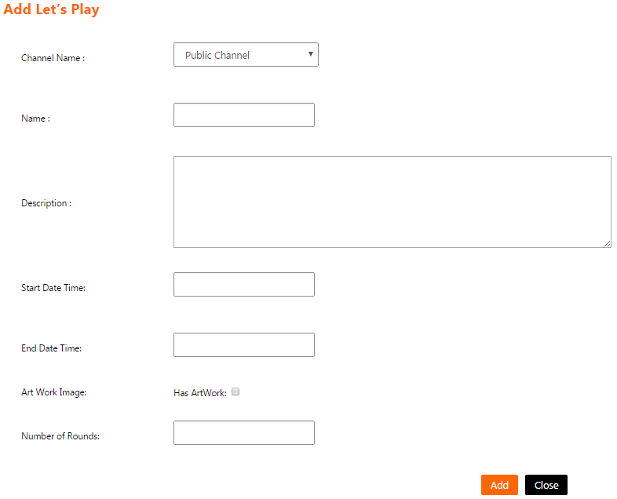
Figure 72: Add Let’s Play Screen

Edit Let’s Play Contest Screen
The channel administrator will access this screen by clicking on the link “Edit” on a specific contest on the list on “Let’s Play List Screen”.
This screen enables the channel administrator to edit a contest in let’s play function in the system.

- The following fields are displayed and filled for the chosen contest:
  - Channel Name:
    - The name of the channel.
    - It is a mandatory field.
  - Name:
    - The name of the contest.
    - It is a mandatory field.
  - Description:
    - The description of the contest.
    - It is a mandatory field.
  - Start Date/Time:
    - The start date and time of the contest.
    - Must be greater than current date/time plus one hour.
    - It is a mandatory field.
  - End Date/Time:
    - The end date and time of the contest.
    - Must be greater than the value of the field start date/time.
    - It is a mandatory field.
  - Art Work Image:
    - If checked, then the channel administrator can add an image to be used as a cover image when displaying the contest on the mobile application for the end users.
    - If checked, then it will be mandatory to select a valid image file.
  - Number of Rounds:
    - The allowed number of rounds for the end user to retake the contest.
    - It must be a numeric value with no fractions.
    - It is a mandatory field.

- The channel administrator can press “Update” button to save the contest modifications and return to “Let’s Play List Screen”.

- The channel administrator can press “Close” button to cancel contest modifications and return to “Let’s Play List Screen”.

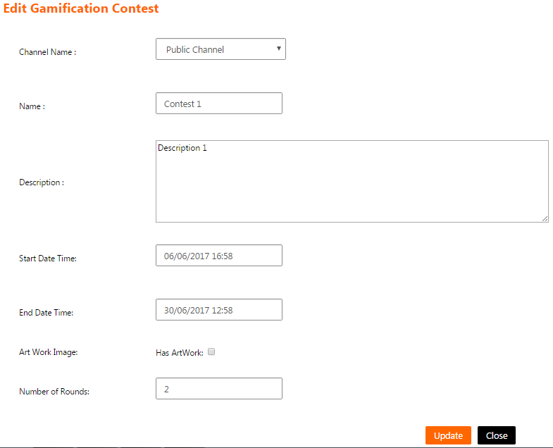
Figure 73: Edit Let’s Play Contest Screen

Let’s Play Questions List Screen
The channel administrator will access this screen by clicking on the link “Manage Questions” on a specific contest on the list on “Let’s Play List Screen”.
This screen enables the channel administrator to manage question and answers for a specific contest in the system.

- The questions list have the following column
  - Text: The question paragraph.

- List can be sorted by clicking on the column header.

- If the list contains more than 15 records, then it will be splitted into pages and each page will show 15 records. The channel administrator can navigate between list pages by clicking on the page number below the list.

- The channel administrator can filter the questions list by filling the following field and click on the button “Search”:
  - Text: To search using the question text.

- The channel administrator can reset the list filtration by clicking on the button “Reset”. This will do the following
  - Clear the field "Text".
  - Reload the page with all the questions.

- The channel administrator can add a question by clicking on the button “Add Question”. This will open “Add Let’s Play Question screen”.

- The channel administrator can edit a question by clicking on the link “Edit” on a specific question on the list. This will open “Edit Let’s Play Question screen”.

- The channel administrator can delete a question by clicking on the link “Delete” on a specific question on the list. Clicking this link will show the following confirmation message to the channel administrator “Are you sure to delete this record? (OK/Cancel)”. The channel administrator can click “OK” button to continue and delete the question or click “Cancel” button to cancel the operation.

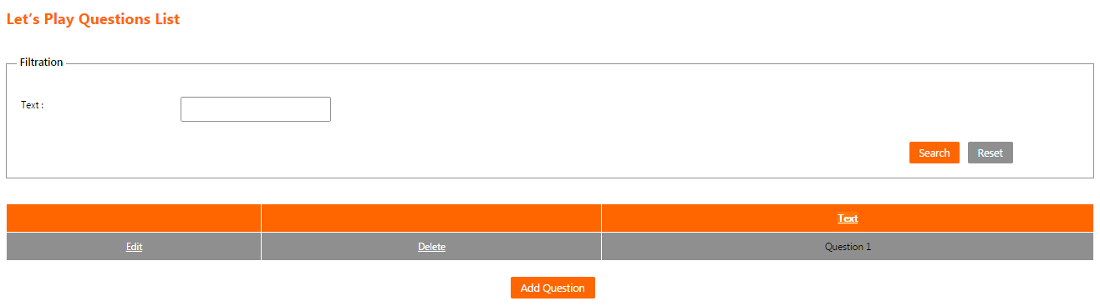
Figure 74: Let’s Play Questions List Screen

Add Let’s Play Question Screen
The channel administrator will access this screen by clicking on the button “Add Question” on “Let’s Play Questions List Screen”.
This screen enables the channel administrator to add a question in a specific contest in the system.

- The following fields are displayed for the new question:
  - Question Text:
    - The question paragraph.
    - It is a mandatory field.
  - Score:
    - The score of the question.
    - Must be a numeric value with no fractions.
    - It is an optional field.
  - Duration:
    - The duration of the question in seconds. This is the time allowed to the end user to answer the question.
    - Must be a numeric value with no fractions.
    - It is an optional field.

- The channel administrator will fill the following fields for the each answer then press the button “Add Answer”:
  - Answer Type:
    - The system give the option to specify the answer as text or as image.
  - Text (If answer type is Text Answer):
    - The answer text.
    - It is a mandatory field.
  - Image (If answer type is Image Answer):
    - The answer image file.
    - It is a mandatory field.
  - Is Right Answer
    - To indicate whether this answer will be considered as correct or wrong answer. More than one answer can be specified as correct answer for the same question.

- The channel administrator must fill exactly four answers for each question.

- A list of the question’s answers will be displayed with the following fields and the channel administrator can press the button “Delete” to delete an answer record:
  - Answer Text: The answer text (If answer type is Text Answer).
  - Answer Image: The answer image (If answer type is Image Answer).
  - Is Right Answer: Indicates whether this answer is considered as correct or wrong answer.

- Answers list can be sorted by clicking on the column header.

- The channel administrator can press “Add” button to save the contest’s question and return to “Let’s Play Questions List Screen”.

- The channel administrator can press “Close” button to cancel contest’s question creation and return to “Let’s Play Questions List Screen”.
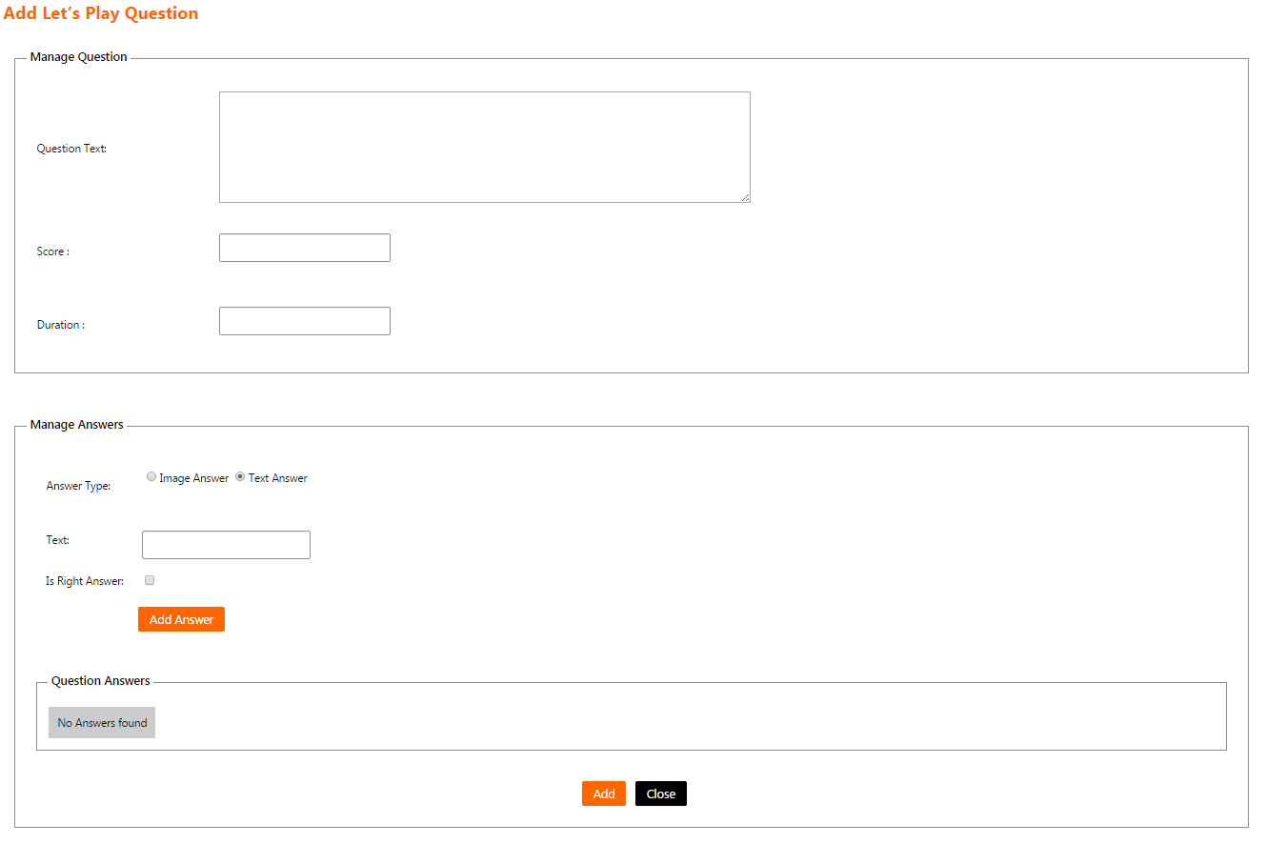
Figure 75: Add Let’s Play Question Screen

Edit Let’s Play Question Screen
The channel administrator will access this screen by clicking on the link “Edit” on a specific contest’s question on the list on “Let’s Play Questions List Screen”.
This screen enables the channel administrator to edit a question in a specific contest in the system.

- The following fields are displayed and filled for the chosen question:
  - Question Text:
    - The question paragraph.
    - It is a mandatory field.
  - Score:
    - The score of the question.
    - Must be a numeric value with no fractions.
    - It is an optional field.
  - Duration:
    - The duration of the question in seconds. This is the time allowed to the end user to answer the question.
    - Must be a numeric value with no fractions.
    - It is an optional field.

- The channel administrator will fill the following fields for the each answer then press the button “Add Answer”:
  - Answer Type:
    - The system give the option to specify the answer as text or as image.
  - Text (If answer type is Text Answer):
    - The answer text.
    - It is a mandatory field.
  - Image (If answer type is Image Answer):
    - The answer image file.
    - It is a mandatory field.
  - Is Right Answer
    - To indicate whether this answer will be considered as correct or wrong answer. More than one answer can be specified as correct answer for the same question.

- The channel administrator must fill exactly four answers for each question.

- A list of the question’s answers will be displayed with the following fields and the channel administrator can press the button “Delete” to delete an answer record:
  - Answer Text: The answer paragraph (If answer type is Text Answer).
  - Answer Image: The answer image (If answer type is Image Answer).
  - Is Right Answer: Indicates whether this answer is considered as correct or wrong answer.

- Answers list can be sorted by clicking on the column header.

- The channel administrator can press “Update” button to save the contest’s question modifications and return to “Let’s Play Questions List Screen”.

- The channel administrator can press “Close” button to cancel contest’s question modifications and return to “Let’s Play Questions List Screen”.
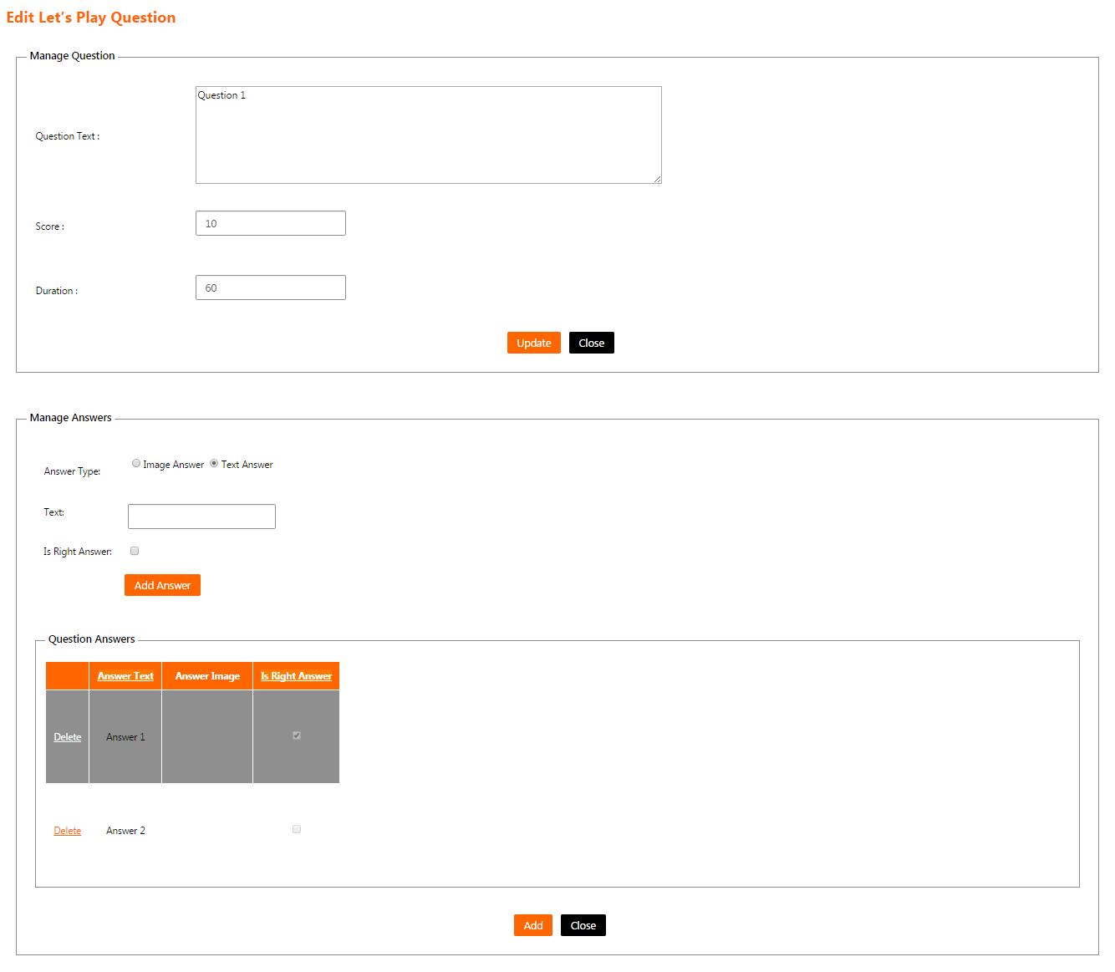
Figure 76: Edit Let’s Play Question Screen

Message List Screen
The channel administrator will access this screen by clicking on the menu (Messages).
This screen shows a list of messages that will be shown on the mobile application for the end users and enables the channel administrator to manage them.

- The messages list have the following columns
  - Title: The title of the message.
  - Description: The description of the message.
  - Channel Name: The name of the channel.

- List can be sorted by clicking on the column header.

- If the list contains more than 15 records, then it will be splitted into pages and each page will show 15 records. The channel administrator can navigate between list pages by clicking on the page number below the list.

- The channel administrator can filter the messages list by filling the following field and clicking on the button “Search”:
  - Search text: To search using the message’s title.

- The channel administrator can reset the list filtration by clicking on the button “Reset”. This will do the following
  - Clear the field "Search text".
  - Reload the page with all the defined messages.

- The channel administrator can add a message by clicking on the button “Add”. This will open “Add Message screen”.

- The channel administrator can edit a message by clicking on the link “Edit” on a specific message on the list. This will open “Edit Message screen”.

- The channel administrator can delete a message by clicking on the link “Delete” on a specific message on the list. Clicking this link will show the following confirmation message to the channel administrator “Are you sure to delete this record? (OK/Cancel)”. The channel administrator can click “OK” button to continue and delete the message or click “Cancel” button to cancel the operation.

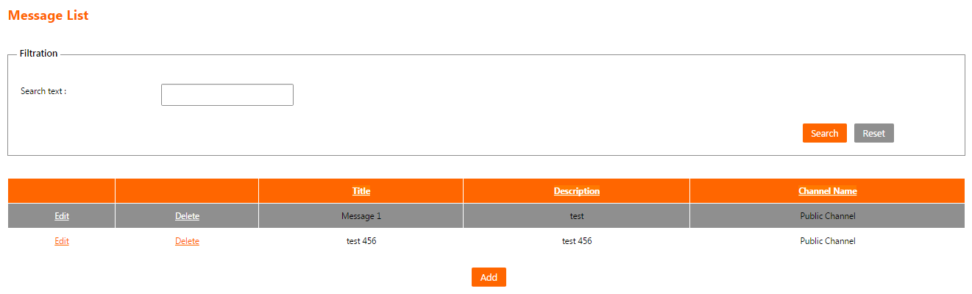
Figure 77: Message List Screen

Add Message Screen
The channel administrator will access this screen by clicking on the button “Add” on “Message List Screen”.
This screen enables the channel administrator to add a message in the system to be shown on the mobile application for the end users.

- The following fields are displayed for the new message:
  - Title:
    - The title of the message.
    - It is a mandatory field.
  - Description:
    - The description of the message.
    - It is a mandatory field.
  - Channel Name:
    - A list of channels that the current logged in user is administrator on them.
    - It is a mandatory field.

- The channel administrator can press “Add” button to save the message and return to “Message List Screen”.

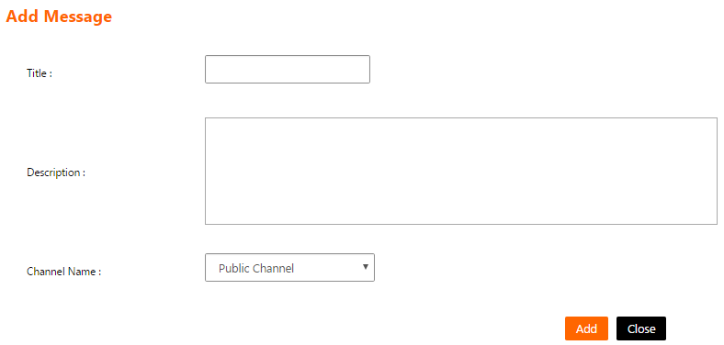
- The channel administrator can press “Close” button to cancel message creation and return to “Message List Screen”.
Figure 78: Add Message Screen

Edit Message Screen
The channel administrator will access this screen by clicking on the link “Edit” on a specific message on “Message List Screen”.
This screen enables the channel administrator to edit an existing message in the system to be shown on the mobile application for the end users.

- The following fields are displayed and filled for the chosen message:
  - Title:
    - The title of the message.
    - It is a mandatory field.
  - Description:
    - The description of the message.
    - It is a mandatory field.
  - Channel Name:
    - A list of channels that the current logged in user is administrator on them.
    - It is a mandatory field.

- The channel administrator can press “Update” button to save the message modifications and return to “Message List Screen”.

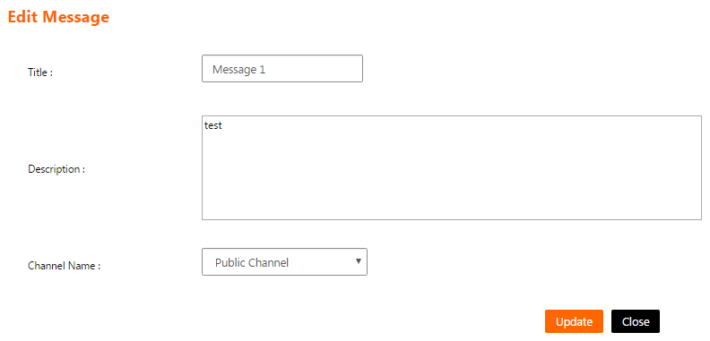
- The channel administrator can press “Close” button to cancel message modifications and return to “Message List Screen”.
Figure 79: Edit Message Screen

Reports section

Login Report
- The same “Login Report” displayed to the administrator.

Application Download Report
- The same “Application Download Report” displayed to the administrator.

Gamification Users Report
- This report will only be shown to any user who is an administrator on a channel that is linked to Let’s Play function.

- The gamification users report will show a list of all users who a played contests in the system.

- The channel administrator can filter the list using one or more of the following criteria
  - Contest Status: The status of the contest
    - Closed: Current date/time is greater than contest’s End Date/Time.
    - Pending: Current date/time is less than contest’s Start Date/Time.
    - Opened: Current date/time is greater than contest’s Start Date/Time and less than contest’s End Date/Time.
  - Gamification Contest: The title of the contest.
  - Date From/To: The date range when the users played the contest. The value of the date to field must be greater than the date from field value.

- The channel administrator can reset the list filtration by clicking on the button “Reset”. This will do the following
  - Clear the fields "Contest Status", “Gamification Contest”, “Date From” and “Date To”.
  - Reload the page with all the data.

- The channel administrator will click “Search” button
  - The system will show the message “No Logs found” if there is no result matching the filtration criteria.
  - The system will show the result list with the following fields
    - Username: The name of the user who played the contest.
    - User Full Name: The full name of the user who played the contest.
    - Gamification Contest Title: The title of the contest that the user played.
    - Gamification Contest Status: The current status of the contest that the user played.
    - Gamification Contest Round Number: The number of times that the user played the contest.
    - User Score: The user score in the last round of the contest.
    - Date/Time: The date and time when the user played the contest.
- If the list contains more than 15 records, then it will be splitted into pages and each page will show 15 records. The channel administrator can navigate between list pages by clicking on the page number below the list.

- The channel administrator can click the button “Export to excel” to export the displayed data to an excel sheet.

Figure 80: Gamification Users Report
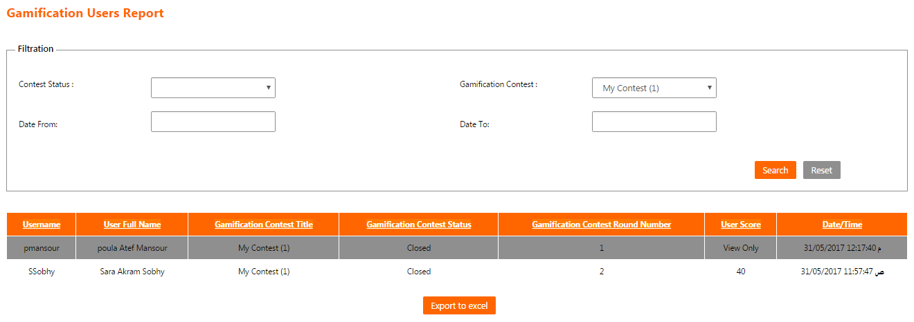

Gamification Top Ten Report
- This report will only be shown to any user who is an administrator on a channel that is linked to Let’s Play function.

- The gamification top ten report will show top ten users’ scores for a specific contests in the system.

- The channel administrator can filter the list using the following criteria
  - Gamification Contest: The title of the contest.

- The channel administrator can reset the list filtration by clicking on the button “Reset”. This will do the following
  - Clear the field “Gamification Contest”.
  - Clear the data displayed in the report.

- The channel administrator will click “Search” button
  - The system will show the message “No Logs found” if there is no result matching the filtration criteria.
  - The system will show the result list with the following fields
    - Rank: The rank of the user. It is a number from 1 to 10.
    - Username: The name of the user who played the contest.
    - Full User Name: The full name of the user who played the contest.
    - Contest Title: The title of the contest that the user played.
    - Contest Status: The current status of the contest that the user played.
      - Closed: Current date/time is greater than contest’s End Date/Time.
      - Pending: Current date/time is less than contest’s Start Date/Time.
      - Opened: Current date/time is greater than contest’s Start Date/Time and less than contest’s End Date/Time.

- If the list contains more than 15 records, then it will be splitted into pages and each page will show 15 records. The channel administrator can navigate between list pages by clicking on the page number below the list.

- The channel administrator can click the button “Export to excel” to export the displayed data to an excel sheet.

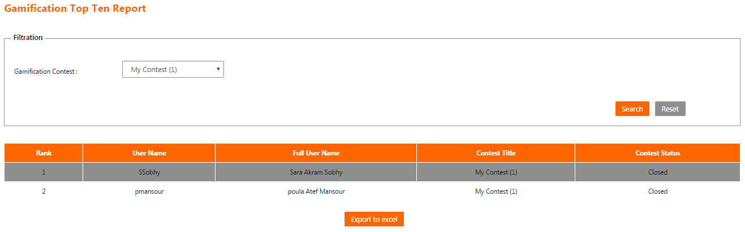
Figure 81: Gamification Top Ten Report

The Iknow mobile application

System login screen
- The mobile user will fill his user name and password in the login screen and then click “Login” button.

- If the mobile user didn’t enter a user name and/or a password and clicked “Login” button, then the system will show the following error message “Please, fill in the missing fields”.

- If the mobile user entered an invalid password and clicked “Login” button, then the system will show the following error message “Sorry, User login failed”.

- If the mobile user entered an invalid user name and clicked “Login” button, then the system will show the following error message “Sorry, Unable to get user by username”.

- If the mobile user clicked “Login” button while the mobile device is not connected to the internet, then the system will show the following error message “Connection error”.

- If the mobile user clicked “Login” button while his account is suspended, then the system will show the following error message “Sorry, this user is suspended”.

- If the mobile user forgot the password, he/she can click on the link “Forgot Password?” Clicking this link will show the following confirmation message to the mobile user “Do you want to send your new password to your email? (OK/Cancel)”. The mobile user can click “OK” button so the system will generate a new password and send it to the mobile user’s E-Mail or click “Cancel” button to cancel the operation.

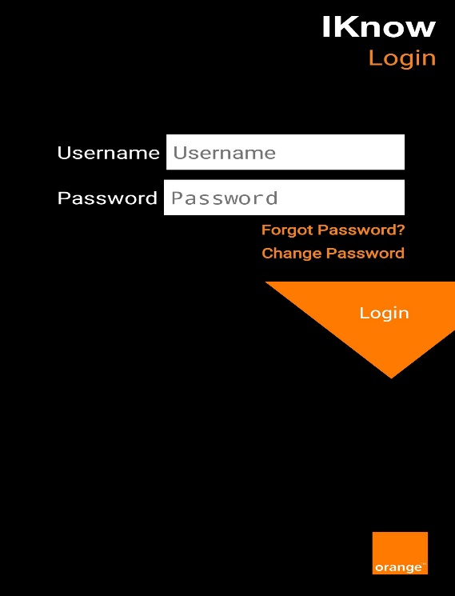

Figure 82: System login screen

Change password screen
- The mobile user can change his/her password by clicking on “Change Password” link in “System login Screen”.

- The mobile user will be required to enter his/her user name, old password, new password and to confirm the new password.

- The mobile user will press “Submit” button to change the password.

- The mobile user can press “Back” to return to the previous screen.

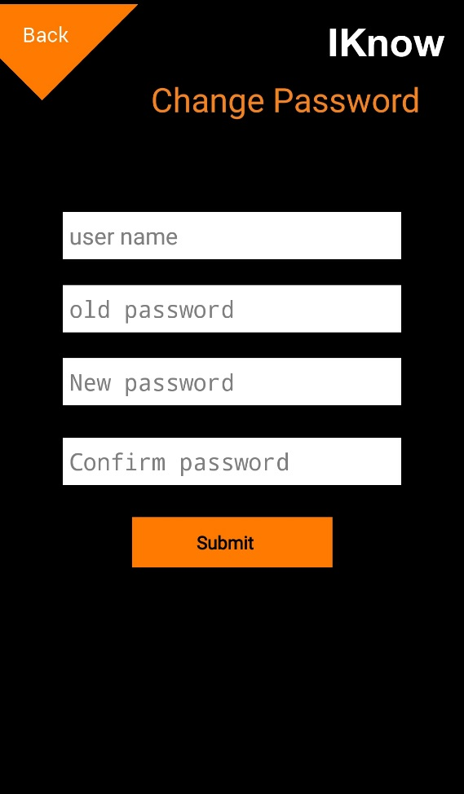

Figure 83: Change password screen

System Menu (Mobile user)
- Iknow mobile application consists of the following sections.
  - Notifications
  - Orange Catalogue
  - Tutorials
  - Think Tank
  - Business tips
  - Network Coverage
  - "Special" Program points
  - My Business
  - Select Calculator
  - Contests
  - Operational Forms
  - Let's Play
  - Phone Advisor
- If the mobile user is linked to many channels and those channels linked to the same function, then when the mobile user clicks on the function on the menu, the system will show a list of linked channels for the end user to choose only one channel to show the function contents for it.

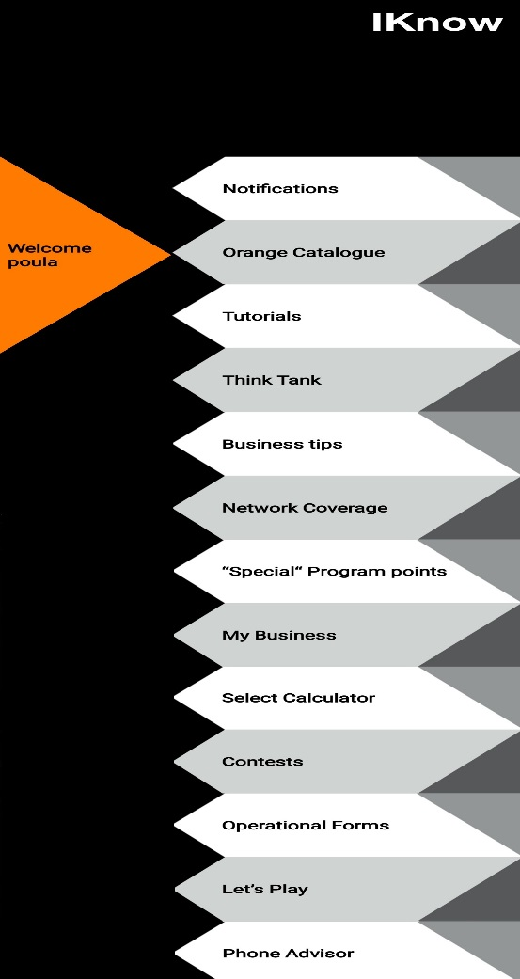
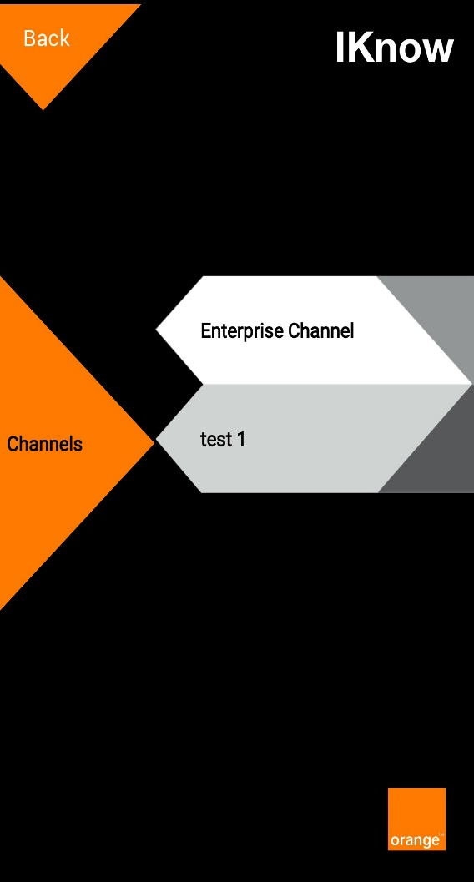

Figure 84: Mobile application menu
Figure 85: Function's channels list

Notifications Screen
The mobile user will access this screen by clicking on the menu (Notifications).

- This screen shows a list of notifications about changes in the system contents like:
  - New contest is added in Let’s Play function.
  - New tip is added in Business Tips function.
  - New form is added in Operational Forms function.

- Each notification in the list will be displayed in the following format
  - The title of the notification.
  - The description of the notification.
  - The notification date.
  - An envelope icon (Opened/Closed) that indicates whether this notification was opened by the mobile user or not.

- The mobile user can open any notification to view more details about it.

- The mobile user can press “Back” to return to the previous screen.

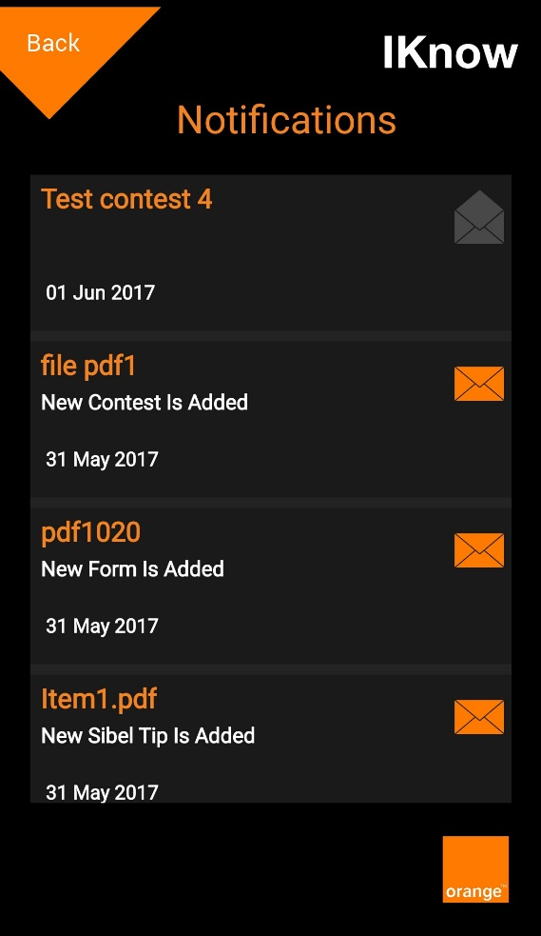

Figure 86: Notifications Screen

Orange Catalogue Screen
The mobile user will access this screen by clicking on the menu (Orange Catalogue).

- This screen shows the contents of orange catalogue function in the system.

- The Orange catalogue is organized into the following categories/sub-categories
  - Orange

  - Orange Consumer
    - Voice Plan
    - Internet Plans
    - Services
    - Entertainment
    - Offers and Promotions

  - Orange Business
    - Business Plans
    - Business Solutions
    - Services & Bill Payments
    - SPECIAL for Business
    - Offers and Promotions
    - Support

- The mobile user can open any category/sub-category to view the contents.
  - The contents exists only in the last level of the categories tree.
  - The content can be paragraphs of any text provided by the channel administrator.

- The mobile user can press “Back” to return to the previous screen.

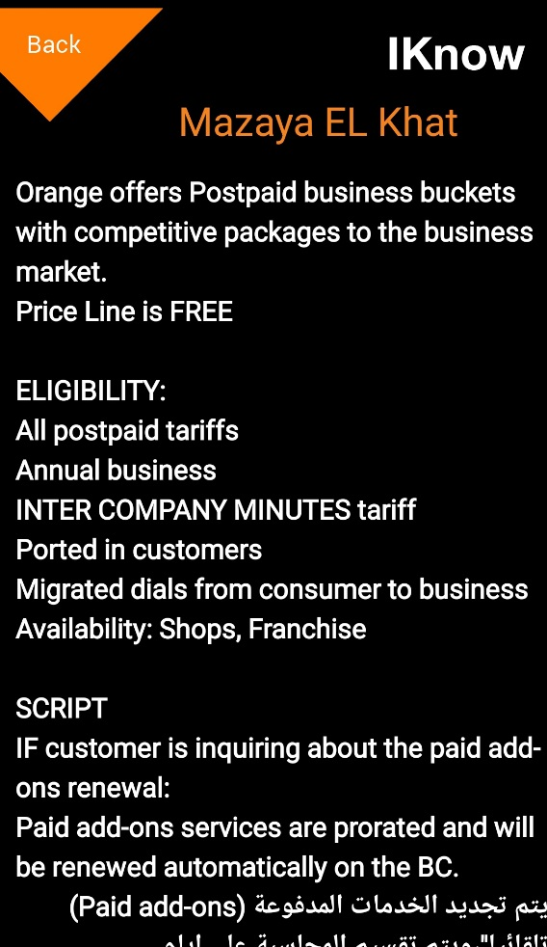
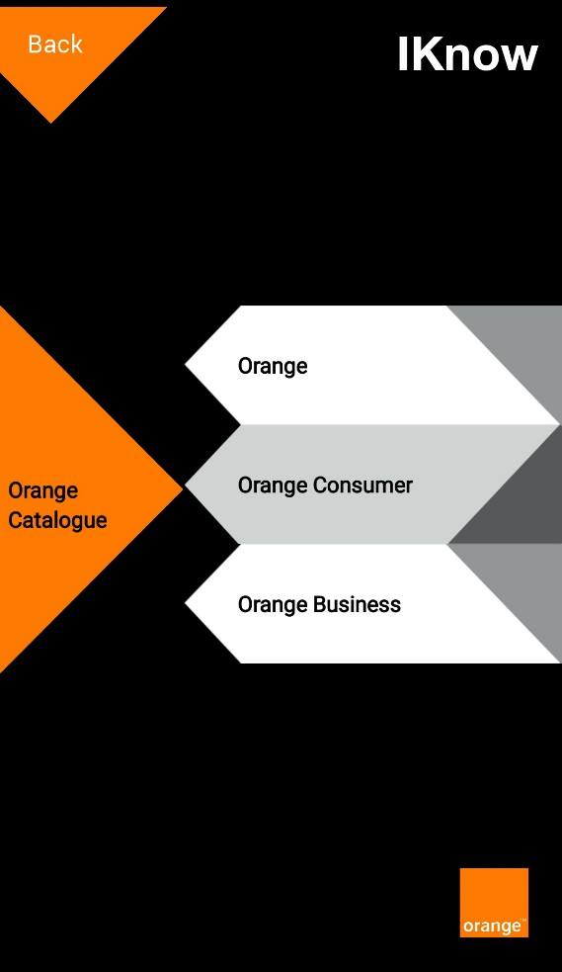
Figure 87: Content view
Figure 88: Orange Catalogue Screen

Tutorials Screen
The mobile user will access this screen by clicking on the menu (Tutorials).

- This screen shows the contents of the tutorials function in the system.

- The tutorials are organized into two categories
  - Commercial
  - Sales

- The mobile user can open any category to view the contents.
  - The contents are YouTube Videos provided by the channel administrator.

- The mobile user can press “Back” to return to the previous screen.

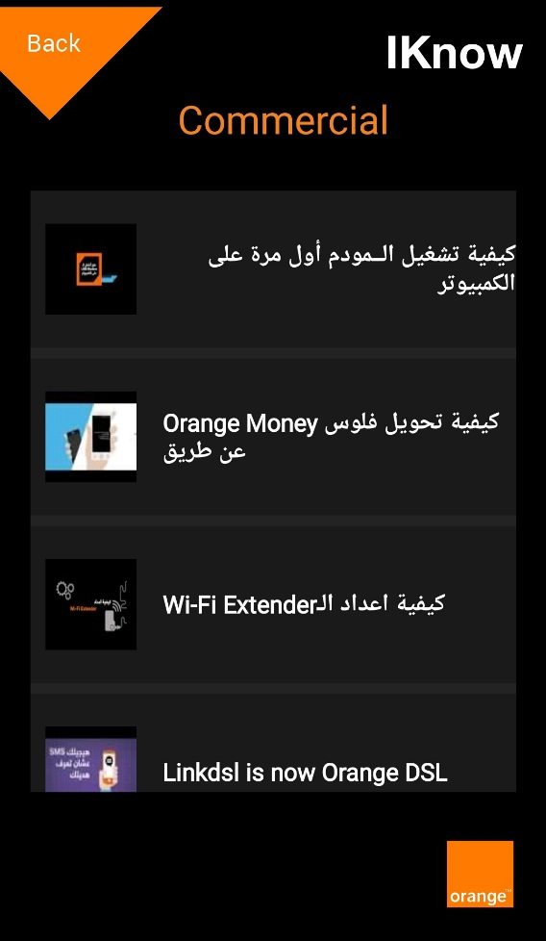
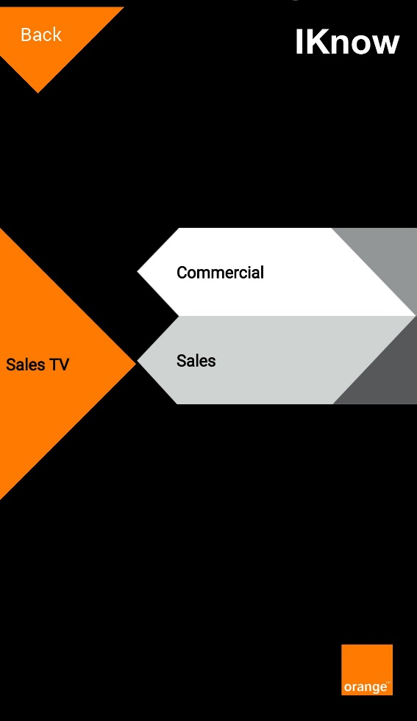
Figure 89: Commercial Tutorials Screen
Figure 90: Tutorials Screen

Think Tank Screen
The mobile user will access this screen by clicking on the menu (Think Tank).

- This screen allows the mobile user to submit contents on the think tank function in the system.

- The mobile user can view a summary about the function by clicking on the tab “What’s Think Tank”.

- The mobile user can submit a new idea to be viewed by the channel admin by clicking on the tab “Submit your idea here”. The mobile user will fill the following fields (All the fields are mandatory) then click on the button “Send”:
  - Idea name: The name of the idea.
  - Main Concept: The main concept of the idea.
  - Area of development: The development area of the idea.
  - Expected benefits For Orange: The expected value in return for Orange.
  - Expected benefits For Customer: The expected value in return for Orange customers.

- The mobile user can press “Back” to return to the previous screen.

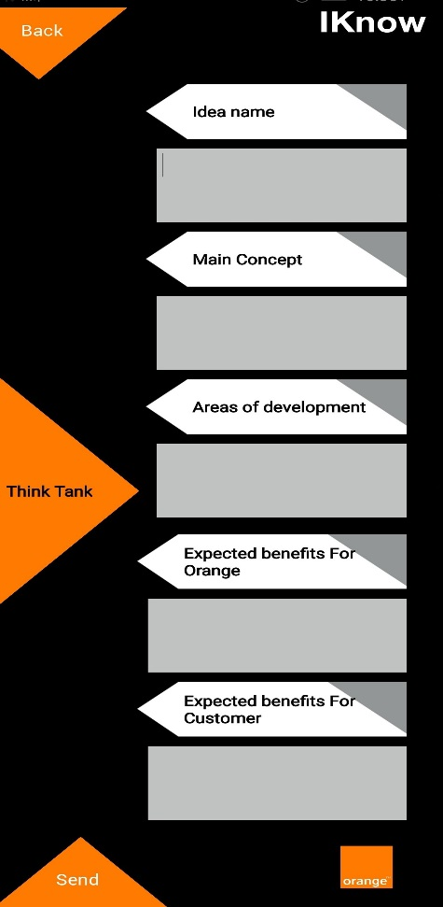
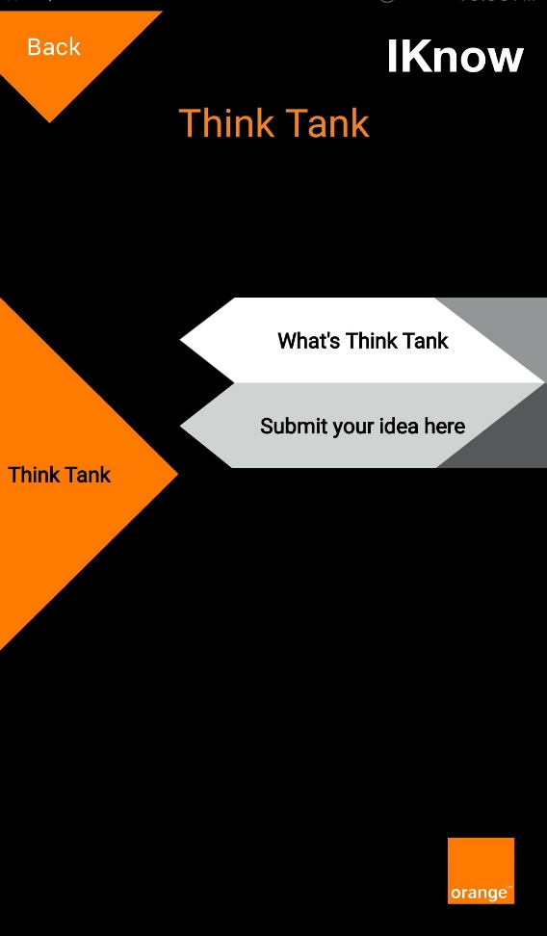
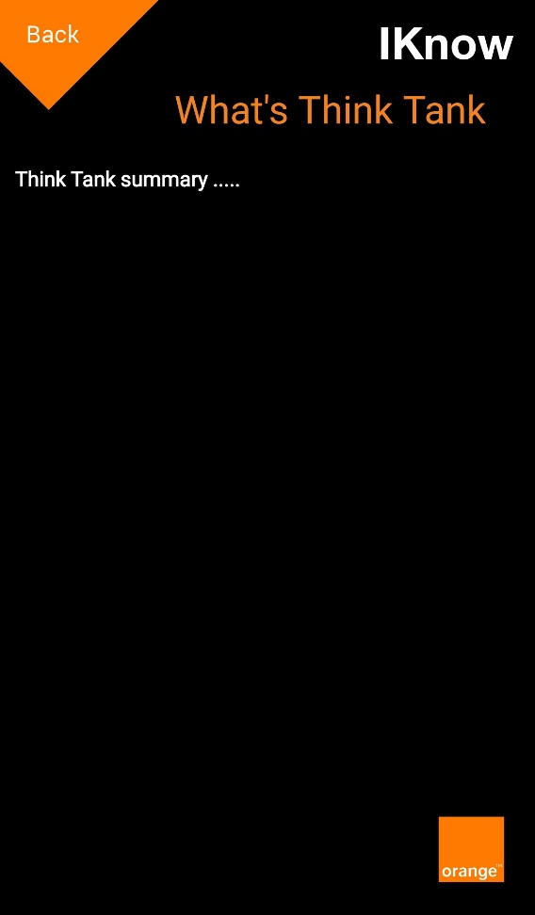
Figure 91: Submit idea Screen
Figure 92: What’s Think Tank Screen
Figure 93: Think Tank Screen

Business tips Screen
The mobile user will access this screen by clicking on the menu (Business tips).

- This screen shows the contents of business tips function in the system.

- The business tips is organized into categories/sub-categories.

- The mobile user can open any category/sub-category to view the contents.
  - The contents exists only in the last level of the categories tree.
  - The content can be paragraph of any text with or without a file which is provided by the channel administrator.

- The mobile user can press “Back” to return to the previous screen.

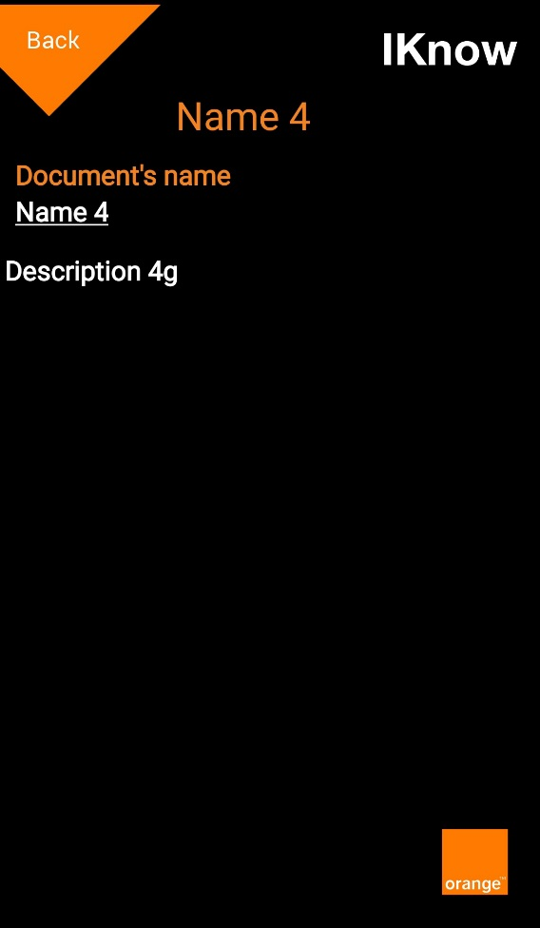
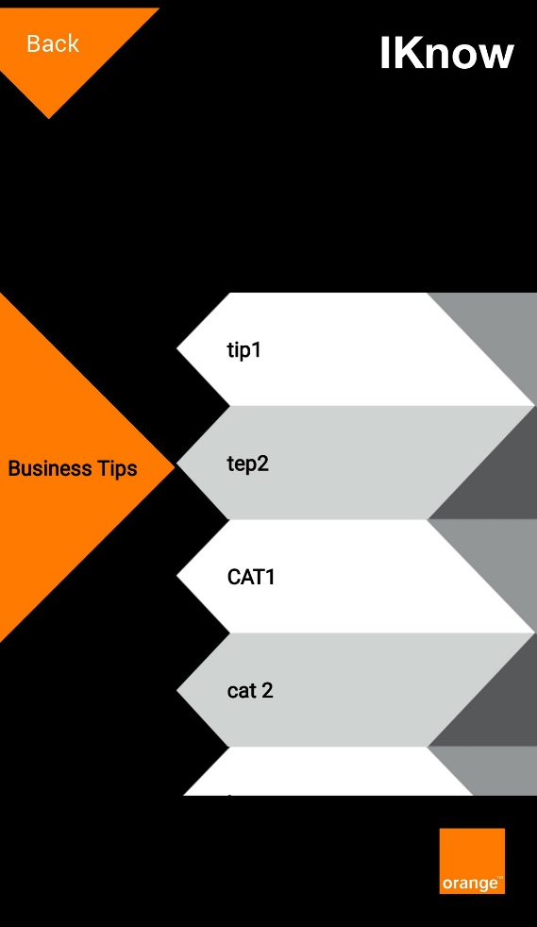
Figure 94: Content view
Figure 95: Business tips Screen

Network Coverage Screen
The mobile user will access this screen by clicking on the menu (Network Coverage).

- This screen allows the mobile user to view/submit contents on the network coverage function in the system.

- The mobile user can view the contents by clicking on the tab “Important Tips”.
  - The tips is organized into categories/sub-categories.
  - The mobile user can open any category/sub-category to view the contents.
    - The contents exists only in the last level of the categories tree.
    - The content can be paragraph of any text with a file which is provided by the channel administrator.
    - The mobile user can send the content file to a specific E-Mail address by typing the desired E-Mail address and click the button “Send”.

- The mobile user can submit a new coverage claim to be sent to a specific E-Mail address by clicking on the tab “Coverage Claim”. The mobile user will fill the following fields then click on the button “Fill and send”. The system will ask the mobile user to enter an E-Mail address to send this claim to it:
  - Personal Information
    - Corporate Name
      - The name of the company where the network issue exists.
      - It is a mandatory field.
    - Account Number
      - The account number of the company where the network issue exists.
      - It must be a numeric value with no fractions.
      - It is a mandatory field.

  - Address Information
    - Address Location
      - The address of the company where the network issue exists.
      - It is a mandatory field.
    - Landmark
      - The nearest landmark to the company where the network issue exists.
      - It is a mandatory field.
    - Google Map XY
      - The longitude and latitude of the location on Google maps in case of petroleum locations.
      - It is an optional field.

  - Problem Details
    - Problem Type
      - The type of the problem.
      - It is a mandatory field.
    - Problem Details Description
      - The details of the problem.
      - It is a mandatory field.
    - Problem Start Date
      - The mobile user will choose the month, the day and the year when the problem started at the company.
      - It is a mandatory field.

  - Signal
    - Indoor Signal Level
      - The level of the indoor signal.
      - It is a list of choices (Excellent – Good – Fair – No signal).
      - It is a mandatory field.
    - Outdoor Signal Level
      - The level of the outdoor signal.
      - It is a list of choices (Excellent – Good – Fair – No signal).
      - It is a mandatory field.
    - Sample of Impacted Dial
      - A mobile number of anyone impacted of the signal issue.
      - It must be a numeric value with no fractions.
      - It is a mandatory field.

  - Contact Details
    - Contact Name
      - The name of the contact person.
      - It is a mandatory field.
    - Contact Number
      - The phone number of the contact person.
      - It must be a numeric value with no fractions.
      - It is a mandatory field.
    - Contact Title
      - The title of the contact person.
      - It is a mandatory field.
    - Account Manager Name
      - The name of the account manager.
      - It is a mandatory field.
    - Account Manager Number
      - The phone number of the account manager.
      - It must be a numeric value with no fractions.
      - It is a mandatory field.

  - Revenue & Solution
    - Average Monthly Revenue in EGP
      - It must be a numeric value with no fractions.
      - It is a mandatory field.
    - Fixed Dial at impacted location (for HDSL)
      - It must be a numeric value with no fractions.
      - It is an optional field.
    - AM confirm that problem is related to CP premises
      - It is a list of choices (Yes CP Premises – No CP Home).
      - It is a mandatory field.
    - Solution Implemented Before For the account
      - It is a list of choices (Not Available – Repeaters – Nano – Macro site – Micro site).
      - It is a mandatory field.

- The mobile user can press “Back” to return to the previous screen.

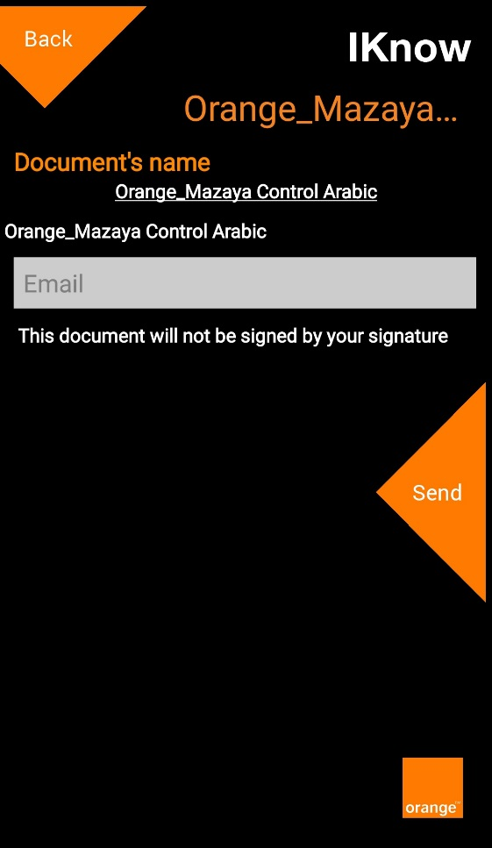
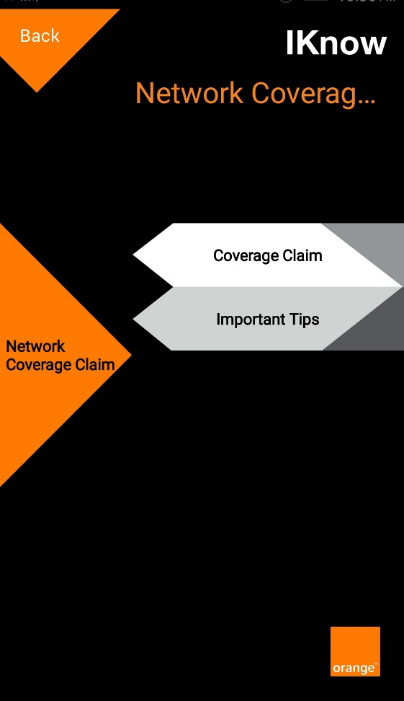

Figure 96: Important Tips file view/send
Figure 97: Network Coverage Screen

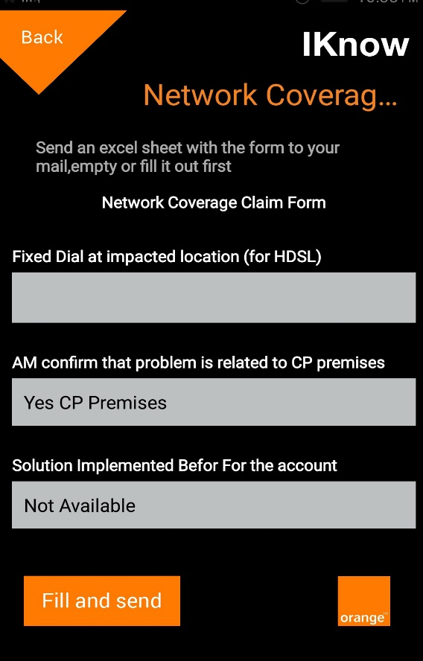
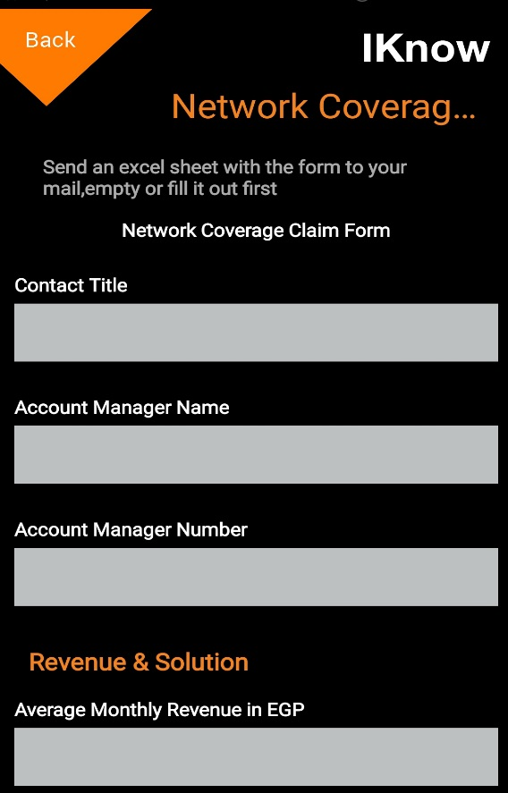
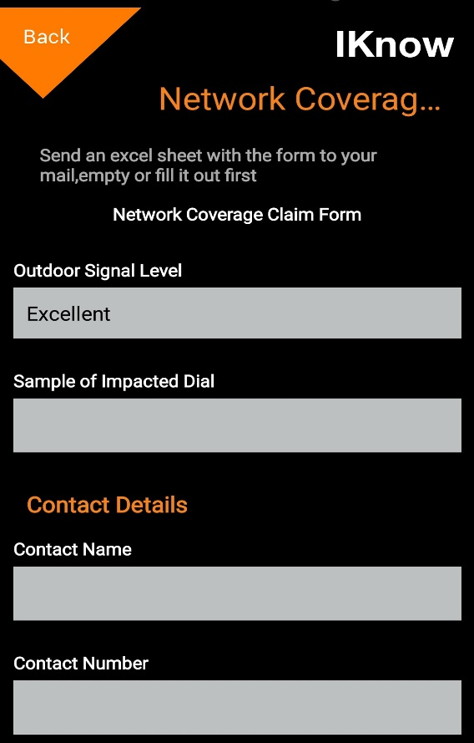
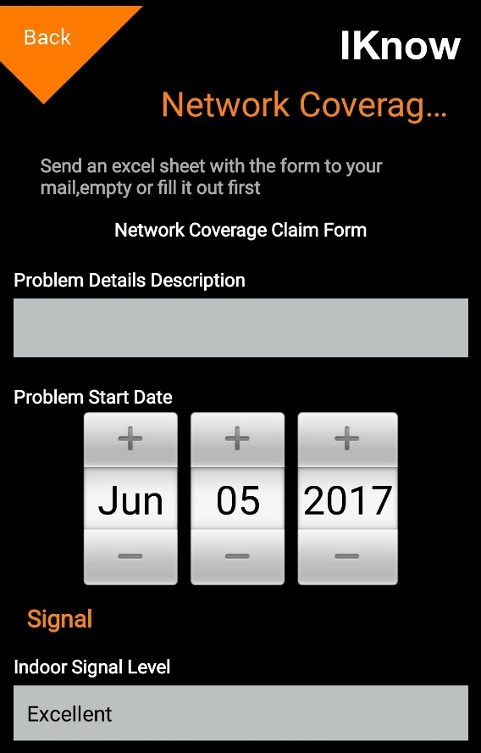
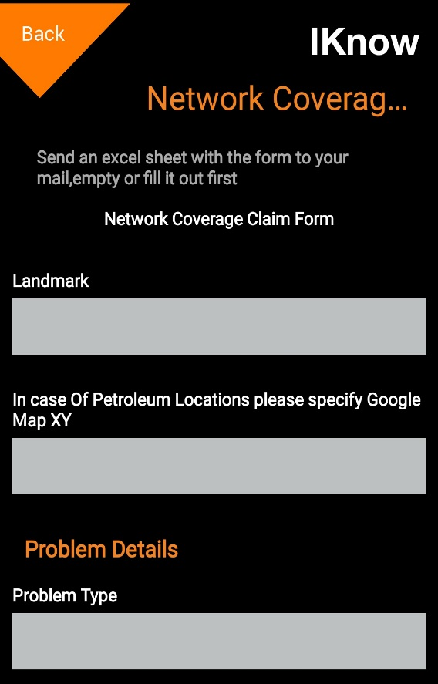
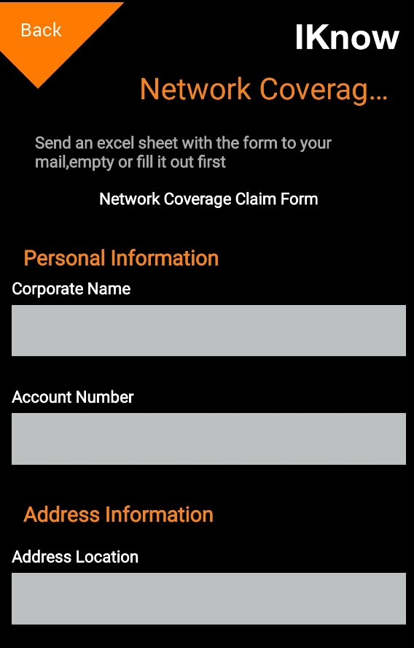
Figure 98: Network Coverage Claim Form

Special program points Screen
The mobile user will access this screen by clicking on the menu (“Special” program points).

- This screen allows the mobile user to view details about the programs that matches his/her number of points.

- The mobile user will fill the following fields (All the fields are mandatory) then click on the button “Calculate”:
  - User Type:
    - It is a list of choices (Individual - Corporate).
  - User Type:
    - It is a list of choices (Dial - Account).
  - Points:
    - The number of mobile user’s points.
    - It must be a numeric value with no fractions.

- The system will show details about the program that matches the mobile user’s number of points.

- The mobile user can click on the button “View Suppliers” to view the contacts of the programs suppliers.

- The mobile user can press “Back” to return to the previous screen.

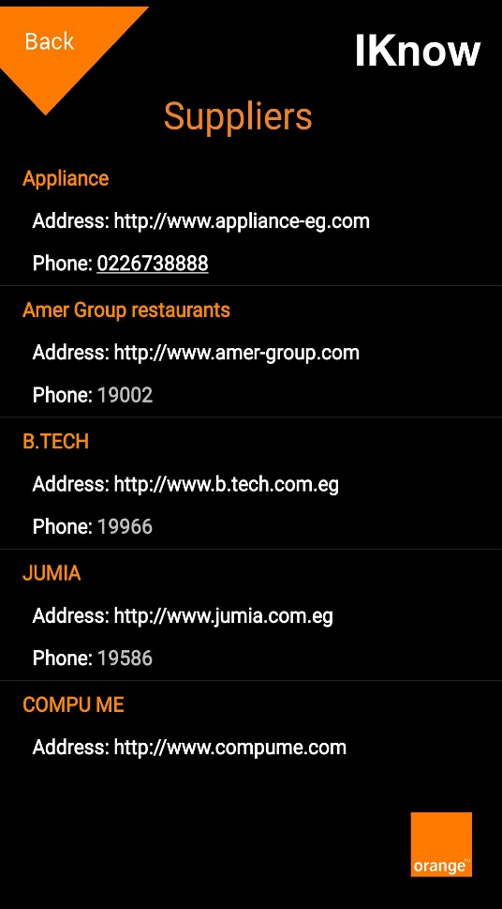
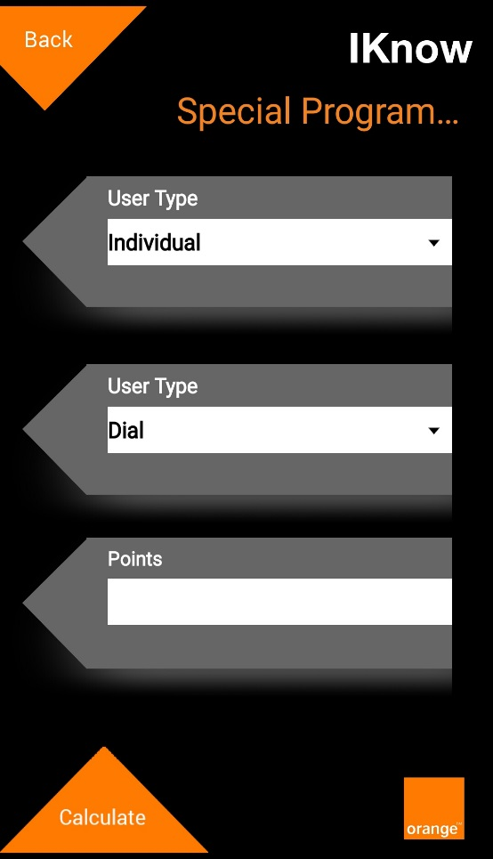
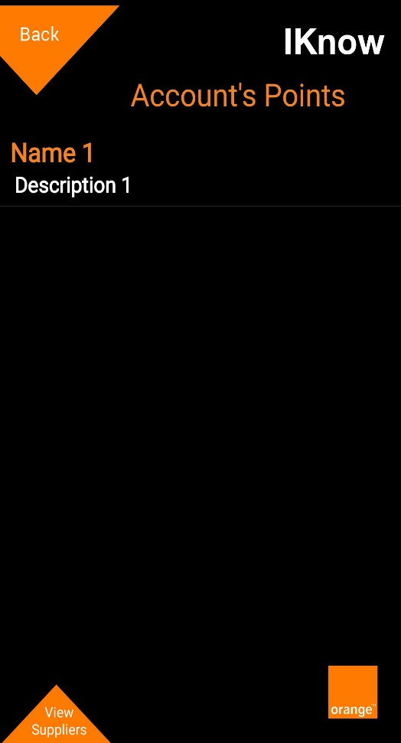
Figure 99: Suppliers Screen
Figure 100: Program details screen
Figure 101: Special program points Screen

My Business Screen
The mobile user will access this screen by clicking on the menu (My Business).

- This screen allows the mobile user to view contents on my business function in the system.

- My business is organized into categories/sub-categories.

- The mobile user can open any category/sub-category to view the contents.
  - The contents exists only in the last level of the categories tree.
  - The content can be paragraph of any text with a file which is provided by the channel administrator.
  - The mobile user can send the content file to a specific E-Mail address by typing the desired E-Mail address and click the button “Send”.

- The mobile user can press “Back” to return to the previous screen.

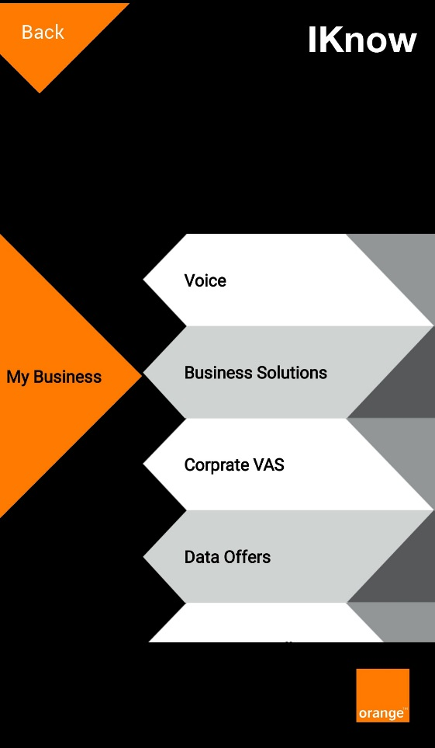

Figure 102: File view/send
Figure 103: My Business Screen

Select Calculator Screen
The mobile user will access this screen by clicking on the menu (Select Calculator).

- This screen allows the mobile user to calculate units/pay for his/her Orange mobile line.

- The mobile user will fill the following fields then click on the button “Calculate”:
  - Voice
  - SMS
  - MMS
  - Video Call
  - Data Bucket

- The system will show details about the needed units/pay.

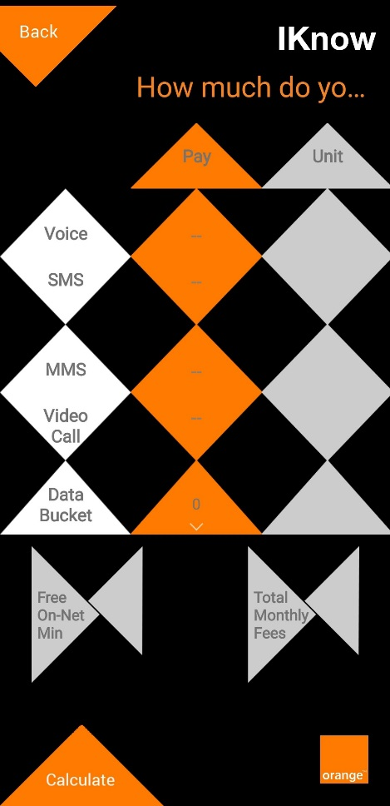
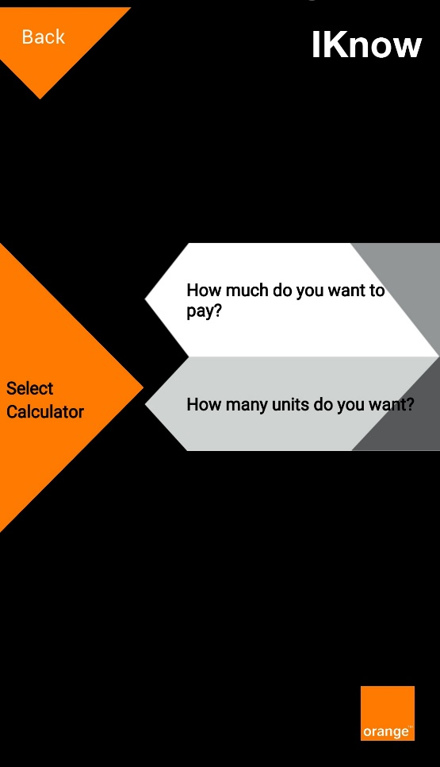
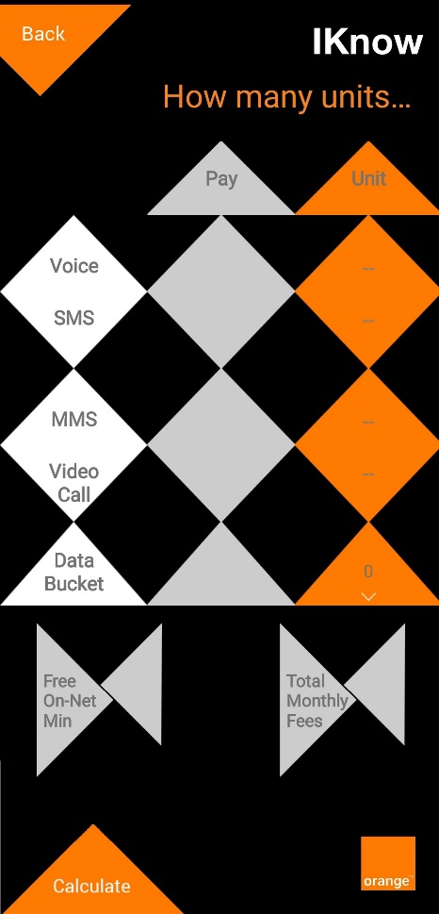
- The mobile user can press “Back” to return to the previous screen.
Figure 104: How many units do you want?
Figure 105: How much do you want to pay?
Figure 106: Select Calculator Screen

Contests Screen
The mobile user will access this screen by clicking on the menu (Contests).

- This screen allows the mobile user to view contents on the contests function in the system.

- Contests function contents are organized into categories/sub-categories.

- The mobile user can open any category/sub-category to view the contents.
  - The contents exists only in the last level of the categories tree.
  - The content can be paragraph of any text with a file which is provided by the channel administrator.
  - The mobile user can send the content file to a specific E-Mail address by typing the desired E-Mail address and click the button “Send”.

- The mobile user can press “Back” to return to the previous screen.

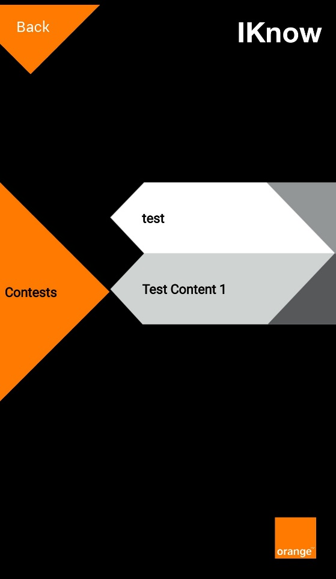

Figure 107: File view/send
Figure 108: Contests Screen

Operational Forms Screen
The mobile user will access this screen by clicking on the menu (Operational Forms).

- This screen allows the mobile user to view contents on the operational forms function in the system.

- Operational forms function contents are organized into categories/sub-categories.

- The mobile user can open any category/sub-category to view the contents.
  - The contents exists only in the last level of the categories tree.
  - The content can be paragraph of any text with a file which is provided by the channel administrator.
  - The mobile user can send the content file to a specific E-Mail address by typing the desired E-Mail address and click the button “Send”.

- The mobile user can press “Back” to return to the previous screen.

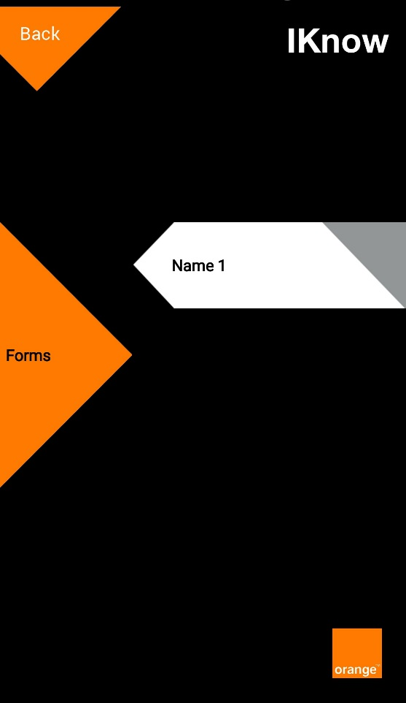

Figure 109: File view/send
Figure 110: Operational Forms Screen

Let's Play Screen
The mobile user will access this screen by clicking on the menu (Let's Play).

- This screen allows the mobile user to view/play contests on the let's play function in the system.

- A list of open/closed contests will be shown to the mobile user.
  - Open contests (Current date/time is greater than contest’s Start Date/Time and less than contest’s End Date/Time).
  - Closed contests (Current date/time is greater than contest’s End Date/Time).
  - The closed contests will be colored with a gray background but it will be accessible.

- The mobile user can click on any contest to open it.
  - A summary about the contest will be shown with the following data
    - The name of the contest.
    - Art Work Image (If exists).
    - Contest duration which is contest start and end dates (If open contest).
    - Contest end date (If closed contest).
    - Number of questions in the contest.
    - The description of the contest.

- The mobile user can do the following actions for open contests if he/she didn’t played it
  - Play the contest by clicking the button “Play”. This will open “Contest questions Screen”.
  - View the top ten winners with the highest score by clicking the button “Top 10 Ranks”. This will open "Contest top 10 ranks Screen".

- The mobile user can do the following actions for open contests if he/she already played it
  - View his/her own score by clicking the button “Result”. This will open "Contest result Screen".
  - View the top ten winners with the highest score by clicking the button “Top 10 Ranks”. This will open "Contest top 10 ranks Screen".

- The mobile user can do the following actions for closed contests if he/she didn’t played it
  - View the top ten winners with the highest score by clicking the button “Top 10 Ranks”. This will open "Contest top 10 ranks Screen".

- The mobile user can do the following actions for closed contests if he/she already played it
  - View his/her own score by clicking the button “Result”. This will open "Contest result Screen".
  - View the top ten winners with the highest score by clicking the button “Top 10 Ranks”. This will open "Contest top 10 ranks Screen".
  - View his/her own answer along with the correct answer highlighted for each question in the contest by clicking on the button “View Answers”. This will open "Contest answers Screen".

- The mobile user can press “Back” to return to the previous screen.

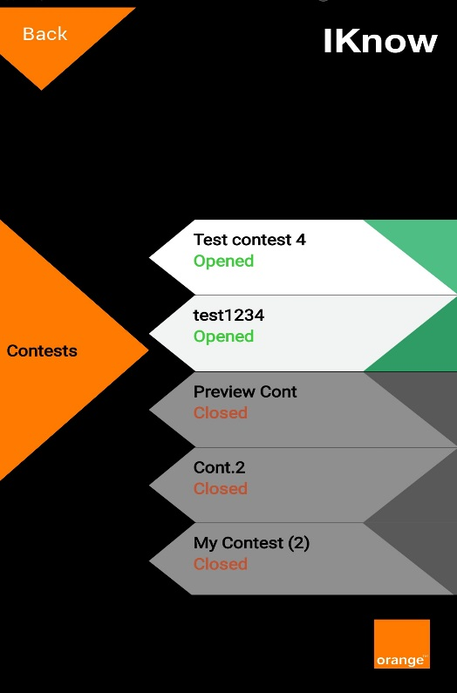

Figure 111: Let's Play Screen

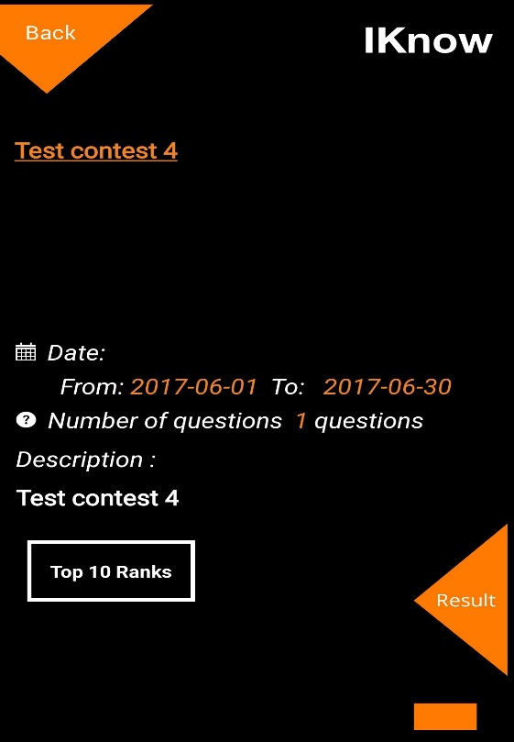
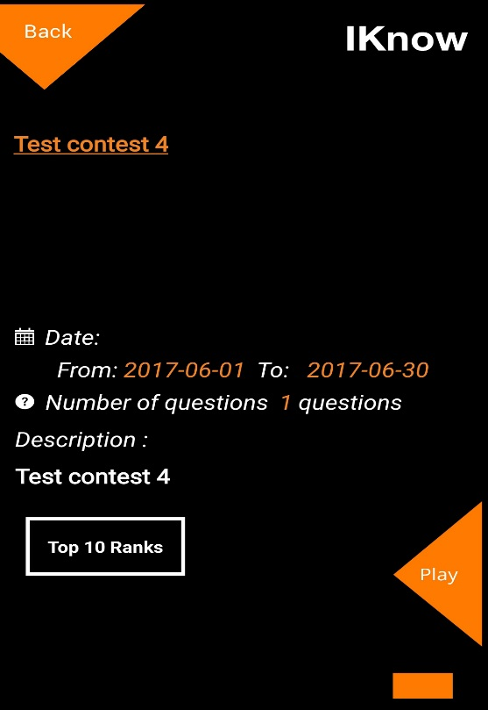

Figure 112: Open contest - Not played by the user
Figure 113: Open contest - Played by the user

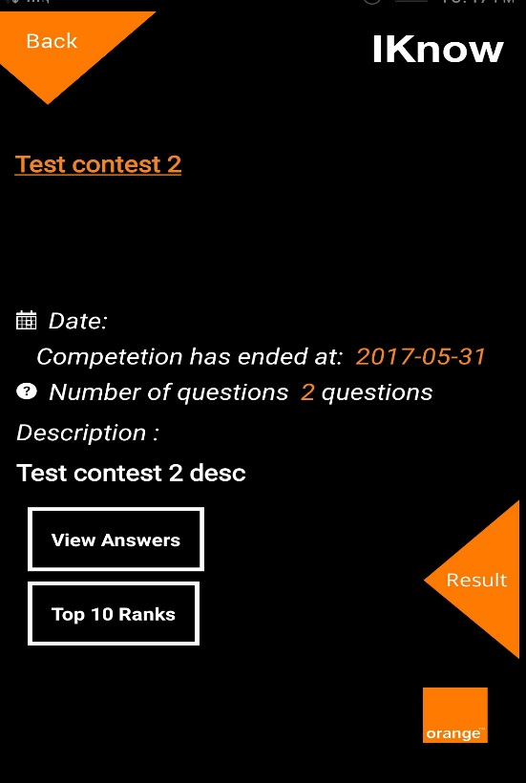
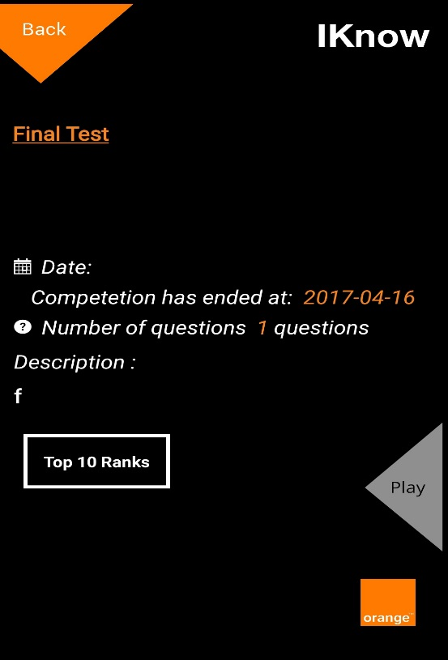

Figure 114: Closed contest - Played by the user
Figure 115: Closed contest - Not played by the user

Contest questions Screen
The mobile user will access this screen by clicking on an open contest then clicking the button “Play”.

- Questions of the contest will be displayed to the mobile user one by one.
  - Each question will be displayed with four answers. The mobile user can choose one or more answer(s). Answer can be a text or an image.
  - The mobile user will be required to answer the question during a specific duration which is a predefined duration by the channel admin. After the duration ends, the system will navigate to the next question automatically.
  - After answering a question, the mobile user can click on the button “Next” to go to the next question.
  - If the answer of the mobile user is correct, the user score displayed will be incremented with the value of the score of the question, otherwise, the user score will remains the same value.

- The mobile user can press “Back” to end the contest playing and return to the previous screen.

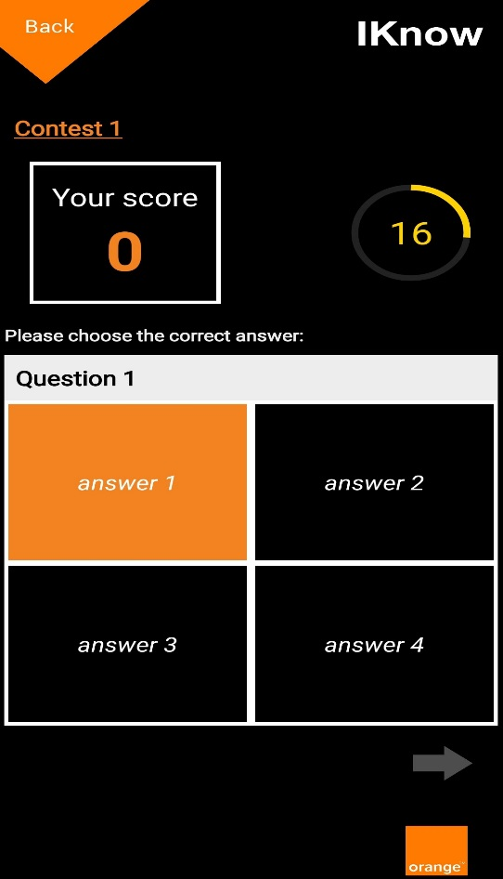

Figure 116: Contest questions Screen

Contest result Screen
After the mobile user answers the last question in a contest, the system will show this screen.
This screen will also be shown when the end user clicks the button “Result” on a contest that he/she already played.

- Result of the contest will be displayed for the mobile user with the following data
  - The name of the contest.
  - The score of the mobile user in this contest.
  - The rank of the mobile user. It is a number from 1 to 10 upon the score.

- The mobile user can view the top ten winners with the highest score by clicking the button “Top 10 Ranks”.

- The mobile user can press “Back” to return to the previous screen.

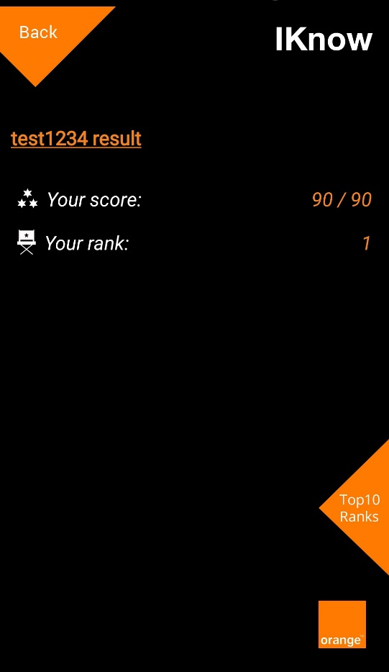

Figure 117: Contest result Screen

Contest top 10 ranks Screen
This screen will be shown when the end user clicks the button “Top 10 Ranks” on a specific contest.

- The top ten list will be displayed for the mobile user with the following data
  - The rank of the user in the contest.
  - The full name of the user.
  - The score of the user in the contest.

- The mobile user can press “Back” to return to the previous screen.

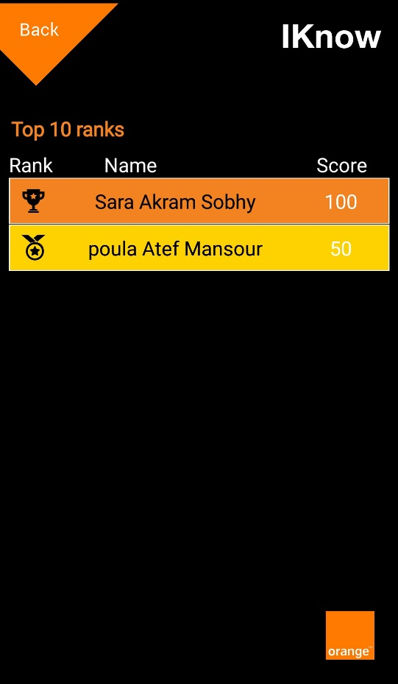

Figure 118: Contest top 10 ranks Screen

Contest answers Screen
This screen will be shown when the end user clicks the button “View Answers” on a closed contest that he/she already played.

- Each question of the contest will be displayed for the mobile user with the following data
  - The name of the contest.
  - A message that indicates whether the mobile user answered this question correctly or not.
  - The question paragraph.
  - The text of the four answers.
  - The chosen answer(s) by the mobile user will be highlighted.
  - The right answer(s) of the question will be highlighted.

- The mobile user can navigate to previous or next question by clicking the arrows under the question body.

- The mobile user can press “Back” to return to the previous screen.

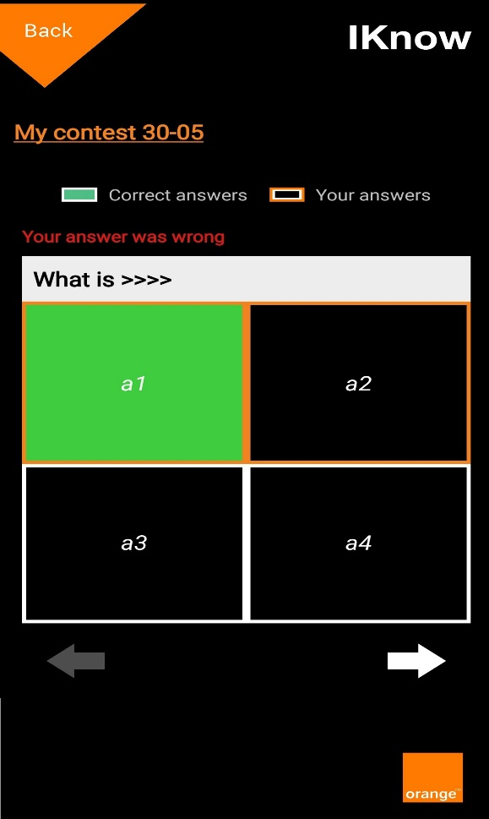

Figure 119: Contest answers Screen

Phone Advisor
The mobile user will access this function by clicking on the menu (Phone Advisor).

- This function opens a web page with a predefined URL to access the phone advisor site.

